CAPSTONE FINAL REPORT
BY: Fahad Ali

AI‑Powered Transaction Intelligence & Financial Coaching System

Executive Summary
Today, consumers generate large amounts of financial data through credit card purchases, debit transactions, and digital payment platforms. Despite having access to this data, many people struggle to understand their spending patterns or gain meaningful insights from their transaction history. Raw transaction records often appear as long lists of purchases without any clear structure or explanation of what the data reveals about a person’s financial behavior.
The goal of this project is to demonstrate how data science and machine learning can transform raw transaction data into useful financial insights. Specifically, this project focuses on building a predictive model capable of estimating transaction amounts based on user demographics, transaction categories, and time-related features.
The predictive model serves as the analytical foundation for a future AI‑powered financial coaching system. Such a system could analyze user spending behavior and provide personalized financial guidance in a clear and understandable way.
The final solution developed in this project includes these key components:
- Data cleaning and feature engineering to structure raw transactional data
- A Random Forest regression model to predict transaction amounts
- Model interpretation using feature importance analysis
- A reusable preprocessing pipeline designed for future deployment
Overall, this project demonstrates how predictive analytics can be used to better understand financial behavior and potentially support smarter financial decision-making.

Problem Statement
Financial transaction data contains valuable information about consumer behavior. However, both consumers and financial institutions often struggle to extract meaningful insights from this data. One major challenge is that transaction records are typically unstructured and difficult to interpret. While data such as merchant names, transaction categories, and timestamps are recorded, these variables do not automatically reveal patterns in spending behavior.
Another challenge is that many individuals lack visibility into how their spending habits change over time. Without analytical tools, it can be difficult to identify trends such as seasonal spending increases, category-specific expenses, or unusual financial behavior.
The objective of this capstone project is to address these challenges by developing a machine learning model that can learn patterns in spending behavior. By predicting transaction amounts based on contextual features, the system can help reveal underlying behavioral patterns in financial activity.
Ultimately, this predictive model could serve as the analytical engine behind an AI-powered financial coaching tool that translates data-driven insights into personalized financial advice.

Data Overview
The dataset used in this project contains approximately 50,000 financial transaction records. Each record represents an individual financial transaction and includes a variety of attributes describing both the customer and the transaction itself.
The dataset includes information such as:
- Customer demographic attributes
- Transaction amounts
- Merchant names
- Transaction categories
- Dates and time-related features
- Indicators distinguishing income from expenses
Together, these features provide a detailed view of consumer spending behavior and allow the machine learning model to identify relationships between contextual factors and transaction amounts.

Key Variables Used for Modeling
Feature | Description
age | Calculated from the customer’s birthdate
month | The month in which the transaction occurred
day_of_week | The day of the week for the transaction
is_expense | Binary variable indicating whether the transaction is an expense
category | Category assigned to the transaction
merchant_name | Merchant associated with the purchase
Target Variable
The primary variable the model attempts to predict is:
transaction_amount
This value represents the dollar amount of each transaction and serves as the target variable for the regression model.

Data Preprocessing
Before training the machine learning model, the dataset required several preprocessing steps to ensure the data was clean, structured, and suitable for modeling.
Feature Engineering
Several new features were created from existing data fields to capture useful patterns in the data. For example, the customer’s birthdate was converted into age, which provides a more meaningful variable for modeling demographic differences in spending behavior. Transaction timestamps were also used to create additional time-based features such as month and day of the week, which allow the model to identify temporal spending trends.
Additionally, a binary indicator was created to distinguish between expense transactions and income transactions, which helps the model better understand the context of each transaction.
Handling Missing Values
Missing values were addressed during preprocessing to ensure that incomplete records did not negatively impact model training. Standard imputation techniques were used for categorical features where necessary.
Encoding Categorical Features
Because machine learning models require numerical inputs, categorical variables such as merchant names and transaction categories had to be encoded.
Two encoding methods were used:
- One‑hot encoding for features with relatively few unique values
- Frequency encoding for high‑cardinality variables such as merchant names
This approach allowed the model to capture useful categorical information while keeping the feature space manageable.
Feature Scaling
Numerical features were standardized using StandardScaler, which helps ensure that variables with different scales do not disproportionately influence the model.
Pipeline Reproducibility
To support future deployment, several components of the preprocessing pipeline were saved, including:
- The trained feature scaler
- Lists of encoded features
- The final feature ordering used during model training
Saving these components ensures that new transaction data can be processed in exactly the same way during future predictions.

Exploratory Data Analysis (EDA)
Exploratory data analysis was performed to better understand the structure of the dataset and identify patterns that could influence model performance.
Several key insights emerged from this analysis.
Transaction Amount Distribution
The distribution of transaction amounts revealed a right‑skewed pattern (Figure 1), where most transactions fall within lower spending ranges while a smaller number of transactions represent significantly larger purchases.
This type of distribution is common in financial datasets and highlights the variability present in consumer spending behavior.
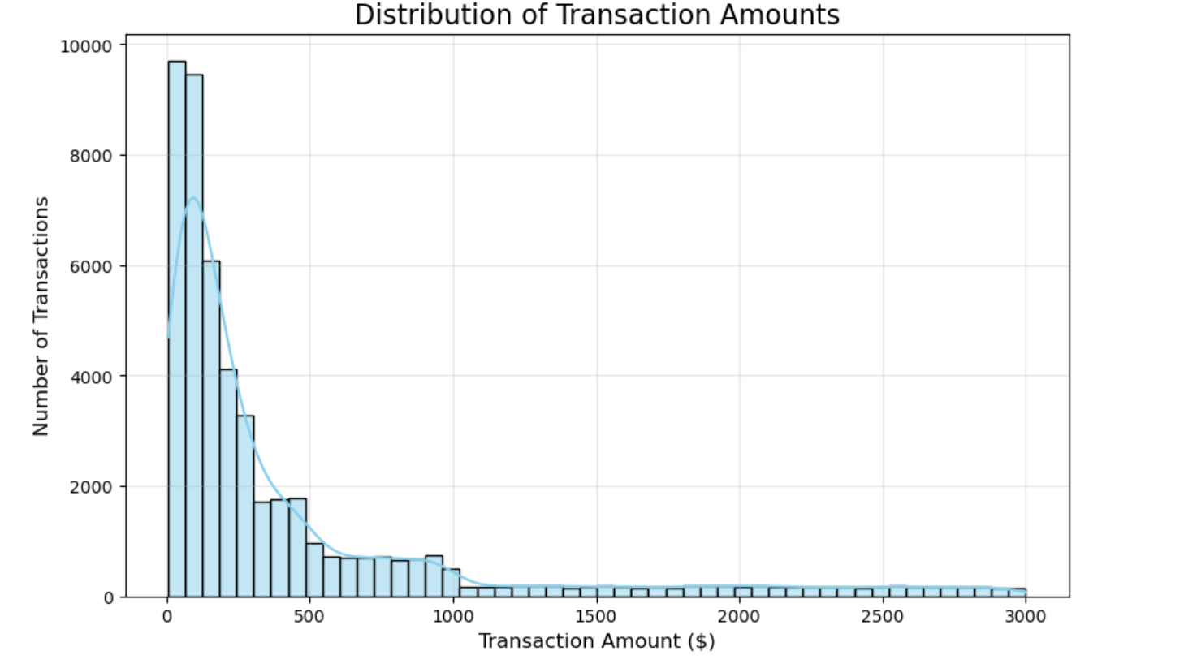
Figure 1: Distribution of Transaction Amounts
Spending is right-skewed with a concentration of low-to-mid value transactions.
Spending by Category
Analysis of spending by category showed that a small number of categories account for a large portion of total spending. Categories such as groceries, dining, and transportation tend to dominate overall expenses.
These insights are especially valuable for financial coaching applications, as they help identify areas where users may be able to adjust their spending habits.
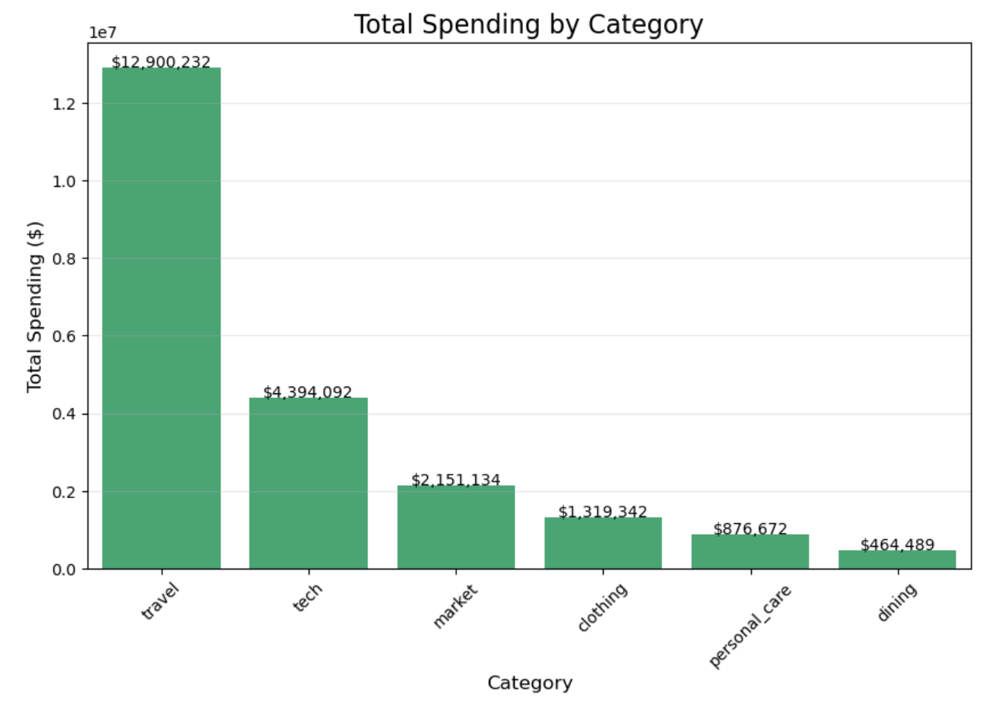
Figure 2: Spending by Category
A small number of categories account for the majority of spending.
Seasonal Spending Patterns
Monthly analysis indicated that spending levels fluctuate throughout the year, suggesting the presence of seasonal spending patterns. Certain months showed noticeably higher transaction activity, which may correspond to holidays, travel seasons, or other consumer behavior trends.
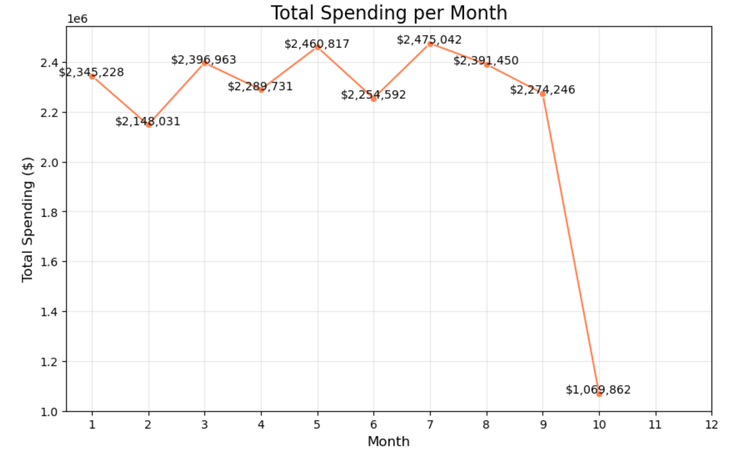
Figure 3: Spending by Month
Seasonal variation exists in transaction behavior.
Feature Importance
Feature importance analysis from the trained Random Forest model revealed that transaction category and merchant information play a significant role in predicting transaction amounts. Time-based features also contributed meaningfully to model performance.
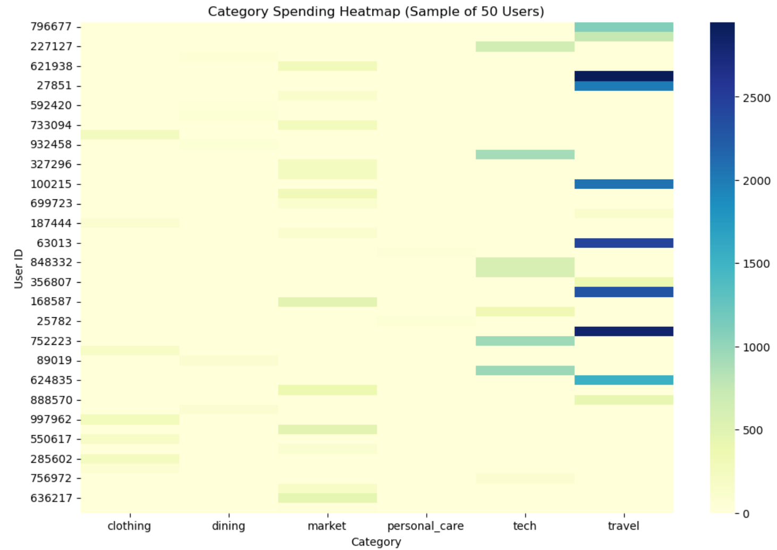
Figure 4: Feature Importance from Model
Category and merchant-level features strongly influence transaction amount prediction.
These results confirm that spending behavior is influenced by a combination of contextual, categorical, and temporal factors.

Modeling Approach
To predict transaction amounts, this project uses a Random Forest regression model.
Random Forest was chosen because it is well-suited for datasets that contain a mixture of numerical and categorical variables. Additionally, Random Forest models are capable of capturing complex nonlinear relationships between features and target variables.
Another advantage of Random Forest models is their ability to provide feature importance metrics, which help interpret which variables have the greatest influence on predictions.
Training Strategy
The dataset was divided into training and testing subsets using an 80/20 train-test split. The model was then trained using the training dataset and evaluated on the testing dataset to measure its predictive performance on unseen data.
Due to time constraints within the scope of this capstone project, extensive hyperparameter tuning was not performed. Instead, a baseline Random Forest model using default parameters was implemented.
Despite this, the model produced strong predictive performance and demonstrated the viability of the approach. After training, the model was saved for potential deployment in a future application.

Model Performance
To evaluate how well the model predicts transaction amounts, several standard regression performance metrics were used. These metrics help measure how closely the model’s predictions match the actual transaction values in the dataset.
The Random Forest regression model produced the following results:
- R² Score: 0.82
- Mean Absolute Error (MAE): 24.15
- Root Mean Squared Error (RMSE): 36.90

The R² score of 0.82 indicates that the model can explain approximately 82% of the variance in transaction amounts within the dataset. This suggests that the model successfully captures many of the underlying patterns that influence spending behavior.
The Mean Absolute Error (MAE) of 24.15 means that, on average, the model’s predictions differ from the actual transaction values by about $24. Considering the wide range of transaction values in the dataset, this level of error is considered reasonable.
The Root Mean Squared Error (RMSE) of 36.90 provides another measure of prediction accuracy while placing greater emphasis on larger prediction errors. The RMSE value indicates that the model performs consistently across most transaction ranges while still capturing larger spending events.
Overall, these results demonstrate that the model can learn meaningful relationships within the transaction data and generate reasonably accurate predictions.

Key Findings
Several important insights emerged during the analysis and modeling process.
First, transaction category plays a major role in determining spending behavior. Certain categories consistently produced higher transaction values, while others tended to involve smaller purchases. This suggests that category-based analysis can be very useful when evaluating consumer spending habits.
Second, merchant-level information significantly improved prediction accuracy. Different merchants often correspond to specific types of purchases, which helps the model better understand expected transaction sizes.
Third, time-related features such as month and day of the week also influenced spending patterns. This indicates that spending behavior can vary depending on the time of year or the day on which transactions occur.
Finally, the expense versus income classification provided additional context that helped the model differentiate between different types of financial activity. These findings demonstrate that spending behavior is influenced by a combination of demographic, contextual, and temporal factors.

Business Recommendations
The insights generated by this model could support several practical applications within financial technology platforms.

Behavioral Spending Alerts
Financial applications could use model predictions to detect unusual spending behavior. If a transaction significantly exceeds what the model predicts for a user’s typical spending patterns, the system could generate an alert to notify the user.
This type of alert system could help users identify overspending, unexpected charges, or unusual financial activity.

Personalized Budgeting Insights
Because the model identifies which spending categories contribute most to overall transaction amounts, financial platforms could use this information to generate personalized budgeting suggestions. For example, if a user consistently spends a large portion of their budget on dining or entertainment, the platform could suggest strategies for reducing those expenses.

AI‑Powered Financial Coaching
The predictive model developed in this project could also be integrated with a large language model (LLM) to provide personalized financial advice in natural language. Instead of presenting users with raw data or charts, the system could translate analytical insights into easy‑to‑understand recommendations.
For example, the system might generate a message such as:
“Your spending on dining tends to increase during weekends. Setting a weekly dining budget may help you maintain more consistent savings.”
This type of system could make financial insights more accessible to everyday users.

Limitations
While the results of this project are promising, several limitations should be considered.
First, hyperparameter tuning was not extensively explored due to the time constraints of the capstone project. More advanced tuning techniques could potentially improve model performance.
Second, the dataset used in this project does not include external economic or behavioral variables, such as inflation rates or geographic spending trends. Including these additional variables could improve the predictive capabilities of the model.
Another limitation relates to categorical encoding for high-cardinality features, such as merchant names. Frequency encoding was used to simplify the dataset and reduce computational complexity, but more advanced encoding methods could potentially capture additional information.
Finally, the dataset may represent synthetic or limited financial behavior patterns, meaning the model’s performance could vary when applied to real-world financial transaction data.
These limitations highlight opportunities for future improvement and expansion of the system.

Future Work
Several potential improvements could significantly enhance the capabilities of this system.
One important improvement would be to perform hyperparameter optimization on the Random Forest model. Techniques such as grid search or randomized search could be used to identify parameter combinations that improve predictive accuracy.
Another potential extension would involve implementing time-series forecasting techniques to better model spending behavior over time. Models such as ARIMA, Prophet, or recurrent neural networks could capture longer-term trends in financial activity.
The system could also be expanded by incorporating customer segmentation through clustering techniques. Grouping users with similar spending patterns could enable more targeted financial recommendations.
In addition, a real-time interactive dashboard could be developed using tools such as Streamlit. This would allow users to upload transaction data, visualize their spending patterns, and receive AI-generated financial insights.
Finally, integrating the predictive model with a conversational AI interface could create a fully interactive financial assistant capable of answering questions and providing personalized financial guidance.

Conclusion
This capstone project demonstrates how data science techniques can be used to transform raw financial transaction data into meaningful predictive insights. Through a structured workflow involving data preprocessing, exploratory analysis, feature engineering, and machine learning modeling, the project successfully developed a system capable of predicting transaction amounts based on behavioral and contextual features.
The Random Forest regression model achieved strong performance, explaining a significant portion of the variability in transaction values and providing useful insights into the factors that influence consumer spending. Beyond predictive modeling, the project also highlights the potential for integrating machine learning with AI-driven financial coaching tools. By translating analytical insights into understandable recommendations, such systems could help individuals gain better awareness of their financial habits and make more informed financial decisions.
Overall, this project provides a foundation for future work in AI-powered financial analytics and personalized financial coaching systems.

