**Visualization – Matplotlib, Plotly and cufflink**

Data Visualization is an important part of business activities as organizations nowadays collect a huge amount of data.

**BoxPlot:**

For some distributions/datasets, you will find that you need more information than the measures of central tendency (median, mean, and mode). We need to have information on the variability or dispersion of the data. A boxplot is a graph that gives you a good indication of how the values in the data are spread out. Although boxplots may seem primitive in comparison to a histogram or density plot, they have the advantage of taking up less space, which is useful when comparing distributions between many groups or datasets.

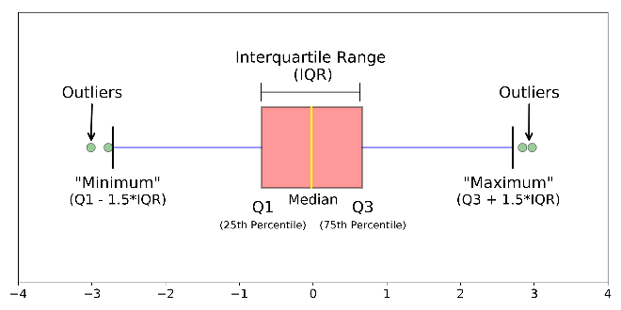

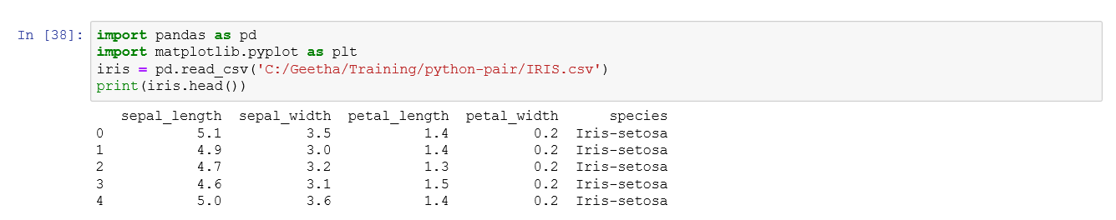

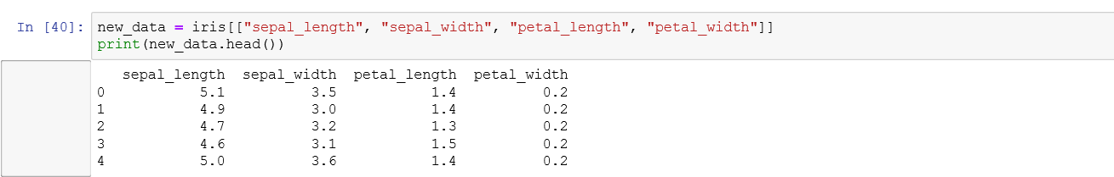

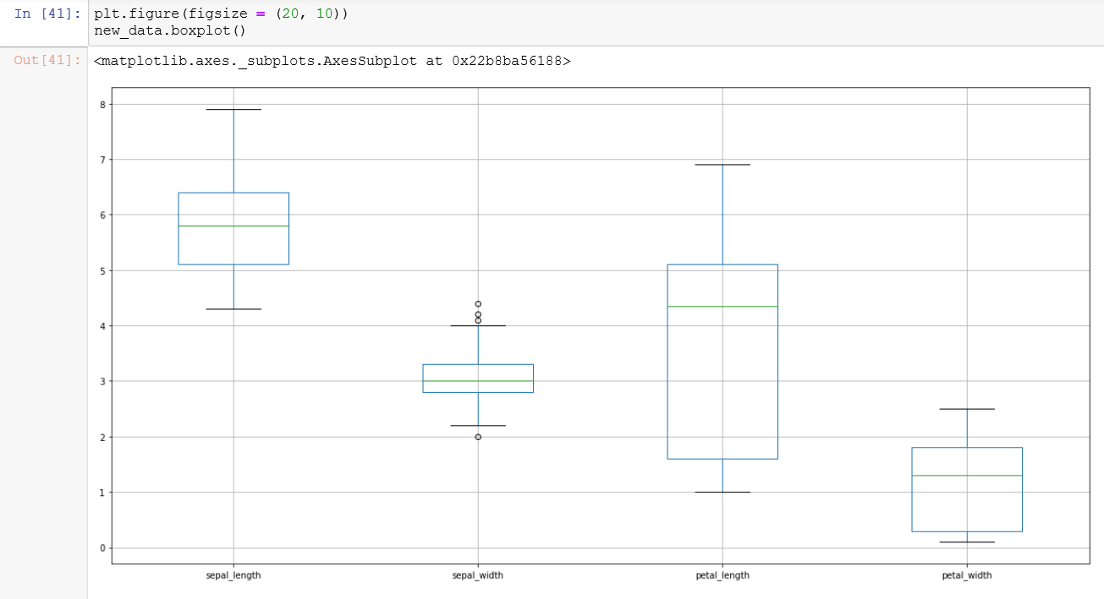

**Line Chart:**

In Matplotlib we can create a line chart by calling the plot method. We can also plot multiple columns in one graph, by looping through the columns we want and plotting each column on the same axis.

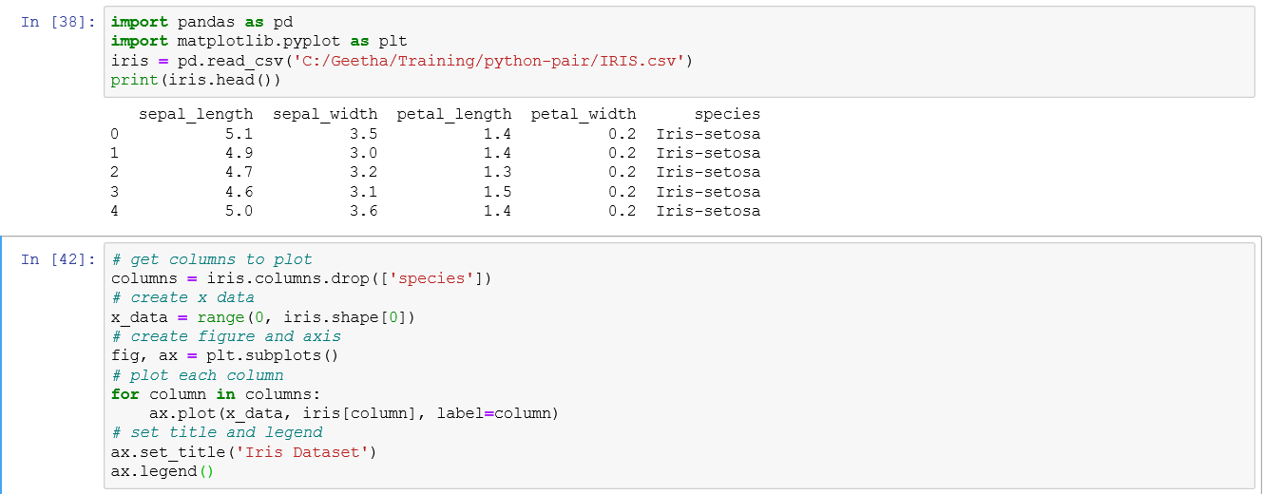

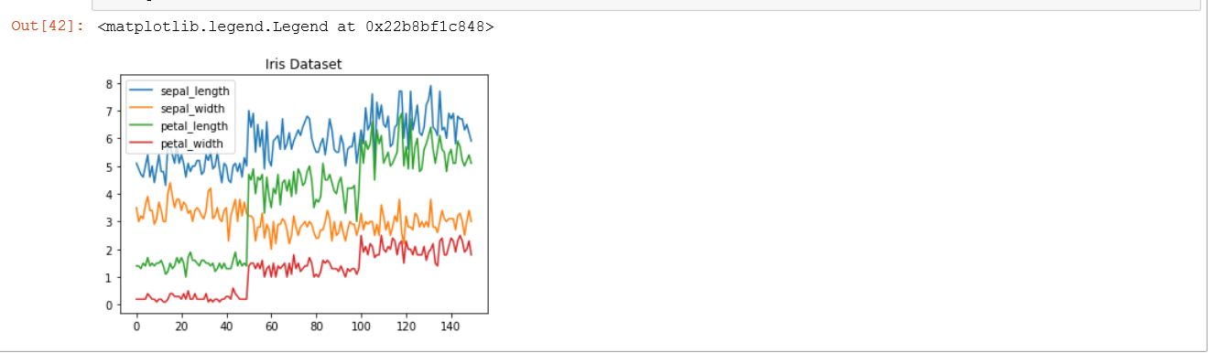

**Histogram:**

In Matplotlib we can create a Histogram using the hist method. It will automatically calculate how often each class occurs. For example, in the iris dataset it shows how often the each of the Septal_Length is seen in the given dataset.

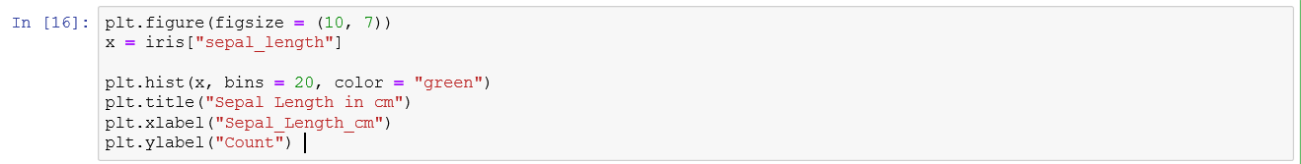

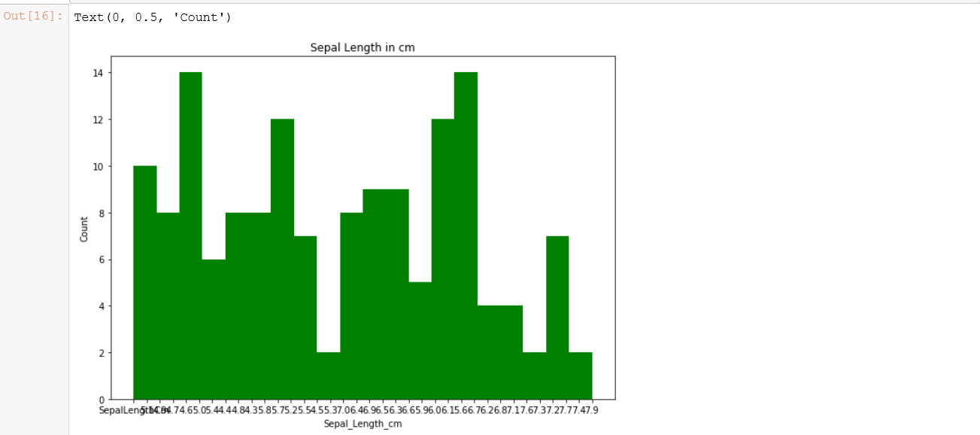

**Bar Chart:**

A bar chart can be created using the bar method. The bar-chart isn’t automatically calculating the frequency of a category, so we are going to use pandas value_counts function to do this. The bar-chart is useful for categorical data that doesn’t have a lot of different categories (less  than 30) because else it can get quite messy.

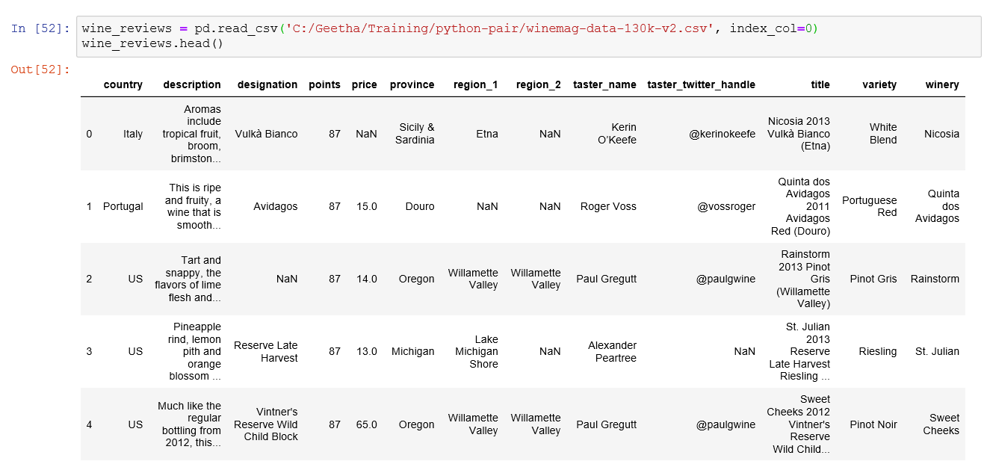

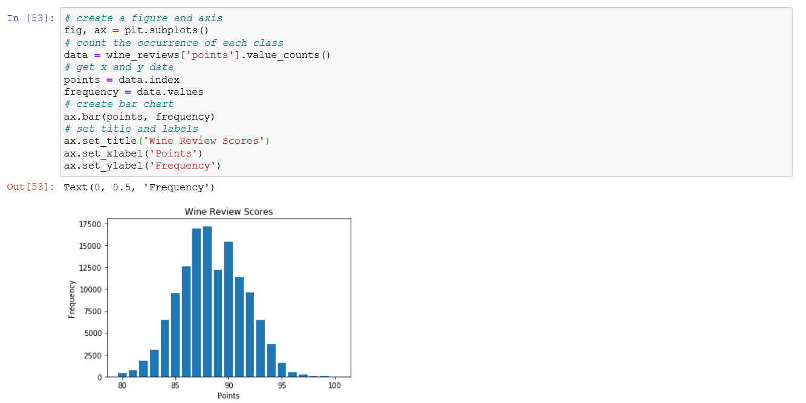

**Pie Chart:**

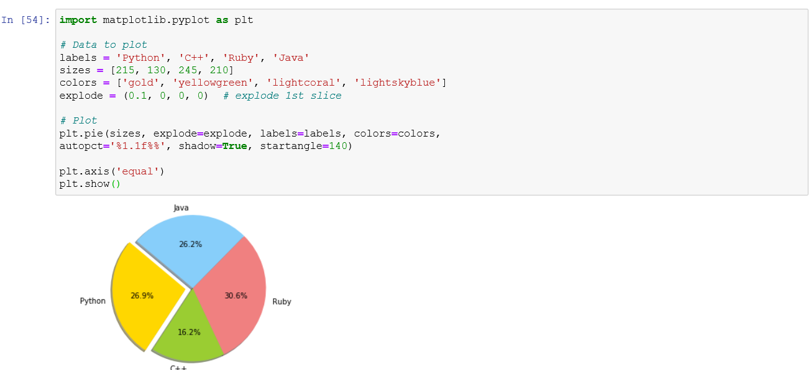

**Plotly: (Sample Interactive Graph using Plotly)**

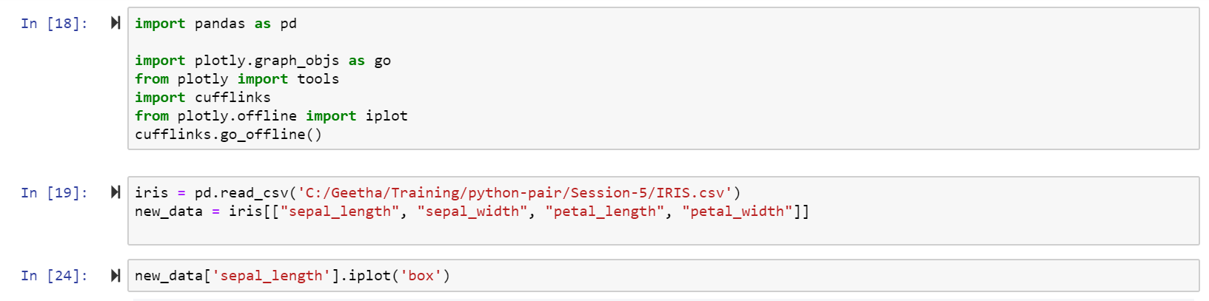

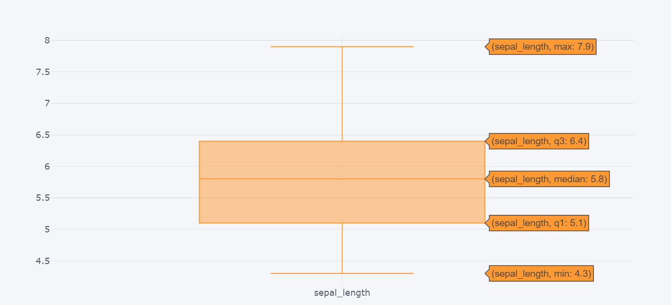

**Choropleth Map:**

A Choropleth Map is a heatmap using geographical boundaries. It is used to represent spatial variations of a quantity.

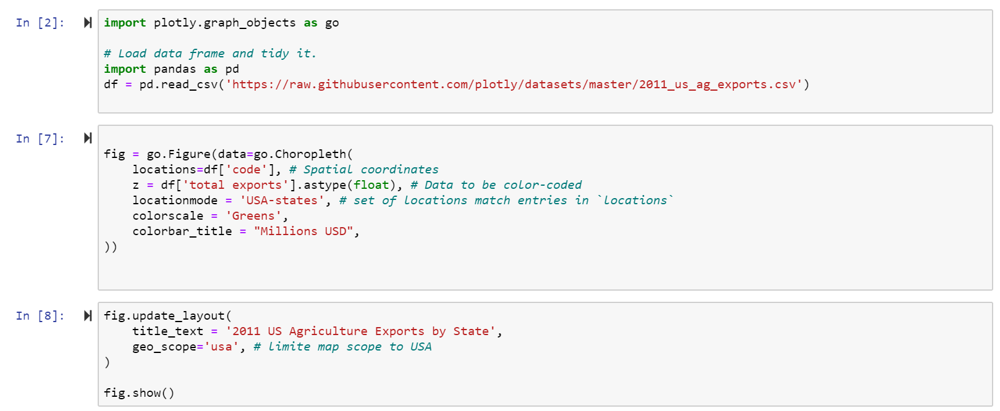

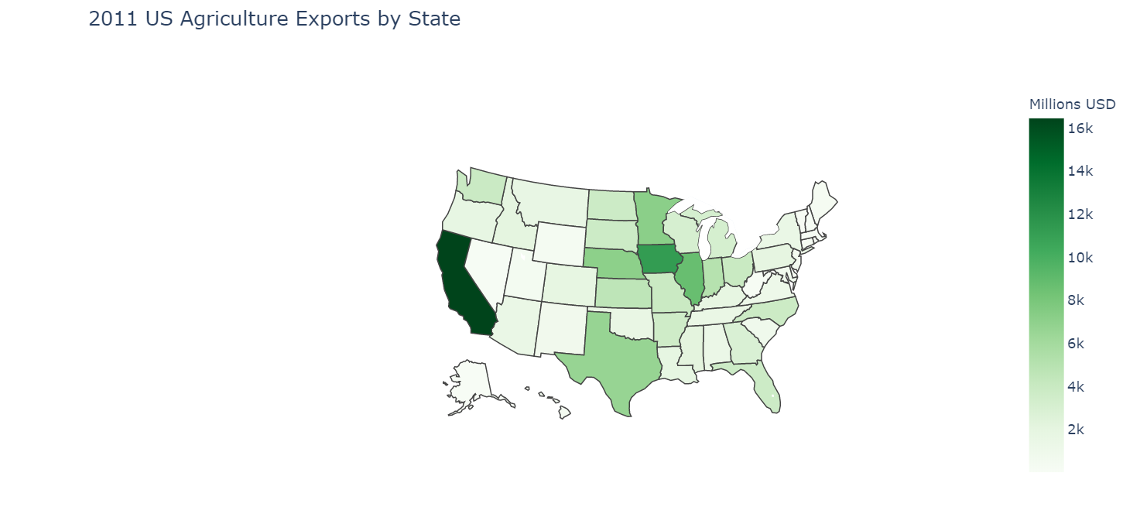

**HeatMap: (**To visualize the correlations between numerical values)



