**Algorithm Adventure GDD (Game Design Document)**

**Deadline**

10/04/2024

**Summary**

**Unique Features**

**List 2-3 unique selling features of your game**

**MVP**

**Describe the minimal viable product you’ll be delivering.**

**Story**

**Gameplay**

**Levels**

**Art**

The map will look something similar to this art style:

**Summary –** This is a 3D world space. The game will use the Universal Render Pipeline and Post processing to give more realism and better special effects.

**UI, Systems & Options**

**UI –** The UI will look something like this:

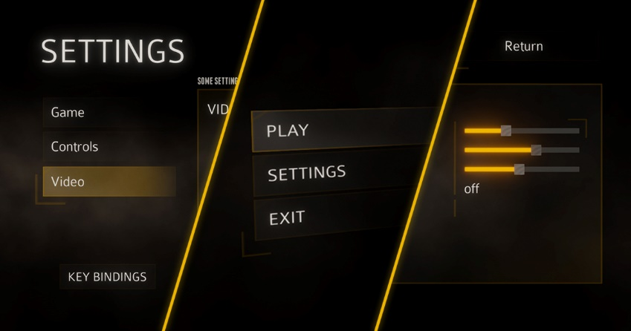

**Summary:**

* Instrumental music is played in the main menu (not when in game).
* Instrumental music is played in game (depending on the map).
* Instrumental music changes depending on the situation the player is in.

**Analysis**

**Technical Analysis**  - Experimental features include:

**Legal Analysis –** Some assets will be used from the Unity Asset Store.

**Target**

**Target Audience:**

**Target Device –** PC

**Target Budget –**