

**SOMBIZZ MAGAZINE**

**business**

Sombizz magazine issue: 1. July.2024

**Group 4**

**Mohamed Mustaf Mohamed**

**Falis Hussien Shire**

**Asma Hussien Ali**

**Hamza Ahmed Abdulahi**

**Farhan Ahmed Mohamed**

**Trends in business**

1. **Artificial Intelligence (AI)**

AI is revolutionizing business operations through automation, enhanced decision-making, and personalized customer experiences.

**- Customer Service:** AI-powered chatbots provide 24/7 support, improving customer satisfaction and reducing costs.

- **Marketing:** AI analyzes consumer data to personalize marketing efforts, predict trends, and optimize campaigns.

- Operations: AI-driven automation streamlines processes, from supply chain management to inventory control, increasing efficiency and reducing errors. 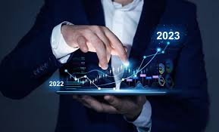

2. Remote Work and Digital Collaboration

The rise of remote work has transformed traditional office environments, with digital tools enabling seamless collaboration.

- Video Conferencing: Platforms like Zoom and Microsoft Teams facilitate communication and collaboration among remote teams.

- Cloud Services: Cloud-based tools like Google Workspace and Slack allow for efficient file sharing and project management.

- Flexible Work Arrangements: Companies offer flexible schedules and remote work options to attract and retain talent. 

3. Sustainability

Sustainability is becoming a core focus for businesses, driven by consumer demand and regulatory requirements.

- Green Offices: Adoption of eco-friendly practices such as using renewable energy, recycling programs, and sustainable materials.

- Sustainable Products: Development of products with minimal environmental impact, promoting a circular economy.

- Corporate Social Responsibility (CSR): Businesses are increasingly engaging in CSR initiatives to enhance their brand image and meet societal expectations.

4. Big Data and Analytics

Data-driven decision-making is at the heart of modern business strategies.

- Data Collection: Businesses gather vast amounts of data from various sources, including customer interactions and IoT devices.

- Data Analysis: Advanced analytics tools help companies interpret data to identify trends, optimize operations, and make informed decisions.

- Personalization: Leveraging data to offer personalized experiences to customers, enhancing satisfaction and loyalty.

5. Internet of Things (IoT

IoT technology connects everyday objects to the internet, enabling smarter business operations.

- Smart Devices: Integration of sensors and smart devices in the workplace for real-time monitoring and automation.

- Operational Efficiency: IoT improves asset tracking, inventory management, and predictive maintenance, reducing downtime and costs.

- Customer Experience: Businesses use IoT to enhance customer experiences, such as smart home products and connected services.

These trends are reshaping the business landscape, offering new opportunities for innovation and growth while addressing contemporary challenges.



Inflation

Inflation is a general increase in the price of goods and services in an economy over a period of time. This rise in prices decreases the purchasing power of currency

Causes of Inflation

Demand-Pull Inflation

When demand for goods and services exceeds supply, prices rise.

Cost-Push Inflation

When production costs increase, businesses pass those costs onto consumers.

Money Supply Inflation

When there's too much money in circulation, it can cause prices to rise.

Built-in Inflation

Wage-price spirals can contribute to inflation when labor costs are passed down to consumers.



Effects of Inflation

Reduced Purchasing Power

Inflation erodes the value of money, making it harder to afford goods and services.

Interest Rate Increases

Central banks may raise interest rates to combat inflation, which can increase borrowing costs.

Economic Uncertainty

High inflation can create uncertainty and make it difficult for businesses to plan for the future.

Inflation Rates Around the World

United States

Inflation rates in the United States have been relatively high in recent years.

European Union

The European Union has also experienced elevated inflation rates.

Japan

Japan has historically experienced very low inflation rates.

India

India has seen a significant increase in inflation rates recently. 

**FOREX TRADE**

Forex trading, or foreign exchange trading, involves buying and selling currencies in the foreign exchange market with the aim of making a profit. It’s the largest and most liquid financial market in the world, and it operates 24 hours a day, five days a week. Here's a basic overview of how forex trading works: 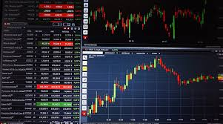

**1. Understanding Forex Trading:**

* **Currency Pairs:** In forex trading, currencies are traded in pairs. For example, EUR/USD (Euro/US Dollar) or GBP/JPY (British Pound/Japanese Yen). You buy one currency and sell another simultaneously.
* **Bid and Ask Price:** The bid price is what you receive when selling a currency, and the ask price is what you pay when buying. The difference between these two prices is known as the spread.
* **Leverage:** Forex brokers often offer leverage, allowing you to control a large position with a relatively small amount of capital. This can amplify both potential gains and losses

**2. Getting Started:**

1. **Choose a Reliable Forex Broker:**
   * Look for brokers with a good reputation, proper regulation, low spreads, and reliable trading platforms. Examples include OANDA, IG Group, and Forex.com.
2. **Open a Trading Account:**
   * Sign up for an account with your chosen broker. You might start with a demo account to practice trading without risking real money.
3. **Deposit Funds:**
   * Once you're comfortable with your trading strategy, deposit funds into your live trading account.
4. **Develop a Trading Strategy:**
   * Strategies can be based on technical analysis (using charts and indicators), fundamental analysis (considering economic factors), or a combination of both.

* **3. Trading Basics**: Analyze the Market:
  + Use technical analysis tools like moving averages, Relative Strength Index (RSI), and candlestick patterns to identify potential trade opportunities.
  + Keep an eye on economic news and events that can impact currency values, such as interest rate decisions, employment reports, and geopolitical events.
* Place a Trade:
  + Decide which currency pair to trade and whether you want to buy or sell. Input your trade size, set stop-loss and take-profit orders to manage risk.
* Monitor and Manage:
  + After placing a trade, monitor its performance. You can adjust stop-loss and take-profit levels as the market conditions change.

**4. Risk Management:**

* Use Stop-Loss Orders:
  + Set stop-loss orders to automatically close a trade if it moves against you by a certain amount. This helps limit potential losses.
* **Manage Leverage:**
  + Use leverage cautiously. High leverage can magnify profits but also increases the risk of significant losses.
* Diversify:
  + Don’t put all your capital into one trade or currency pair. Diversifying helps manage risk.

**5. Education and Tools:**

* Stay Informed:
  + Continuously educate yourself about market trends, trading strategies, and economic factors affecting currencies.
* Use Trading Tools:
  + Many brokers provide trading platforms with integrated tools for technical analysis, economic calendars, and news feeds.

**6. Regulations and Compliance:**

* Regulation:
  + Ensure your broker is regulated by a reputable financial authority, such as the FCA (UK), ASIC (Australia), or NFA (US). Regulation helps protect your investments and ensures fair trading practices.
* Be Aware of Scams:
  + Be cautious of brokers that offer unrealistic returns or require large upfront deposits. Stick with well-known and regulated brokers.

Resources for Further Learning:

* Books:
  + *“Currency Trading for Dummies”* by Kathleen Brooks and Brian Dolan.
  + *“Trading in the Zone”* by Mark Douglas.
* **Online Courses**:
  + Many platforms offer free and paid courses on forex trading, including Coursera, Udemy, and Investopedia.



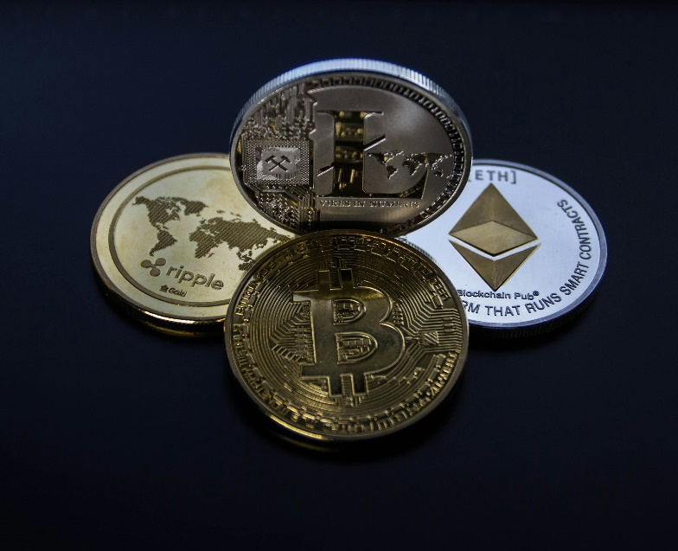**Crypto-currency**

**Introduction to Cryptocurrencies**

Cryptocurrencies are a form of digital or virtual money that uses cryptography to secure and verify transactions, as well as to control the creation of new units. Here is some basic information about cryptocurrencies:

Basics:

-Cryptocurrencies: Bitcoin (BTC), Ethereum (ETH), Litecoin (LTC), Ripple (XRP), and others.

- Exchanges: Platforms like Binnacle, Coinbase, Kraken allow buying, selling, and t

Trading Strategies:

- HOD Ling: Buying cryptocurrencies and holding them for a long period, b

Trading Strategies:

e- Day Trading: Buying and selling cryptocurrencies on the same day to take advantage of short-term price fluctuations.

- Swing Trading: Holding assets for several days or weeks to profit from expected price changes.

- Arbitrage: Buying cryptocurrencies on one exchange and selling them on another to profit from price differences.

Risks and Considerations:

- Volatility: Cryptocurrencies are known for their high price volatility, which can lead to significant losses in a short period.

- Security: Using insecure exchanges and wallets may result in the loss of assets due to hacks or scams.

- Regulation: Laws related to cryptocurrencies vary from country to country and can affect their trading and value.

Advantages:

- Decentralization: Cryptocurrencies are not controlled by any central authority like banks or governments.

- Transparency: All transactions are recorded in a public ledger that everyone can see.

- Low Fees: Transaction fees are generally lower compared to traditional financial systems.

Disadvantages:

- Complexity: Trading in cryptocurrencies requires a deep understanding of technology and financial markets.

- Scalability Issues: Some cryptocurrencies face challenges in handling a large number of transactions quickly.

- Environmental Impact: Mining, especially for Bitcoin, consumes significant amounts of energy.

Popular Cryptocurrencies:

- Bitcoin (BTC): The first and most well-known cryptocurrency, considered the benchmark for other cryptocurrencies.

- Ethereum (ETH): Known for its smart contract functionality and decentralized applications.

- Ripple (XRP): Focuses on enabling instant cross-border payments and reducing their costs.

Regulatory Environment:

- Regulation Varies by Country: Some countries embrace cryptocurrencies, while others ban or heavily regulate them.

- Tax Implications: Trading and holding cryptocurrencies may have tax implications depending on local laws.

Getting Started:

1. Choose an Exchange: Look for a reputable exchange to buy and sell cryptocurrencies.

2. Create a Wallet: Set up a secure wallet to store your cryptocurrencies.

3. Educate Yourself: Learn about market trends, security practices, and trading strategies.

4. Start Small: Begin with a small investment to understand how the market works before committing more funds.

Staying informed about market news and developments is key to making informed trading decisions.

- Exchanges: Platforms like BinnacleKraken allow buying, selling, and 

**Subsidies**

A subsidy is a direct or indirect payment to individuals or firms, usually in the form of a cash payment from the government or a targeted tax cut. In economic theory, subsidies can be used to offset market failures and externalities to achieve greater economic efficiency.



Two of the most common types of individual subsidies are welfare payments and unemployment benefits.

The most common type of subsidy is a production subsidy, which reduces the costs of producing a good or service. This can be done by providing tax breaks or direct payments to businesses. Another common type of subsidy is a consumption subsidy, which reduces the cost of consuming a good or service.

Subsidies come in various forms including: direct (cash grants, interest-free loans) and indirect (tax breaks, insurance, low-interest loans, accelerated depreciation, rent rebates). Furthermore, they can be broad or narrow, legal or illegal, ethical or unethical.

In general, businesses may seek out and utilize government subsidies or other forms of financial assistance to help fund various projects or initiatives. Subsidies can come in many forms, such as:

- Direct cash payments or tax credits

- Low-interest loans or loan guarantees

- Grants for research, development, or infrastructure

- Tax exemptions or deductions

Businesses may use these subsidies to help offset the costs and risks associated with launching new products, expanding operations, investing in R&D, or other strategic projects. The availability and terms of subsidies can be an important factor in a business's decision-making process when planning and executing various projects.



**Digital Economy**

A Journey Through the Digital Economy:

Welcome to the world of the digital economy, where technology transforms business operations and strategies. Let's embark on an academic journey through this evolving landscape from a business perspective.

The Foundation

Imagine a city where everything is interconnected. Beneath the streets and across oceans lie broadband cables and data centers that power our digital world. How do these infrastructures enable businesses to operate efficiently and reach global markets? Understanding the digital economy's foundation is essential for leveraging technology for growth and innovation.

The Marketplace

Picture yourself in a bustling online marketplace. Here, businesses can sell anything from books to gadgets and groceries. What mechanisms make seamless transactions possible? Digital wallets and online banking have transformed commerce. What challenges and opportunities does this shift present for businesses in logistics, customer engagement, and competition?

The Services

Step into the world of digital services. Imagine streaming your favorite TV shows, browsing social media, or ordering food with just a few taps. How have these platforms become integral to business models and customer engagement strategies? Analyzing data-driven marketing and user engagement reveals much about attracting and retaining customers in a digital age.

The Power of Data

Think of data as the treasure chest of this digital world. Vast amounts of data are collected and analyzed every second, driving personalized experiences and business innovation. How do big data and artificial intelligence (AI) transform raw information into actionable business insights? Exploring data analytics' role in decision-making and product development is crucial for modern businesses.

Artificial Intelligence (AI)

AI is transforming sectors by enabling automation, enhancing decision-making, and personalizing user experiences. How can businesses harness AI to improve efficiency and drive innovation?

- Customer Service: AI-powered chatbots and virtual assistants handle inquiries 24/7, improving satisfaction and reducing costs.

- Marketing: AI analyzes consumer data to personalize marketing, predict trends, and optimize campaigns.

- Operations: AI-driven automation streamlines operations, from supply chain management to inventory control.

The Retail Transformation

Shopping has never been more thrilling. Picture an AI assistant that knows your preferences, recommending products just for you. How do mobile commerce and social media influence consumer behavior and marketing strategies? Investigating these trends highlights the importance of personalization and convenience in driving sales and loyalty.

The Future Our journey through the digital economy is just beginning. As technology continues to advance, the possibilities are endless. What future trends will shape the digital economy, and how can businesses prepare for and adapt to these changes? The digital economy promises a future that is more interconnected, intelligent, and dynamic than ever before, offering countless opportunities for business innovation and growth.

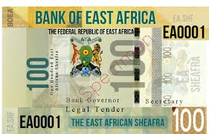

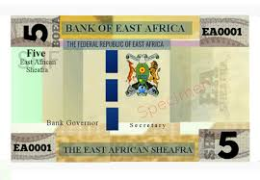

*SOMBIZZ MAGAZINE*