Task 1
1. Comparison Assignment
Create a comparison between Flat File Systems and Relational Databases covering:
• Structure
• Data Redundancy
• Relationships
• Example usage
• Drawbacks

Feature | Flat File Systems | Relational Databases
Structure | Data is stored in a single table or file (like a spreadsheet or CSV). It has a simple, two-dimensional structure of rows and columns with no formal internal organization beyond simple delimiters. | Data is organized into multiple tables (relations). Each table has a defined schema with rows and columns, and data is structured to link between these tables.
Data Redundancy | High potential for data redundancy. The same information (e.g., a customer's address) may be repeated across multiple records, which is inefficient and can lead to data inconsistency. | Minimized data redundancy through a process called normalization. Each unique piece of information is stored once, and other tables link to it.
Relationships | Lack built-in mechanisms for defining or managing relationships between different data elements or files. Any relationships must be managed manually by the application or user. | Explicitly defines and manages relationships using primary keys and foreign keys. This allows for complex connections (one-to-many, many-to-many) between data in different tables.
Example Usage | Ideal for simple applications, small datasets, configuration files, or logs where complexity is low. A common example is a personal contact list on a phone or a simple inventory spreadsheet. | Suited for complex, large-scale applications requiring data integrity and robust querying. Examples include online banking systems, inventory control for multi-branch businesses, and social media platforms.
Drawbacks | Prone to data inconsistencies and errors.

2. DBMS Advantages Mind Map
Draw a mind map (or use online tools like MindMup) illustrating the advantages of using a DBMS. Include short
descriptions or icons for:
• Security
• Integrity
• Backup
• Redundancy
• Concurrency
• Data sharing

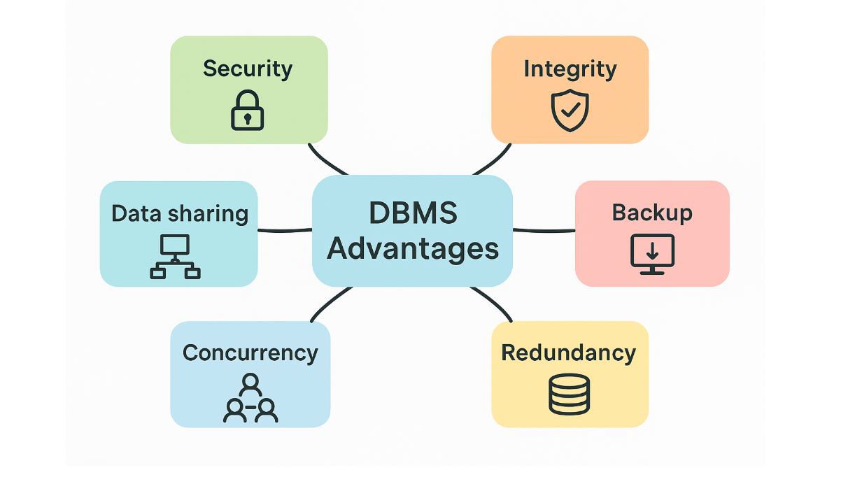
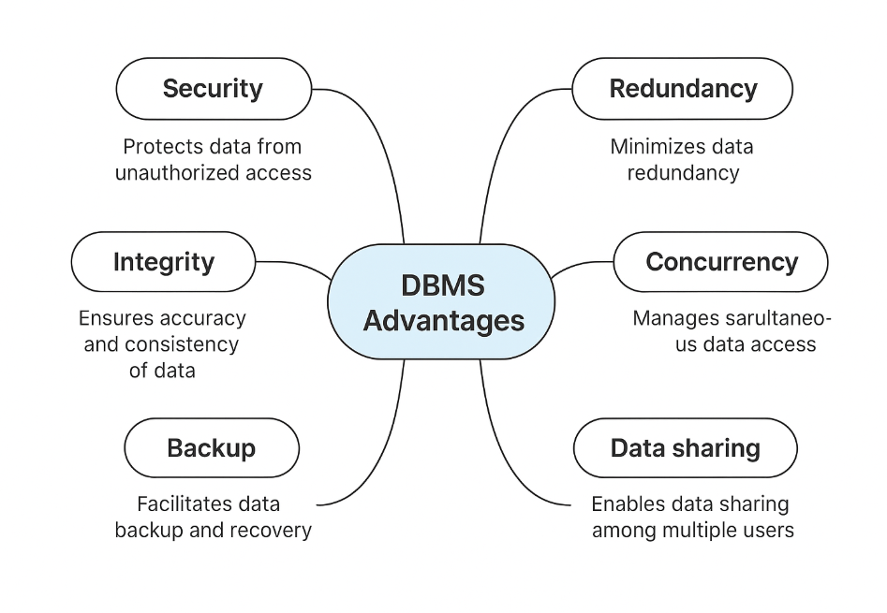

3. Roles in a Database System
Explaining each of the following roles:
• System Analyst
• Database Designer
• Database Developer
• DBA (Admin)
• Application Developer
• BI Developer

1. System Analyst
The System Analyst is responsible for understanding business needs and translating them into system requirements.
Key tasks:
- Meets with users and stakeholders to gather requirements.
- Analyzes current systems and identifies improvements.
- Creates system specifications that describe what the database should do.

2. Database Designer
The Database Designer focuses on designing the structure of the database.
Key tasks:
- Creates conceptual, logical, and physical database models.
- Designs tables, relationships, keys, and constraints.
- Ensures the design supports performance, integrity, and scalability.

3. Database Developer
The Database Developer builds the actual database based on the design.
Key tasks:
- Writes SQL queries, stored procedures, triggers, and functions.
- Implements tables, views, and relationships.
- Works closely with designers and application developers.

4. DBA (Database Administrator)
The DBA is responsible for managing and maintaining the database.
Key tasks:
- Handles installation, configuration, and upgrades.
- Ensures security, backup, and disaster recovery.
- Monitors performance and optimizes queries.
- Manages user access and permissions.

5. Application Developer
The Application Developer builds the front-end or back-end applications that interact with the database.
Key tasks:
- Writes application code (e.g., Java, C#, Python, JavaScript).
- Connects the app to the database using APIs or ORM tools.
- Ensures data flows correctly between the app and the database.

6. BI Developer (Business Intelligence Developer)
The BI Developer focuses on analyzing data and creating insights for decision-making.
Key tasks:
- Builds dashboards, reports, and data visualizations.
- Works with data warehouses, ETL tools, and analytics platforms.
- Helps organizations make data-driven decisions.

4. Types of Databases
- Search and briefly describe:
• Relational vs Non-Relational (e.g., MongoDB, Cassandra)
• Centralized vs Distributed vs Cloud Databases
• Use case examples

Relational vs Non-Relational Databases
1. Relational Databases (RDBMS)
Definition:
Databases that store data in tables (rows + columns) with fixed schema.
Features:
- Structured data
- Uses SQL
- Strong consistency
- Supports complex joins
Examples:
- MySQL
- PostgreSQL
- Oracle
- SQL Server
Use Cases:
- Banking systems
- HR systems
- Inventory management
- Applications needing ACID transactions

2. Non-Relational Databases (NoSQL)
Designed for flexible, semi-structured or unstructured data, high scalability.
Types:
- Document-based: MongoDB
- Wide-column: Cassandra
- Key-value: Redis
- Graph: Neo4j
a) MongoDB
- Document database (JSON-like documents)
- Flexible schema
- Good for rapidly changing data
Use Cases:
- E-commerce catalogs
- Mobile apps
- Content management systems
b) Cassandra
- Wide-column store
- Designed for big data and high availability
- Horizontal scalability across many nodes
Use Cases:
- IoT data
- Logging systems
- Social media analytics

✅ Centralized vs Distributed vs Cloud Databases
1. Centralized Database
Definition:
All data stored in one single location/server.
Advantages:
- Easy to manage
- Strong consistency
Disadvantages:
- Single point of failure
- Scalability limitations
Use Cases:
- Small organizations
- Local office systems

2. Distributed Database
Definition:
Data stored on multiple servers (nodes) connected over a network.
Features:
- High availability
- Faster access across regions
- Fault tolerance
Use Cases:
- Large enterprises
- Banks and telecom
- Systems requiring continuous availability

3. Cloud Database
Definition:
Databases hosted on cloud platforms: AWS, Azure, Google Cloud.
Features:
- On-demand scalability
- Reduced infrastructure management
- Pay-as-you-go
Examples:
- AWS RDS (SQL)
- Google Firestore (NoSQL)
- Azure SQL Database
Use Cases:
- Modern web/mobile apps
- SaaS platforms
- Global-scale applications

- Cloud Storage and Databases
  - What is Cloud Storage and how does it relate to databases?
  - Advantages and Disadvantages of using cloud-based databases (e.g., Azure SQL, Amazon RDS, Google
  - Cloud Spanner)
- Database Engines and Languages

1. What is Cloud Storage and how does it relate to databases?
Cloud Storage
Cloud Storage is a service that allows you to store files and data on remote servers managed by cloud providers such as AWS, Azure, or Google Cloud, instead of storing them on local computers.
Examples:
- Storing images, videos, documents
- Backups
- Application files
Relationship to Databases
Although cloud storage stores files, cloud databases store structured or unstructured data in a managed database service.
Cloud Storage | Cloud Database
Stores files (objects) | Stores data in tables/documents
Not a database | A fully functional DB system
Used for backups, media files | Used for applications, transactions, analytics
Services: S3, Azure Blob, Google Cloud Storage | Services: RDS, Azure SQL, Cloud Spanner
Both are in the cloud, but they serve different purposes.

2. Advantages of Cloud-Based Databases
(Examples: Azure SQL, Amazon RDS, Google Cloud Spanner)
✅ 1. Scalability
You can easily increase or decrease database capacity depending on your needs.
✅ 2. High Availability
Cloud providers automatically replicate your database across regions and servers.
✅ 3. Automatic Backups & Updates
No need to manage hardware or manual backups—the provider handles maintenance.
✅ 4. Cost-Effective
You pay only for the resources you use (pay-as-you-go).
✅ 5. Security
Built-in encryption, identity management, and network protection.
✅ 6. Global Access
Your database can be accessed from anywhere with internet connection.

3. Disadvantages of Cloud-Based Databases
❌ 1. Internet Dependency
If the internet is down, the system cannot access the database.
❌ 2. Cost Can Increase
As data grows, cloud usage fees may become expensive.
❌ 3. Limited Customization
You cannot fully control the underlying hardware or configuration.
❌ 4. Data Privacy Concerns
Some organizations are uncomfortable storing sensitive data off-premises.
❌ 5. Vendor Lock-In
Migrating from AWS → Azure → Google Cloud can be difficult.

Database Engines and Languages
Database Engines
A database engine is the core software that stores, processes, and retrieves data.
Examples:
- MySQL Engine (InnoDB)
- SQL Server Engine
- PostgreSQL Engine
- Oracle Engine
- Cloud Engines:
  - Azure SQL Engine
  - Amazon Aurora Engine
  - Google Cloud Spanner Engine
What the engine does:
- Handles queries
- Ensures transactions
- Manages indexes
- Controls storage & performance

Database Languages
1. SQL (Structured Query Language)
Used for relational databases (MySQL, SQL Server, PostgreSQL).
Examples:
- SELECT
- INSERT
- UPDATE
- DELETE
2. NoSQL Query Languages
Used for non-relational databases:
- MongoDB Query Language (MQL)
- Cassandra Query Language (CQL)
- Firebase Realtime Database rules
3. Procedural Languages (used inside databases)
- PL/SQL (Oracle)
- T-SQL (Microsoft SQL Server)
- Search about:
• What is a Database Engine?

A Database Engine is the core software component of a Database Management System (DBMS) responsible for storing, retrieving, managing, and processing data. It is the “brain” of the database.

• Examples: SQL Server, MySQL, Oracle, PostgreSQL

1. SQL Server
- Developed by Microsoft.
- A powerful relational database engine widely used in enterprises.
- Supports advanced analytics, BI tools, and integrates well with Windows systems and Azure.
2. MySQL
- Developed by Oracle Corporation (originally by MySQL AB).
- Very popular for web applications and open-source projects.
- Known for speed, reliability, and ease of use.
3. Oracle Database
- A high-performance enterprise database.
- Supports large, mission-critical applications.
- Known for reliability, scalability, and advanced features like clustering and strong security.
4. PostgreSQL
- Open-source, object-relational database engine.
- Highly extensible and standards-compliant.
- Great for complex queries, geographic data (PostGIS), and enterprise systems.

• What languages do they use? (e.g., T-SQL, PL/SQL, ANSI SQL)

SQL Server (Microsoft)
- T-SQL (Transact-SQL)
Microsoft’s extended version of SQL
Includes extra functions, stored procedures, error handling, etc.
MySQL / MariaDB
- ANSI SQL (standard SQL)
- MySQL SQL dialect
(MySQL supports standard SQL but has its own functions/extensions.)
PostgreSQL
- ANSI SQL
- PL/pgSQL (for stored procedures and triggers)
Oracle Database
- PL/SQL (Procedural Language/SQL)
Oracle’s procedural extension to SQL.

• Is there a relationship between the engine and the language?

Database Engine | Language / Dialect | Notes
SQL Server | T-SQL (Transact-SQL) | Microsoft’s extended version of SQL
Oracle DB | PL/SQL | Adds procedural features (loops, functions, etc.)
PostgreSQL | PL/pgSQL + standard SQL | Extensible, supports custom languages
MySQL / MariaDB | Standard SQL + MySQL dialect | Slightly different syntax and limits

• Can one language work across different engines?

Yes, a single programming language can work across different engines and is a common practice in software development. This is known as language interoperability, and the specific methods depend on how the languages and engines are designed to interact.
How it Works
Different programming languages can work together and with different engines in several ways:
- Scripting and Core Languages: It is common for high-performance engines (like game engines) to have their core written in a low-level, fast language like C or C++, while allowing game logic, AI, and user interfaces to be written in a higher-level, more flexible "scripting" language such as Python or Lua. The core engine "hosts" an interpreter and provides an Application Programming Interface (API) for the script to use its functionality.
- Shared Runtimes/Virtual Machines (VMs): Multiple languages can be compiled into a shared intermediate format that runs on the same virtual machine. The .NET framework (C#, VB.NET, etc.) and the Java Virtual Machine (JVM) (Java, Scala, Clojure) are examples where different source languages end up as the same bytecode, allowing seamless interoperation.
- Foreign Function Interfaces (FFI) and Libraries: Most languages provide a mechanism (FFI) to call functions written in another language (usually C, which is a "lingua franca" of programming) by adhering to a common Application Binary Interface (ABI). This allows developers to use existing libraries in other languages.
- Inter-Process Communication (IPC): Two different programs (processes) written in entirely different languages can run simultaneously and communicate by passing messages through mechanisms like network sockets (even on the same machine via loopback), shared memory, or named pipes.
- Compilers/Transpilers: Tools exist to translate source code from one high-level language to another (transpilers) or into a common target, such as JavaScript for web browsers.
Key Considerations
- Efficiency: Mixing languages can introduce overhead when data is passed between different runtime environments, so design choices must be made to balance performance with ease of development.
- Complexity: Using multiple languages makes development more complex, requiring knowledge of how different parts interact and the specific interfaces between them. Staying primarily within one language is often preferred unless there's a strong technical reason to use another.

Can We Transfer a Database Between Engines?
Search and answer:
• Is it possible to migrate a database from SQL Server to MySQL, or Oracle to PostgreSQL?
• What are the challenges of engine-to-engine migration?
• What should we consider before transferring (data types, triggers, stored procedures, etc.)?

