**InSAR observations of lake loading at Yangzhuoyong Lake, Tibet: constraints on crustal elasticity**

Wenliang Zhao1, Falk Amelung1, Marie-Pierre Doin2, Timothy H Dixon3, Shimon Wdowinski1, Guoqing Lin1

**Supplementary Information**

This document contains the supporting information of main text. There are 7 figures and 1 table: figure S1 illustrates the lake level history of Yangzhuoyong Lake since 1974; figure S2 is the InSAR interferogram baseline networks used for this study; figure S3 shows 2 examples on the tropospheric delay removal and DEM error correction (one for each); figure S4 shows the fitted variance and covariance of observation and associated weights for data blocks used for modeling; figure S5 presents two different models, a layered model with rheology obtained from seismic data and a pure half-space model, and there residuals; figure S6 shows another profile (BB’) associated with the one (AA’) shown in figure 3 in main text; figure S7 illustrates different experiments on atmospheric delay correction; and table S1 presents parameters in each layer used for modeling.

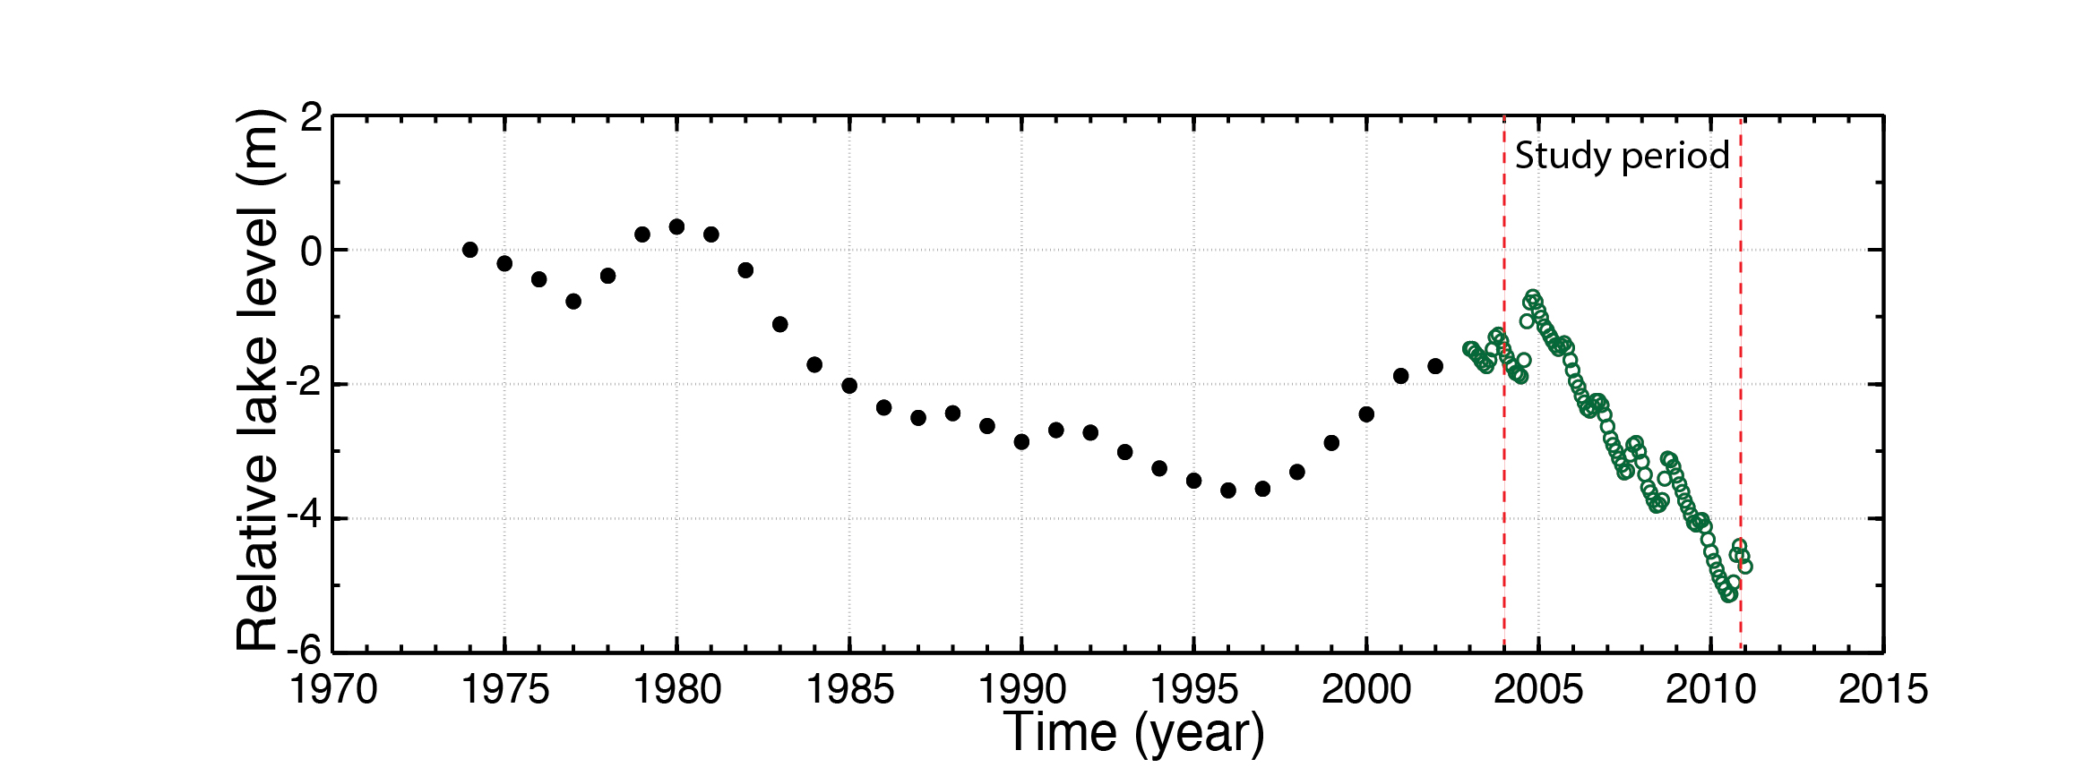

**Figure S1:** Lake level variation at Yangzhuoyong Lake (1974-2010) [Chu et al., 2012b]. Black circles: annual average. Green circles: monthly average. Red dashed lines indicate the study period.

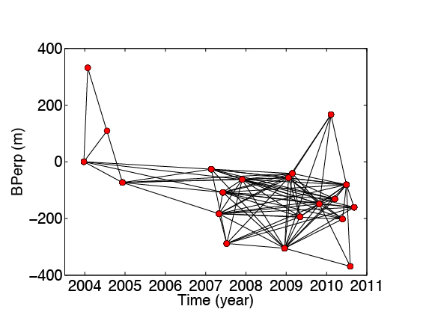

**Figure S2:** Baseline-time plot of the network of SAR acquisitions (red dots) and interferograms (black lines) used for the time-series inversion.

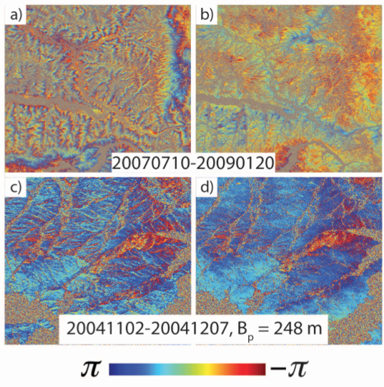

**Figure S3:** APS and DEM corrections on wrapped phase. a) and b) Interferograms before and after APS correction. c) and d) interferograms before and after DEM correction.

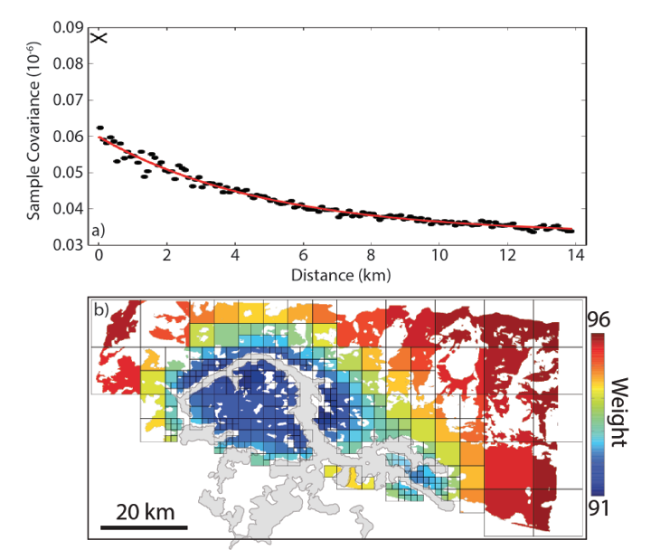

**Figure S4:** a) Variance (cross at zero distance), sample covariance (dots), and fitted covariance function (red line). b) Variance-covariance weights [*Sudhaus and Jonsson*, 2009] calculated from a). The weight is dimensionless because the unit of our data is mm/m.

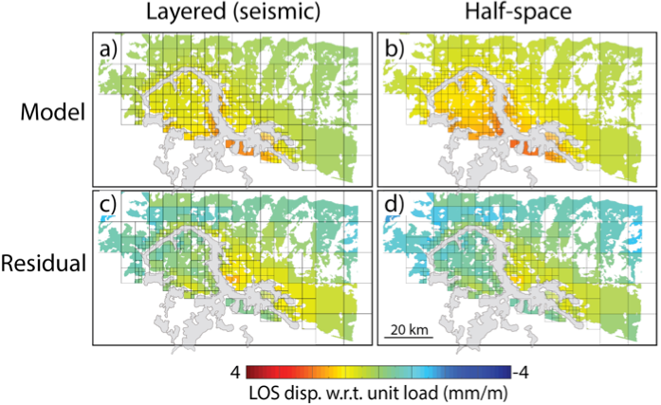

**Figure S5:** a), b) Same as Figure 3b but for the layered model using the seismic Young’s moduli and for the best-fitting half-space model (Young’s modulus of 81 GPa). c,d) Differences between data and model predictions. The RMSE of the seismic layered model is 0.67 mm/m and 0.65 mm/m for the half-space model.

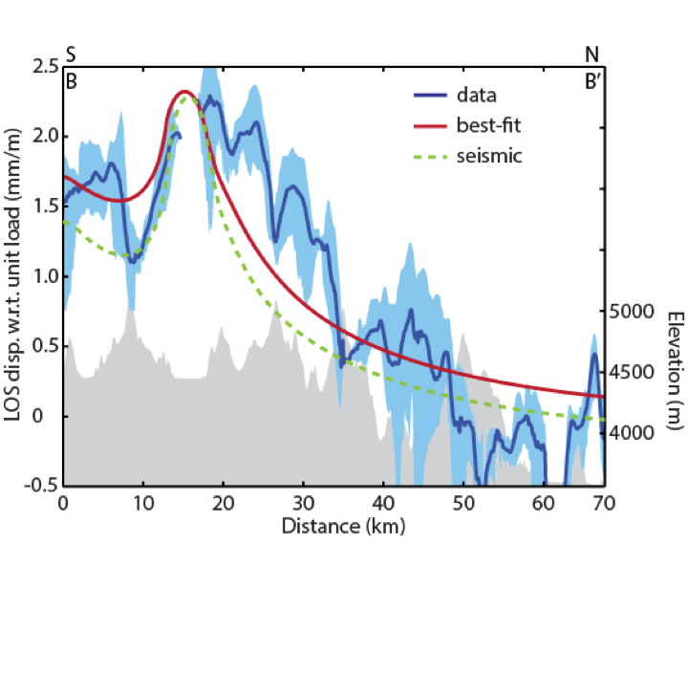

**Figure S6:** Same as Figure 4 but for profile BB’.

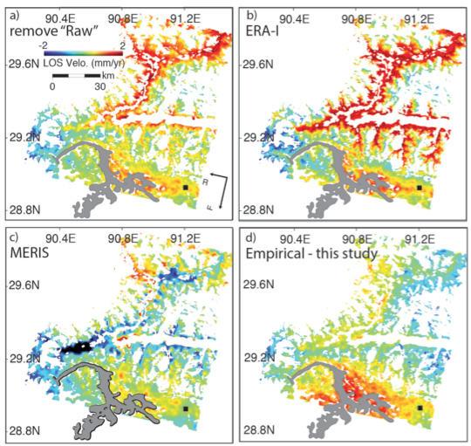

**Figure S7:** Averaged InSAR LOS velocities obtained using different atmospheric delay correction approaches. a) Original velocity without atmospheric delay correction. b) Correction using the ERA-Interim global atmospheric model (using the same SAR acquisitions as in Figure 1b). c) Correction using cloud free scenes and MERIS. d) Empirical estimation and removal of the topography-correlated phase.

**Table S1:** Earth modela

|  |  |  |  |  |  |
| --- | --- | --- | --- | --- | --- |
| Depth (km) | *Vp* (km/s) | *Vs* (km/s) | Density (kg/m3)** | Young’s  modulus (GPa)* | Poisson’s  ratio** |
| 5 | 5.2 | 3.1 | 2400 | 56(50) | 0.22 |
| 15 | 5.7 | 3.36 | 2550 | 71(50) | 0.23 |
| 35 | 6.1 | 3.6 | 2700 | 86 | 0.23 |
| 65 | 6.65 | 3.73 | 3000 | 106 | 0.27 |
| half-space | 7.8 | 4.4 | 3300 | 162 | 0.27 |

aVp is from [*Yin et al.*, 1990] covering Yangzhuoyong Lake, Vs and density are from [*Mechie et al.*, 2004] based on INDEPTH III [*Zhao et al.*, 2001] covering Siling Lake (~300 km north of Yangzhuoyong Lake). Young’s modulus and Poisson’s ratio are calculated from columns 2-4. (*) bracketed values from inversion. (**) Density of 2700 kg/m3 and Poisson’s ratio of 0.25 used in inversion. The equations used for elastic parameters conversion are given by the follows: , , , where *v* is Poisson’s ratio, *Vp* and *Vs* are P- and S- wave velocities, M is the P-wave modulus, *ρ* is density, and *E* is Young’s modulus.