D3 Notes
Set the coordinates of this point till the end of the trial

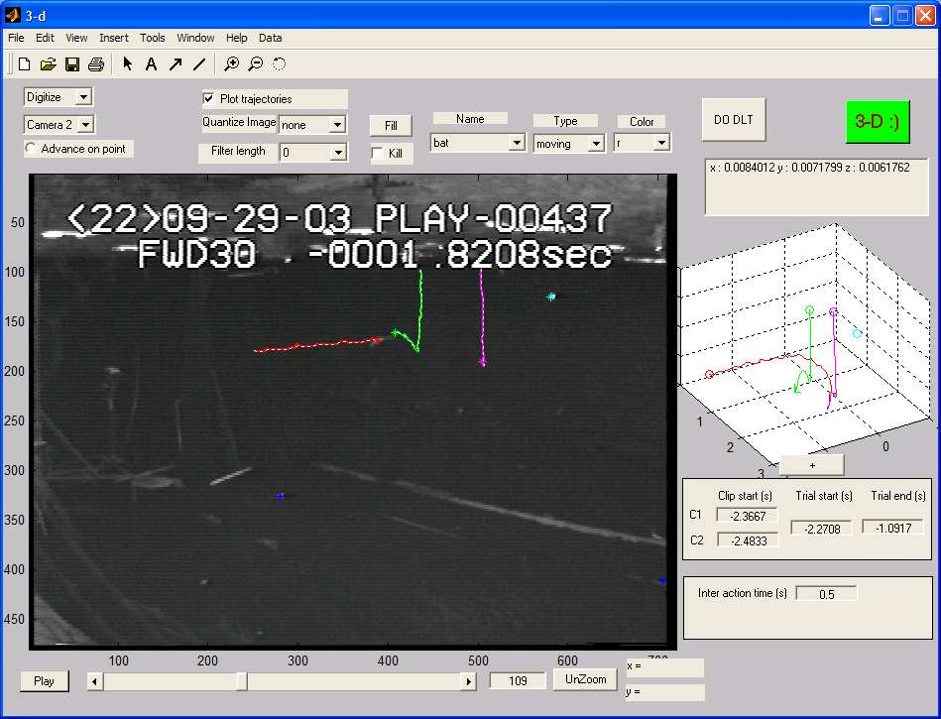
Stop automatic clicking of stationary points
Advance frames for single point
Space error

- The menu can be accessed by right-clicking the figure outside the camera view
- You can zoom using the figure zoom tool button
- To acquire video
  - use a computer that has a fire-wire (or DV) port
  - use windows movie maker to acquire
  - set the acquisition mode to DV-AVI 25 Mbps (720x480)
  - don’t bother to closely crop the video, you can set this in D3
- Load the calibration frame
- Load calibration videos
- Do calibration point clicking, Save calibration
- Click “Do DLT” to calibrate and find out the space error.
- You can set the clip start time and trial start and end times before you import the video, but…
- You can load the video, then set the times, but you need to do it in the following order to prevent problems
  - Set cam#1 clip start time
  - Set cam#2 clip start time
  - Set trial start time
- Load the appropriate spatial model
- Load the videos for both cameras from the menu
- Click as in motus to set the coordinates
- Check the “Show trajectory button” to show trajectories like in the figure
- At any point during any process using “save” from the menu will save all your work completely.
- The FILL button lets you set the current coordinates for the current point from the current frame right up to trial end
- The KILL switch prevents D3 from automatically going and setting stationary object coordinates
- The menu items “Cam1 speed adjust” enables you to take care of those embarrassing moments when you download video at odd speeds like 15 fps or 60 fps. The speed adjust defaults to 30fps (the lab standard) and can be set to other values when needed. Note that if you downloaded at 60 fps you are going to miss every second frame on the tape itself, D3 will merely repeat each frame twice.

TODO
- A quick save<done>

