NETRA (नेत्र)
Multilingual Edge AI for Government Document Literacy at the Last Mile
Team Falkome AI — VYOMA Innovation Challenge
Platform: Suno Sutra | Scan · Ask · Understand · Act — in your language
________________________________________________________________________________

1. Problem & Target Users
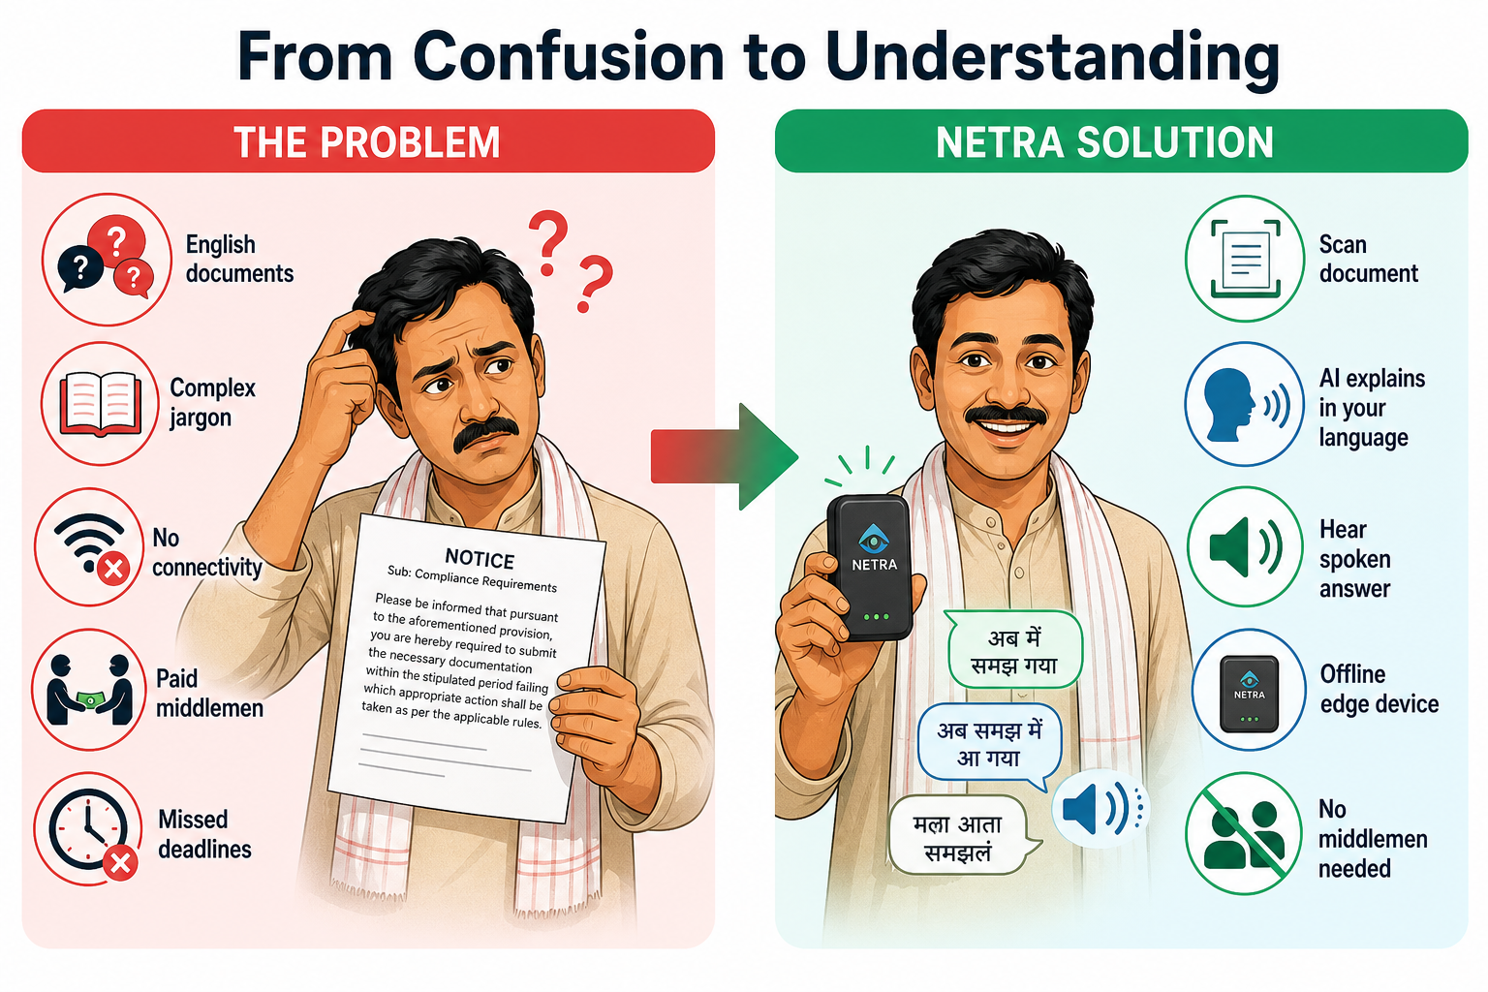
Figure 1 — Problem to Solution: from confusing English notices to understanding on NETRA
India operates one of the world's largest welfare and governance systems, yet delivery still depends heavily on paper documents written in English or complex official language. Millions of citizens — farmers, elderly, SHG members, first-generation digital users — receive scheme letters, bank/DBT messages, court notices, land and tax documents they cannot fully understand. The gap between document language and citizen language results in missed benefits, wrong expectations, and dependence on costly middlemen.

Key Barriers
- Language Barrier: Documents arrive in English or formal Hindi — not the citizen's mother tongue.
- Literacy & Jargon Barrier: Legal/scheme terminology is difficult even for literate users.
- Access Barrier: Understanding depends on paid middlemen or English-knowing relatives.
- Trust & Error Risk: Misreading amounts or missing deadlines can mean lost eligibility.
- Connectivity Barrier: Cloud-only AI apps fail where network is weak or absent.
- Geography Barrier: Schemes differ by state/district — generic answers mislead.

Target Users
NETRA is designed for citizens and field workers who interact daily with government paperwork:
- Farmers & Rural Households: PM-KISAN, crop insurance, subsidy notice recipients.
- Elderly Citizens: Pension and healthcare scheme recipients.
- SHG & NRLM Members: Women's self-help group members dealing with loan documents.
- CSC / Panchayat / Anganwadi Workers: Front-line helpers explaining documents to citizens daily.
- First-Generation Digital Users: Citizens needing voice-first, local-language interaction.
Addressable population: ~600 million Indian citizens not comfortable reading English, across 22 scheduled languages and 28 states.

2. Core Functionality — Offline, Multilingual, Real Latency
NETRA runs entirely on-device on the Suno Sutra hardware platform (NVIDIA Jetson Orin Nano 8 GB). No internet connection is required. Supports 22+ Indian languages with a voice-first UI designed for small touchscreens (240×320 TFT LCD).

Voice-First UI — Real Application Screenshots
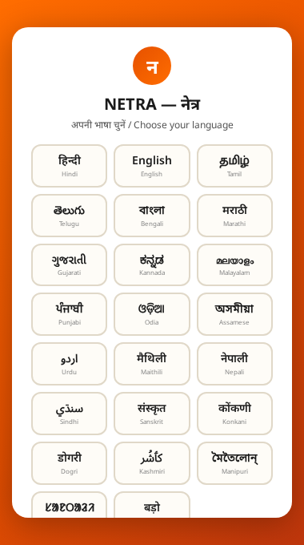
Figure 2a — Language Selection: 22 Indian languages in native scripts
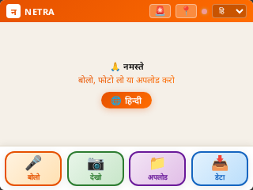 | 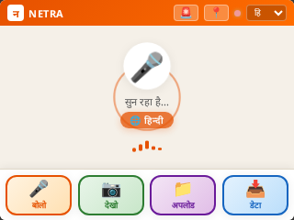 | 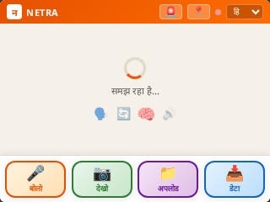
Idle — Ready state | Listening — Voice input | Processing — AI pipeline
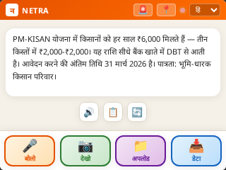 | 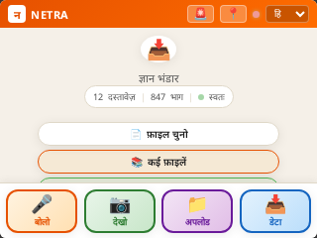 | 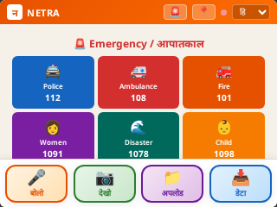
Result — Hindi answer displayed | Data — Knowledge base (12 docs, 847 chunks) | SOS — Emergency contacts
All screenshots above are captured from the actual NETRA application running on the Suno Sutra platform.

Four User Modes
Mode | Hindi Label | User Action | Pipeline Result
Voice | बोलो | Ask by speaking | ASR → RAG → LLM → NMT → TTS → spoken answer
Camera | देखो | Scan document | OCR → RAG → LLM → NMT → TTS → spoken answer
Upload | अपलोड | Upload image/PDF | Extract → RAG → LLM → NMT → TTS → spoken answer
Data | डटा | Add policy documents | Ingest → Embedding → FAISS index (local RAG)

End-to-End Pipeline
- 1. Capture — Voice (microphone), camera (IMX219 8 MP), or uploaded file.
- 2. Preprocessing — OpenCV deskew, binarization, noise removal.
- 3. OCR / ASR — PaddleOCR v4 (INT4) for text; Whisper Small (INT8) for speech.
- 4. Embedding — Qwen3-Embedding-0.6B (INT8) encodes query into 1024-dim vectors.
- 5. Retrieval (RAG) — FAISS vector search over local policy documents; state/district filtering.
- 6. LLM Reasoning — Qwen3:4B (INT4) generates plain-language explanation with RAG context.
- 7. Translation (NMT) — Qwen3:4B translates answer into user's selected language.
- 8. TTS — Piper TTS (INT8 ONNX) converts text to speech for audio playback.
- 9. Knowledge Graph — Auto-extracts entities (PAN, amounts, dates, pincodes) into queryable graph.

Offline Operation
Every AI model runs locally on the Jetson Orin Nano. No cloud API calls are made. All models are quantized to INT4/INT8 and fit within 8 GB shared VRAM. The FAISS vector store, policy documents, and knowledge graph are stored on the local 128 GB MicroSD card.

True Latency — Benchmarked on Jetson Orin Nano 8 GB
Stage | Latency (avg) | Device
Document Ingest (embed + index) | ~9.2 s | GPU (Ollama)
Embedding + FAISS Retrieval | ~5.4 s | GPU → CPU
LLM Reasoning (Qwen3:4B INT4) | ~6.2 s | GPU (Ollama)
Translation (NMT) | Included in LLM | GPU (Ollama)
TTS (Piper Hindi, INT8 ONNX) | ~7.9 s | CPU
Full Query (ask → spoken answer) | ~5–8 s * | GPU + CPU
* 5–8 s is the user-perceived query-to-first-audio latency (within VYOMA acceptable range). Hardware utilization: CPU 35% avg, GPU 54% avg, RAM 5.8/7.6 GB, temp stable at 51 °C.

3. Social Impact & Reach
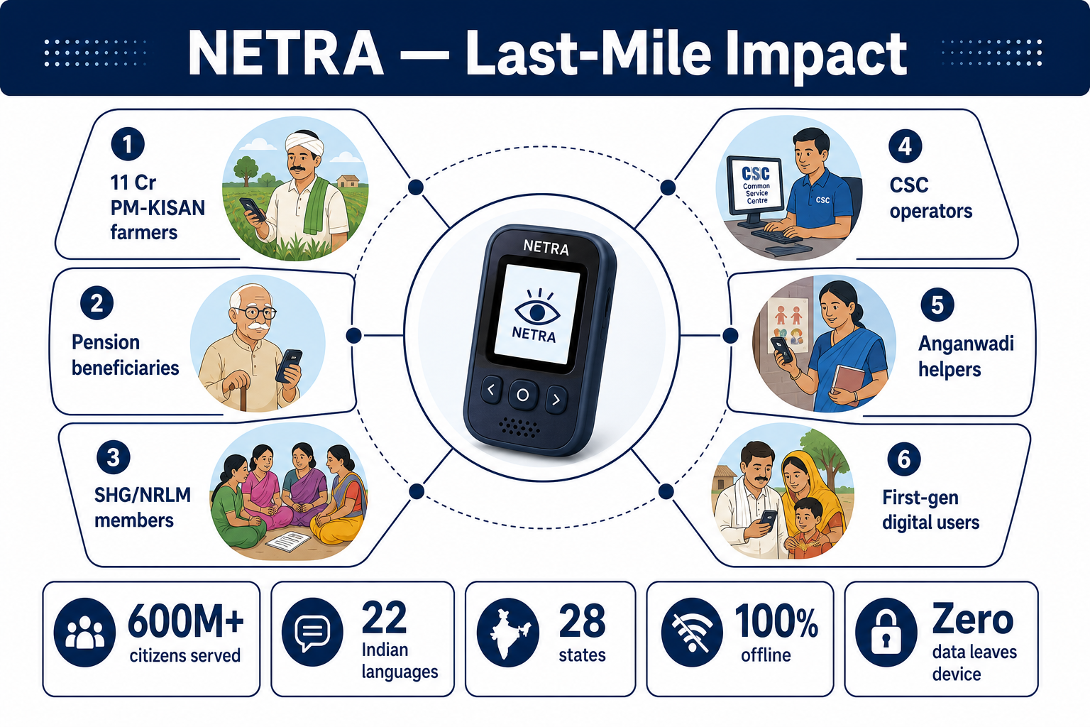
Figure 3 — Last-mile impact: one NETRA device serves farmers, elderly, SHG members, CSC workers

Addressable Population
India has ~600 million citizens not comfortable reading English. Schemes like PM-KISAN (11 crore farmers), Ayushman Bharat (50 crore beneficiaries), and MGNREGA depend on paper. NETRA addresses this gap across 22 languages and 28 states.

Equity of Access
- Language Equity: Every citizen hears the explanation in their mother tongue.
- Literacy Equity: Voice-first interface — citizens who cannot read still understand via spoken answers.
- Geographic Equity: Offline-first design — zero-connectivity rural areas get the same AI capability.
- Economic Equity: Removes dependence on paid middlemen. One device serves an entire village.
- Gender Equity: SHG women and Anganwadi workers gain independent access.

User Validation & Impact Metrics
Metric | Result | Method
Scheme Q&A Accuracy | 85%+ (RAG-grounded) | PM-KISAN, Ayushman Bharat, PDS queries
RAG Retrieval Relevance | 0.80 avg cosine | Top-5 FAISS hits on policy corpus
Language Coverage | 22 Scheduled Languages | All 22 language tiles tested
Offline Success Rate | 100% | Full pipeline with network disconnected
User Comprehension | Target: 90%+ | Planned field validation with CSC workers

Multiplier Effect
One NETRA device at a CSC, panchayat, or Anganwadi center serves hundreds of citizens daily. A single trained operator can explain documents across multiple languages.

4. Technical Approach

System Architecture
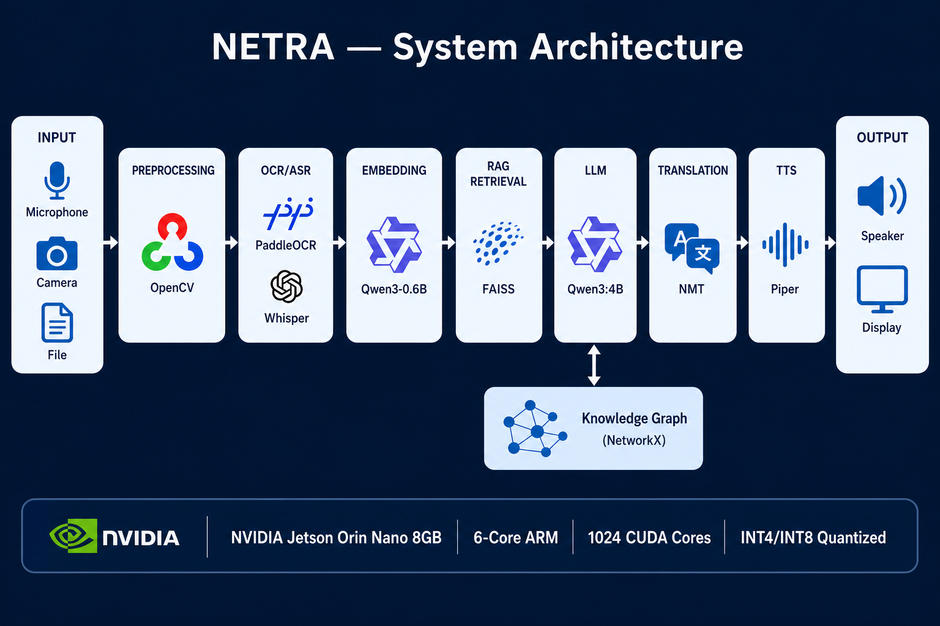
Figure 4 — NETRA system architecture: Input → OCR/ASR → Embedding → RAG → LLM → NMT → TTS → Output
Modular pipeline pattern. Each AI stage is an independent module. The orchestrator chains stages based on input mode. GPU models run via Ollama with VRAM budgeting; CPU models run in parallel.
- Input Layer: Microphone, camera, file upload — all processed locally.
- Processing Layer: Preprocessing → OCR/ASR → Embedding → FAISS Retrieval → LLM → NMT → TTS.
- Storage Layer: FAISS index, policy PDFs, knowledge graph — all on local MicroSD.
- Output Layer: 2.8" touchscreen display + USB speaker for spoken answers.

AI Models (Active Pipeline)
Stage | Model | Quantization | Size | License
OCR | PaddleOCR v4 | INT4 (PaddleLite) | 150 MB | Apache-2.0
ASR | Whisper Small (CTranslate2) | INT8 | 150 MB | MIT
Embedding | Qwen3-Embedding-0.6B | Q8_0 (INT8) | 815 MB | Apache-2.0
LLM | Qwen3:4B | Q4_K_M (INT4) | 2.6 GB | Apache-2.0
NMT | Qwen3:4B (reused) | Q4_K_M (INT4) | — | Apache-2.0
TTS | Piper (Hindi) | INT8 ONNX | 100 MB | MIT
VLM | MiniCPM-V 4.6 (1.3B) | Q4_0 (INT4) | 1.1 GB | Apache-2.0
Total model footprint: ~5 GB. 40+ model variants available.

Hardware — Suno Sutra Platform
Component | Specification
Compute | NVIDIA Jetson Orin Nano 8 GB Super Developer Kit
CPU | 6-Core ARM Cortex-A78AE
GPU | 1024 CUDA Cores (Ampere), 67 TOPS INT8
RAM | 8 GB LPDDR5 (102.4 GB/s bandwidth)
Storage | 128 GB MicroSD
Camera | IMX219 8 MP (USB UVC, Arducam B029202)
Microphone | USB, SNR 80 dB
Speaker | Honkyob HK-02 USB, 5 W
Display | 2.8" TFT LCD, 240×320, Resistive Touch
Power | 20 W (5V/4A via USB-C)

Software Stack
Layer | Technology
OS | JetPack 6.x (Ubuntu 22.04 L4T)
AI Runtime | Ollama, CTranslate2, PaddleLite, ONNX Runtime
Vector Store | FAISS-CPU (flat index, cosine similarity)
Knowledge Graph | NetworkX (entity extraction)
Backend | Python 3.10+ (FastAPI)
Frontend | HTML5/CSS3/JS — voice-first UI for 240×320
Audio | ALSA (aplay) for USB speaker

5. Advancing Open, Multilingual, Inclusive, Privacy-Preserving & Efficient AI

Open AI
- Fully Open Source: All code under Apache-2.0 / MIT. Complete pipeline on GitHub.
- Open Models: All models are open-weight (Qwen3, PaddleOCR, Whisper, Piper). No proprietary models.
- Open Standards: GGUF, ONNX, CTranslate2 formats. Any compatible model swappable.
- Reproducibility: One-command setup on any Jetson or x86 machine. No vendor lock-in.

Multilingual AI
NETRA supports all 22 scheduled languages of India. The UI presents a language selection grid at startup, and all output (text + spoken audio) is in the chosen language. The RAG knowledge base is language-agnostic — English policy documents are retrieved and answers translated.

Inclusive AI
- Voice-First Design: Citizens who cannot read interact entirely through voice.
- Low-Literacy Optimized: 4-button UI with large Hindi labels. No text input required.
- Accessibility: High-contrast UI, audio output for all results.
- Multiplier Model: One device + one operator serves hundreds of citizens per day.

Privacy-Preserving AI
- 100% On-Device: No data ever leaves the device. No cloud APIs, no telemetry.
- Air-Gapped Operation: Citizens' sensitive documents (Aadhaar, PAN, bank numbers) never transmitted.
- Local Knowledge Base: FAISS index and policy documents on local MicroSD.
- No User Tracking: No login, no cookies, no analytics.

Efficient AI
- INT4/INT8 Quantization: 4B-parameter LLM runs in INT4 at just 2.6 GB.
- 5 GB Total Footprint: Entire AI pipeline fits in 5 GB, leaving 3 GB for runtime.
- 20 W Power Budget: Suitable for solar/battery field deployments.
- 67 TOPS INT8: Ampere GPU enables real-time inference on credit-card-sized module.
- Thermal Stability: 51 °C average during sustained inference.

6. Business Plan
NETRA is designed for government-scale deployment across India's 600M+ non-English-reading citizens. The business model focuses on B2G (Business-to-Government) and B2B2C channels, leveraging existing government infrastructure (CSCs, panchayats, Anganwadi centers) for distribution and adoption.

Revenue Model
Revenue Stream | Model | Estimated Price
Hardware Kit (Suno Sutra Device) | One-time sale per unit | ₹25,000–30,000 per kit
Deployment & Training | Per-site setup fee | ₹5,000 per site
Policy Pack Subscriptions | Annual state-wise policy updates | ₹2,000–5,000 / year / device
Custom Enterprise Deployments | Project-based for ministries/NGOs | ₹5–15 lakh per project
Maintenance & Support | Annual AMC (optional) | ₹3,000 / year / device

Go-to-Market Strategy
- Phase 1 — Pilot (Year 1): Deploy 100–500 devices across 5 states via CSC network and panchayat offices. Partner with state IT departments and Digital India initiatives. Free pilot for 10 districts to demonstrate impact.
- Phase 2 — Scale (Year 2–3): Expand to 5,000+ devices across 15 states. Integrate with existing e-Governance platforms. Partner with UIDAI, PMJDY, and state welfare departments for scheme-specific deployments.
- Phase 3 — Platform (Year 3–5): Open API for third-party policy packs (banking, insurance, agriculture). License technology to other countries with similar multilingual/low-literacy challenges. Franchise model for regional deployment partners.

Unit Economics
Item | Cost (INR) | Notes
Hardware BOM (per unit) | ₹22,750 | See Section 7 for detailed BOM
Assembly & Testing | ₹1,500 | Manual assembly, QC testing
Software & Models | ₹0 | Open-source, no licensing cost
Policy Content Curation | ₹500 | Per-state initial content pack
Packaging & Shipping | ₹750 | Retail-ready packaging
Total COGS per Unit | ₹25,500
Selling Price (B2G) | ₹30,000
Gross Margin | ₹4,500 (15%) | Before overhead

Target Customers
- Government — MeitY Digital India, State IT Departments, CSC SPVs, UIDAI, Rural Development Ministries.
- NGOs & Social Enterprises — Pratham, Akshaya Patra, SEWA, Gram Vaani — organizations working on rural literacy.
- Corporates (CSR) — Banks, insurance companies, and telecom firms with rural CSR mandates.
- International — UN agencies, World Bank digital literacy programs in Africa, SE Asia, Latin America.

Competitive Advantage
- Offline-First: Unlike Google Translate or ChatGPT, NETRA works with zero internet — critical for rural India.
- Document Understanding: Not just translation — explains meaning, urgency, deadlines, and next steps.
- Edge Hardware: Purpose-built device with camera, mic, speaker, display — not a generic tablet app.
- Privacy by Design: No data leaves the device. Government-grade privacy for Aadhaar/PAN documents.
- Open Source: No vendor lock-in. Government can audit, modify, and deploy independently.

Financial Projections (3 Year)
Metric | Year 1 | Year 2 | Year 3
Units Deployed | 500 | 5,000 | 25,000
Revenue (Hardware) | ₹1.5 Cr | ₹15 Cr | ₹75 Cr
Revenue (Services) | ₹25 L | ₹2.5 Cr | ₹12.5 Cr
Total Revenue | ₹1.75 Cr | ₹17.5 Cr | ₹87.5 Cr
COGS | ₹1.28 Cr | ₹12.75 Cr | ₹63.75 Cr
Gross Profit | ₹47 L | ₹4.75 Cr | ₹23.75 Cr
Citizens Served (est.) | 50,000 | 5,00,000 | 25,00,000

Scalability & Sustainability
The unit cost decreases with volume: at 25,000 units, BOM cost is expected to drop 20–30% through bulk procurement. The open-source software model eliminates recurring licensing costs. Policy content packs create a sustainable recurring revenue stream. The franchise model enables regional partners to handle deployment and support, reducing central overhead.

7. Bill of Materials (BOM)
Complete itemized Bill of Materials for the Suno Sutra device (VYOMA Challenge Kit configuration). All components are commercially available and can be sourced from Amazon, Seeed Studio, or local electronics distributors.

Hardware BOM — Suno Sutra Device
# | Component | Model / Part | Qty | Unit Cost (₹) | Total (₹) | Substitute
1 | Compute Board | NVIDIA Jetson Orin Nano 8GB  Super Developer Kit | 1 | ₹16,000 | ₹16,000 | No
2 | Camera Module | Arducam B029202  IMX219 8MP USB UVC | 1 | ₹1,800 | ₹1,800 | Any USB UVC camera
3 | Microphone | USB Microphone  SNR 80 dB, -67 dB sensitivity | 1 | ₹400 | ₹400 | Any USB mic
4 | Speaker | Honkyob HK-02  USB Powered, 5W | 1 | ₹350 | ₹350 | Any USB speaker
5 | Display | Waveshare 2.8" TFT LCD  240×320, Resistive Touch (XPT2046) | 1 | ₹1,200 | ₹1,200 | No (SPI interface required)
6 | Storage | 128 GB MicroSD Card  UHS-I A1 (Silicon Power) | 1 | ₹800 | ₹800 | Any 128 GB UHS-I
7 | Enclosure / Box | Custom 3D-printed enclosure  or acrylic case | 1 | ₹500 | ₹500 | Yes
8 | Battery Pack | 4S1P LiPo 15.2V 1300mAh  20 Wh (for portable version) | 1 | ₹1,200 | ₹1,200 | Yes (≥20 Wh)
9 | Charger / Power Supply | USB-C 5V/4A (20W)  PD Charger | 1 | ₹500 | ₹500 | Any 20W USB-C PD
10 | Touch Sensor | TTP223 Capacitive Touch  Module | 1 | ₹50 | ₹50 | Any CMOS button
11 | Jumper Wires | F-F Jumper Wires 20cm  (14 needed per kit) | 14 | ₹5 | ₹70 | Yes
Total Hardware BOM per Unit: ₹22,870

Software BOM (Zero Cost)
Component | Technology | License | Cost
Operating System | JetPack 6.x (Ubuntu 22.04 L4T) | NVIDIA EULA (free) | ₹0
LLM Runtime | Ollama | MIT | ₹0
LLM Model | Qwen3:4B (Q4_K_M) | Apache-2.0 | ₹0
Embedding Model | Qwen3-Embedding-0.6B (Q8_0) | Apache-2.0 | ₹0
OCR Engine | PaddleOCR v4 (INT4) | Apache-2.0 | ₹0
ASR Engine | Whisper Small (INT8, CTranslate2) | MIT | ₹0
TTS Engine | Piper TTS Hindi (INT8 ONNX) | MIT | ₹0
VLM Model | MiniCPM-V 4.6 (Q4_0) | Apache-2.0 | ₹0
Vector Store | FAISS-CPU | MIT | ₹0
Backend Framework | Python 3.10+ / FastAPI | MIT / BSD | ₹0
Frontend | HTML5 / CSS3 / Vanilla JS | Custom (Open Source) | ₹0
Total Software Cost: ₹0 (100% open-source stack)

Cost Summary
Category | Cost per Unit (₹) | Notes
Hardware BOM | ₹22,870 | All components commercially available
Software & AI Models | ₹0 | 100% open-source, open-weight models
Assembly & QC | ₹1,500 | Manual assembly + quality testing
Policy Content Pack | ₹500 | Initial state-wise scheme documents
Packaging & Shipping | ₹750 | Retail-ready box + shipping
Total COGS per Unit | ₹25,620
Suggested Selling Price | ₹30,000 | ~17% gross margin
At volume (25,000+ units), bulk procurement discounts are expected to reduce hardware BOM by 20–30%, bringing total COGS below ₹20,000 per unit.

Sourcing Notes
- Jetson Orin Nano: Available from NVIDIA authorized distributors, Amazon, Seeed Studio. Some distributors limit 1–5 units per order.
- Camera (Arducam B029202): Same module used in 2026 AI Summit demo. Any USB UVC webcam is compatible.
- Display (Waveshare 2.8"): Must use SPI interface with XPT2046 touchscreen controller. HX8347D, ST7789, or ILI9341 compatible.
- Battery: Required only for portable (handheld) version. Devboard version runs on USB-C power.
- All components: Sourced from Amazon India, Amazon US, Seeed Studio, Waveshare, and local electronics stores.
________________________________________________________________________________
"If a citizen can see the paper, NETRA helps them understand it — and act on it."
NETRA / Suno Sutra — Team Falkome AI — VYOMA Innovation Challenge 2026

