CSD310: Database Development and Use
Module 4.2 Assignment: MySQL Install
Isaac Ellingson
11/11/2025

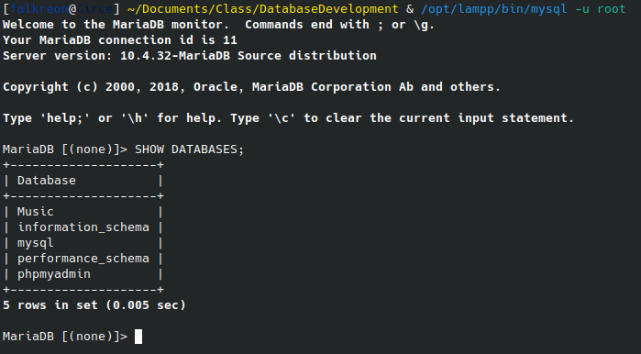
Initial MySQL connection

Creation of Movies Database
