CSD310 Database Development and Use
Module 2.2 Assignment: Visual Paradigm
Isaac Ellingson
11/1/2025

I used the Chen ERD symbols instead of the default, because I couldn’t stand using 0.1 and 0.* symbols to recreate a 1.1 and 1.* ERD. Unfortunately the correct symbols are smaller, less flexible, and harder to read. Sorry about that!

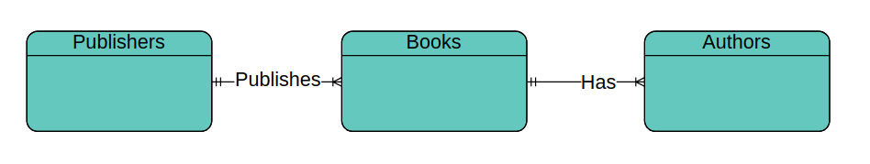
Also, I’m using all plural names for tables. Surely we’re storing more than one publisher record.

