CSD310: Database Development and Use
Module 2.3 Assignment: Data Models
Isaac Ellingson
11/1/2025

Part 2:

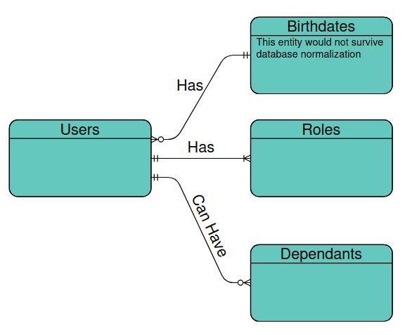

Part 3:

