CSD310: Database Development and Use
Module 6.2 Assignment: Movies: Setup
Isaac Ellingson
11/19/2025
5. Running the SQL Script
Adjustments were made to the user creation script as there are no auth plugins installed.

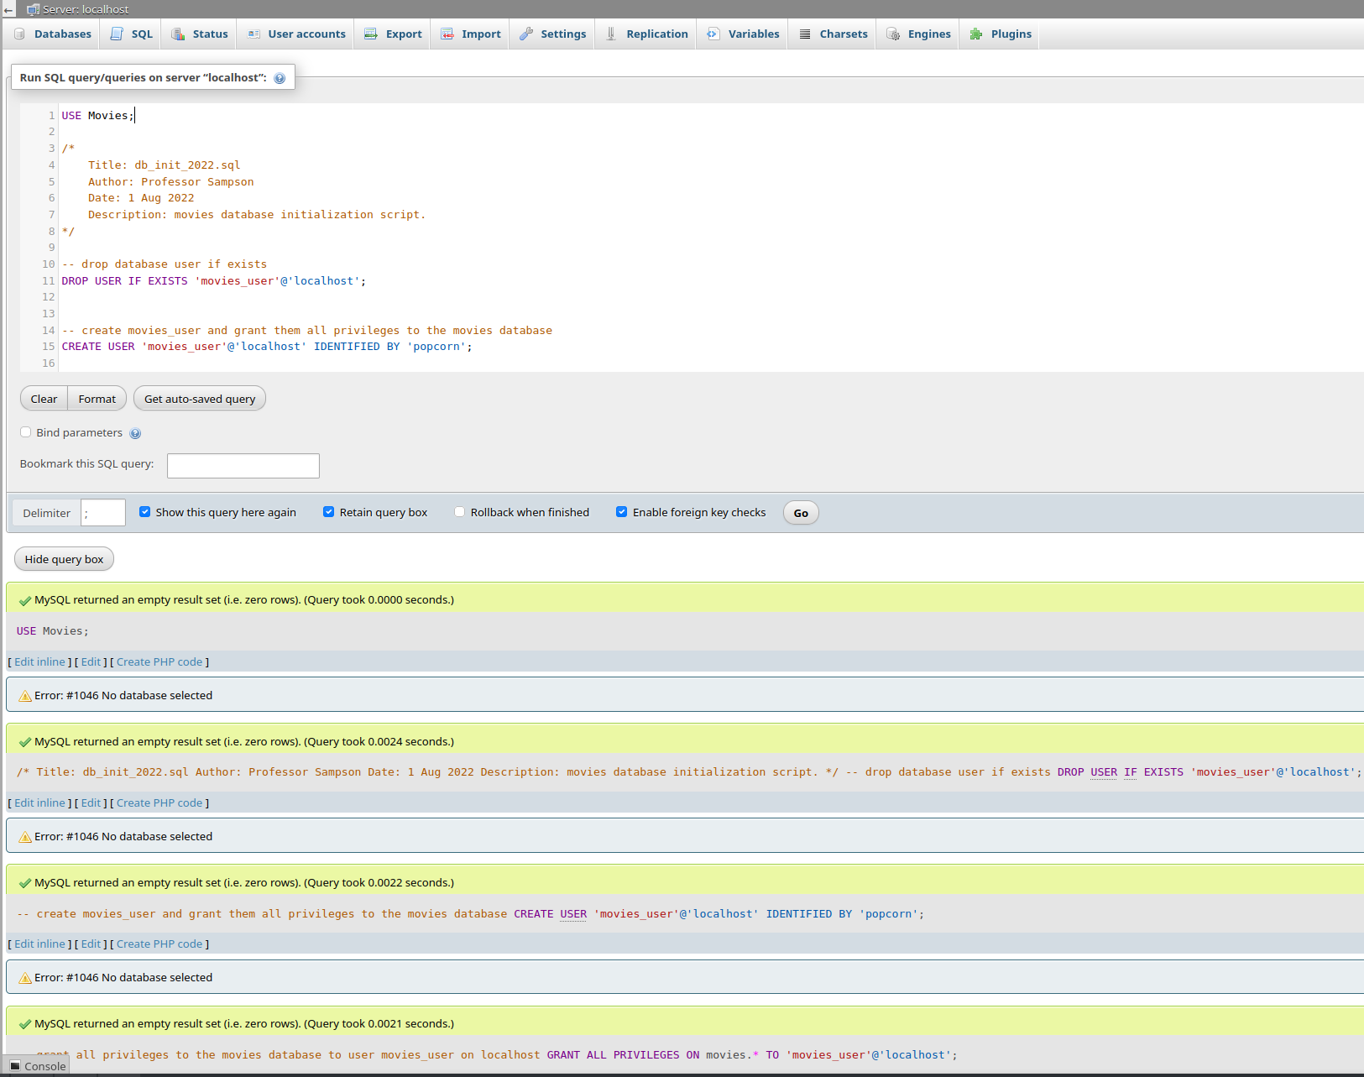

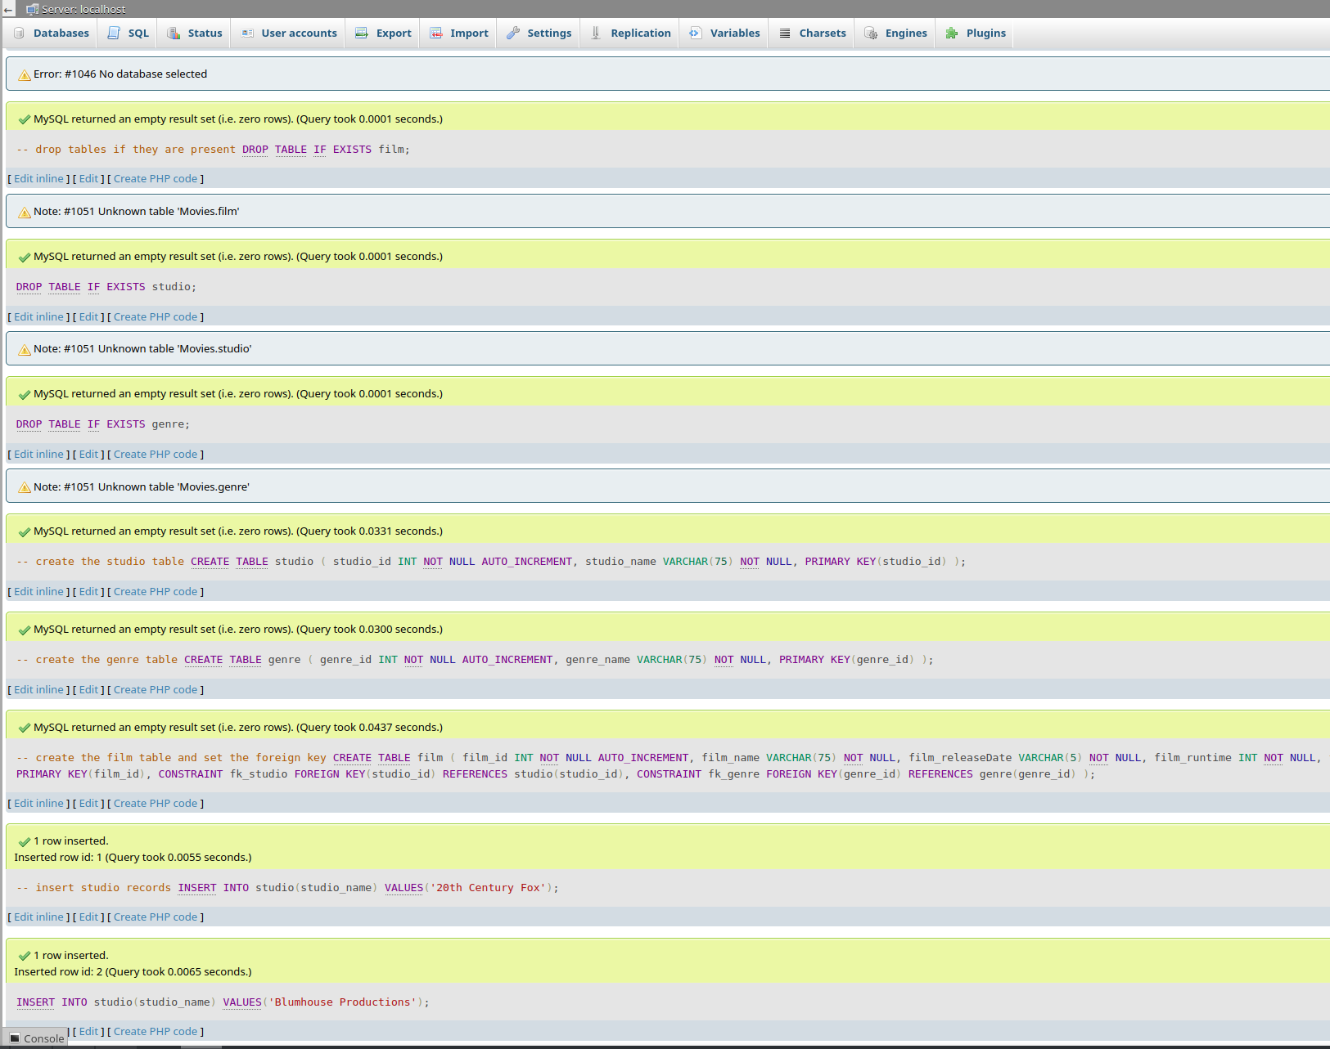

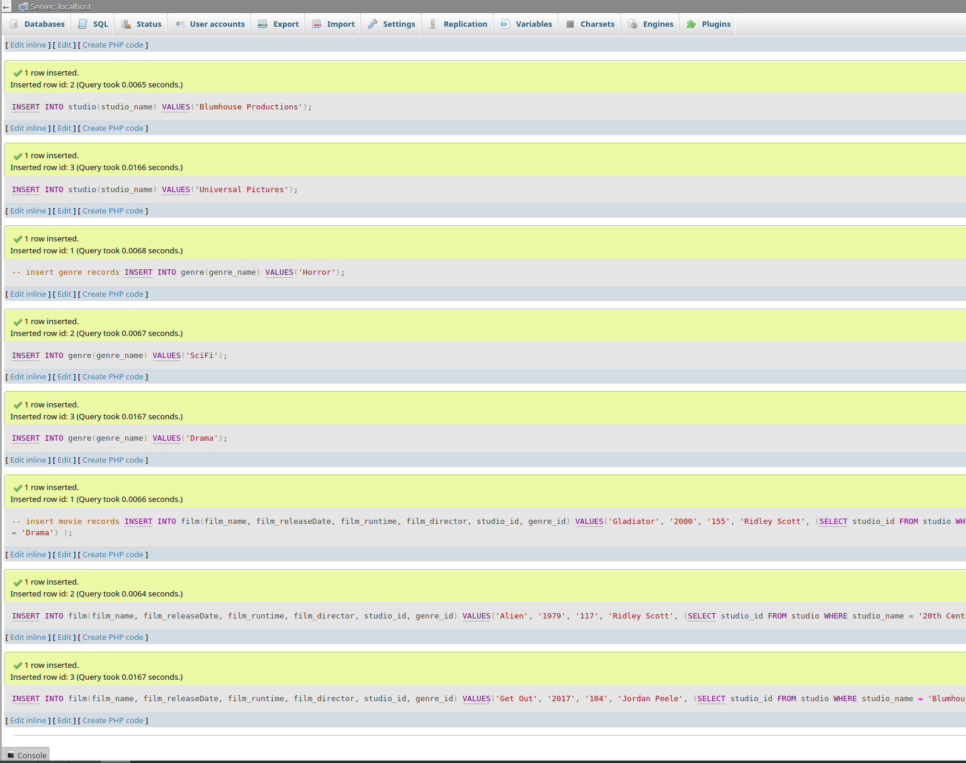
Revoked priveleges and ran a final “
GRANT ALL PRIVILEGES ON Movies.* TO 'movies_user'@'localhost';
” to fixup case issues on the database name.
.env was also edited to reflect ‘Movies’
6. Showing Tables
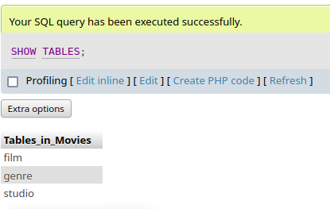

9. mysql_test.py
