CSD 310: Database Development and Use
Module 5.3 Assignment: Movies!
Isaac Ellingson
11/16/2025

Table names have been pluralized, column names have been de-smurfed.

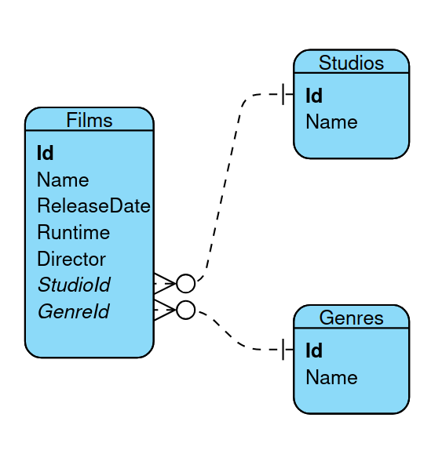
The business rules describe a one-to-many relationship from studios to films, and suggest but do not mandate a one-to-one relationship from genres to films. Had I chosen a one-to-one relationship there, the design would not survive database normalization, so I have chosen to represent each genre being associated with multiple films. This technically passes the “one genre per film” rule, as well as normalization, but this would still want to be a point of clarification with the client.

The Design:

