CSD310: Database Development and Use
Module 7.2 Assignment: Table Queries
Isaac Ellingson
11/22/2025

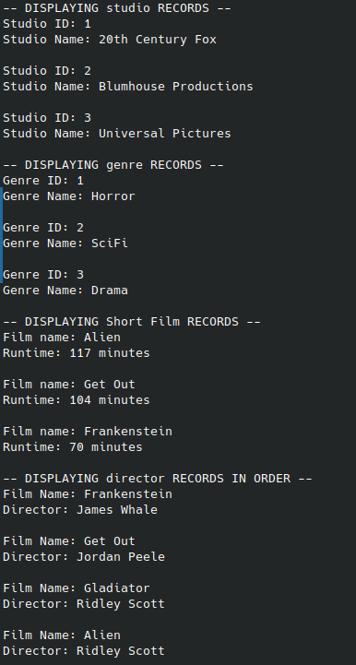
Output will include “extra” data. I did a test insert of the classic Frankenstein to check the key constraints on the database. To my surprise, the insert succeeded; this is structurally an implementation of my design.

GitHub Link:
https://github.com/falkreon/CSD-310

