CSD325: Advanced Python
Module 11.2 Assignment: Django Basics
Isaac Ellingson
12/3/2025

Project Stub:
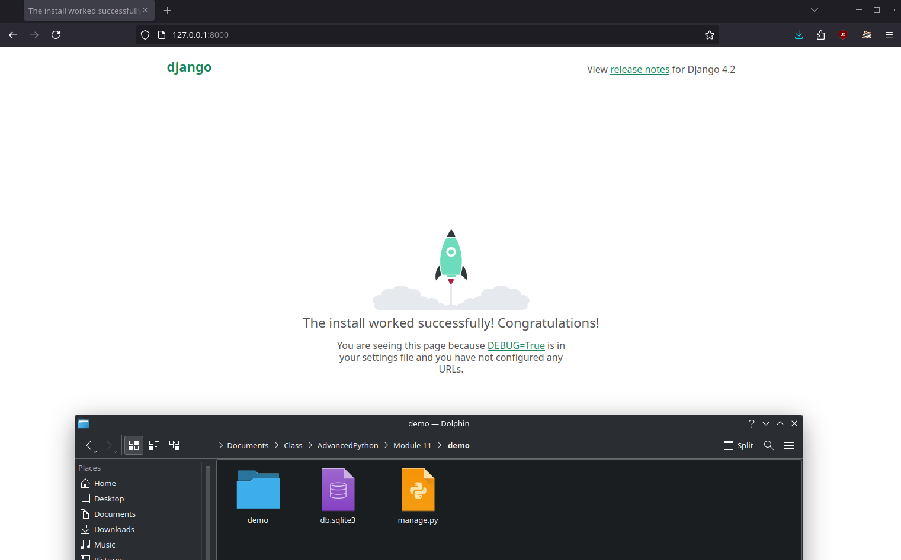

After ~10 min of tutorial:

