CSD325: Advanced Python
Module 7.2 Assignment: Test Cases
Isaac Ellingson
11/20/2025

Starting with stub function returning None:
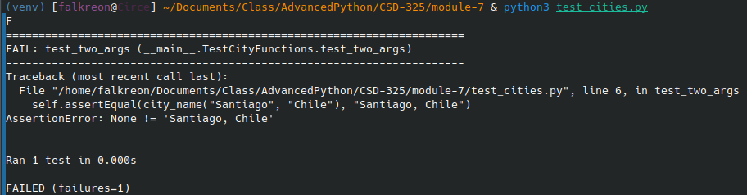
Implementing the function:
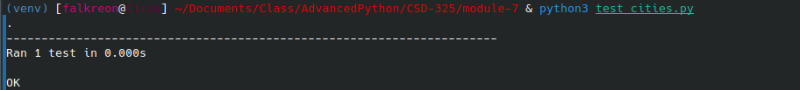
Adding an argument:
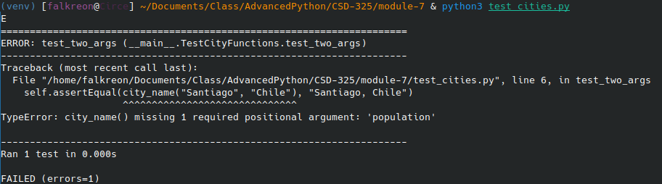
Making the argument optional:
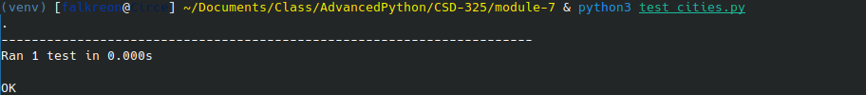

Adding another argument (argument order has been adjusted):
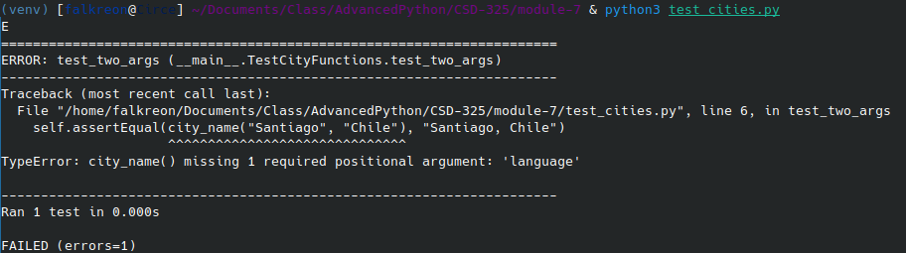

Adjusting the parameter so that it, too is optional (re-adjusted argument order):
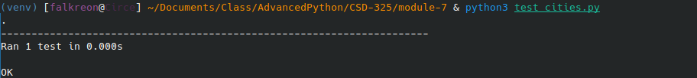
Running the function through all combinations of optional arguments:

