CSD325: Advanced Python
Module 12.2: Redo Assignment –
Module 2.2 Assignment: Documented Debugging + Flowchart(s)
Isaac Ellingson
12/21/2025

Program selected: Calculate the sum of the first 5 prime numbers
Accessed from https://pynative.com/python-find-sum-of-first-n-prime-numbers/ on 12/21/2025

Step 7 (with debugging started)

Step 8 (stepping into the function)

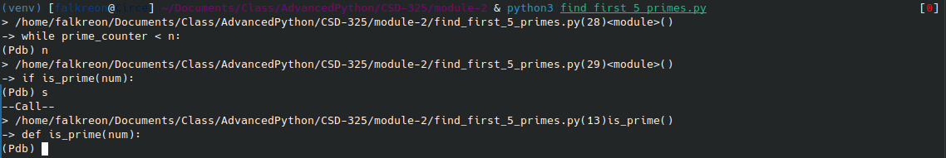
Step 9 (introducing an intentional error and stepping into it)

