CSD325: Advanced Python
Module 1.2: GitHub Repository Setup
Isaac Ellingson
10/25/2025

GitHub Repository
https://github.com/falkreon/CSD-325

Local / working directory
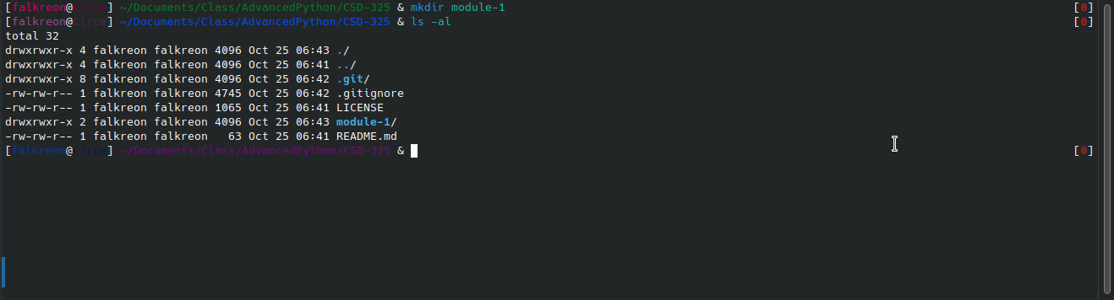

Remote / origin

