CSD 325: Advanced Python
Module 8.2 Assignment: JSON Practice
Isaac Ellingson
11/20/2025

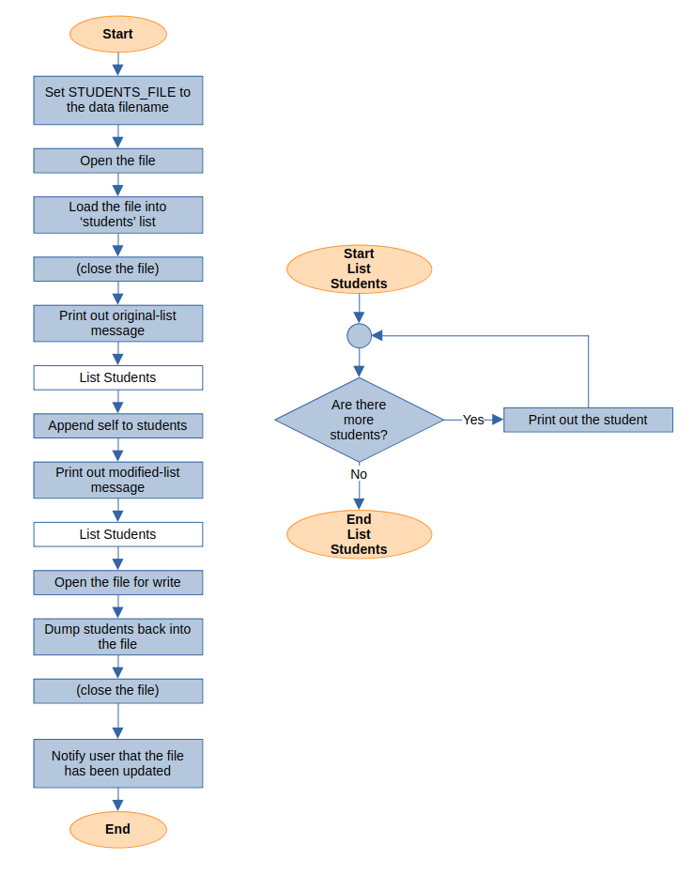
Program Flowchart

Running the file:
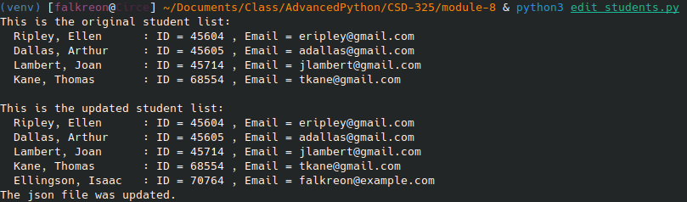
KWrite just “watched” the file and updated its unedited contents without prompting, so here’s a screenshot of the updated file.
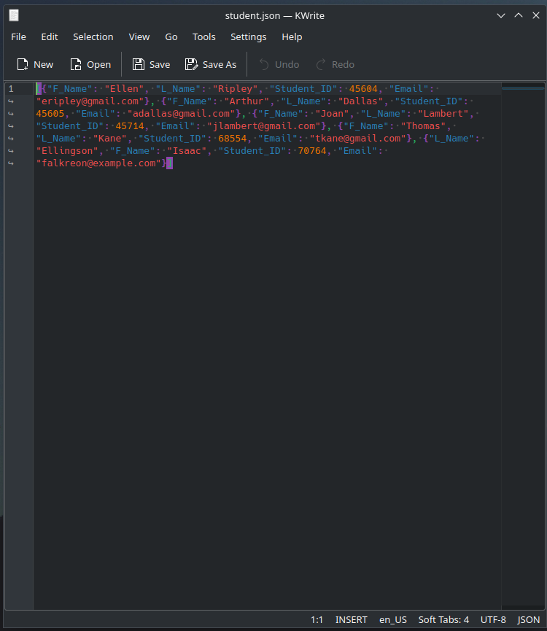

Clearly it needed indents, and after updating with indents we did get a more metered response since I edited it (to delete my entry) before re-running the program:

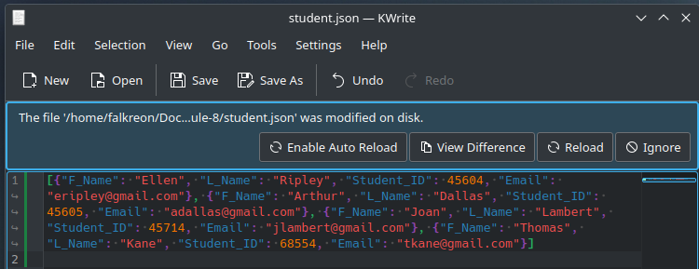
And after hitting Reload:

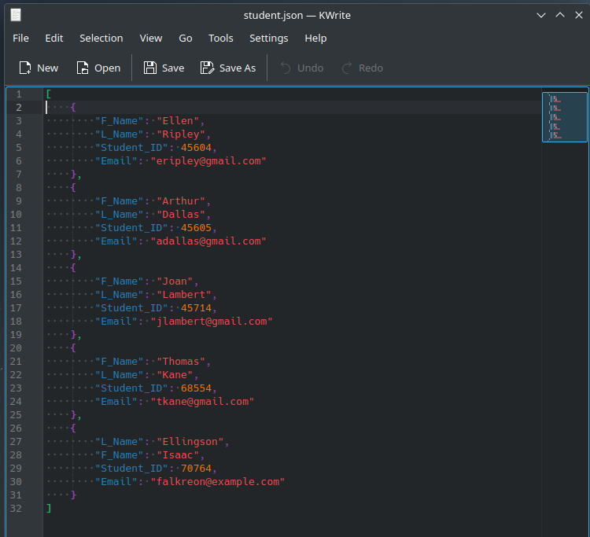
It’s clear to me that there’s no “appending” going on; it’s rewriting the complete file.

