CSD325: Advanced Python
Module 9.2 Assignment: APIs
Isaac Ellingson
11/30/2025

Unformatted Currently-Orbiting-Astronauts Output:

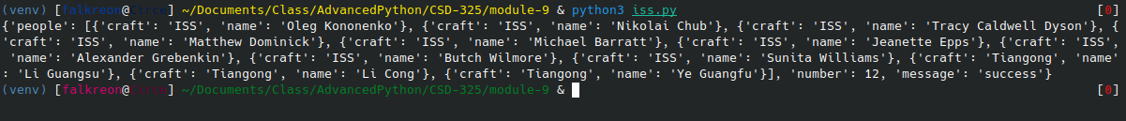

Formatted Output:

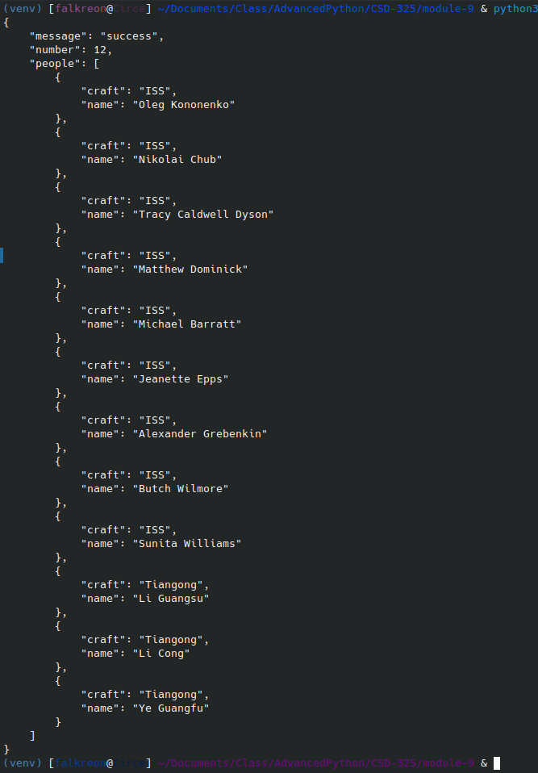
Chosen API Endpoint with No Formatting:
Formatted API Endpoint:
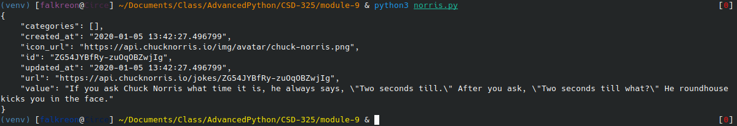
Final output with the important data extracted and processed:

