Project: | Assignment 4.2
Course: | CSD-380
Description: | Test Plan for Todo Application
Date: | 6/28/2026

Table of Contents
Create a new todo task item 1
Delete a todo task item 2
For invalid URLs, provide users with a custom 404 error page 3
Prevent users from submitting a task form without entering a todo item 4
Prevent users from submitting the edit form without entering a todo item 5

Test 1 | Create a new todo task item
 | Test Objective: Verify that a user can enter a valid task item (four or more characters) and add it to the Todo List. | Developer:  Sara White  Date tested: 2026/06/25 | Peer tester: Isaac Ellingson  Date tested: 2026/06/28
Step | Action | Expected results: | Developer pass/fail | Tester pass/fail
1 | Go to https://buwebdev.github.io/todo/ | The website should load successfully | Yes | Yes  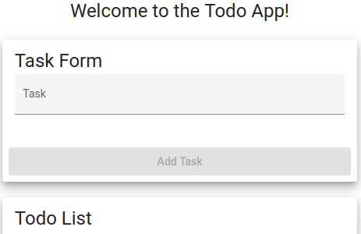
2 | Type in a task item (you can type “Test task item” | Add task button should remain grey/unclickable until at least 4 characters have been entered into the task form field | Yes | Yes  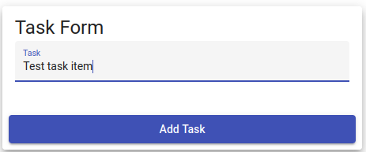
3 | Click “add task” | After clicking “add task” the new task item should be added to the bottom of the todo list | Yes | Yes  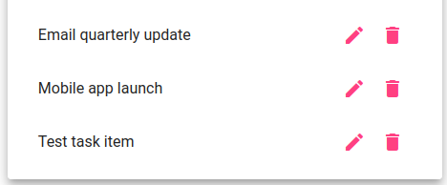
Comment  s | The website loaded with no issues. I was able to type in a task item using the provided text (Test task item). After 4 characters were present in the input field, the “add task” went from grey to dark pink. I was able to click the “add task” button and the new task appeared at the bottom of the to do list.  All steps reliably succeed. However, entering four or more blank spaces allows addition of a blank task, and identical duplicate items can be added without issue. New tasks appear infallibly at the end of the list as expected.

Test 2 | Delete a todo task item
 | Test Objective:  Verify that a user can remove an existing task item from the Todo List | Developer:  Sara White  Date tested: 2026/06/25 | Peer tester: Isaac Ellingson  Date tested: 2026/06/28
Step | Action | Expected results: | Developer pass/fail | Tester pass/fail
1 | Go to https://buwebdev.github.io/todo/ | The website should load successfully | Yes | Yes
2 | Click the trashcan icon to the right of a Todo List task item | Task item should disappear from Todo List | Yes | Yes  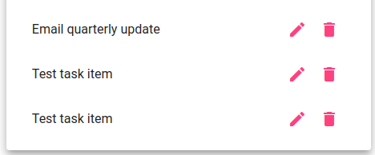
Comments | The website loaded properly and after clicking the trashcan icon, the task item was removed from the Todo list.  Items delete reliably and successfully. This is true even for large lists, or for deleting lists until they are empty. Because an empty list has no trash cans to click, it does not appear possible to "over-delete" past the empty list.

Test 3 | For invalid URLs, provide users with a custom 404 error page
 | Test Objective:  Verify that a custom 404 message displays when an invalid Todo website URL is entered | Developer: Sara White  Date tested: 2026/06/25 | Peer tester: Isaac Ellingson  Date tested: 2026/06/28
Step | Action | Expected results: | Developer pass/fail | Tester pass/fail
1 | Go to https://buwebdev.github.io/todo/404test | The site does not load a regular Todo page | Yes | Yes  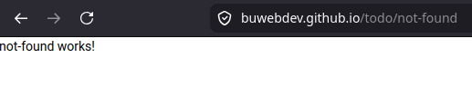  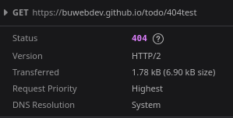
2 | Confirm a custom 404 message is displayed | User should see a custom 404 message (“not-found works!”) instead of a generic browser error | Yes | No  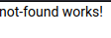
Comments | After visiting the provided invalid Todo URL, a page was displayed with a custom 404 message that read “not - found works!”  The website serves a custom page with a custom message on invalid page access. The page is returned with a 404 HTTP status code as expected. However, this appears to be a page stub. It neither explains what happened to the user, nor helps the user navigate back to the correct Todo app URL.

Test 4 | Prevent users from submitting a task form without entering a todo item
 | Test Objective:  Verify that the task form prevents a user from submitting a task item that is less than four characters. | Developer:  Sara White  Date tested: 2026/06/25 | Peer tester: Isaac Ellingson  Date tested: 2026/06/28
Step | Action | Expected results: | Developer pass/fail | Tester pass/fail
1 | Go to https://buwebdev.github.io/todo/ | The website should load successfully | Yes | Yes
2 | Click inside the Task Form input field | Placeholder text (“Task”) should shrink above caret | Yes | Yes  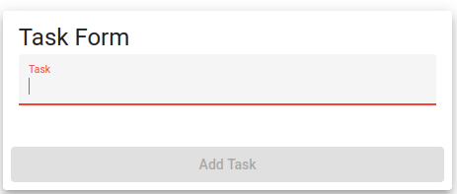
3 | Type “123” into the Task Form | “Add task” button should remain grey and inactive | Yes | Yes  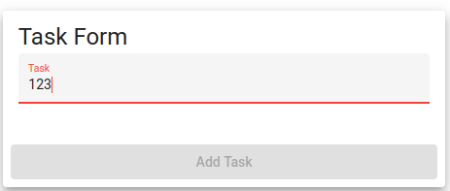
5 | Click “add task” | Nothing should happen. | Yes | Yes  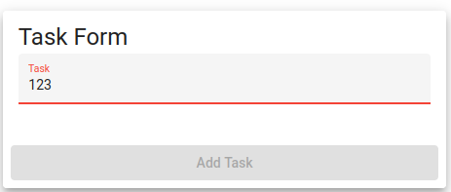
Comments | After typing “123” (with no additional characters or spaces) into the task form, the “add task” button was greyed out. I attempted to click the button, and nothing happened.  While the screenshot indicates red hilighting in the input form, the initial click into the input field shows blue. This visual cannot be captured because capturing the screen causes focus to be lost, triggering input validation. As mentioned above, entering five spaces enables the button, allowing blank tasks to be submitted.

Test 5 | Prevent users from submitting the edit form without entering a todo item
 | Test Objective:  Verify that the task form within the edit popup prevents a user from submitting a task item that is less than four characters. | Developer:  Sara White  Date tested: 2026/06/25 | Peer tester: Isaac Ellingson  Date tested: 2026/06/28
Step | Action | Expected results: | Developer pass/fail | Tester pass/fail
1 | Go to https://buwebdev.github.io/todo/ | The website should load successfully and task items should be present in the Todo List | Yes | Yes
2 | Click the edit icon to the right of one of the task items in the Todo List | Edit Form will pop up in the center of the page with the current task item in the input field | Yes | Yes  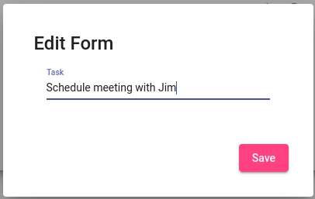
3 | Delete the text in the task item field (do not type anything into the field) | User should be able to delete the existing task item and the “save” button should appear grey | No | No  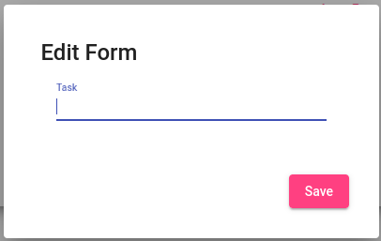
4 | Click the “save” button in the bottom right corner | Nothing should happen. The “save” button should not be clickable and should only be active and appear dark pink if four or more characters have been entered in the task item field | No | No  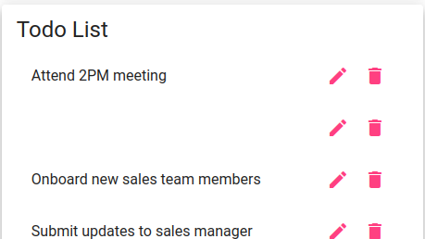
Comments | The website loaded successfully and the edit button is working correctly, but the “save” button does not grey out and is still active when no text or characters are in the task item field. I was able to save a blank task item.  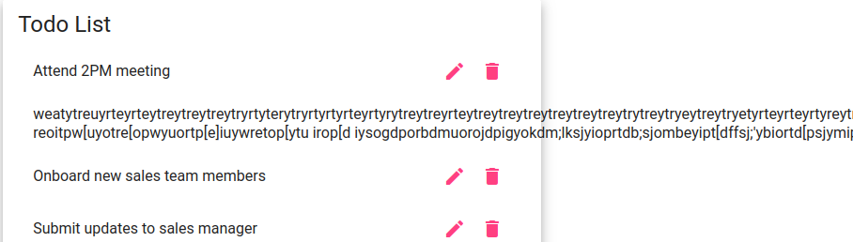  Users will expect the same input validation on the Edit Task popup as they do on the Task Form. The current app state is extremely permissive:  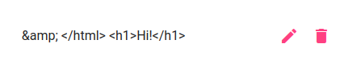  However, this lack of validation is somewhat mitigated by spectacular HTML escaping within the list itself.

