CSD-430: Server Side Development
Module 1: Installation & Configuration
Assignment 2: GitHub Repository Setup
Isaac Ellingson
6/7/2026

GitHub Repository
https://github.com/falkreon/CSD-430

GitHub Remote Repository Page
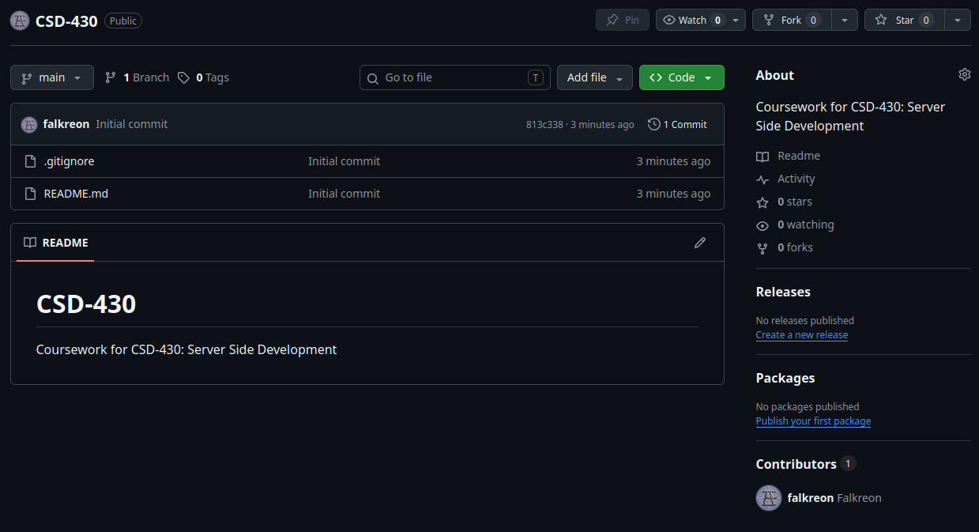

Local Repository Setup

