CSD430: Server Side Development
Module 5.2 & 6.2: Working with CRUD-READ, JDBC & JavaBeans - Project Part 1
Isaac Ellingson
7/5/2026

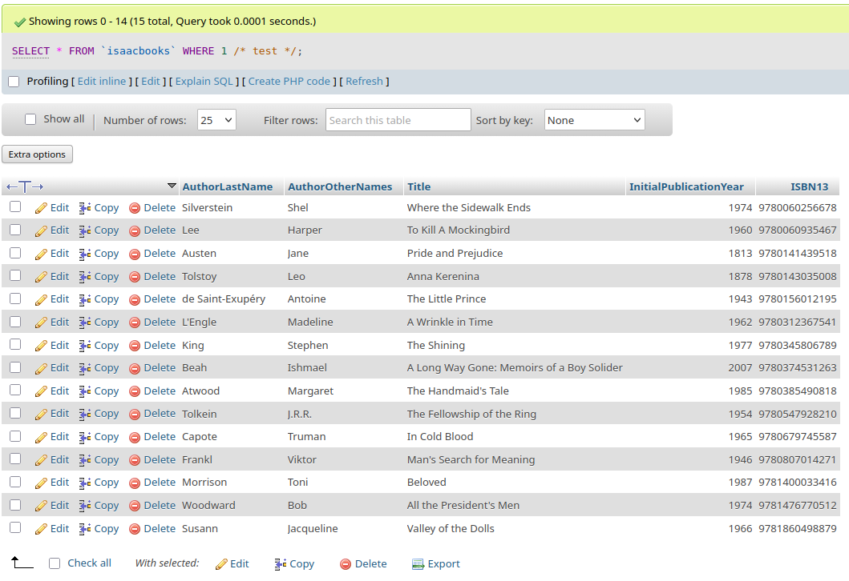
Table Creation and Population
(all changes made from the provided SQL, not through this UI)

User Access Control
(all changes made from the provided SQL, not through this UI)
