CSD-430: Server Side Development
Module 1: Installation & Configuration
Assignment 3: Programming Assignment
Isaac Ellingson
6/7/2026

Java Installed
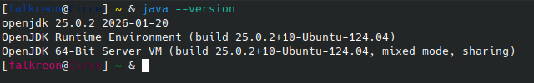

Eclipse Installed and Configured for Java EE
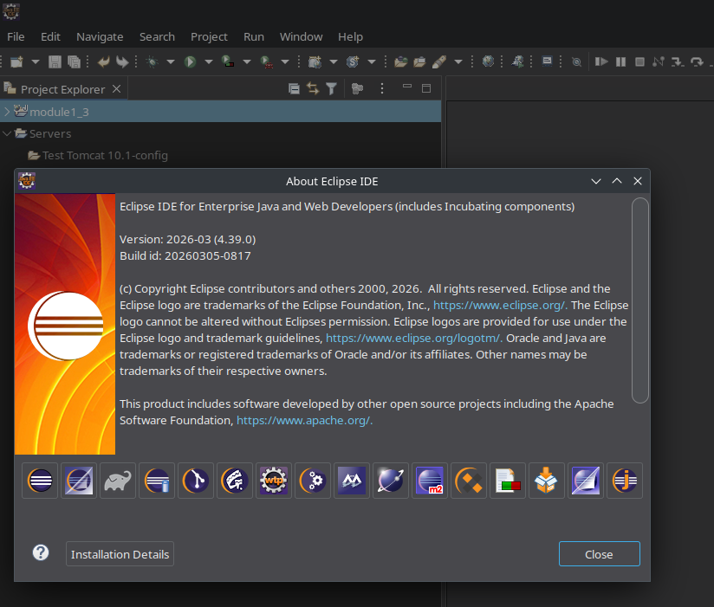

Tomcat Installation
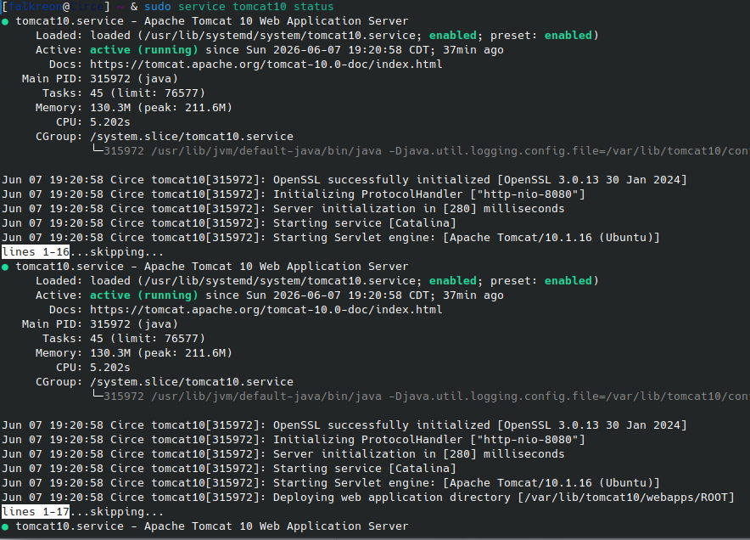

Simple JSP Page
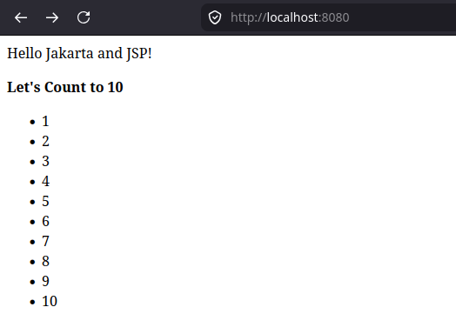

JSP Page Source (index.jsp)

<%@ page language="java" contentType="text/html; charset=UTF-8"
pageEncoding="UTF-8"%>
<!DOCTYPE html>
<html>
<head>
<meta charset="UTF-8">
<title>Test JSP Page</title>
</head>
<body>
<%
String HELLO = "Hello Jakarta and JSP!";
out.println(HELLO);
%>
<p><b>Let's Count to 10</b>
<ul>
<%
for(int i=1; i<=10; i++) {
out.println("<li>" + i);
}
%>
</ul>
</body>
</html>

