CSD440: Server-Side Scripting
Module 1: Apache Web Server - XAMPP Install
Assignment 2: GitHub
Isaac Ellingson
8/16/2026

Remote:
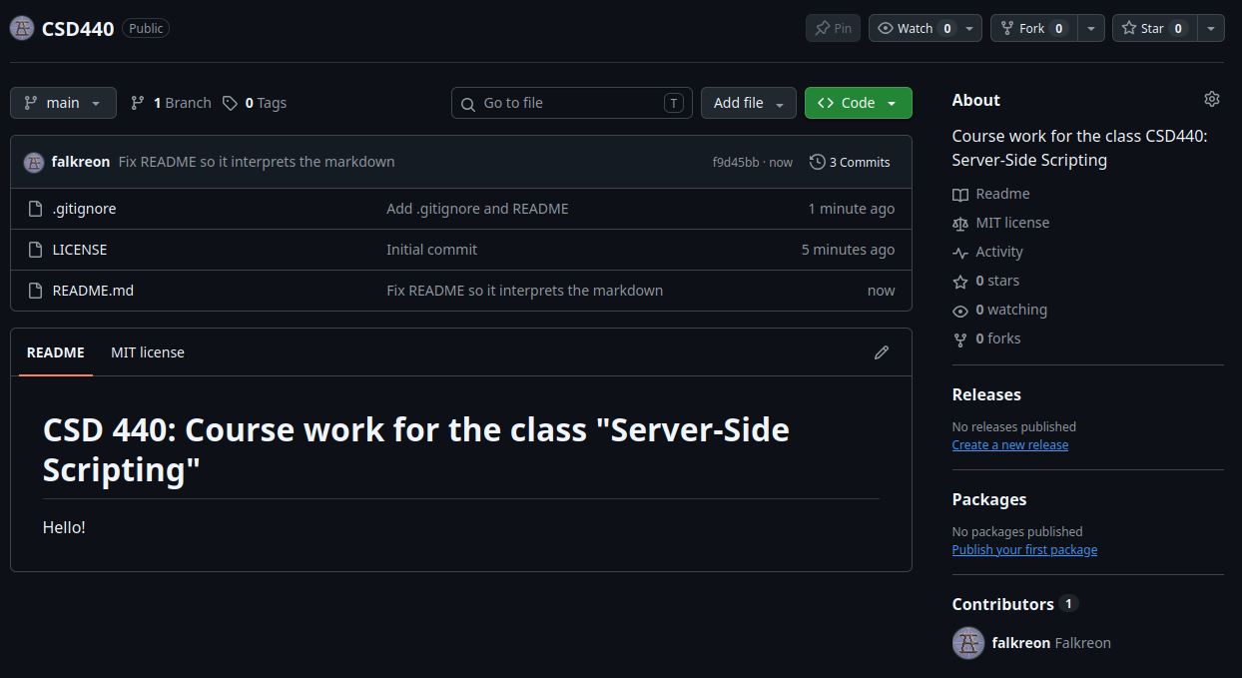

Local:
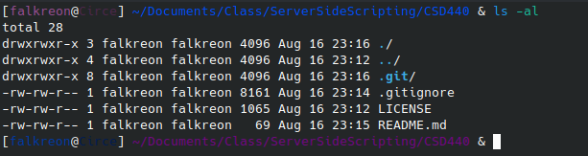

Extra Diagnostics:
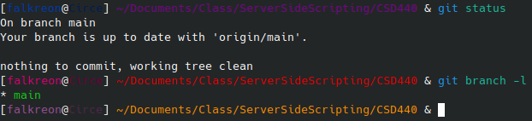

GitHub Link:
https://github.com/falkreon/CSD440

