CSD440: Server-Side Scripting
Module 1: Apache Server - XAMPP Install
Assignment 3: Programming Assignment
Isaac Ellingson
8/16/2026

XAMPP Install:
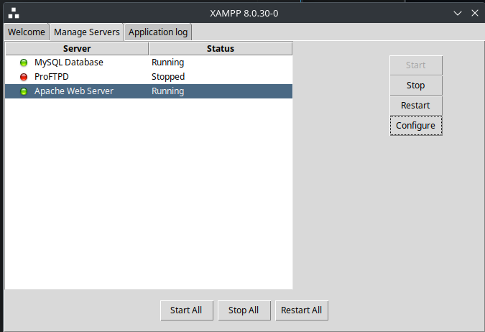

Running PHP:
