Project: Moffat Bay Lodge
Course: CSD460 Capstone in Software Development
Description: Test the Reservation page
Date: 2026/09/13
To complete the test case plan, fill out the information for Project, Course, Description and Date in the header below.
.
TABLE OF CONTENTS
Input Options and Validation 3
Appropriate Redirection If Not Logged In 3
Accurate Rates 4
Resist Malicious Input 5

For each test, the developer should: provide a test description, a test objective, the developer name and date tested. For each step, fill out the actions to be taken and describe the expected results, and indicate yes or no for each step depending upon the result. The peer tester should provide their name, date tested, indicate yes or no for each step depending upon the result, and a screenshot (thumbnail) of the result.

Test 1 | Input Options and Validation
 | Test Objective: Ensure bad data can't be submitted | Developer: Isaac  Date tested: 2026/09/13 | Peer tester: Jose  Date tested: 2026/09/13
Step | Action | Expected results: | Developer pass/fail | Tester pass/fail  + Screenshot
1 | Open the Moffat Bay landing page and login to a valid user account | User is logged in successfully | yes | yes  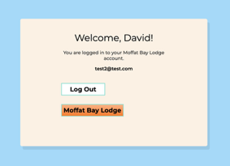
2 | Click "Book Your Vacation" on the navigation bar at the top | User is taken to a form to book a reservation | yes | yes  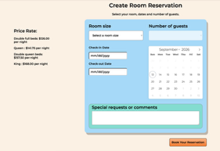
3 | Open "Select a Room Size" dropdown and select "Queen" | Dropdown [only] contains expected items: Double Full, Queen, Double Queen, King | yes | yes  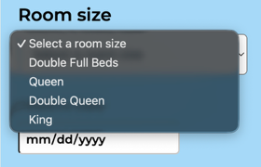
4 | Set the calendar to the current month. Click on the 18th and then the 14th. | Calendar UI element does not allow the user to select a check-out date earlier than the check-in date. | yes | yes  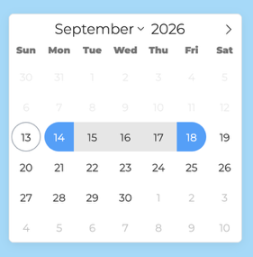
5 | Open the "Number of persons" dropdown and select "2" | Dropdown reflects the room type's maximum occupancy of 2 | yes | yes  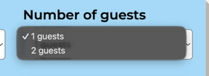
6 | Hit "Book Your Reservation". | User is taken to a confirmation screen with accurate information. | yes | yes  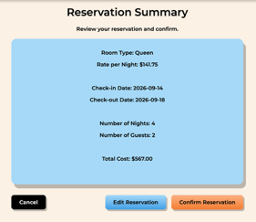
7 | Hit "Confirm Reservation". | The reservation is created successfully. | yes | yes  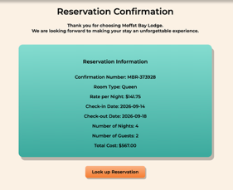
Comments | Book the reservation flow is fluid and easy to follow. The page loads with no visible errors and acts as expected. The calendar portion loads as expected and user can go through several dates and months. User cannot select dates in the past. Calendar does not allow user to select a check-out date earlier than the check-in date, instead calendar switches dates to make the check-out date the new check-in date. Finally, user is able to go to confirmation booking and then they can confirm, site responds with proper confirmation page.

Test 2 | Appropriate Redirection If Not Logged In
 | Test Objective: Ensure that the user is properly guided to the register/login pages if they attempt to book a reservation without logging in. | Developer: Isaac  Date tested: 2026/09/13 | Peer tester: Jose  Date tested: 2026/09/13
Step | Action | Expected results: | Developer pass/fail | Tester pass/fail
1 | Go to the Moffat Bay landing page |  | yes | yes  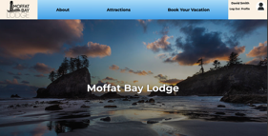
2 | If the user widget on the top right shows a login name, click "Log Out" |  | yes | yes  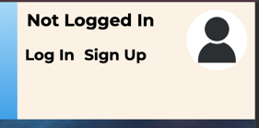
3 | Back at the landing page, click "Book Your Vacation" in the navigation bar at the top. | User does not see the Create Room Reservation form; instead, they are prompted to register (or log in) | no; User is prevented, but comment visible at top of page | no  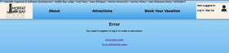
Comments | User is not able to make a reservation without properly signing into site. When they select Book Vacation tab without being logged in they are prompted to either log in or make an account. Both links work redirect user to the correct page. There is an issue now showing on the page where a comment is visible at the top.

Test 3 | Accurate Rates
 | Test Objective: Ensure that rates are clearly and accurately calculated and disclosed. | Developer: Isaac  Date tested: 2026/09/13 | Peer tester: Jose  Date tested: 2026/09/13
Step | Action | Expected results: | Developer pass/fail | Tester pass/fail
1 | Go to the Moffat Bay landing page and login to a valid user account |  | yes | yes  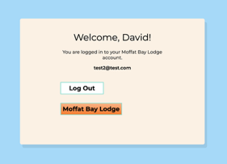
2 | Click "Book Your Vacation" in the top navigation bar | User is taken to the Create Room Reservation form | yes | yes
3 | Observe the rates in the side panel | Rates are shown as follows (5% markup from original requirements doc):  Double Full: $126.00  Queen: $141.75  Double Queen: $157.50  King: $168.00 | yes | yes  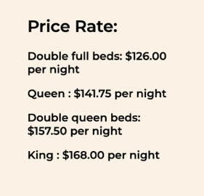
4 | Select "Double Queen" and 2 guests. Select the 5th and the 6th of the current (or next available) month. | Form permits the selection which falls within the room's occupancy limit and permitted date ranges. | yes | yes  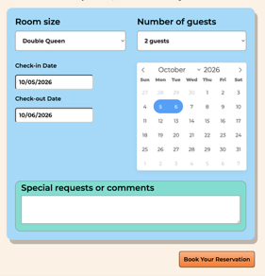
5 | Click "Book Your Reservation" | User is taken to the summary / confirmation page, where the total cost is displayed as $157.50 - the price does not change based on occupancy count. | yes | yes  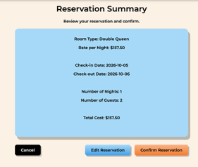
Comments | User is easily able to log into page a make a reservation. They are shown the maximum number of guests permitted based on the room type they select. User is able to see the calculations on Summary page when booking room based on the rates shown in the booking process.

Test 3 | Resist Malicious Input
 | Test Objective: Ensure that reservation form resists malicious input in the Special Requests field | Developer: Isaac  Date tested: 2026/09/13 | Peer tester: Jose  Date tested: 2026/09/13
Step | Action | Expected results: | Developer pass/fail | Tester pass/fail
1 | Go to the Moffat Bay landing page and login to a valid user account |  | yes | yes
2 | Click "Book your Vacation" in the top navigation bar |  | yes | yes
3 | Enter in valid room type, occupancy count, and date range |  | yes | yes  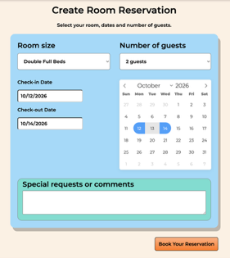
4 | Enter the following Special Request (you may need to copy-paste the emoji in):  ;DROP FROM Reservation;{$_SESSION['user_id']} <h1>hi</h1></body></html>🏳️‍🌈 |  | yes | yes  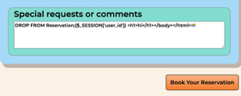
5 | Click "Book Your Reservation" | Reservation summary page is not cut off or altered. Special request is displayed faithfully. No html tags in the message are rendered, and the user's id is not retrieved. Emoji is faithfully reproduced. | yes | yes  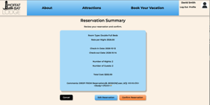
9 | Click "Confirm Reservation" | Reservation is completed successfully. Database contains both the new reservation and prior ones. | yes | yes  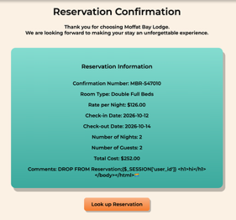  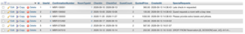
Comments | User is able to book a reservation based on their preferences and has the ability to make a special request. The page is able to detect when there is malicious date in the special request field. Rather run any sort of commands the Summary page does not run any commands and instead shows the code as plain text. The text appears as the user entered and properly reproduced the emoji. After the reservation is made the data is stored into the database with the proper information and special request.

