Project: Moffat Bay Lodge Website
Course: CSD460-308A Capstone in Software Development
Description: This Project Test Case will demonstrate the
Date: 2026/09/01
To complete the test case plan, fill out the information for Project, Course, Description and Date in the header below.
.
TABLE OF CONTENTS
<User Registration Page Test> 2
<User Login Page Test> 2
<Landing Page Button Test> 2-3
<Landing Page Test> 3
<User Registration Required Information Test> 3-4
<User Registration 1 time Per User Test> 4
<Nav Bar Button Test> 2-3

For each test, the developer should: provide a test description, a test objective, the developer name and date tested. For each step, fill out the actions to be taken and describe the expected results, and indicate yes or no for each step depending upon the result. The peer tester should provide their name, date tested, indicate yes or no for each step depending upon the result, and a screenshot (thumbnail) of the result.

Test 1 | User Registration Page
 | Test Objective: User is able to input data for registration and data is saved to database when submit is clicked | Developer: Cannon  Date tested: 2026/09/06 | Peer tester: Jose  Date tested: 2026/09/06
Step | Action | Expected results: | Developer pass/fail | Tester pass/fail  + Screenshot
1 | User enters Email | Email is displayed correctly in the email field. | <yes/no> | <yes/no>  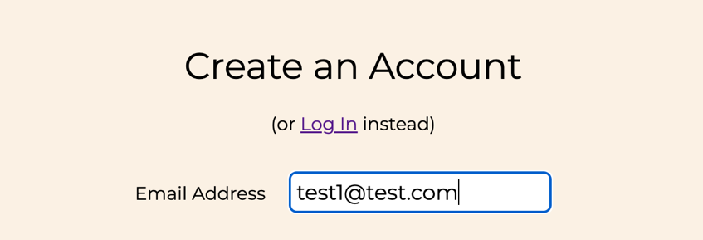
2 | User enters unique password | Password is entered successfully and is masked in the password field | <yes/no> | <yes/no>  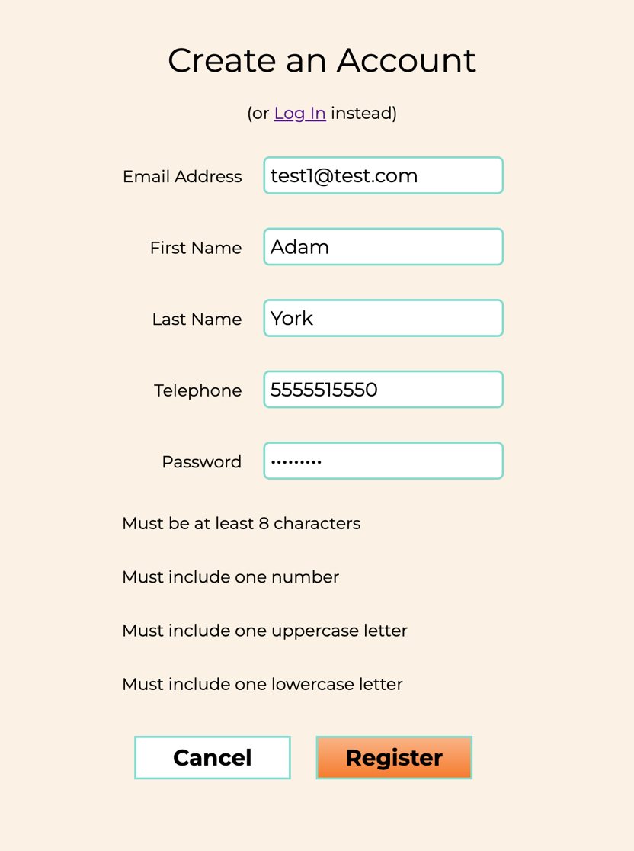
3 | User enters first name | First name is displayed correctly in the first-name field. | <yes/no> | <yes/no>  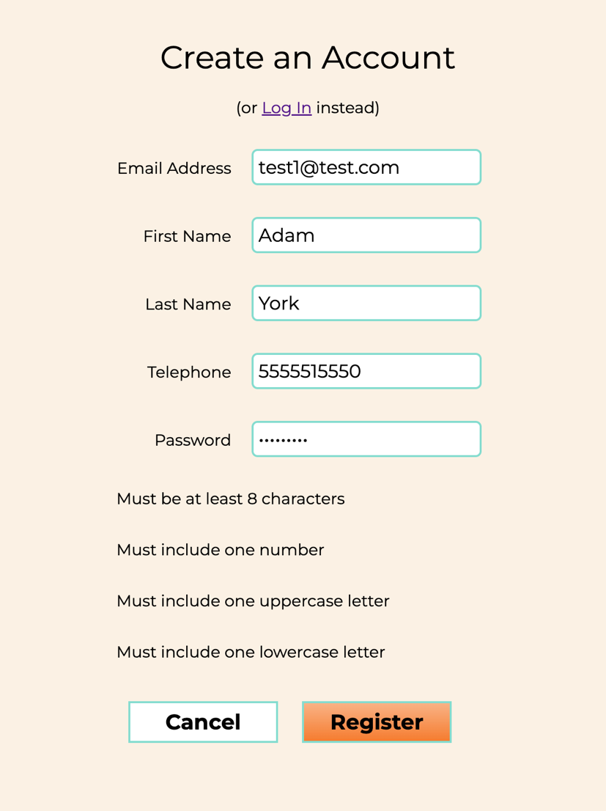
4 | User enters last name | Last name is displayed correctly in the last-name field. | <yes/no> | <yes/no>  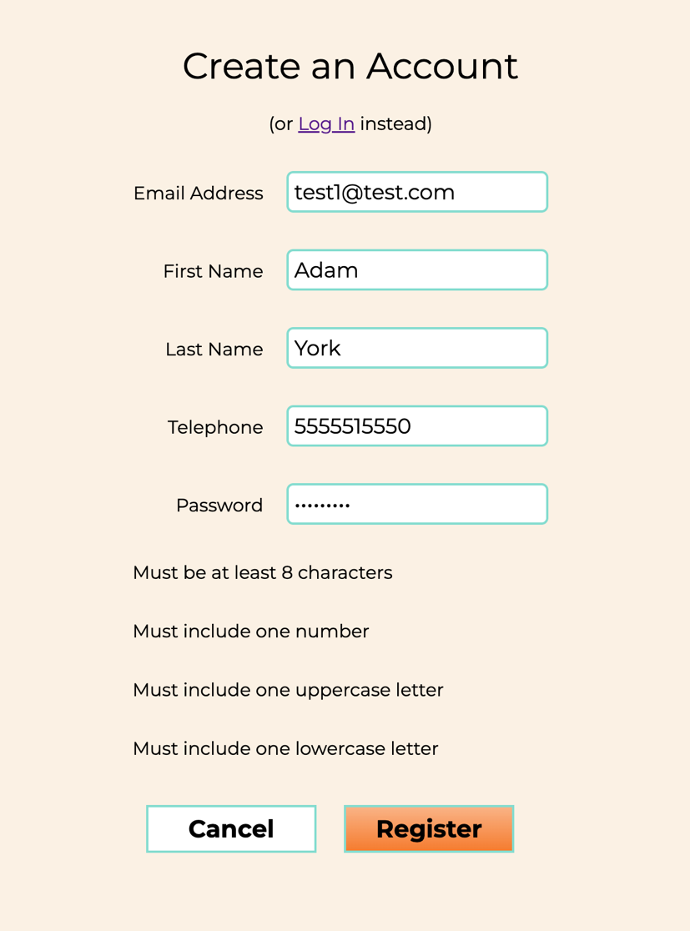
5 | User enters telephone | Telephone number is displayed correctly in the telephone field. | <yes/no> | <yes/no>  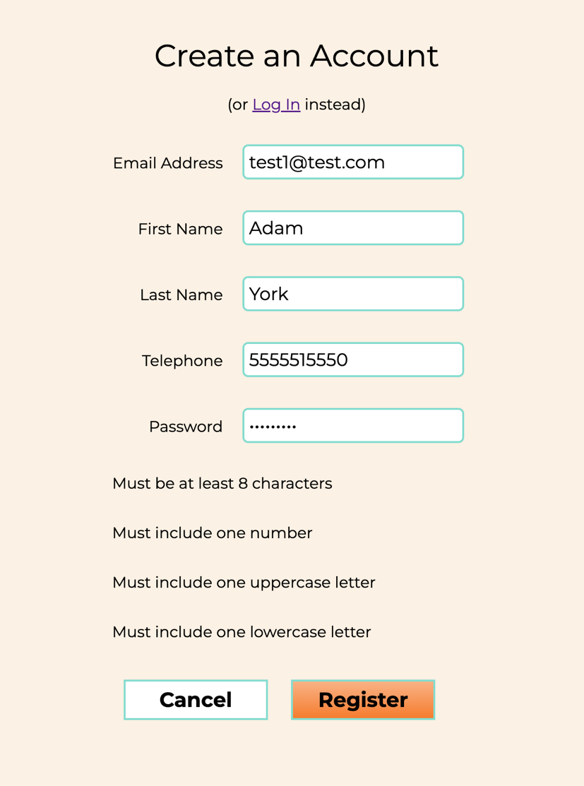
6 | User submits form | Registration is submitted successfully, a success message is displayed, and the user is redirected to home page | <yes/no> | <yes/no>  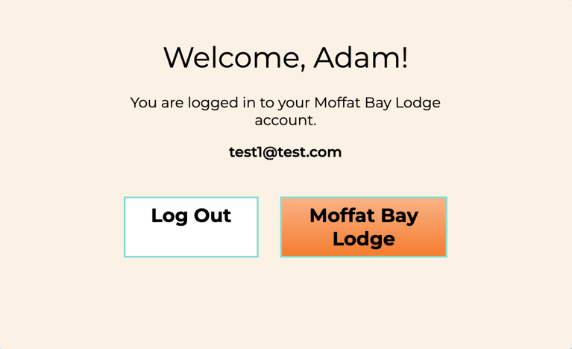
7 | User’s information is saved to database | The user's registration information is successfully saved to the database. The password is stored securely as a hash rather than as plain text. | <yes/no> | <yes/no>  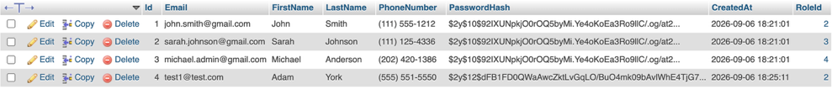
Comments | Registration is seamless. Page does a good job showing user how they are entering the fields. It shows a green bar for the correct input and is easy to understand. When user is registered, they are given a success message that then allows them to continue to the website or to log out.

Test 2 | User Login Page
 | Test Objective: User is able to Login and data is retrieved from database successfully | Developer: Cannon  Date tested: 2026/09/06 | Peer tester: Jose  Date tested: 2026/09/06
Step | Action | Expected results: | Developer pass/fail | Tester pass/fail
1 | User Enters email | Email is displayed correctly in the email field. | <yes/no> | < yes /no>  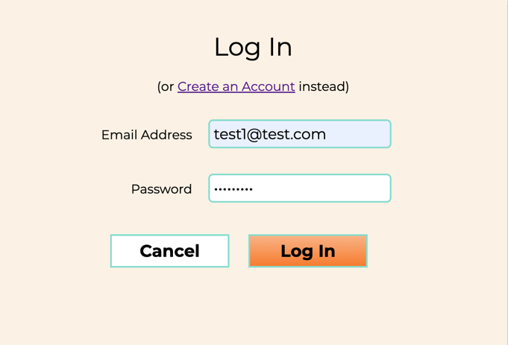
2 | User Enters Password | Password is entered successfully and is masked in the password field. | <yes/no> | < yes /no>  
3 | User Submits form | Login is submitted successfully, a success message is displayed | <yes/no> | < yes /no>  
4 | Users Data is retrieved from database | The user's information is successfully pulled from the database and accessible to user | <yes/no> | < yes /no>  
5 | User is redirected to home page | User is sent back to home page | <yes/no> | < yes /no>  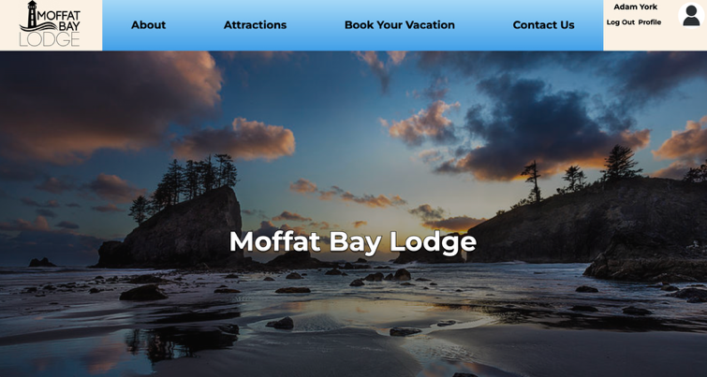
Comments | Logging into account works as expected. User can hit Log In link and is redirected to enter email and password. Once credentials are entered, they are able to hit Log in and user is directed into account. From there they can continue onto the site.

Test 3 | Nav Bar Buttons
 | Test Objective: Landing Page Links Test | Developer: Cannon  Date tested: 2026/09/06 | Peer tester: Jose  Date tested: 2026/09/06
Step | Action | Expected results: | Developer pass/fail | Tester pass/fail
1 | User Navigates to Landing Page | User successfully loads the Landing Page(index.php) | <yes/no> | < yes /no>  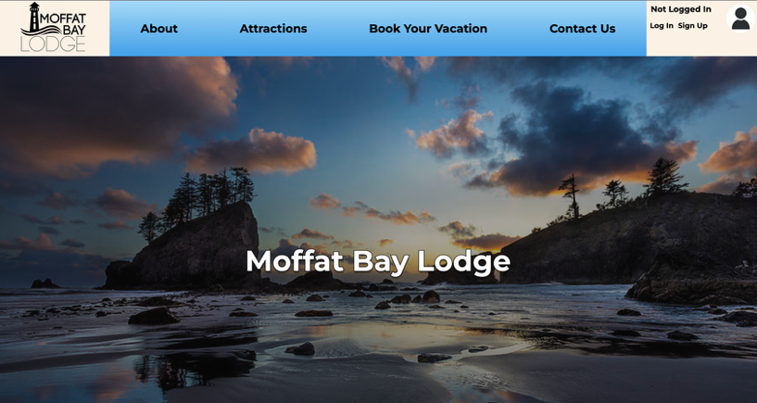
2 | User Scrolls Down to the Create an account and book your vacation button and clicks on it | User clicks on button and is sent to login page | <yes/no> | < yes /no>  
3 | User navigates back to the landing page scrolls down to the Access the Marina button and clicks on it | User successfully navigates back to the Landing page and when the button is clicked is sent to the top of the landing page. | <yes/no> | < yes /no>  
4 | User Scrolls down to the Attractions Link and clicks on it | User is sent to the Attraction Page | <yes/no> | < yes /no>  
5 | User Navigates back to the landing page scrolls down to the bottom and clicks back to top of page | User successfully navigates back to the landing page and when the button is clicked, User is sent to the top of landing page. | <yes/no> | < yes /no>  
Comments | All buttons on home page work as expected. User clicks on call-to-action button to book vacation and is prompted to log in to site or to create account. Access Marina button helps user locate navbar and explore site. Attractions page works as expected and brings user to attractions page. Finally, link at bottom of page works and brings user back to top of page without having to scroll.

Test 4 | Landing Page Test
 | Test Objective: | Developer: Cannon  Date tested: 2026/09/06 | Peer tester: Jose  Date tested: 2026/09/06
Step | Action | Expected results: | Developer pass/fail | Tester pass/fail
1 | User opens the Moffat Bay Lodge website by navigating to index.php | The landing page loads successfully without displaying PHP errors, database errors, or a blank page. | <yes/no> | < yes /no>  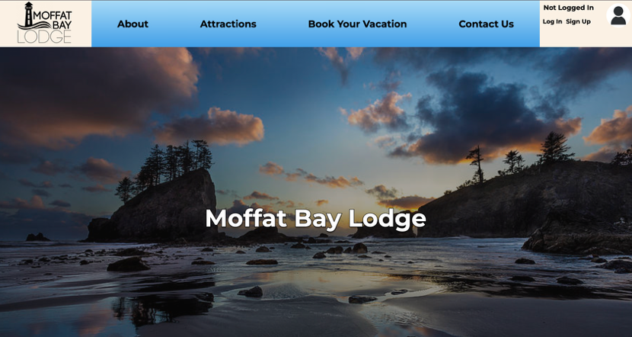
2 | User views the top section of the landing page | The Moffat Bay Lodge name, logo, or main page heading is displayed correctly and is clearly visible. | <yes/no> | < yes /no>
3 | User reviews the main content displayed on the landing page. | The landing page displays the intended text, images, and information about Moffat Bay Lodge correctly without missing or broken content. | <yes/no> | < yes /no>  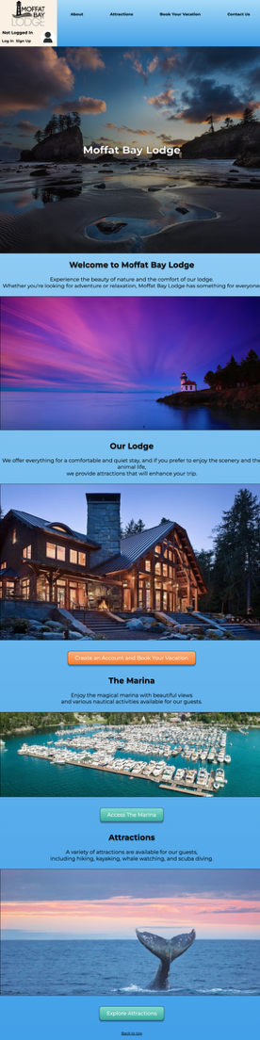
4 | User scrolls from the top to the bottom of the landing page. | All sections of the landing page display correctly, images load properly, and the page can be viewed without overlapping or improperly formatted content. | <yes/no> | < yes /no>  
Comments | All aspects of initial landing page work as expected and there are no visible errors that display. Text and boxes are laid out well and images load with no issues.

Test 5 | User Registration Page Required Information
 | Test Objective: User should not be allowed to register if information requirements aren’t met. | Developer: Cannon  Date tested: 2026/09/06 | Peer tester: Jose  Date tested: 2026/09/06
Step | Action | Expected results: | Developer pass/fail | Tester pass/fail
1 | User Enters Email | Email is displayed correctly in the email field. | <yes/no> | < yes /no>  
2 | User Enters Password | Password is entered successfully and is masked in the password field. | <yes/no> | < yes /no>  
3 | User submits form | User is alerted by website that Required Information is missing and needs to be completed before submitting again | <yes/no> | < yes /no>  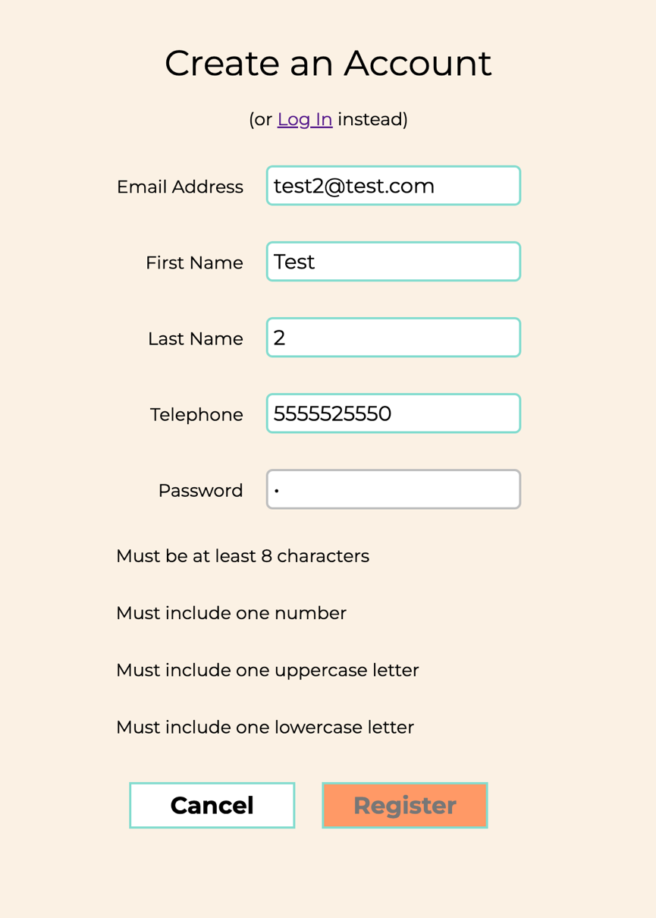
4 | User Enters information prompted to be required | Missing information is displayed correctly in there respective fields | <yes/no> | < yes /no>  
5 | User Resubmits | User will be registered when data is correct | <yes/no> | < yes /no>  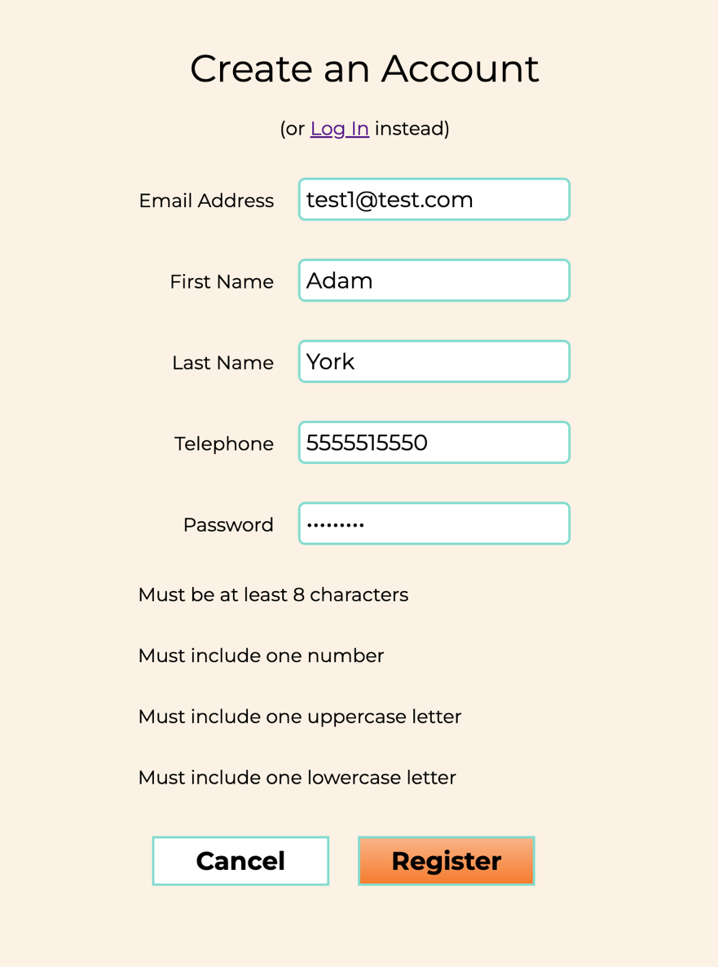
Comments | User can see whether not they entered valid information in fields. They are prompted to review the information they entered through the green outline around the input field. If they entered something that is not valid it will remain grey. Once they enter valid information they will get the green box. The Register button at the bottom of the page will also remain grayed out until the user enters correct information. Once they do, they will be able to hit the Register button.

Test 6 | Login Session Test
 | Test Objective: When the User Logs In they should stay logged in for a period of time in which they should not be allowed to login or sign up unless signed out. | Developer: Cannon  Date tested: 2026/09/06 | Peer tester: Jose  Date tested: 2026/09/06
Step | Action | Expected results: | Developer pass/fail | Tester pass/fail
1 | User Logs In | User Logs in Successfully | < yes /no> | < yes /no>  
2 | User returns to Landing Page | User returns to Landing Page with them still being logged in from the indication in the top right corner | < yes /no> | < yes /no>  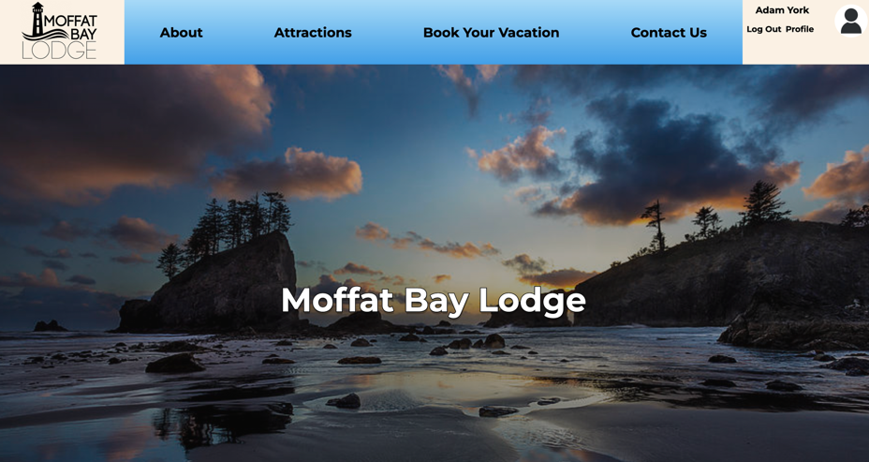
3 | User goes to reservations | User is allowed into the reservation page without being prompted to login | < yes /no> | < yes /no>  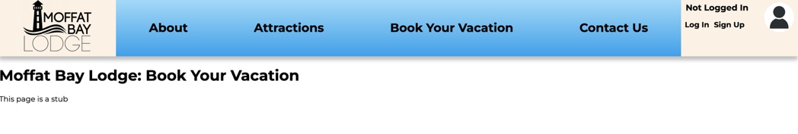
4 | User returns to Landing Page | User returns to Landing page still logged in | < yes /no> | < yes /no>  
5 | User goes to account information | User is able to see account information | < yes /no> | < yes /no>  
Comments | Site can know when user is logged in as they continue to browse the site. Users are confirmed by this because they can see their account information in the top right-hand corner of the page. While a user may be able to start to make a reservation while logged in, they do not have to be. A new user may still access the Book Your Vacation page without the need to log into site.

