Project: Moffat Bay Cabin Project
Course: CSD460-308A Capstone in Software Development
Description: This Test Case is for the Attractions Page and is used to test whether the page works successfully.
Date: 2026-9-21
To complete the test case plan, fill out the information for Project, Course, Description and Date in the header below.

TABLE OF CONTENTS
Attractions Page Test 3
Attractions CSS Test 6

For each test, the developer should: provide a test description, a test objective, the developer name and date tested. For each step, fill out the actions to be taken and describe the expected results, and indicate yes or no for each step depending upon the result. The peer tester should provide their name, date tested, indicate yes or no for each step depending upon the result, and a screenshot (thumbnail) of the result.

Test 1 | Attractions Page Test
 | Test Objective: Verifies that all text, and images load properly | Developer: Cannon  Date tested: 2026/09/23 | Peer tester: Patrice  Date tested: 2026/09/24
Step | Action | Expected results: | Developer pass/fail | Tester pass/fail  + Screenshot
1 | Open Attraction Page | The Attractions page opens successfully without errors. The page title, text, and main content should display correctly. | <yes/no> | Yes  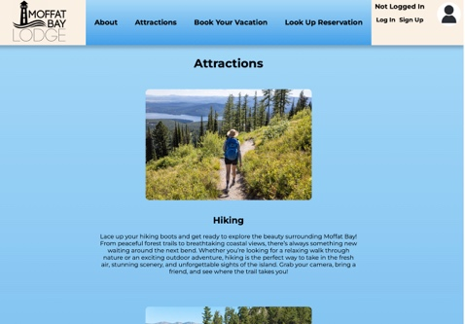
2 | Hiking Img and text loads successfully | The Hiking image loads successfully, and the related Hiking text is displayed clearly with no missing content. | <yes/no> | Yes  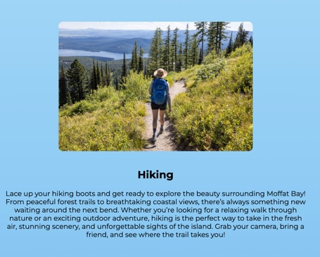
3 | Kayaking img and text loads successfully | The Kayaking image loads successfully, and the related Kayaking text is displayed clearly with no missing content. | <yes/no> | Yes  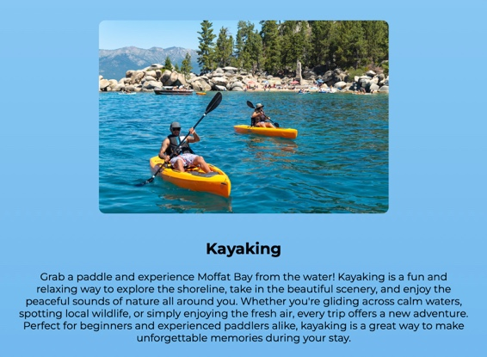
4 | Whale Watching img and text loads successfully | The Whale Watching image loads successfully and the related Whale Watching text appears correctly with no missing content. | <yes/no> | Yes  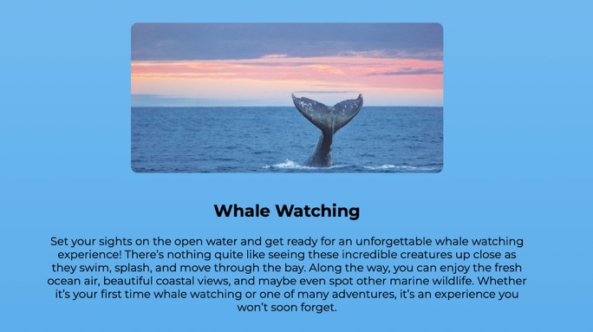
5 | Scuba Diving img and text loads successfully | The Scuba Diving image loads successfully and the related Scuba Diving text appears correctly with no missing content. | <yes/no> | Yes  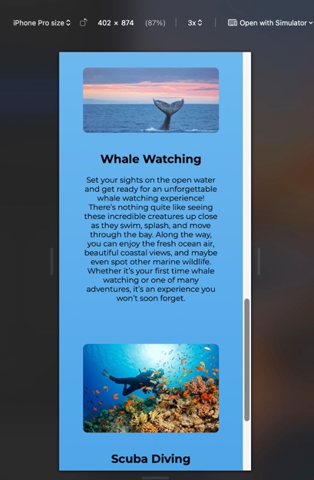  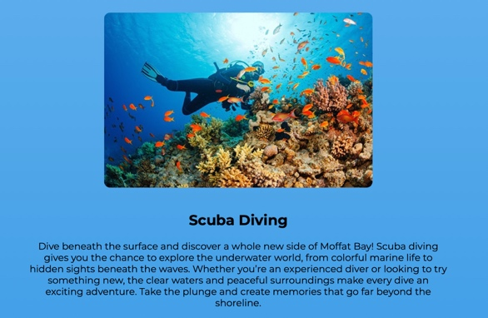
Comments | The Attractions page loaded correctly, and each attraction section displayed its image and text as expected. The Hiking, Kayaking, Whale Watching, and Scuba Diving sections were easy to identify and had no noticeable missing content. The page could be improved further by making sure all images remain clear and properly displayed on different screen sizes.  The Page loads correctly and the elements are centered (titles, text and pictures). The page is responsive and displays very well on mobile format devices.

Test 2 | Attractions CSS Test
 | Test Objective: Verifies That all CSS loads properly | Developer: Cannon  Date tested: 2026/09/23 | Peer tester: Patrice  Date tested: 2026/09/24
Step | Action | Expected results: | Developer pass/fail | Tester pass/fail
1 | Open Attraction Page | The Attractions page opens successfully with all CSS styling applied. The page should not display as unformatted HTML. | <yes/no> | Yes  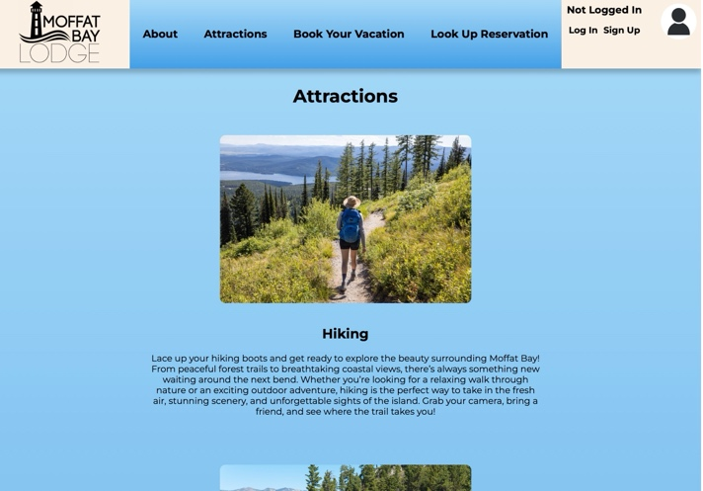
2 | Background Color shows up and fades darker as you go down | The background color displays correctly and gradually become darker as the user moves down the page. The transition should appear smooth and consistent. | <yes/no> | Yes  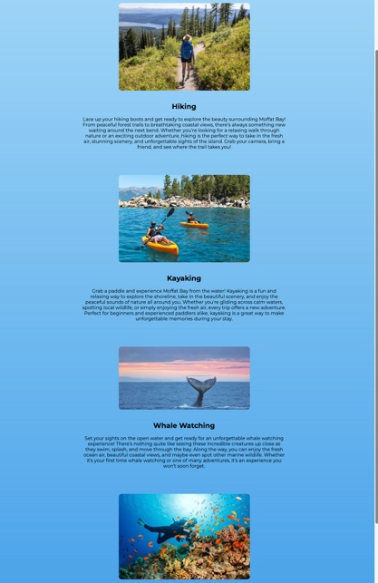
3 | Images are centered | All attraction images are centered on the page and appear consistently aligned with one another. | <yes/no> | Yes
4 | Text is Centered | All headings, descriptions, and attraction text are centered correctly and are easy to read. | <yes/no> | 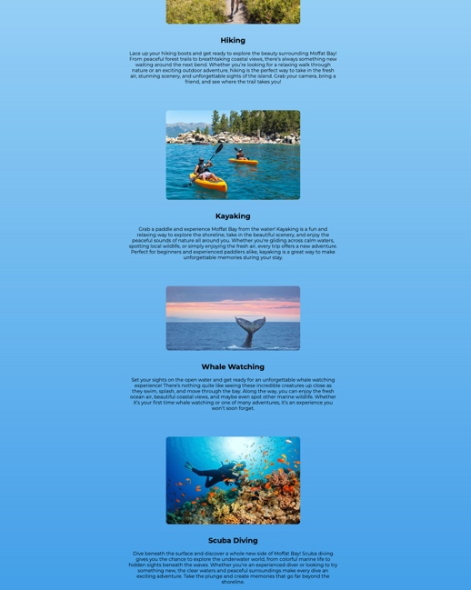  Yes
5 | Images are sized properly | All images are displayed at an appropriate and consistent size without appearing stretched, distorted, or unusually large or small. | <yes/no> | 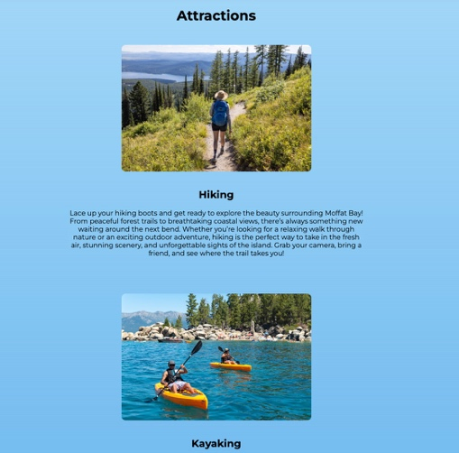  Yes
Comments | The CSS styling displays properly and gives the Attractions page a consistent appearance. The centered images and text make the page organized and easy to follow, while the background gradient adds visual interest. The image sizing should also be checked on both smaller and larger screens to make sure the layout remains consistent and responsive.  The CSS styling brings depth to the background thanks to the color gradient, and displays perfectly in desktop and mobile format.

