CSD 340: Web Development with HTML and CSS
Module 1.3 Assignment: Building a Web Page Exercise, Part 1
Isaac Ellingson
1/15/2026

Validation of Starter Code:
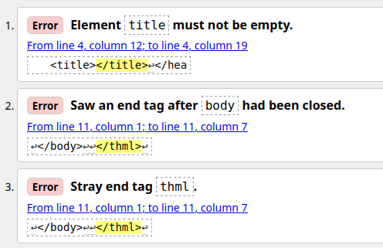
While there are three problems listed, only two exist: the empty title and the mis-typed html closer.

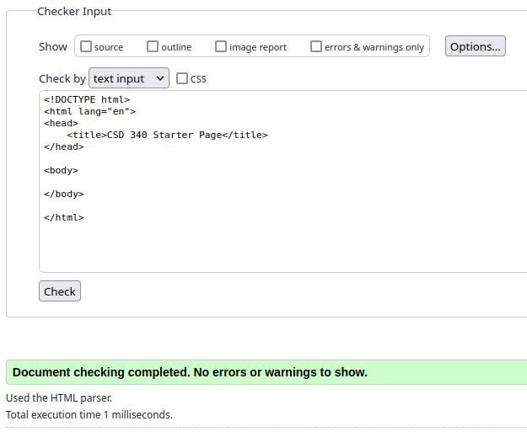

All errors cleared after fixing those two problems.
After requested changes:
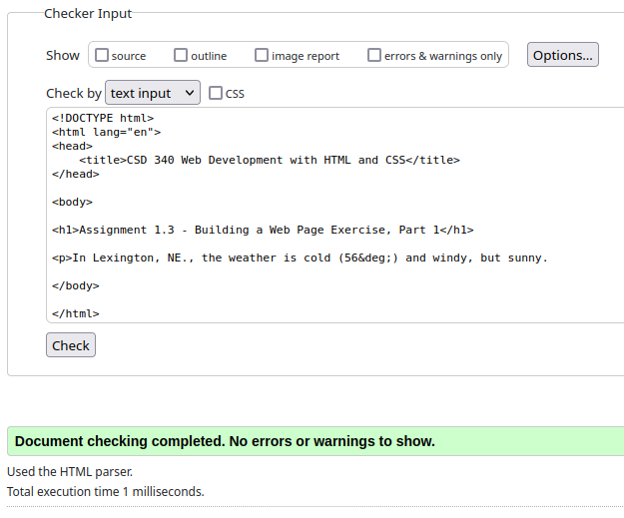
Browser render:
