CSD 340: Web Development with HTML and CSS
Module 1.2 Assignment: GitHub Repository Setup
Isaac Ellingson
1/15/2026

GitHub Repository: https://github.com/falkreon/csd-340

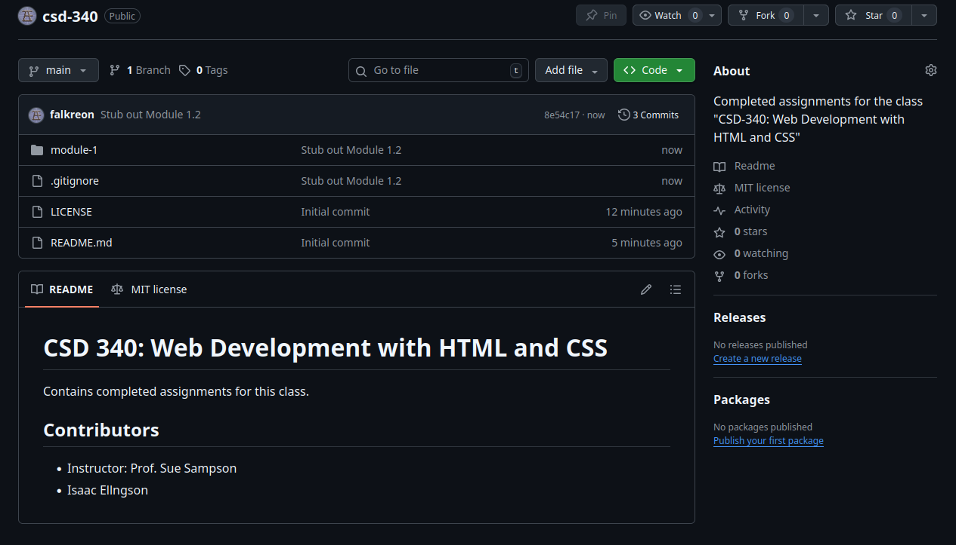

Local / Cloned Repository:
