CSD 340: Web Development with HTML and CSS
Module 5.2 Assignment: BioSite Ideas, Sketches, and Inspiration
Isaac Ellingson
2/8/2026

I chose to create the biography for my father, Roger Ellingson.

Style Guide and Mockups

Landing page will always start with a graphic format uniquely representative of the subject. Layout will be different from other pages and no navbar is shown – the layout is the initial navbar, and creates the mental map for the site.

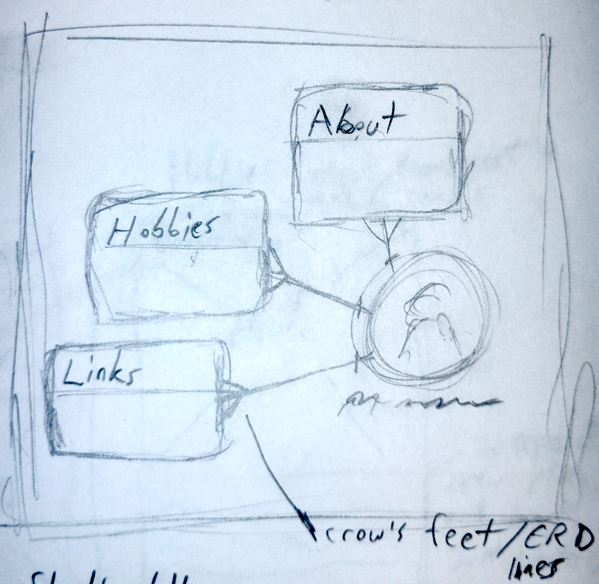

The Navbar will have solid, flat colors and clearly dilineated edges, but no borders between individual nav elements. A white box sits at the bottom of the navbar displaying breadcrumbs. The navbar shall be composed with flow so that it automatically stacks up when space is limited. Mechanically, the navbar will always be an html nav element.

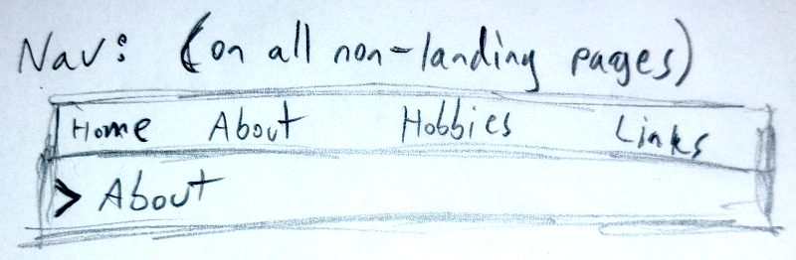


Overall, elements throughout the site will be flat, with crisp edges and clearly-delineated borders. Plenty of whitespace should be used, and tweaked as the site comes together to maintain a tone of calm, organization, and intelligence fitting the subject. This will be reinforced with a primary powder blue (B1D1FC) and light theme, often resembling print media. However, a modern, neutral sans-serif font will be chosen instead of the traditional Times. When call-to-actions are needed, they’ll be provided in a pastel orange (FFAE6F), and a secondary color of dark teal (52A797; may be altered or desaturated as needed) is provided for alternatives or accents. This makes up a “split complementary” palette.

( image generated by https://color.adobe.com/create/color-wheel – I’m very glad you linked this tool for everyone, I’ve used this a lot over the years! )

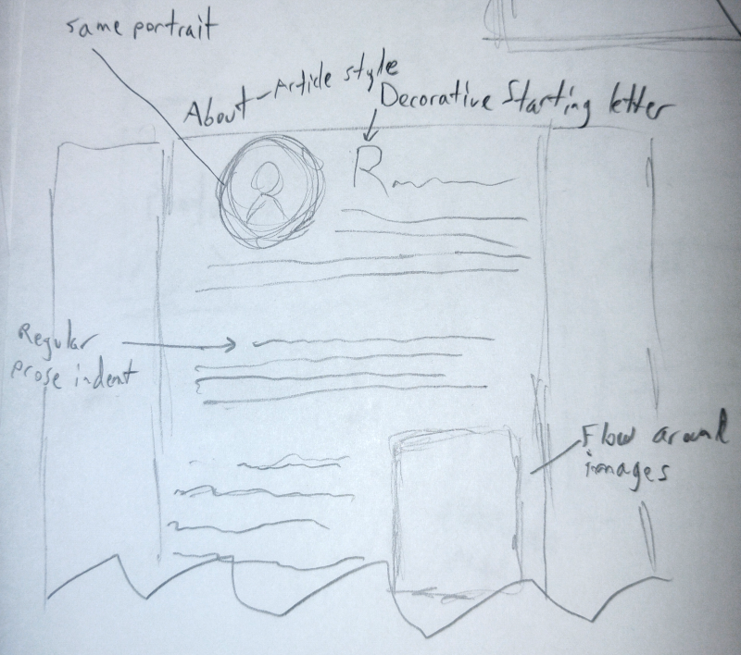
The layout for the About page will be patterned after a magazine article, and use an article html element as the primary container for the page. A portrait will begin the article, and photos will be alternated between sides. Float will be used to flow text around the (rectangular) images. The first letter of the article should be a large, decorative letter, and the first line of all paragraphs will be indented in classic print style.

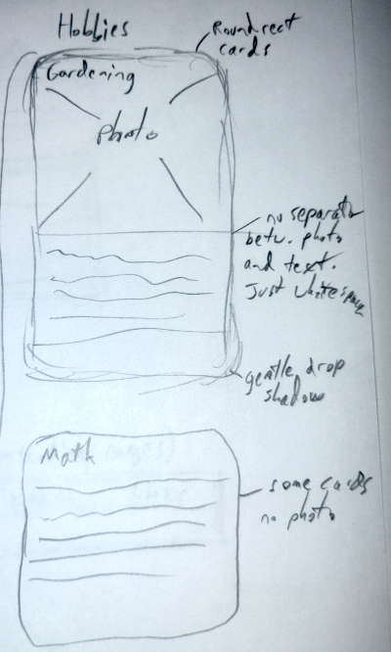
The Hobbies page will be composed of rectangular cards. Title, image (when present), and description shall be stacked vertically for ease of association and contained within a solid border with rounded corners. A gentle drop shadow will create depth against the background, and enough space must be given to prevent erroneous horizontal association between cards.

At the top of the page, hobby cards shall be aligned along their top edge, but as the page goes down, they may stagger as their descriptions vary in lengths. To facilitate this, a “column” flex layout may be used instead of a row one.
Mechanically, cards will be section elements with class “card”. The card image will always be wrapped in a figure element, but a figcaption is optional.

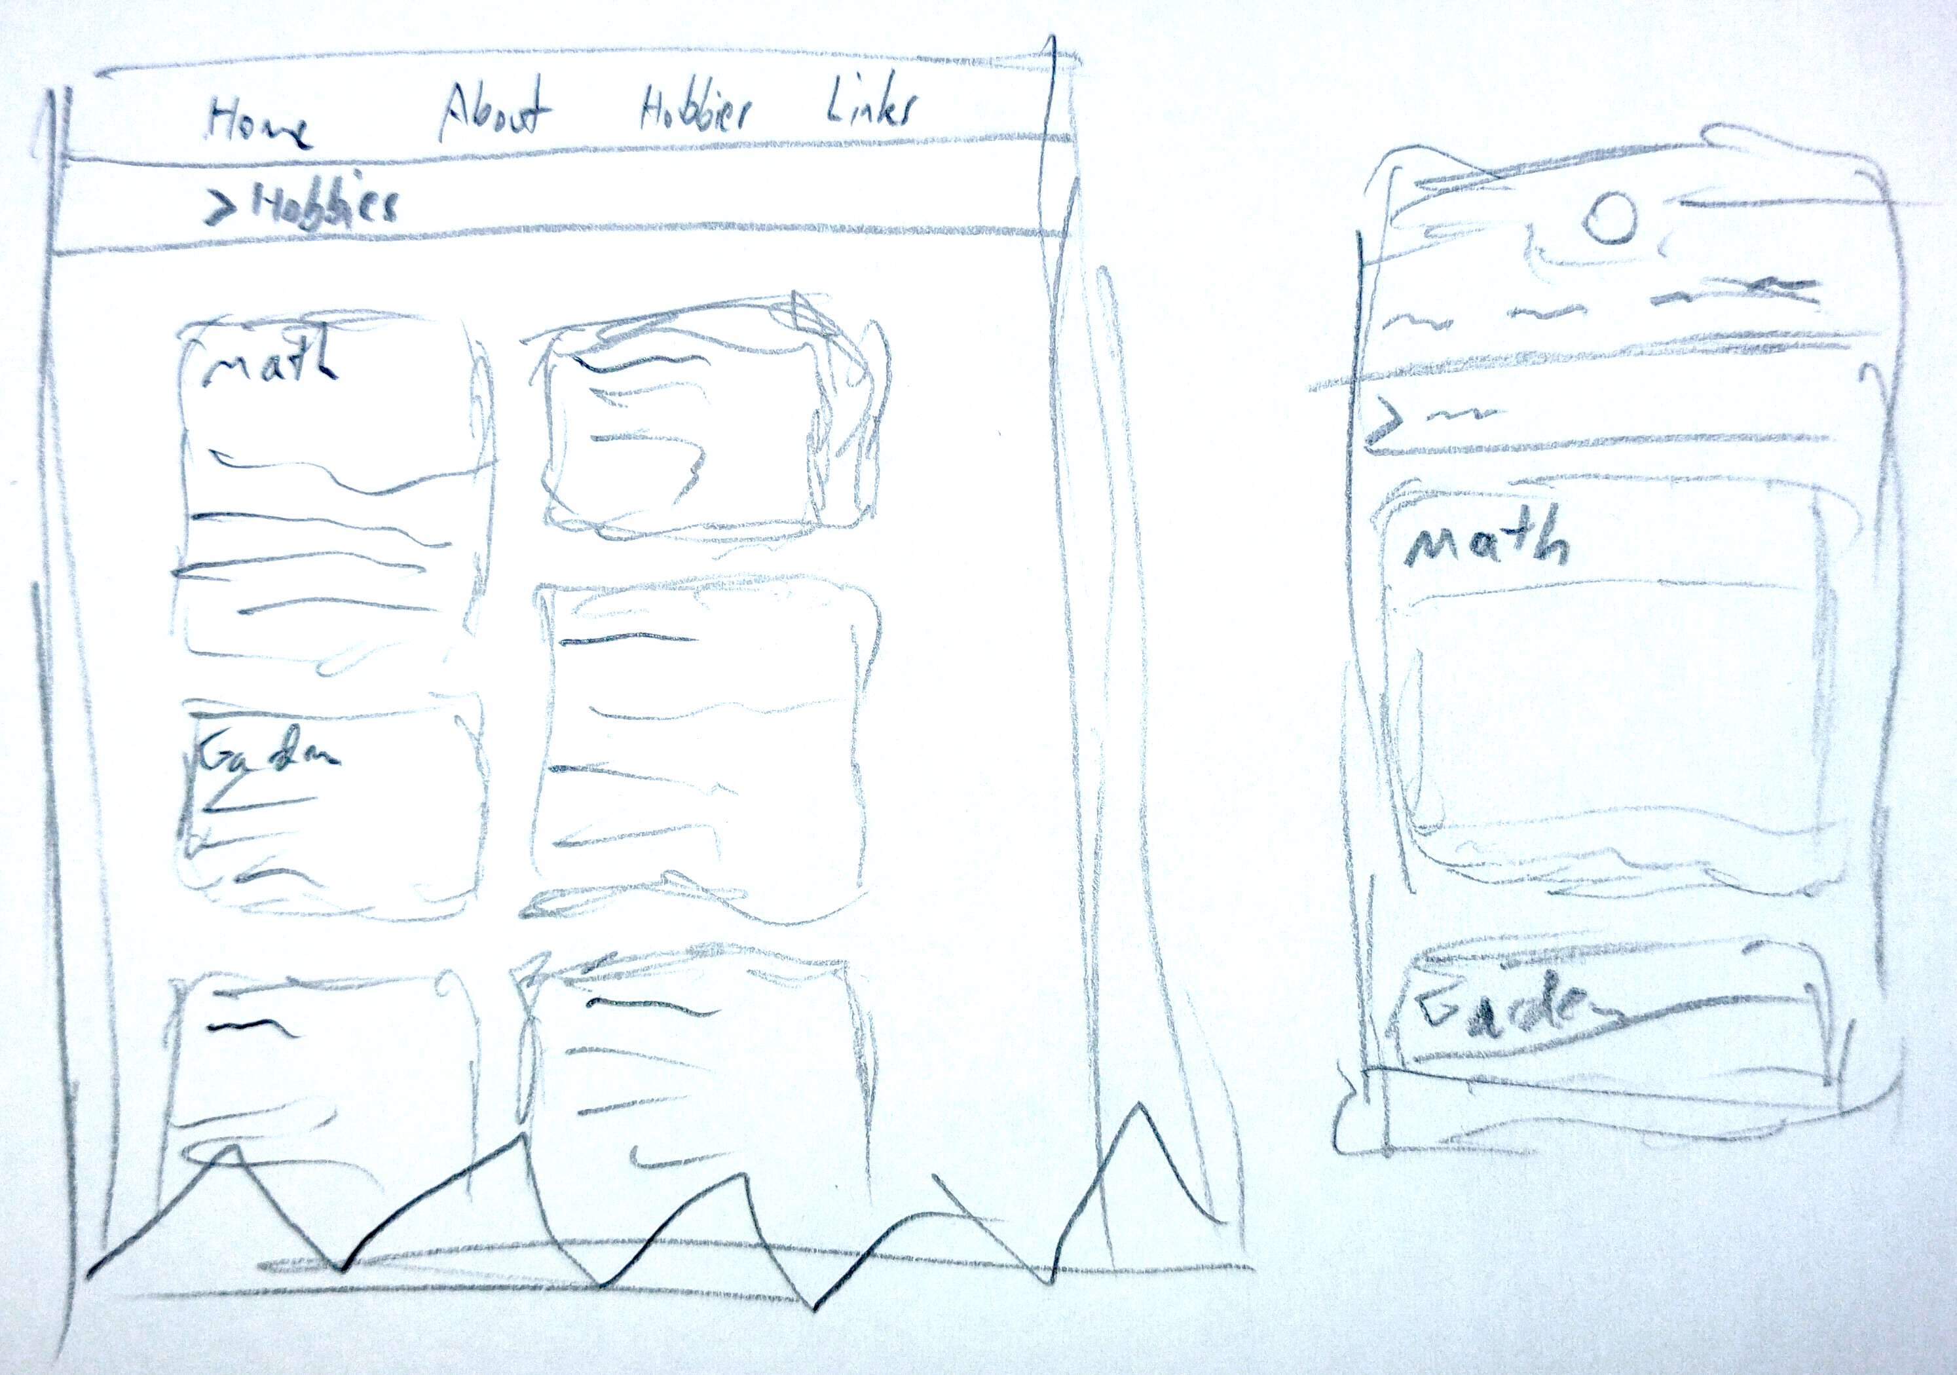
More hobbies mockups in desktop and mobile

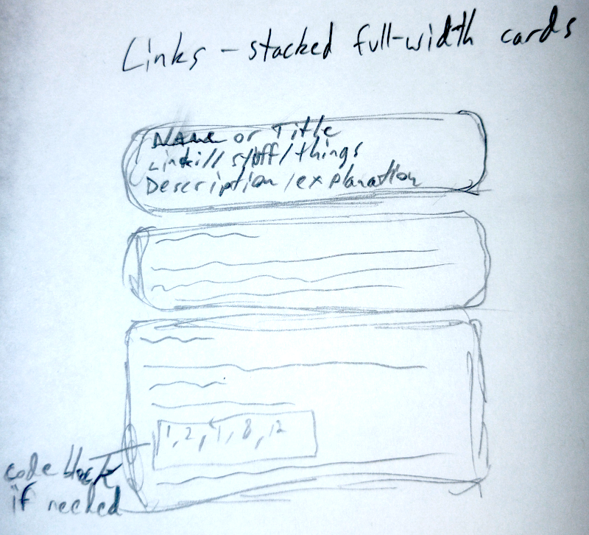
The Links page will be made of cards with the same overall visual appearance as Hobbies, but they will be full-width cards, stacked vertically. The first line will be a textual description of the link. The second will be the clickable URL, shown in blue but without an underline. This may be followed by a description of the link. Descriptions may get quite verbose and have code blocks and examples in them where necessary. They’re also entirely optional and links may be provided with no comment.

Several photos have been gathered, a representative subset is here:
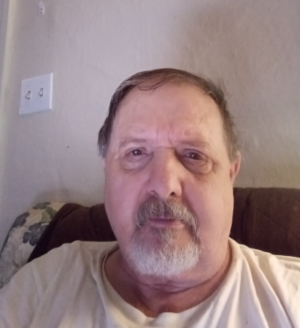

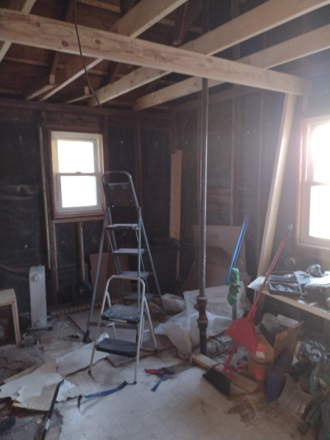
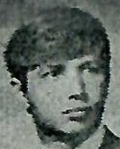
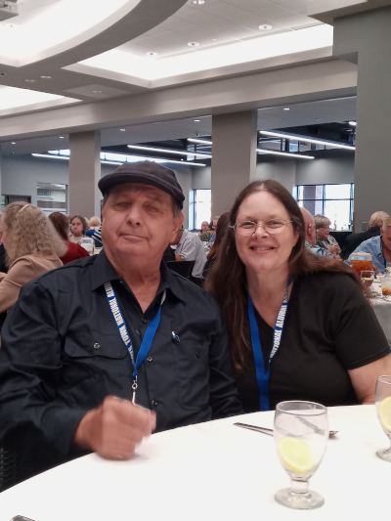
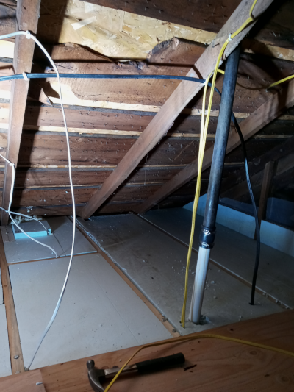
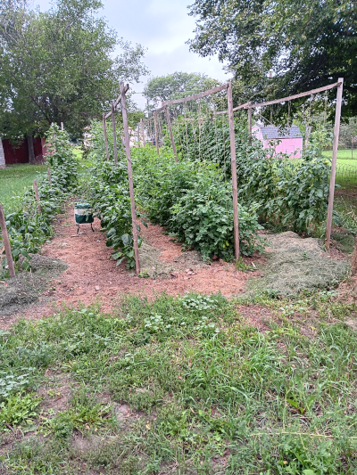
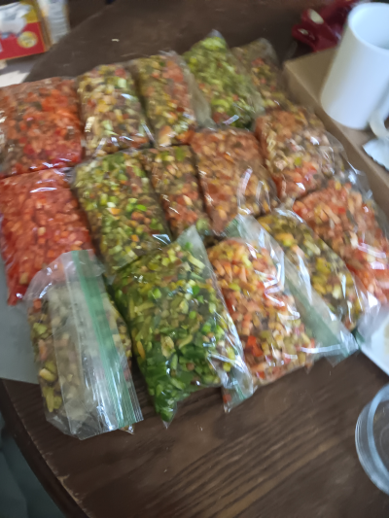
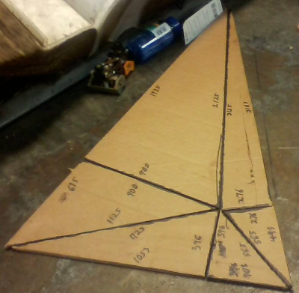
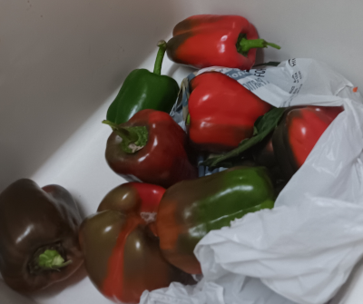
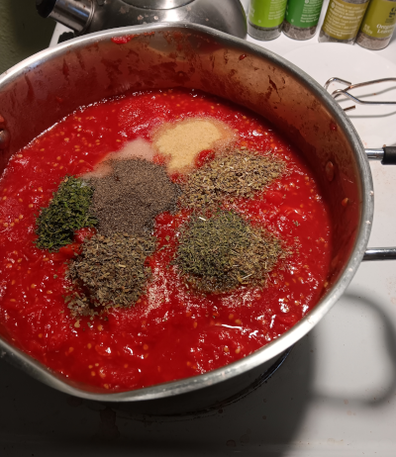
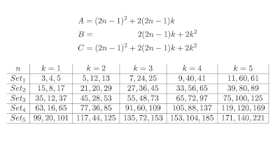
I did not feel a strong delineation between hobbies and achievements represented; we just kind of take photos of things we’re proud of in our hobbies. Between my dad’s camera roll and mine, though, I’m sure we can make it work. More photos are in the repository, and I’ll add more as-needed as we go. I withheld some school certificate images, deeming them to be achievements worth bragging about, but potentially a little too sensitive to share on a public website.

Interview

Q: I’m going to start with two related questions. The first is just to get a sense of your timeline: What jobs have you had, and what major life events in between?
A: My first job was driving a taxi. Did that till someone tried to rob me, I had to fight them off! My mom made me quit.

I was a TV repairman, also in college. Finished my first year of college, then got a job on a truck route. I quit that job because of a disagreement.

My next job was the Navy, because of the draft lottery. In the Navy I was an electronics technician.

After the Navy, I worked my way through the rest of college doing coinstruction.

After I graduated, Northwestern Bell hired me as a computer programmer.

When Bell was broken up, thousands of us were looking for work at the same time. Next job was Dynamics Research in Massachusetts, where I got a job as a database administrator and tech support.

Laid off after 17 years, my next job was as a financial analyst at Zeborg. I trained six people they hired at half my salary, and after six months they laid me off, they didn’t need me.

Next job was in Nebraska, as a welder at Daniel’s Manufacturing. Then I went and landscaped for a while, but I moved back to Ainsworth, and this time I was a farmhand for six years.

Then my next big job was landscaping back in Lexington. And there was a disagreement, so I became a forklift mechanic at Tyson. I did that for five and a half years and retired.

Q: My other question is about hobbies. You’ve been involved in a lot of interesting subjects outside of work. What are your interests?

A: I have a degree in math and physics so I like to do math as well. I like gardening. I like landscaping and working around the house remodeling. I also read, but my preferences are esoteric.

Q: Such as?

A: Sci-fi, biographies, history, fantasy, and technical nonfiction.
Q: Cooking?

A: Oh! Cooking. The favorites among my kids are chili, lasagne, meatloaf, what else do you like? Omelettes?
Q: I’m easy. Burgers.

A: Yes. Especially meatloaf burgers. Oh, and shepherd’s pie.

Q: Briefly, tell me about the math paper.

A: I did not know of any formula for generating Pythagorean triplets. So I studied the first couple hundred of them, the smallest ones. I found patterns, and developed a formula to generate them. A Pythagorean Triplet is one where it’s a right triangle with integers for all sides. The most popular formula is Euclid’s, which generates every one of them, primitive and otherwise. By primitive I mean like 3-4-5 instead of 6-8-10. I wrote a ten to twelve page paper, submitted it to the Journal of the American Mathematical Society. It was rejected. I may rewrite and submit it again.

Q: What separates your formula from Euclid’s?
A: Euclid’s formula generates trivials, like 1-0-1. Mine generates no trivials. The only non-primitives mine generates are where the GCD of ABC is an odd square. Euclid generates this for even squares, doubles, and doubles of squares. My formula generates probably only 20% of the triangles that Euclid’s does, but it generates all primitives and far fewer imprimitives.
Q: What was your education like? Was it easy?
(We both chuckle)

A: Um, I walked ten blocks to an elementary school, K-4. I walked one and three quarters miles to a country school, grades 5-8. High school, home life was not good, I dropped to the lower third of the class and ran away from home at age 16.

I was arrested for truancy, vagrancy, incorrigeable. They were going to put me in the reform school in Kearney. My grandfather helped me get into Boys Town instead. There I studied TV repair, vocational school in addition to regular high school. I graduated 8th in the class, out of 110. Received a scholastic achievement award for coming from the lower third of the class to the top 10. For that I had a Warrior’s scholarship to Cornell University, but it required a financial statement from my father because he was still my legal guardian. He refused, saying it was none of their business. So I went through one year of college on my savings, and then joined the Navy because the draft lottery was on my tail.

I also went to a program for a float college education in the Navy. Free college courses and books. Nothing for a major, but I enjoyed it. In the Navy, I made first of class in electronics school, so I got a two and a half year shore billet.

After the Navy, I went to Dana College for my remaining 3 years of college. At Dana, I got a degree in Math and Physics, and received the senior math award in 1979.

From there, the only college I did was onesy-twosey courses in Massachusetts. I was trying to upgrade my skills so I could get a job after I was laid off from the job I had for 17 years. But there wasn’t time. I had to sell my house and move to Nebraska where I had family that could help me get back on my feet.

Q: I see a LOT of books here. Do you have a favorite?

A: If I had to, I would say the 15-book Foundation series by Isaac Asimov.

Q: You’ve done a lot of kinds of work. Do some of these jobs resonate with you more than others? Would you say that you’re a Database Administrator MORE than you’re a trucker, for example, or is there some other pattern that you feel defines you.

A: I felt the best job that I loved the most was Database Administrator. I see patterns that other people don’t. That let me design for update and access other people don’t see. I also wrote and presented four papers at computer conferences. The first was SETMAP: a high-performance approach to database restructures. The second was Database Capacity Planning. The third was MINIMA: SLOC and Data Reduction. And the fourth one was SQL as a Second Language. I co-presented the last one with the guyt that came and introduced SQL to my company, which had never done it before.

Q: Dynamics Research had never done SQL before???

A: Yes. Also, the conversion, they had trouble converting some data from tape, some data from online, to the same target format. I said, well, take both of them, unload the data to a pre-conversion format. After that you’ve sent pretty much the same thing from both sides, but different data. Now a single conversion program can process both. They ran about six weeks ahead of schedule because of it.

Q: That begs the question, what did they do before SQL? Were you there for any of that?
A: I was there. I was hired from Nebraska to be on their F-16 centralized data system. Where we used a CODASYL DBMS, kept track of all maintenance, parts, orders, schedule, and scheduled maintenance of all F-16’s throughout the world. There was a combination of batch programming and TP (Transaction Processing) systems. TP meaning online. Secondly, I was there, they had a problem how to get batch data online without taking the system down. And I showed them, instead of having to run multiple processes that would run continually day and night, we got it up there in 10-15 min. I reduced some database restructures from 18 hours to 3 hours. That was the subject of my first paper, and when I got back, they gave me an office with a door!

Q: So, getting into the weeds, I know a lot of your work was with COBOL and JCL. How does that compare to other languages you’ve worked with?

A: My first language was BASIC and I loved it. It was very simple and still is today. My second language was Report Program Generator, which was generally used to generate things like telephone bills. My third language was COBOL of course, from Northwestern Bell. Toward the end of my job, at DRC, I studied Ada. It was of no value to me. After I got laid off from DRC, I studied C/C++, perl, and scripting languages. It was useful, but without more than academic experience, they did not help me find a job. My favorite languages are still BASIC and COBOL.

Q: What is it that makes them nice to use?

A: They read like English. C and BASIC aren’t that much different except that I never understood the need for endif when a period would do. I never understood ==. I never saw the need for it. COBOL and BASIC pretty much read like english language.

Q: Now that you’re retired, and your health is looking pretty good, what’s next? Is there anything you’re hoping to spend more time on or accomplish? Any astronomical events you’d like to witness?
[ed. Note: Roger is an avid fan of solar eclipses. The end of this question also elicits a chuckle.]

A: I want to continue getting my houses in order. My yard, my remodeling next door, re-fencing the rental property. I want to see my kids graduate from college. And I want to start piano again.

Q: That’s right, you did some pretty big recitals.

A: One. Hayden’s Concerto in C Major, Third Movement. I can’t play worth a damn any more, so I want to get back into it. I loved it. I haven’t played the piano in over 45 years.

Q: Thanks, I think we have quite a bit here.

Bio

Roger Ellingson has led a complex life, with an unusual number of jobs and roles. He’s full of contrasts, presenting himself humbly, but animated or argumentative when the need arises. He hasn’t lived an easy life, but it’s one he’s clearly proud of.

As a child, his home life and relationship with his parents was difficult. His grades tanked to the lower third of his class, and he was miserable. At age 16 he ran away from home. Caught and charged with truancy, he was almost sent to a reform school in Kearney, but his grandfather got him admitted to BoysTown.

BoysTown wasn’t easy either. The social environment was mean, the other kids were from similar rough circumstances. But he took vocational school alongside regular high school, and picked up valuable skills like television repair. He rose to 8th in his class of 110 kids, and earned himself a scholastic achievement award and a scholarship to Cornell University. Unfortunately, this scholarship still required a finanical statement from his father, who angrily rejected the idea, saying it was none of their business.\
So Roger went to college on his own savings and work, but this only lasted a year. With the draft lottery looming near, he went from there into the Navy. He was a technician, and a good one. He went through “Afloat College Education” courses through the Navy, and was top of his class for electronics.

From the Navy, he went to Dana College for his remaining 3 years, working construction to pay his way through. While pursuing his degree in Math and Physics, he studied piano and did a piano recital, did set construction for the theatre, and built and donated a full, working harpsichord to the school.

From college he was hired into Northwestern Bell as a programmer. After Bell was broken up, he found work at Dynamics Research corporation way out in Massachusetts.

DRC, now part of Engility Holdings, was a government contractor, providing program, engineering, and lifecycle support, as well as IT modernization and various other services. Roger worked on their F-16 global database, harmonizing different kinds of data and improving processes that affected all F-16 schedules, parts, and repairs worldwide. At DRC, he presented four papers, creating a big shift each time in how databases are restructured, planned, and accessed. His fourth and final presentation for the company, SQL as a Second Language, marked his company’s transition into SQL and what we’d think of as modern practice.

After 17 years at DRC, he was laid off, and eventually moved back to Nebraska to get back on his feet with the help of his family. He worked everything from landscaping, to welding, to cattle herding, before finally settling into forklift maintenance at Tyson. His organization and consistency kept them running smoothly for five and a half years, at which point he retired.

Roger still keeps busy! He gardens, pursues math and music, and he’s remodeling a house. He loves cooking for his kids, is always a friend to his neighbors, and is always at the ready with a joke. With all the wild, weird, and wonderful things that have happened, it’s impossible to say what’s next, but one thing’s certain: this story’s not over yet.

