Zachary Falkner

CSCI480 Wheeler

2016/05/03

Project 2 Ping Pong Regression

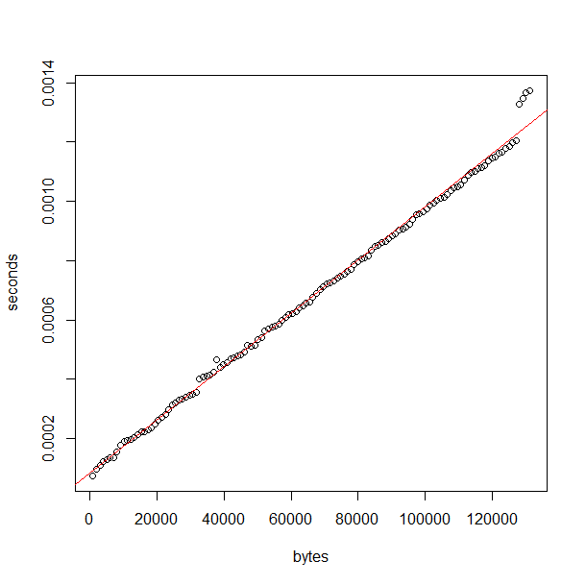

Latency: 8.271149e-05 seconds, 82.71149 microseconds

Bandwidth: 111328196 Bytes/second, 111.328196MB/s