The team of Iranian farmers, thank you for the opportunity you gave us to our new plan in the field of smart agriculture.

It is greatly appreciated. Our experts, who are in the field of data, IOT, software, law and business, presented an idea to improve the situation of farmers who are in charge of planting vegetables and edible vegetables.

**Problems and their solutions**

Iran is a country of four seasons, but most of its areas have hot and dry weather, but the villages and cities around these areas have suitable soil and weather for growing summer crops, but farmers face problems such as the imbalance of suitable weather and hail. And monsoon rains and hot and cold weather are facing, that's why the farmers tried to prevent damage to the seedlings by using plastic covers on these products, but this type of care has some problems

The summer crops start to be planted in the month of faburey and they bear fruit until the month of June. At this time, they need special care because the water that is given to these crops through drip irrigation evaporates and on the roof of the covers. It becomes plastic and air circulation is not created, and this humidity rises and causes the plant to rot, so farmers start to make holes in the covers to allow air to flow, which causes animals to enter the land where the product is located and damage it. This type of plastic cover is non-renewable and non-recyclable and must be purchased annually, which brings a lot of money

**Solution:**

According to the previouce explanations, the problems of the system are the increase in temperature and humidity and the disposable and non-recyclable structure of the system

Our solution for this problem consists of two parts:

Mechanics and structure

IOT and data

**Mechanics and structure** :

ترجمه بیش از حد طولانی است و ذخیره نمی‌

According to the conducted research, the construction of a dome-shaped chamber made of special kind known as Superhydrophobic is a so-called self-cleaning material that can be used in its sheet model, which is more resistant, and this plastic can be renewable with micro-organisms. which collects this vaporized water and directs it to the furrows around the soil until it returns to the ground when the soil dries. For air circulation, you can use pipes that have a blower on one side and a suction on the other side, and the air flows through the grooves inside the pipe. Resistance and renewability is an obvious advantage of the structure.

**Data and IOT:**  
  
Infrastructure:  
Our infrastructure contains four different parts:

* Sensor Nodes
* Network
* Edge Node
* Accessibility Options: Cloud and gsm network

Sensor Nodes:

In a single sensor node, we will have different sensors to measure different metrics of an area including plants and soil. At the first step, we want to sense temperature, Oxygen, PH and Humidity which desired sensors will be packed together associated with a Bluetooth or ZigBee module and a long-life battery.

Network:  
In order to collect sensors data, we demonstrate a Bluetooth mesh network to be able to collect data almost real-time and transfer them to an edge node which we will explain in the next section.

Edge Node:

In our use case, there might be some problems with accessing internet. In the other hand, collecting all the sensors data will be a good option for analysing these data with AI technologies later and providing some suitable signals for the farmer.

In this node, we will use a embedded board associated with GSM and Wi-Fi module to have options of accessing both networks depends on the farm accessible networks.

Accessibility Options: Cloud and gsm network:  
The farmer needs to access data of his farm. Also, we need to analyse data and provide suitable signals for him.  
There will be a dashboard panel accessible offline and also online for the farmer. Also, if the internet access is a problem in the area, there should be gsm network coverage with confident. Farmer can send and receive simple operations in this network.

**Market:**

ترجمه بیش از حد طولانی است و ذخیره نمی‌شود

The primary requirement of our product is drip irrigation and a smartphone, which according to the following comprehensive information includes a great purpose.

1) 1.3 million hectares of agricultural land are available for planting summer crops(according to the report of the Agricultural Jihad Organization)

2) It had 4.4 million hectares of irrigated land, of which approximately 77% was used by traditional methods and the remaining 23% was under irrigation (according to the (FAO) report in 2019).

3) Hormozgan, 70% of its agricultural lands benefit from drip irrigation (according to the report of the Deputy Minister of Water and Soil, Ministry of Agricultural Jihad, 2023).

4) The number of active mobile phone subscribers in Iran is about 102 million people, which represents a penetration rate of 123.2% of the population (according to the report of the Iranian Statistics Center in 2020).

**Biusines plan:**

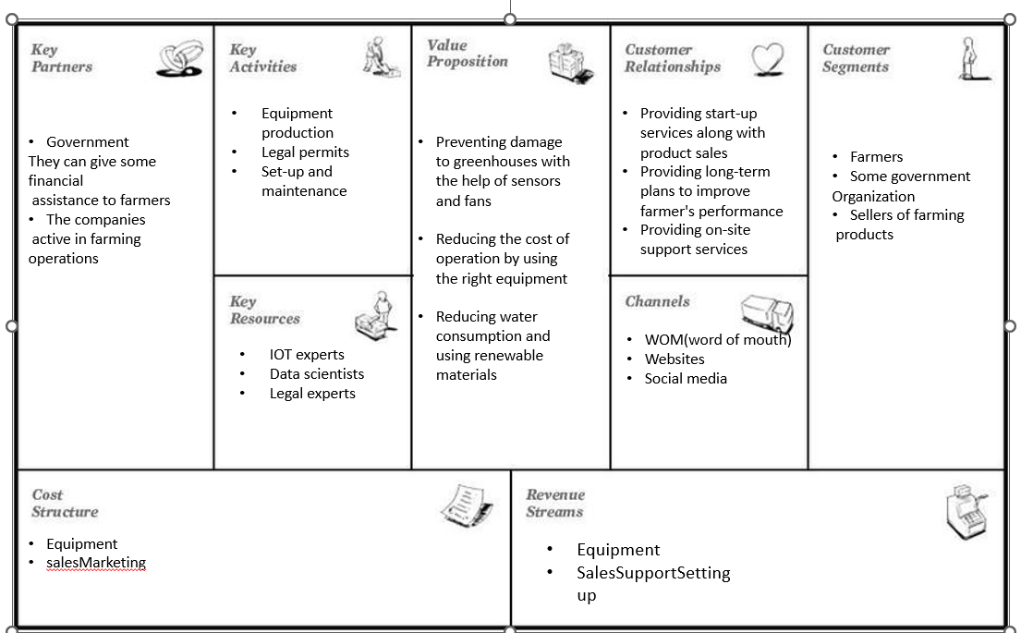

**Product Feature :**

1. Controls temperature and heat with IOT sensors

2. By using the stored data, a more appropriate solution can be found to produce more and more healthy products in the future Intelligent

3. Air circulation setup

4.Scalebel : Can work different sensor with different price and setup simply

5. Long lifetime

6. Low maintenance cost

7.simple application just need smart phone for control without any Internet connection

**Next Step**

We tried our product to cover all aspects of technology and to be simple, accessible, and low-cost for farmers

1) We can use image processing to analyze the product's health and take preventive measures when it is rotting.I

2) Improving the condition of plants and crops with the help of collected data

3) Production of sensors with long life and high resistance

4) Trying to build a highly scalable product

5) Construction of a resistant and renewable protection chamber