Report for Design and Analysis of Algorithms
bonus task

Student: Denis Li SE-2436

Goal:
Implement the Rabin-Karp algorithm, collect metrics, and test the algorithm on strings of different lengths

Algorithm:
The algorithm calculates the hash of the pattern, the hash of the original string, and if the hashes match, after a second, additional check, adds the match index to the ArrayList.

Pros:
- Finds matches quickly.
- Good for both large and small inputs.
Cons:
- Collisions possible, additional validation required.

Metrics and Export
The implementation includes the following metrics:

- Collision Counter
- False positive counter
- Hash calculation number
- Matches number
- Total time
The results are saved in CSV, allowing you to visualize the algorithm's performance on lines of different lengths.

Testing

The test was performed on three lines:

Small line:
"ababababab"
Pattern:
"abab"

Medium Line:
"thequickbrownfoxjumpsoverthelazydogthequickbrownfoxjumpsoverthelazydog"
Pattern:
"quickbrown"

Large line:
Generated line of abc with length 102;
Pattern:
"abcabc"

Metrics for each test:
Large input
: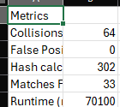
Medium input
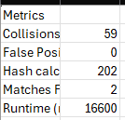
Small input
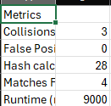

Complexity

Time complexity:

Average: O(n + m), where n is the string length and m is the pattern length.

Worst-case (for hash collisions): O(n * m).

Space complexity: O(n) for storing prefix hashes.

Conclusion:
Rabin-Korp is a good algorithm for finding substrings based on a pattern in a larger string. It performs well on both large and small values. The implemented metrics show that even on strings under 100 characters, the algorithm performs quite quickly.

