Transport Type Classification
Computer Vision Course Assignment 1
Student: Li Denis SE-2425

1 Objective and dataset
This project classifies a photograph as bicycle, bus, car, motorcycle or truck. A MobileNetV3 Small network provides the classifier, and a FastAPI web page accepts an uploaded image and returns the predicted class with confidence scores.
The source dataset contains 873 readable images. The latest additions made the training classes uneven, especially bicycle and car. I kept validation and test separate and balanced only the data used to update the model. A SHA256 check found no exact file shared between different splits. One identical pair remains inside the car test folder, so the reported test score is an internal project result rather than a clean benchmark.
Class | Original total | Train | Saved edits | Effective train | Val | Test
bicycle | 199 | 154 | 0 | 154 | 22 | 23
bus | 169 | 124 | 30 | 154 | 22 | 23
car | 188 | 139 | 15 | 154 | 22 | 27
motorcycle | 151 | 106 | 48 | 154 | 22 | 23
truck | 166 | 121 | 33 | 154 | 22 | 23

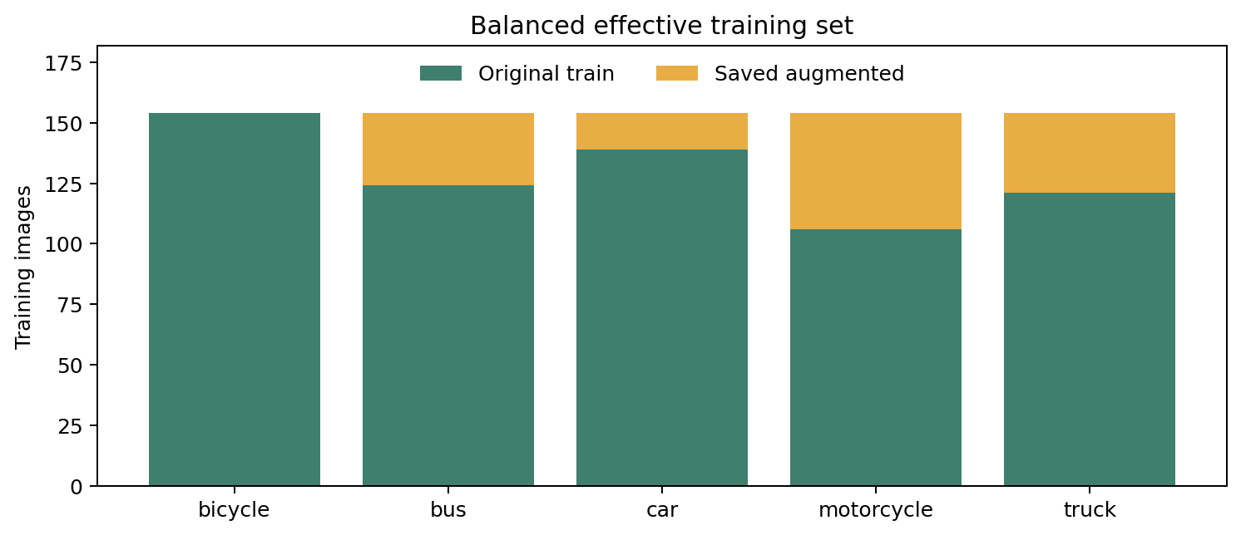

2 Image preparation and saved augmentation
The new preparation script reads only dataset train. It leaves every source image unchanged and writes edited JPEG copies to dataset_augmented train. The manifest records the seed, target count, source path and output path for every generated file. Repeating the script with the same seed recreates the same set.
Operation | Configuration
Balance target | 154 effective training images per class
Saved copies | 126 files in a separate augmented directory
Crop and resize | Random edge crop from 3% to 12%, restored to source size
Geometry | Horizontal reflection with probability 0.5 and rotation up to 10 degrees
Colour | Brightness and contrast 0.85 to 1.15, colour 0.90 to 1.10
Network input | Random 224 pixel crop for train, centre crop for validation and test
Normalization | ImageNet RGB mean and standard deviation

Saved copies are added through a second ImageFolder and combined with the original training set. Validation and test load only their original folders. During training, random crop, reflection, rotation and mild colour jitter are still applied in memory. This gives the model different views while keeping a visible, reproducible set of edited files for the assignment.

3 Model
MobileNetV3 Small starts with ImageNet weights. In the base run, the convolutional feature extractor is frozen and the final classifier is replaced for five transport classes. The classifier is trained with AdamW and cross entropy with label smoothing. A second run opens the last three feature blocks at smaller learning rates. It keeps the base checkpoint when validation accuracy does not improve.

4 Training protocol
The random seed is 42 and the run used the CPU. Each epoch sees 770 balanced training items. The validation set selects the checkpoint and the test set is evaluated after that choice. Early stopping limits unnecessary epochs.
Training setting | Value
Architecture | MobileNetV3 Small with ImageNet initialization
Seed and device | 42 and CPU
Base optimizer | AdamW with classifier learning rate 0.001
Batch size and loss | 32 and cross entropy with 0.05 label smoothing
Stopping rule | Up to 15 epochs, patience 4 on validation accuracy
Executed and selected epoch | 9 executed, epoch 5 selected
Fine tuning | Last 3 feature blocks, 4 executed epochs, no validation gain

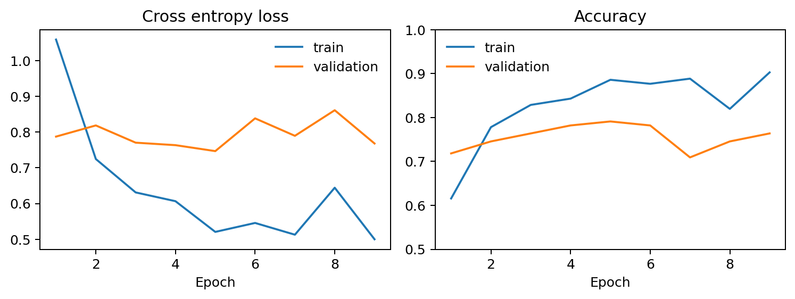
Validation accuracy reached its best value on epoch 5. Later training accuracy continued to rise while validation varied, so the saved model comes from the earlier checkpoint. Fine tuning did not beat that validation result and therefore retained the same weights.

5 Results and error analysis
The test set contains 119 images. Accuracy is the fraction of correct predictions. Precision measures how often a predicted class is correct, recall measures how many real examples are found, and F1 combines both. Macro values give each class the same weight.
Checkpoint | Accuracy | Macro precision | Macro recall | Macro F1
Base | 82.35% | 82.29% | 82.25% | 82.15%
Fine tuned output | 82.35% | 82.29% | 82.25% | 82.15%

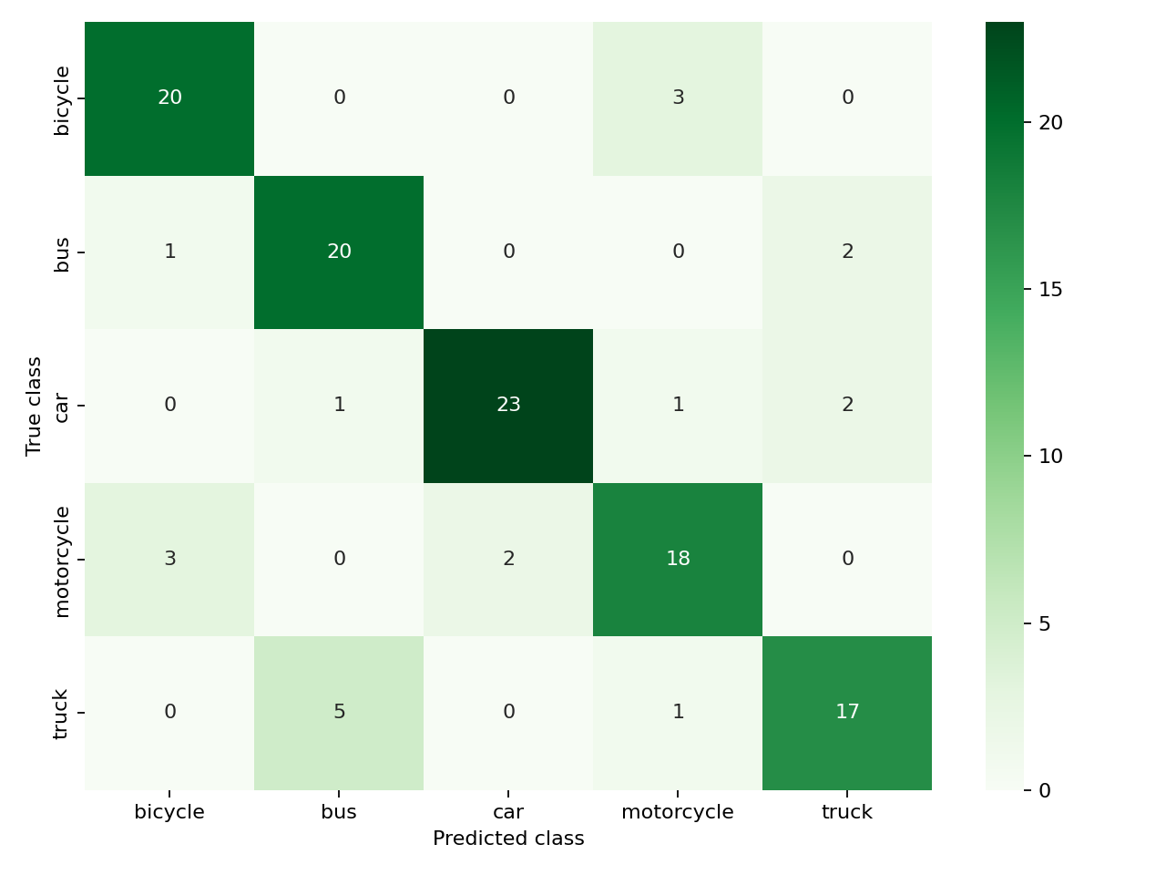
Class | Precision | Recall | F1 | Test N
bicycle | 0.833 | 0.870 | 0.851 | 23
bus | 0.769 | 0.870 | 0.816 | 23
car | 0.920 | 0.852 | 0.885 | 27
motorcycle | 0.783 | 0.783 | 0.783 | 23
truck | 0.810 | 0.739 | 0.773 | 23

The final accuracy is 82.35% and macro F1 is 82.15%. The remaining errors are spread across similar road vehicle classes. The result is useful for checking this project build, but it does not measure performance on a new camera, location or collection session.

6 Web application and limitations
The web application loads transport_classifier_finetuned.pt when it starts. The health route confirmed that all five classes loaded. A prediction request with a held out bus image returned bus with confidence 0.9972. Uploaded JPG, PNG and WebP files are converted to RGB, resized, centre cropped to 224 pixels and normalized before inference.
The classifier always chooses one of the five known classes. It has no unknown class and no object detector, so a photograph without a clear vehicle can still receive a confident label. The dataset is relatively small and includes images with different sizes and sources. The car test split also contains one exact duplicate pair. A stronger evaluation would remove that pair and use a new held out collection captured after all training choices are fixed.

Reproducibility and deliverables
Run prepare_augmented_dataset.py before training. Then run train.py and fine_tune.py from the project environment. Seed 42 controls the split independent saved augmentation. The project contains the augmented manifest, both checkpoints, JSON metrics, training plots and confusion matrices. The tested environment used Python 3.11, PyTorch 2.8.0 with CPU support and torchvision 0.23.0.

