Transport Classification with DINOv2
Computer Vision Assignment 2
Astana IT University
Instructor Nurym Kaiyrkhan
November 2026

Abstract
This project upgrades a five-class vehicle classifier from a supervised MobileNetV3 baseline to a DINOv2 visual foundation model. A frozen DINOv2 ViT-S/14 backbone produces 384-dimensional embeddings, and a linear classification head is trained on the existing Open Images based dataset. The selected configuration reaches 91.60% test accuracy and 91.58% macro-F1, improving the Assignment 1 baseline by 9.24 and 9.43 percentage points respectively. The web application reports top-class probabilities, CPU latency, a patch-relevance heatmap, and nearest training examples.
Model | Test accuracy | Macro F1 | Mean latency
MobileNetV3 baseline | 82.35% | 82.15% | Not remeasured
DINOv2 selected model | 91.60% | 91.58% | 63.15 ms CPU

The main conclusion is that a frozen self-supervised representation substantially outperforms the earlier task-specific transfer-learning baseline on the same held-out test set.

1 Introduction
Assignment 1 established an end-to-end vehicle recognition pipeline for bicycle, bus, car, motorcycle, and truck images. MobileNetV3 Small was pretrained on ImageNet, its feature extractor was initially frozen, and the classifier was trained on the project dataset. The resulting 82.35% test accuracy was useful, but the errors between visually related road vehicles indicated that a stronger general visual representation could help.
Assignment 2 replaces the feature extractor with DINOv2, a self-supervised Vision Transformer trained to produce general-purpose image and patch features [1]. The goal is not only to increase accuracy, but also to make the system easier to inspect through spatial relevance and example-based explanations.

2 Dataset Update
Split | Original images | Saved augmentations | Role
Train | 644 | 126 | Fit linear head
Validation | 110 | 0 | Checkpoint selection
Test | 119 | 0 | Final evaluation only

The original dataset contains 873 cropped vehicle images derived from Open Images V7 [3]. The split is unchanged from Assignment 1: 644 training, 110 validation, and 119 test images. This preserves a direct baseline comparison. The training set also has 126 saved transformations created by horizontal flips, small rotations, crops, and color changes. Validation and test images are never augmented.

2 1 Data Quality and Disclosure
- No generated or synthetic images are used, so the synthetic share is 0%.
- Saved transformations remain linked to their source through dataset_augmented manifest.json.
- The same random seed 42 and unchanged test split are used in all reported experiments.
- Class-wise metrics are reported because overall accuracy can hide weak minority classes.

3 DINOv2 Method
DINOv2 learns visual representations without class labels by combining self-distillation, masked-image modeling, and regularization at large scale [1]. The official ViT-S/14 checkpoint has approximately 21 million parameters, uses 14 × 14 pixel patches, and emits a 384-dimensional class token [2]. The pretrained backbone is frozen in this project. Only a linear layer with five outputs is optimized, which reduces overfitting risk and makes training practical on a small dataset.
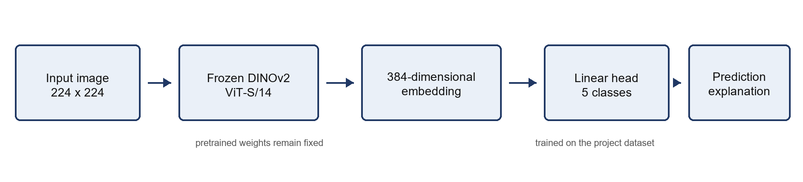
Figure 1 DINOv2 classification and explanation pipeline

3 1 Feature Extraction and Classification
Each image is resized, center-cropped to 224 × 224 pixels, normalized with ImageNet statistics, and passed through the frozen backbone. The normalized class-token embedding is given to a linear classifier. Cross-entropy with label smoothing 0.05 is minimized by AdamW. ReduceLROnPlateau halves the learning rate after validation accuracy stops improving, and early stopping prevents unnecessary optimization.

3 2 Explainability
For spatial explanation, each normalized patch token is projected onto the learned weight vector of the predicted class. The resulting 16 × 16 relevance grid is interpolated to the display resolution and overlaid on the input. For example-based explanation, cosine similarity between the query class-token embedding and all original training embeddings returns the three nearest images. These two views answer complementary questions: where the classifier found evidence and which training examples have similar representations.

4 Experimental Design
Two DINOv2 linear-probe experiments isolate the effect of the saved Assignment 1 augmentations. Both use the same pretrained backbone, validation split, test split, optimizer settings, and random seed. Model selection uses validation accuracy only.
Setting | No augmentation | With augmentation
Training examples | 644 | 770
Saved transformed copies | 0 | 126
Initial learning rate | 0.003 | 0.003
Maximum epochs | 150 | 150
Early stopping patience | 20 | 20
Best validation accuracy | 92.73% | 94.55%

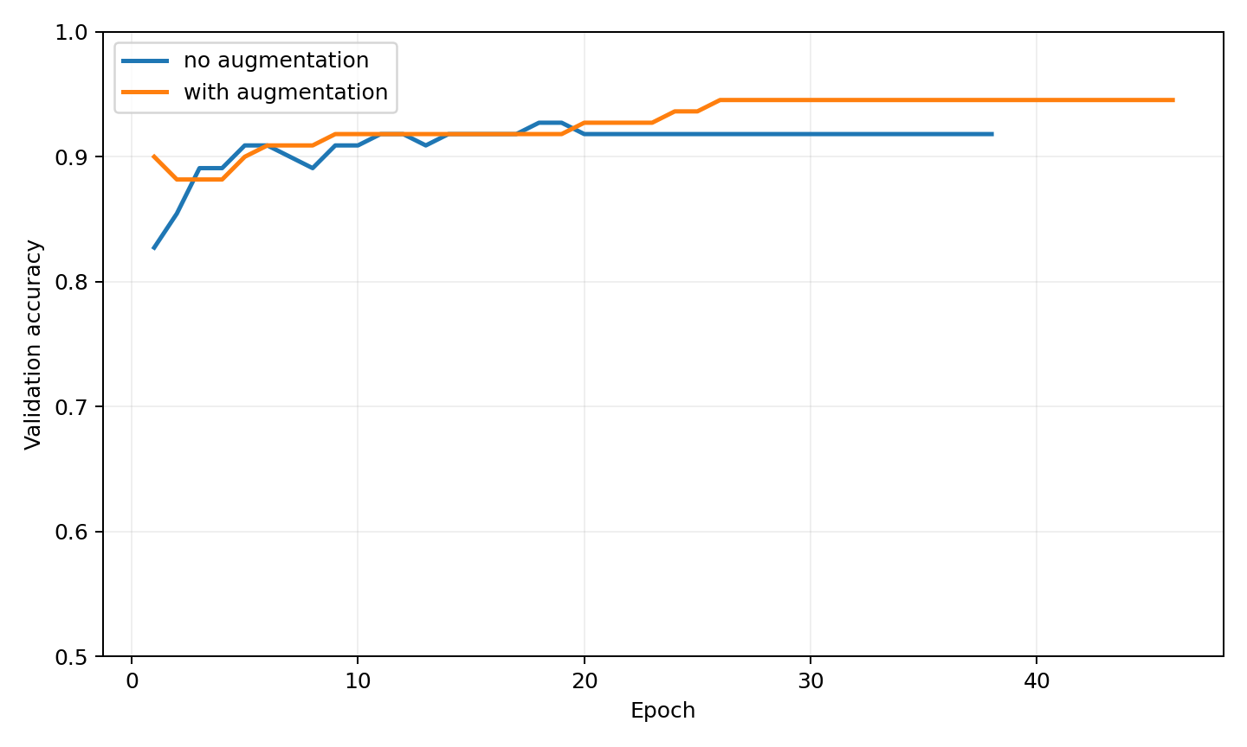
Figure 2 Validation accuracy during the ablation experiments
The augmented run reaches the highest validation accuracy, 94.55%, and is therefore the preselected deployment checkpoint. The non-augmented run reaches 92.73%. Test metrics are computed only after this selection rule is fixed.

4 1 Evaluation Measures
Accuracy measures the proportion of correct predictions. Macro-F1 averages the F1 score of all five classes with equal weight. Precision, recall, and F1 are also reported per class. Latency is measured for 30 single-image forward passes after one warm-up pass on the available CPU environment.

5 Results
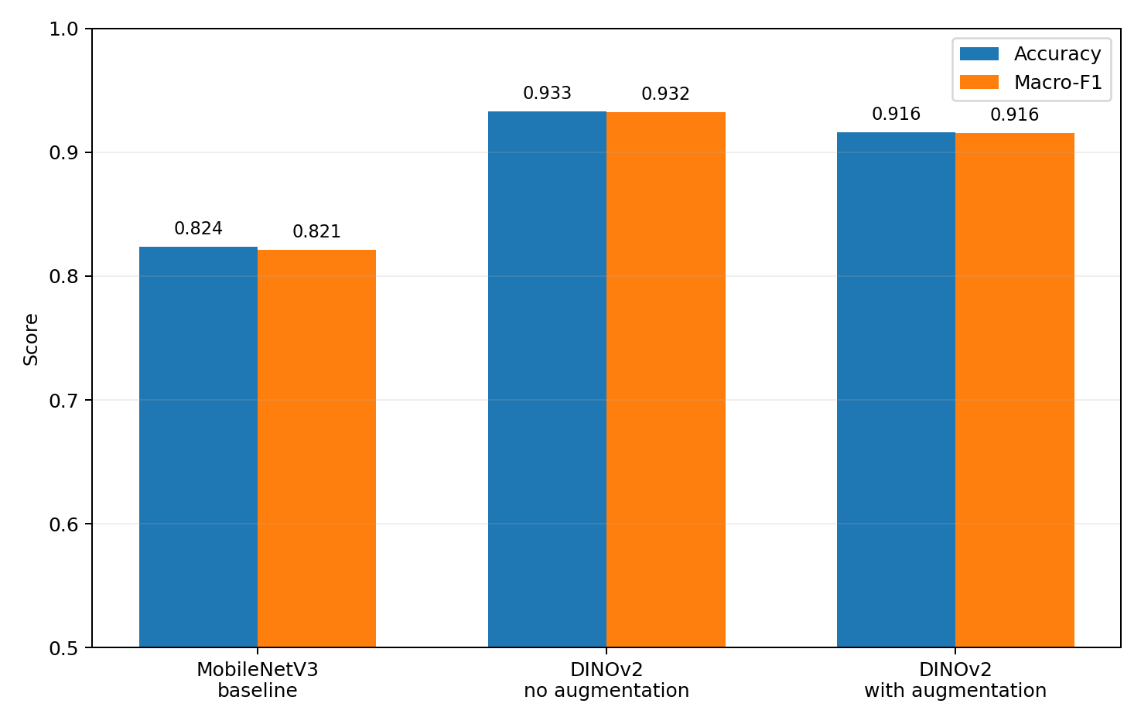
Figure 3 MobileNetV3 baseline and DINOv2 test results
Experiment | Validation accuracy | Test accuracy | Macro F1
MobileNetV3 baseline | 79.09% | 82.35% | 82.15%
DINOv2 no augmentation | 92.73% | 93.28% | 93.24%
DINOv2 with augmentation | 94.55% | 91.60% | 91.58%

The selected DINOv2 model improves test accuracy from 82.35% to 91.60% and macro-F1 from 82.15% to 91.58%. This corresponds to gains of 9.24 and 9.43 percentage points. The non-augmented ablation produces the highest test accuracy, 93.28%, even though its validation accuracy is lower. This disagreement suggests that some saved transformations shift the training distribution toward the validation set without improving the held-out test distribution. It does not justify selecting the non-augmented model after observing test labels; instead, it motivates revisiting augmentation strength in future work.
Class | Precision | Recall | F1 | Support
bicycle | 100.00% | 100.00% | 100.00% | 23
bus | 88.00% | 95.65% | 91.67% | 23
car | 88.89% | 88.89% | 88.89% | 27
motorcycle | 91.67% | 95.65% | 93.62% | 23
truck | 90.00% | 78.26% | 83.72% | 23

6 Explainability and Application
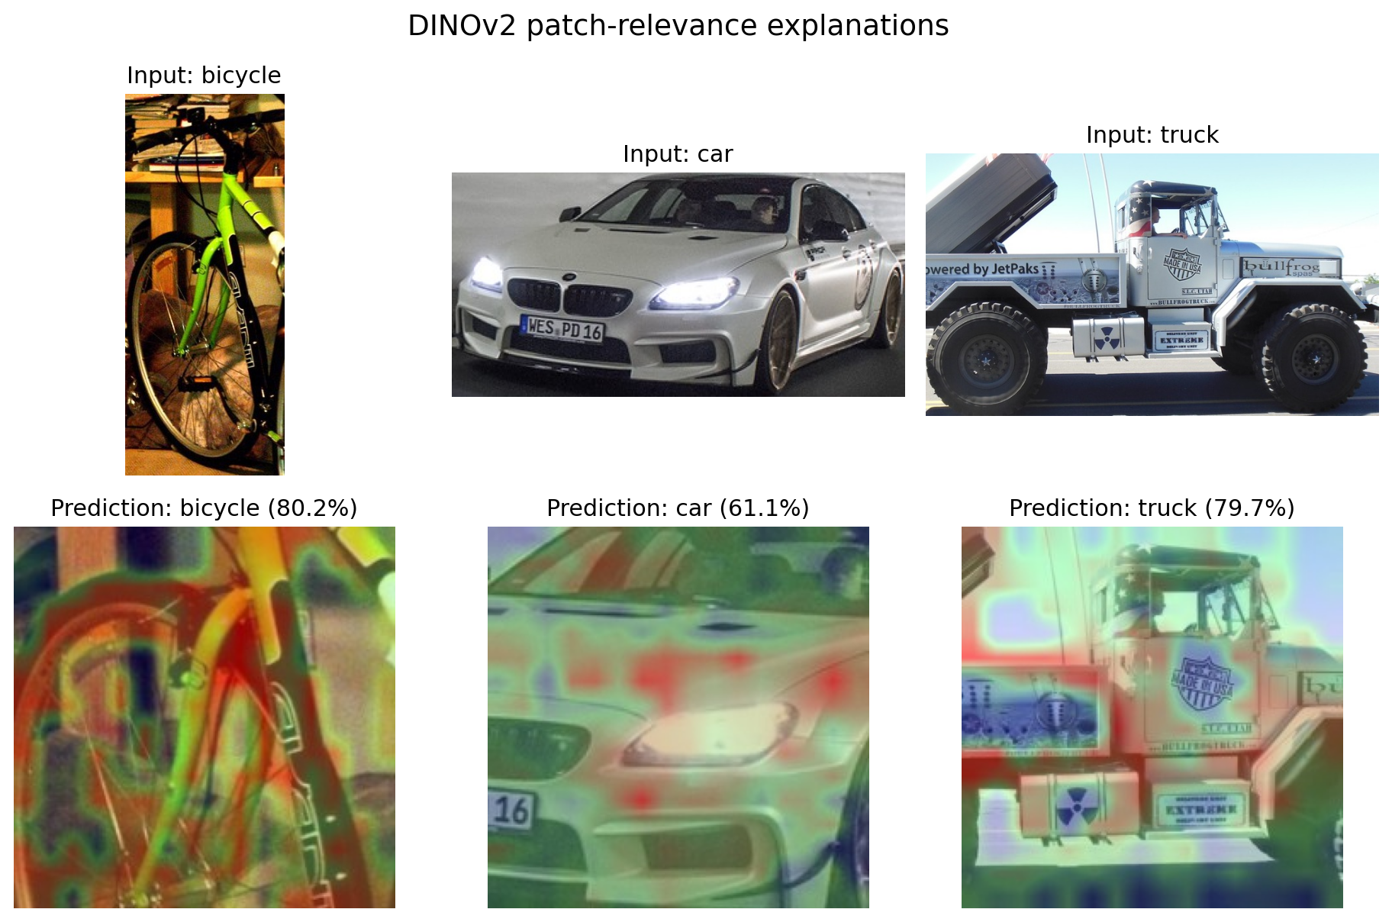
Figure 4 Example patch-relevance overlays from the deployed classifier
The examples show that the model generally emphasizes the vehicle body and characteristic shape rather than a single background region. A heatmap is not a causal proof of the decision and can remain visually plausible when a prediction is wrong, so it must be interpreted together with confidence and retrieved neighbors.

6 1 Interactive Web Application
- Accepts JPG, PNG, and WebP uploads up to 10 MB and supports mobile camera capture.
- Returns the predicted class and ranked probabilities for all five classes.
- Displays measured inference latency and the execution device for each request.
- Shows a patch-relevance overlay and three nearest original training images.
- Exposes a health endpoint with model, device, class list, and loading status.

6 2 Runtime Performance
On the available CPU, mean single-image latency is 63.15 ms, the median is 62.58 ms, and the 95th percentile is 69.05 ms over 30 measured images. The browser request also includes image decoding, heatmap construction, and retrieval, so end-to-end response time can be slightly higher.

7 Ethics and Limitations
- Dataset bias remains possible because Open Images reflects internet photography and may underrepresent local vehicles, weather, viewpoints, and camera quality.
- The system predicts only five known classes. Unknown objects are forced into one of them, so confidence must not be treated as an open-set guarantee.
- Nearest-neighbor examples may expose source images. A public deployment should retain attribution and confirm that redistribution follows the source licenses.
- No faces or personal identity attributes are processed intentionally. Incidental people or license plates may still occur in road images and should be removed for public release.
- No synthetic media is present. If generated images are added later, they must be labeled, counted, and separated during evaluation.

8 Reproducibility
Install requirements.txt, prepare the dataset folders, and run python train_dinov2.py. The script downloads the official DINOv2 ViT-S/14 checkpoint through PyTorch Hub, extracts features, trains both ablation heads, writes metrics and figures, and saves the selected linear head plus retrieval index. Run uvicorn app.main:app --reload and open http://127.0.0.1:8000. The repository records the seed, split sizes, hyperparameters, histories, class-wise metrics, and latency protocol.

9 Conclusion
DINOv2 provides a clear improvement over MobileNetV3 on the existing vehicle dataset while requiring only a small trained head. The selected model gains more than nine percentage points in both accuracy and macro-F1 and remains fast enough for an interactive CPU demo. The ablation also shows that augmentation should be validated carefully rather than assumed to help. Future work should add open-set rejection, collect local adverse-condition images, and evaluate calibration before practical use.

References
[1] M. Oquab et al. DINOv2 Learning Robust Visual Features without Supervision. Transactions on Machine Learning Research 2024. https://arxiv.org/abs/2304.07193
[2] Meta AI Research. DINOv2 official repository and model card. https://github.com/facebookresearch/dinov2
[3] A. Kuznetsova et al. The Open Images Dataset V4. International Journal of Computer Vision 2020. https://storage.googleapis.com/openimages/web/index.html
[4] A. Howard et al. Searching for MobileNetV3. IEEE ICCV 2019. https://arxiv.org/abs/1905.02244

