
School of Computing, Engineering and Technology

Capstone Project
WasteNot
Proactive Demand Forecasting
to Reduce Hospitality Food Waste
A Comparative Analysis of Time-Series Algorithm Using an Exogenous-Aware ML Pipeline for SKU-Level Kitchen Optimization
Alexandru Gabriel Lapos

This report is submitted as part of the requirements for the degree of
BSc (Hons) Computing (Application Software Development)
I confirm that the work contained in this Capstone Project report has been composed solely by myself and has not been accepted in any previous application for a degree. All sources of information have been specifically acknowledged and all verbatim extracts are distinguished by quotation marks.

Contents
Abstract 3
1. Introduction 4
2. Literature Review 4
2.1 The Problem 5
2.1.1 Global Scale and Environmental Themes 5
2.1.2 The Economic Cost 6
2.1.3 Food Waste in Restaurants: Patterns and Causes 7
2.1.4 Problem Description: The Static Par Levels and Granular Kitchen Preparation 7
2.1.5 LSEPS Context (Legal, Social, Ethical, Professional, Security) 8
2.2 The Solution 8
2.2.1 Desirable Features of an Ideal Solution 8
2.2.2 P1: Static Par Levels (Manual Heuristics) 8
2.2.3 P2: Reactive IoT Waste Tracking (e.g., Winnow, Leanpath) 8
2.2.4 P3: Statistical Forecasting Models (e.g., ARIMA) 8
2.2.5 P4: Machine Learning Forecasting (Proposed Approach) 8
2.2.6 Comparative Analysis 9
2.3 Machine Learning Algorithms: A Technical Review 9
2.3.1 ARIMA (Baseline) 9
2.3.2 XGBoost (eXtreme Gradient Boosting) 9
2.3.3 LSTM (Long Short-Term Memory Networks) 10
2.3.4 Prophet 10
2.4 What I Am Going to Do 10
3. Design and Implementation 11
3.1 System Architecture Overview 11
3.2 Data Sources and Preprocessing 12
3.2.1 Sales Data 12
3.2.2 External Data Sources 12
3.3 Feature Engineering 13
3.3.1 Cyclical Time Encoding 13
3.3.2 Lag, Rolling, and Derived Features (Improved XGBoost) 14
3.4 Model Design 15
3.4.1 ARIMA Baseline 15
3.4.2 Facebook Prophet 16
3.4.3 XGBoost — Simple and Improved Variants 16
3.4.4 LSTM 16
3.5 Evaluation Framework 17
3.5.1 Train/Test Split and Horizons 17
3.5.2 Recursive Multi-Step Forecasting 17
3.5.3 The North Star Metric Framework 18
3.6 Hyperparameter Optimisation 19
3.7 Automated Forecasting Pipeline 20
3.7.1 Model Tracking and Selection 20
3.7.2 Pipeline Stages 20
3.8 Implementation Environment 21
3.9 Design Decisions and Justifications 21
4. Testing and Evaluation 22
4.1 Implementation Evaluation 23
4.1.1 Model Performance Evaluation 23
4.1.2 LSEPS Evaluation of the Implementation 31
4.2.1 Revisiting Aims and Objectives 32
4.2.2 Reflection on Professional Development 32
4.2.3 LSEPS Considerations at the Project Level 33
References 34

elf and has not been accepted in any previous application for a degree. All sources of informa

tion have been specifically acknowledged and all verbatim extracts are distinguished by quotation marks.

Abstract
The UK hospitality sector discards over 920,000 tonnes of food annually, with research indicating that approximately 75% of this waste is preventable. This project develops a machine learning-based demand forecasting system for a café in Aberdeen, designed to provide item-level daily preparation targets using three years of point-of-sale data enriched with weather, holiday, and local event features. Nine model configurations across five algorithmic families — ARIMA, Prophet, XGBoost (simple and improved), and LSTM — were trained and evaluated at both daily and hourly granularities using a consistent held-out test set and four evaluation metrics: WAPE, MASE, MAE, and Bias. XGBoost Improved Daily achieved the best one-day WAPE of 0.307, while Prophet Daily Clustered proved more stable at longer horizons. The LSTM hourly variant, despite competitive WAPE, failed the MASE baseline gate, confirming that model complexity does not guarantee practical value. A per-product best-model selection approach reduced the mean one-day WAPE to 0.219. The system follows a human-in-the-loop design to satisfy GDPR Article 22 and the Circular Economy (Scotland) Act 2024.

1. Introduction
I have worked in hospitality kitchens for a few years now, and one thing that has always stood out to me is how much food gets thrown away at the end of a shift. Not because anyone is being careless, but because the whole process of deciding what to prep in the morning is based on rough guesses. The head chef or manager looks at what day it is, thinks about how busy last week was, and sets a target — what the industry calls a par level. That number goes on a whiteboard and it stays there, more or less unchanged, whether it is a quiet rainy Wednesday or the first sunny Saturday of the month.
The issue is that customer demand does not work like that. It shifts around depending on all sorts of things — the weather, whether there is something on locally, school holidays, even what time of year it is. A fixed number cannot capture any of that, and the result is kitchens that consistently over-prepare on slow days and scramble to keep up on busy ones. Either way, food and money get wasted.
Nationally, the numbers are quite stark. The UK hospitality industry throws away over 920,000 tonnes of food every year, and that waste costs the sector billions of pounds while generating millions of tonnes of greenhouse gas emissions. What makes it frustrating is that studies keep showing the same thing: around 75% of this waste did not need to happen. It was food that was perfectly fine to eat but got binned because too much was made. There are systems out there that try to help, like smart bin scales and waste tracking cameras, but those tend to be expensive and they only measure waste after it has already happened. They do not stop you from over-prepping in the first place.
That is what this project is trying to do differently. Instead of measuring waste after the fact, the idea is to predict how much of each menu item a café is likely to sell on a given day, so the kitchen can prep closer to what is actually needed. I built the system for a real café in Aberdeen using three years of their sales data from the till system, combined with external data that I thought would affect demand — hourly weather pulled from the Open-Meteo API, a calendar of Scottish public and school holidays, and a timeline of local events like football matches and festivals that I had to put together manually from various sources because no single database covers Aberdeen events comprehensively.
To work out which forecasting method is actually best, I implemented five different modelling approaches — ARIMA as a simple statistical baseline, Facebook Prophet, two versions of XGBoost with different levels of feature engineering, and a global LSTM neural network. Each was run on both daily and hourly data, giving nine model configurations in total, and they were all compared on the same test period using the same four metrics. The system is also designed around the principle that the chef should always have the final say, partly because that just makes practical sense in a kitchen, but also because it is required under GDPR Article 22 and aligns with what the Circular Economy (Scotland) Act 2024 expects from businesses using automated decision-making tools.

2. Literature Review

2.1 The Problem
This section analyses the problem of food waste, going from a macro-level , global crisis, to a more detailed and granular operational inefficiencies within the restaurant kitchens. While integrating relevant Legal, Social, Ethical, Professional, and Security (LSEPS) in the discussion. The paradoxical issue is that while more than 8.4 million people in UK alone are in food poverty, the world wasted around 30% of the produced food. If this were to be redirected , theoretically, it can provide 10 meals a day , every day, to undernourished people (UNEP, 2024).

2.1.1 Global Scale and Environmental Themes
Food waste is globally recognized as a market failure, the UNEP Food Waste Index Report 2024 estimates that 1.05 billion tonnes of food waste were generated in 2022 alone accros retail, food service and household sectors (UNEP, 2024). This amounts to around 132 kg per capita per year (households 79kg, food service 36kg, 17kg retail). This means 19% of all food available to consumers is wasted, which is in addition to the 13% of the world's food lost earlier in the supply chain from post-harvest up to retail (UNEP, 2024).
In UK the scale is staggering , 9.52 million tonnes of food waste are thrown out in a single year — the equivalent of filling Wembley Stadium nine times over, or 4,000 Olympic-sized swimming pools. Although households account for 70% of this waste, the UK hospitality industry alone wastes an astounding 920,000 tonnes of food, of which 75% may be prevented. In the UK, the most frequently wasted foods are bread and potatoes (Jackman, 2024).

Table 1: Most Commonly wasted Foods in the UK
Rank | Food/Drink | Rank | Food/Drink
1 | Potato (fresh) | 6 | Fruit juice and smoothies
2 | Bread | 7 | Pork
3 | Milk | 8 | Poultry
4 | Homemade & Ready Meals | 9 | Carrots
5 | Fizzy Drinks | 10 | Potato (processed)
*1 kg of poultry and pork emits 6 kg and 7 kg of CO₂e respectively. (Jackman, 2024)

Food waste accounts for around 30% of the world's agricultural land and produces an estimated 8–10% of all greenhouse gas (GHG) emissions worldwide, making the conversion of natural ecosystems for agriculture a major contributor to habitat loss. In 2022, food waste in the UK alone released 18 million tonnes of greenhouse gas emissions, or almost 5.5% of the country's total emissions. This environmental failure is matched by a human one: 150 million children under five experience stunted growth as a result of a chronic lack of vital nutrients, and up to 783 million people worldwide are affected by hunger (UNEP, 2024).

2.1.2 The Economic Cost
Over $1 trillion worth of food is thrown away annually due to food waste worldwide. The UK's economy loses almost £19 billion a year due to consumable food waste (UNEP, 2024).
Waste is a direct loss of earnings for the hospitality sector. Over 8 billion meals are served annually in the UK's Hospitality and Food Service (HaFS) industry, despite producing over 2.87 million tonnes of waste. Food waste accounts for over 1 million tonnes of this, which is an enormous financial leak. The HaFS industry wastes 17.8% of its total food purchases by weight, of which 13.2% can be avoidable. This is the same as discarding one out of every six meals that are served. In 2011, the estimated total cost of food waste to the UK HaFS subsectors was £2.51 billion, with restaurants accounting for the greatest portion of this cost at £682.4 million (WRAP, n.d.).

Subsector | England | Scotland | Wales | N. Ireland | UK Total
Restaurants | 642.4 | 24.2 | 8.7 | 7.2 | 682.4
QSR* | 259.6 | 9.8 | 4.1 | 3.4 | 276.8
Pubs | 321.1 | 18.2 | 11.2 | 6.5 | 357.1
Hotels | 258.4 | 42.7 | 14.4 | 2.2 | 317.8
Leisure | 208.2 | 21.0 | 6.8 | 4.6 | 240.7
Staff Catering | 36.9 | 4.0 | 1.3 | 1.8 | 44.0
Healthcare | 204.5 | 12.0 | 10.8 | 3.0 | 230.4
Education | 205.9 | 23.4 | 12.6 | 7.7 | 249.5
Services | 89.9 | 11.2 | 5.9 | 5.0 | 112.0
Total | 2226.9 | 166.4 | 75.8 | 41.5 | 2510.6
*QSR - Quick Service Restaurants (McDonald's, Subway, KFC, Greggs, etc)
**Note: The figures in the table are expressed in millions (2510.6 -> 2.51 billion)

The Champions 12.3 coalition's research examined 114 restaurants in 12 countries and discovered a strong business case: businesses received an average return of $7 for every $1 invested in food waste reduction initiatives (like the artifact suggested in this project). However, rather than being an operational inefficiency caused by inadequate data, it is frequently seen as an inevitable expense of doing business (champions123.org, n.d.).

2.1.3 Food Waste in Restaurants: Patterns and Causes
Restaurants are in a unique position to be significant contributors to food waste, even though it happens throughout the whole supply chain. The Hospitality and Food Service (HaFS) industry in the UK's out-of-home food consumption market produces over 920,000 tonnes of food waste per year, of which typical restaurants especially account for about 22%, or about 200,000 tonnes (WRAP, 2013) .
Restaurant food waste can be broadly classified by academic literature and the UNEP into three main operational sources: inventory/spoilage waste (items stored but not fully used), preparation waste (generated in the kitchen during cooking, including edible trimmings and inedible peels), and plate waste (items left behind by customers) (UNEP, 2024) . Research regularly demonstrates that, at 45% of total waste, preparation waste is frequently the highest part. Plate waste comes in second at 34%, with spoiling and unserved food making up the remaining portion (Filimonau et al., 2020).
Both operational processes and consumer social practices are intricately linked to the sources of this waste. Significant kitchen excess is caused operationally by overproduction, a lack of consistent forecasting, and aesthetic requirements for food presentation. Massive overpreparation is also encouraged by service concepts like "all-you-can-eat" buffets. Large portion sizes and customer habits like overordering are major causes of plate waste (Papargyropoulou et al., 2019). Importantly, studies show that 75% of this waste is completely preventable and includes food that was completely acceptable to consume (Papargyropoulou et al., 2019) . Food waste resulting from food preparation can be adequately approximated and prevented, while plate waste and waste resulting from spoiling or during transportation are rarely preventable. (Filimonau et al., 2020).

2.1.4 Problem Description: The Static Par Levels and Granular Kitchen Preparation
The primary issue is the gap between preparation and consumption when addressing these patterns at the granular kitchen level. The inventory and preparation waste mentioned above are made worse by commercial kitchens custom of operating on "Par Levels" (Bland, 2022), which are static inventory targets based on past averages or chef intuition (Jenkins, 2021). This operational failure is defined by three interconnected sub-problems:
- The Lead Time Constraint: Whether ordering a particular product or just defrosting, perishable inventory necessitates exact lead time management. Either spoiling (over-preparation or over-ordering) or stockouts (under-preparation or understocking) result from poor forecasting (Mohammed and Mandal, 2024).
- The Variance Problem: Dynamic factors are not taken into consideration by static par levels (Bland, 2022). Demand surges or declines brought on by unforeseen weather, local events, or other disruptive external factors cannot be adjusted for by traditional approaches like simple averages, leading to spoiling or stockouts (Slimstock, 2025).
- The Granularity Gap: Stock Keeping Units (SKUs) are where waste occurs. For a chef who needs to know precisely how many units of particular products to defrost or pre-prepare, an estimate of "total revenue" is insufficient. The item-level granularity necessary for operational execution is not provided by the majority of conventional approaches (Slimstock, 2025).

2.1.5 LSEPS Context (Legal, Social, Ethical, Professional, Security)
Implementing this food waste system doesn't happen in a vacuum. It brings up several Legal, Social, Ethical, Professional, and Security (LSEPS) challenges for the UK and Scotland, which heavily influence how the system is designed.

Legal
The Circular Economy (Scotland) Act 2024 makes it a legal requirement for businesses to reduce waste, so this tool directly helps restaurants stay compliant and avoid penalties (Legislation.gov.uk, 2024). In terms of GDPR, we have to be careful with customer data by only keeping what we strictly need for forecasting, following the data minimisation principle (ICO, 2024). Furthermore, GDPR Article 22 states that humans must have the final say over automated decisions. Because of this, the system uses a "Human-in-the-Loop" design so managers always stay in control (ICO, n.d.).

Social and Ethical
A major social risk is "Algorithmic Management," where chefs might feel forced to just do what the computer says and research shows this causes "technostress" and it can hurt staff morale (Sharma, Mittal and Seema, 2026). If chefs rely entirely on the AI, they might also lose their own ability to predict kitchen demand over time, a problem known as "deskilling" (Pratik Sapkota et al., 2025).
To prevent this, the system is designed to be an ethical "Co-bot" that assists rather than replaces the chef (Pratik Sapkota et al., 2025). Instead of just giving a blind number, the system will generate a report , detailing every product giving the ultimate decision to the chef to understand the AI and confidently override it using their own intuition if necessary.

Professional
From a professional standpoint, accountability is a big deal: if poor data leads to a bad prediction that results in a bin full of food, we have to ask where the responsibility lies. To address this, it's argued that developers must clearly document a model’s limitations and data requirements so the end-user knows exactly what the system can and can't do (Gómez-Talal et al., 2024). I believe there is also a professional duty to prove a system actually works before it ever hits a real kitchen. That’s why this project focuses on rigorously testing multiple models—like XGBoost and Prophet—against a baseline. By using metrics like MAE and RMSE, the goal is to ensure that only a genuinely accurate model is being recommended for use

Security
There are three main security risks for this system. First is "data poisoning": if our external APIs for weather or events send manipulated data, the model will tell the kitchen to prep the wrong amount of food, causing financial loss (Zhao et al., 2025). We need to validate this incoming data. Second, if those APIs crash, the system needs a backup plan so it can still run using just historical sales data instead of failing completely.
Finally, "model drift" is a big concern. Consumer habits change over time (like after COVID), so the model will slowly get less accurate without a regular retraining schedule. Additionally, all the sensitive sales data we use needs to be properly encrypted and access-controlled so competitors can't see it.

Overview
Overall, the LSEPS analysis shows that the non-technical risks are just as important as the code. The system’s design directly handles these issues by keeping a human in the loop (Legal/Ethical), explaining the AI's choices (Social/Professional), having API backups (Security), and thoroughly testing the models before deployment (Professional).

2.2 The Solution
This section evaluates existing industry approaches to food waste, categorizing them from manual heuristics to advanced machine learning, and assesses them against four operational requirements.

2.2.1 Desirable Features of an Ideal Solution
An effective waste reduction system should possess four key features (D):
- D1 (Proactive): Prevents waste before preparation, rather than measuring it afterward.
- D2 (Exogenous Aware): Accounts for external demand drivers like weather, events, and holidays.
- D3 (Granular): Predicts at the specific item (SKU) level to guide exact prep amounts.
- D4 (Low Hardware Cost): Requires no expensive sensors or cameras, keeping it accessible to independent restaurants.

2.2.2 P1: Static Par Levels (Manual Heuristics)
The most common industry approach is the Par Level system: manually setting minimum stock thresholds based on past averages (Jenkins, 2021), (e.g., 'We use 20 kg of chicken on a typical Friday'). While granular (D3) and cheap (D4), it is entirely reactive (fails D1). Furthermore, research shows that managers relying on simple heuristics systematically fail to account for complex external factors like weather or local festivals (Lasek et al., 2016). This lack of accuracy is a major driver of waste, as even small forecasting errors have been shown to lead to chronic overproduction or stockouts in the food sector (Posch et al., 2021).

2.2.3 P2: Reactive IoT Waste Tracking (e.g., Winnow, Leanpath)
Systems like Winnow use smart scales and computer vision to log discarded food (Graber, 2023) (Clark et al., 2025). Winnow Vision, for instance, deploys a camera mounted above a kitchen bin that uses machine learning to identify the food type being discarded, records the weight and associated cost, and generates daily and weekly waste reports for kitchen managers. While highly effective at reducing waste by making it a visible metric, they are fundamentally reactive - measuring waste that has already happened (fails D1). Additionally, their high hardware and subscription costs create a significant barrier to entry for smaller, independent restaurants (D4) (Clark et al., 2025).

2.2.4 P3: Statistical Forecasting Models (e.g., ARIMA)
ARIMA models use historical sales to forecast future demand, making them the first truly proactive solution (D1) (Schmidt, Kabir and Hoque, 2022). However, they project history forward and are completely "blind" to the outside world (D2). Traditional ARIMA models consistently underperform machine learning when dealing with volatile, event-driven demand because they cannot anticipate disruptions like unseasonable weather or local concerts (Jiang, 2024). A local concert, a spell of unseasonable rain, or a public holiday can cause demand to deviate dramatically from historical patterns in ways that ARIMA, by design, cannot anticipate.

2.2.5 P4: Machine Learning Forecasting (Proposed Approach)
The fourth and most advanced option is machine learning (ML) demand forecasting, which is the approach I am taking for this project. Instead of just pushing a single historical trend forward like ARIMA does, ML models learn how a wide range of inputs—such as past sales, day of the week, weather, local events, and holidays—actually impact demand. Because of this, ML is the only solution that checks all the project requirements: it is proactive (D1 ✓), exogenous-aware (D2 ✓), granular at the item level (D3 ✓), and requires no extra hardware (D4 ✓) (Shah, Myller and Sedano, 2025).
To find the best fit, this project implements and compares three main algorithms—XGBoost (a simple version with only lag features and an improved version with additional features, more explained in section 3), Long Short-Term Memory (LSTM) networks, and Prophet—against a basic ARIMA baseline. Each of these models tackles the forecasting problem from a different angle, and each one interacts with our LSEPS constraints (from Section 2.1.5) in its own way. The next subsection breaks down the technical details of these algorithms to explain the design choices I make in Section 3.

2.2.6 Comparative Analysis
Approach / Solution | D1: Proactive | D2: Exogenous Aware | D3: Granularity | D4: Low Cost
P1: Static Par Levels (Manual) | ❌ | ❌ | ✅ | ✅
P2: IoT Waste Tracking (e.g., Winnow) | ❌ | ❌ | ✅ | ❌
P3: Statistical Models (e.g., ARIMA) | ✅ | ❌ | ✅ | ✅
P4: ML Forecasting (Proposed Artefact) | ✅ | ✅ | ✅ | ✅

2.3 Machine Learning Algorithms: A Technical Review
To justify the design decisions in Section 3, this section briefly reviews the specific algorithms being implemented and their suitability for restaurant demand forecasting.

2.3.1 ARIMA (Baseline)
ARIMA serves as the statistical baseline for this project. Its methodology is well-understood and interpretable (Schmidt, Kabir and Hoque, 2022), which supports human oversight. However, its inability to handle non-linear relationships and exogenous variables limits its effectiveness in volatile restaurant environments.

2.3.2 XGBoost (eXtreme Gradient Boosting)
XGBoost builds predictive models using sequential decision trees (Shah, Myller and Sedano, 2025). It is highly suited for this project for three reasons: it easily processes mixed data (e.g., numerical weather and categorical holidays), it generates interpretable feature importance scores (essential for GDPR compliance), and it runs efficiently on standard hardware. Studies show XGBoost consistently outperforms models like LSTM and Random Forest in daily-level catering predictions (Jiang, 2024) (Shah, Myller and Sedano, 2025). There will be 2 versions of XGBoost, simple version with ony lag features and a more improved one with additional features, more on this in section 3

2.3.3 LSTM (Long Short-Term Memory Networks)
LSTMs are excellent at capturing long-term seasonal patterns in sequential data without manual feature engineering (Shah, Myller and Sedano, 2025) (Shah, Myller and Sedano, 2025). However, they require massive amounts of training data, are computationally expensive, and function as a "black box." This lack of interpretability creates tension with GDPR Article 22 and ethical guidelines, meaning LSTM outputs must be carefully contextualized if used by human managers.

2.3.4 Prophet
Developed by Meta, Prophet explicitly breaks time series data into interpretable components: trend, seasonality, and holiday effects (Shah, Myller and Sedano, 2025). This allows a chef to easily understand why a prediction was made, perfectly aligning with LSEPS 'Human-in-the-Loop' compliance. While highly robust, it may underfit complex, non-linear interactions at the daily level compared to XGBoost .

2.4 What I Am Going to Do
Based on this analysis, I will develop a Hybrid Machine Learning Artefact (P4) using the following steps:
- Data Integration: Build a pipeline combining internal POS historical data with the Open-Meteo and Ticketmaster APIs to capture external demand drivers (Huang et al., 2025).
- Feature Engineering: Apply advanced preprocessing, including cyclical encoding and lag features, to capture temporal dependencies (Trainindata.com, 2018).
- Model Implementation: Test XGBoost, LSTM, and Prophet against an ARIMA baseline , doing this will show which model is better for each use. All models with have a daily version and an hourly version to determine what data structure is better to be used.
- Reporting Generation: The artefact will be able to create 3 different types of reports:
1. 1-Day Report: this will be the forecast of products the will be passed to the kitchen for preparation, will include what items will be forecasted to be sold, what ingredients and their weight so the kitchen staff can preprepare in the morning.
2. 1-Week Report: This will be showing the full week at a glance, followed by a "Supplier Order List" with weekly ingredient totals. This is what your manager uses to place the weekly supplier order.
3. 1-Month Report: Weekly breakdown, top 15 and bottom 10 products (menu review candidates), day-of-week patterns for staffing, and monthly ingredient totals. This is the executive summary format.
The idea behind report generation is to also include ”Human-in-the-loop”, while the interface will generate this report, the manager or chef , can agree or disagree with it, to ensure compliance with the Circular Economy (Scotland) Act 2024 and GDPR Article 22, and to mitigate the ethical risks of algorithmic management identified in Section 2.1.5.

3. Design and Implementation
This chapter covers how the forecasting system was designed and built. The goal of the project was to forecast daily and hourly sales for 64 individual menu items at a café in Aberdeen, using several different modelling approaches so they could be compared against each other fairly.

3.1 System Architecture Overview
The system is split into a series of separate stages — data collection and preprocessing, feature engineering, model training, forecasting, and evaluation. Each stage lives in its own Jupyter notebook, which made it easier to develop and debug things independently without breaking everything else. All the models read from the same preprocessed CSV files, so there is no risk of one model accidentally being trained on slightly different data than another.
Figure 3.1 gives an overview of how everything fits together. The raw sales data gets combined with three external sources — weather, public holidays, and local Aberdeen events — and fed into five different model families: ARIMA, Prophet, a simple XGBoost, an improved XGBoost with more engineered features, and a global LSTM. Every model uses the same train/test split and is evaluated with the same metrics, which keeps the comparison fair.
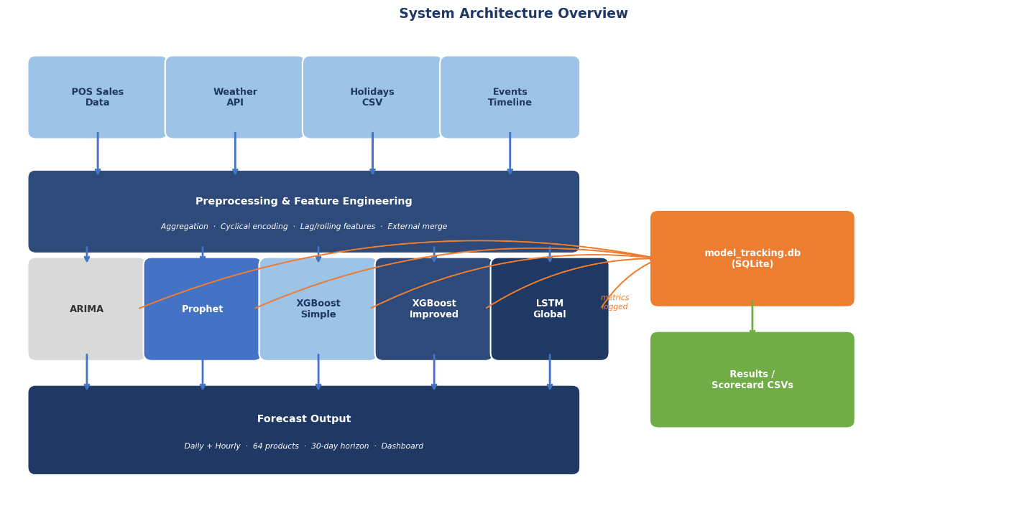

Figure 3.1 — System architecture overview: from raw data sources through model families to forecast output and experiment tracking.
Additionally, each experiment is recorded in a SQLite database called model_tracking.db, which contains information such as the metrics for each product, the hyperparameters utilized, and the overall scorecard findings. This immediately contributes to the model comparison carried out in Chapter 4 and made it simple to go back and compare runs without having to rerun anything.

3.2 Data Sources and Preprocessing

3.2.1 Sales Data
The main dataset is the café's point-of-sale transaction history, covering 2022 to 2025. Each record has a date, a time, and the number of units sold for each product. For the daily models, I aggregated these into one row per day by summing everything up. For the hourly models, I kept the finer granularity and grouped by hour, covering the café's roughly nine-hour trading window (around 08:00–17:00). The final list of products to forecast was fixed at 64 items — anything too sparse or inconsistent was dropped.
One of the bigger design choices made was to train a single global model across all 64 products rather than fitting a separate model for each one. The main reason for this is that some products don't sell very often, and a per-product model wouldn't have enough data to learn from. By combining everything into one long-format dataframe and including a product identity column, the model can still learn product-specific patterns while benefiting from the larger dataset. This approach is supported by recent work on global versus local forecasting models (Montero-Manso and Hyndman, 2021).

3.2.2 External Data Sources
Three external data sources were merged in alongside the sales data, since café demand doesn't happen in a vacuum:
Weather Data: Aberdeen's hourly weather data was taken from the Open-Meteo API. This covers wind gusts, temperature, precipitation, and snowfall. Using WMO criteria, the raw weather codes were transformed into four binary flags (is_clear, is_cloudy, is_rain, and is_snow), which I thought was cleaner than attempting to utilize the raw codes directly. Rain and snow flags were calculated as a daily maximum for daily models, meaning that if it rained at any moment during the day, the flag is 1. Continuous variables were averaged throughout the day.
apparent_temperature | Captures how hot or cold the air actually feels to a person, which drives human decision-making
precipitation | Measures rain volume, which is a primary deterrent for foot traffic and often leads to immediate cancellations or drops in walk-in customers
snowfall | Indicates active snowing, a severe travel disruptor that strongly correlates with people choosing to stay home instead of dining out
snow_depth | Reflects lingering hazardous road and walking conditions, meaning demand might stay suppressed even on a sunny day if the ground is still covered
weather_code | Weather code that signals what type of weather is (clear, thunderstorm), this is used when converting to more simpler features (is_clear,is_snow , etc)
relative_humidity_2m | Influences comfort levels by making heat feel oppressive or cold feel biting, subtly swaying a customer's willingness to leave their house
cloud_cover | Captures the general "dreariness" of a day, which can reduce spontaneous outings and negatively impact the appeal of outdoor seating
visibility | Accounts for fog or heavy downpours that make driving dangerous, reliably leading to reduced travel and lower out-of-town customer numbers
wind_speed_10m | Measures continuous wind that can make walking unpleasant and render outdoor dining areas completely unusable for the day
wind_gusts_10m | Highlights sudden, volatile weather extremes that are more likely to cause abrupt booking cancellations or force unexpected operational changes
*Weather features present in the CSV, date and time are excluded because they will be present in all csv
Holiday data: Scottish public holidays and school holidays are covered by a preprocessed CSV. To obtain a clean binary series, I grouped these by date and maintained the highest flag value per day. Because people frequently act differently in the days immediately preceding or after a holiday, I additionally included lead and lag variants of the holiday flag (holiday_lag_1 and holiday_lead_1) in the enhanced XGBoost model.
is_holiday | Is a binary value that tells if is a holiday or not, designed to capture any rush in customers
holiday_importance | A metric from 0 to 5 to signify the importance of a holiday (Good Friday might not be as important as Christmas day)
days_until_next_holiday | A countdown until the next holiday, is done to capture the rush until a holiday (the day before Christmas might be as busy as the holiday itself )
*Holidays features present in the CSV, date and time are excluded because they will be present in all csv
Local Events Data: This was a manually curated timeline of Aberdeen events — things like football matches, local festivals, and university term dates (there no single sources for these events, they were research manually from different websites , Facebook, P&J Live, and included in a CSV). Without this, a lot of the unusual demand spikes would just look like noise to the model. I aggregated these to daily binary or count features and joined them into the main dataframe.
is_festival | Is a binary value that tells if there is any festivals going on , designed to capture any rush in customers or the lack of
festival_importance | A metric from 0 to 5 to signify the importance of the festivals
is_match_day | Is a binary value that tells if is a footbal match going on , designed to capture any rush in customers or the lack of
match_importance | A metric from 0 to 5 to signify the importance of the matches
*Local Events features present in the CSV, date and time are excluded because they will be present in all csv

3.3 Feature Engineering

3.3.1 Cyclical Time Encoding
The first thing noticed about time features is that encoding the day of the week as a plain integer (0 = Monday, 6 = Sunday) creates a problem — the model would think Sunday and Monday are at opposite ends of some scale, when actually they are adjacent days. To fix this, all have been encoded as cyclical time variables (day of week, month, and hour of day) using sine and cosine pairs. This keeps the circular structure intact. Figure 3.2 shows the difference visually. For the hourly models, I normalised the hour encoding relative to the nine-hour business window (hours 8 through 16) rather than the full 24-hour clock, since the café is only open for part of the day.
Feature | Formula | Rationale
day_sin / day_cos | sin/cos(2π × DoW / 7) | Weekly seasonality, circular
month_sin / month_cos | sin/cos(2π × (month−1) / 12) | Annual seasonality, circular
hour_sin / hour_cos | sin/cos(2π × (hour−8) / 9) | Intraday pattern (hourly models only)
Is_Weekend | Binary flag | Captures weekend demand shift
*Cyclical time encoding features

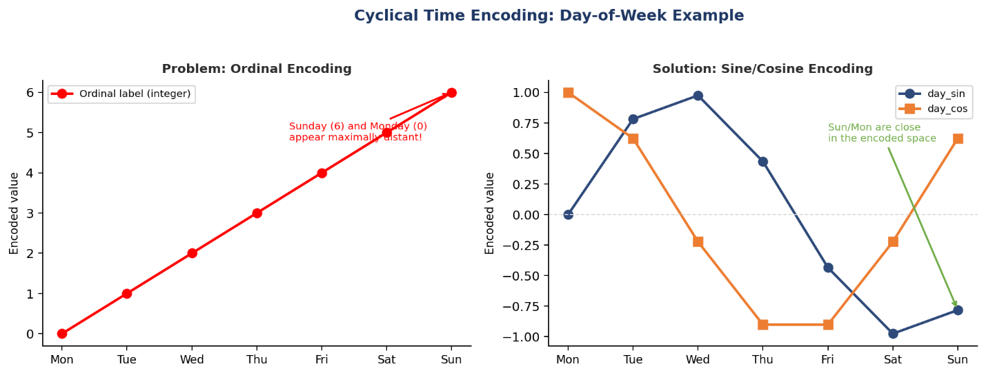
Figure 3.2 — Cyclical encoding: ordinal day labels incorrectly place Sunday and Monday at maximum distance; sine/cosine encoding preserves their adjacency.

3.3.2 Lag, Rolling, and Derived Features (Improved XGBoost)
The simple XGBoost only uses time and external features. The improved version adds a set of autoregressive features built from the sales history itself. I added lag features at 1, 2, 7, 14, and 30 days back — the idea being that yesterday's sales, last week's sales, and last month's sales all carry useful signal. On top of that, I computed rolling mean and standard deviation over 3-, 7-, and 14-day windows. There's also a momentum feature (yesterday's sales minus last week's, sales_1_step_ago − sales_7_step_ago) and a ratio feature (yesterday vs. the 7-day average, sales_1_step_ago / rolling_7d_avg ), which help capture whether sales are trending up or down recently. Figure 3.3 shows all of this grouped together.
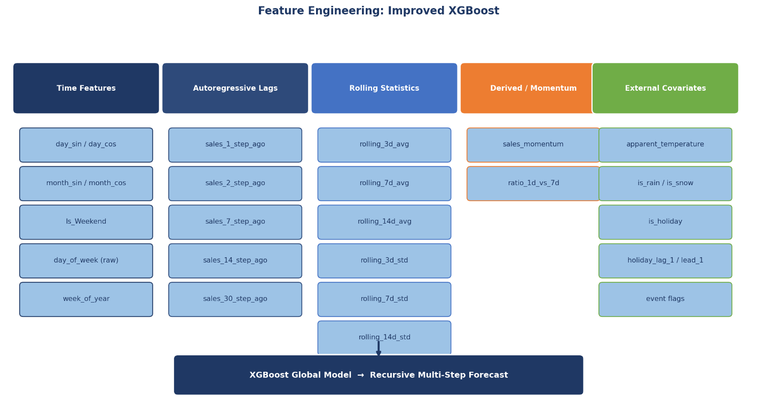
Figure 3.3 — Feature engineering overview for the improved XGBoost model, grouped by category. All lag-based features are computed strictly from past observations to prevent data leakage

One thing to note is about data leakage. All of the lag and rolling features are calculated using only past data points — never the current or future values. This also applies during the recursive forecasting step (covered in Section 3.5.2), where the model's own predictions get fed back into the lag columns for future steps, and the rolling statistics get recalculated accordingly.

Feature Group | Features | Window / Lag
Autoregressive lags | sales_N_step_ago | 1, 2, 7, 14, 30 steps
Rolling mean | rolling_Nd_avg | 3, 7, 14 steps
Rolling std | rolling_Nd_std | 3, 7, 14 steps
Momentum | sales_momentum | lag_1 − lag_7
Ratio | ratio_1d_vs_7d | lag_1 / rolling_7d_avg
*Lag and rolling features in the improved XGBoost model

3.4 Model Design

3.4.1 ARIMA Baseline
ARIMA was included mainly as a baseline to give the other models something to beat. I used the Nixtla StatsForecast library, which lets you fit ARIMA across all products at once rather than writing a loop. The order is fixed at (1,1,1) and no external variables are included — it only looks at the sales series itself. This is intentional; I wanted a simple benchmark that reflects what a basic statistical approach would give you, so that any improvement from the machine learning models is meaningful.

3.4.2 Facebook Prophet
Prophet was trained separately for each product, at both daily and hourly granularity. Prophet's built-in seasonality decomposition along with all the weather, holiday, and event columns were added as extra regressors. Rather than tuning every product individually with Optuna , the products were grouped into clusters based on their demand patterns using K-Means, then tuned one representative product per cluster and applied those settings to the rest. The regressor columns were standardised before fitting, and Prophet's own cross-validation tools were used to evaluate candidate hyperparameter settings.

3.4.3 XGBoost — Simple and Improved Variants
There were two versions of XGBoost build specifically to test how much the extra feature engineering matters. The simple variant uses only time features, the product identity encoded as an XGBoost native categorical variable (enable_categorical=True), and the external covariate set (weather, events & holidays). The improved version gets all of that plus the full set of lag, rolling, and momentum features from Section 3.3.2. Both versions use the same Optuna search space and 30 trials, with walk-forward cross-validation as the objective. Parameters searched include learning_rate, max_depth, min_child_weight, subsample, colsample_bytree, gamma, reg_lambda, and reg_alpha. The tree_method='hist' GPU-accelerated backend is used throughout. The product column is passed as a native XGBoost categorical feature, allowing the single global model to learn product-specific intercepts without one-hot expansion.

3.4.4 LSTM
The LSTM model is a global neural network trained on all 64 products simultaneously. Input sequences are constructed with a sliding lookback window, producing a 3-D tensor of shape (samples, timesteps, features). The network architecture, optimised via Optuna, consists of one or two stacked LSTM layers with L2 regularisation, followed by a Dense output layer. Dropout is applied after each LSTM layer for regularisation.
Key implementation decisions include: GPU memory growth is configured dynamically (set_memory_growth) to prevent CUDA allocation errors; XLA JIT compilation is explicitly disabled to resolve observed CUDA kernel conflicts; and the Huber loss function is used in place of MSE to reduce sensitivity to outlier sales spikes. Training uses the Adam optimiser with early stopping (patience = 10) and a ReduceLROnPlateau scheduler. Product identity is embedded via a LabelEncoder integer and appended to the feature vector, providing a lightweight product-level signal without the memory cost of one-hot encoding.
For the hourly LSTM specifically, memory pressure is addressed through numpy memmap arrays for sequence storage, and Python's garbage collector is explicitly invoked at key points to reclaim GPU and CPU memory. This was necessary because the hourly dataset, with nine timesteps per product per day across 64 products over three years, produces a sequence tensor too large to hold in GPU memory directly.

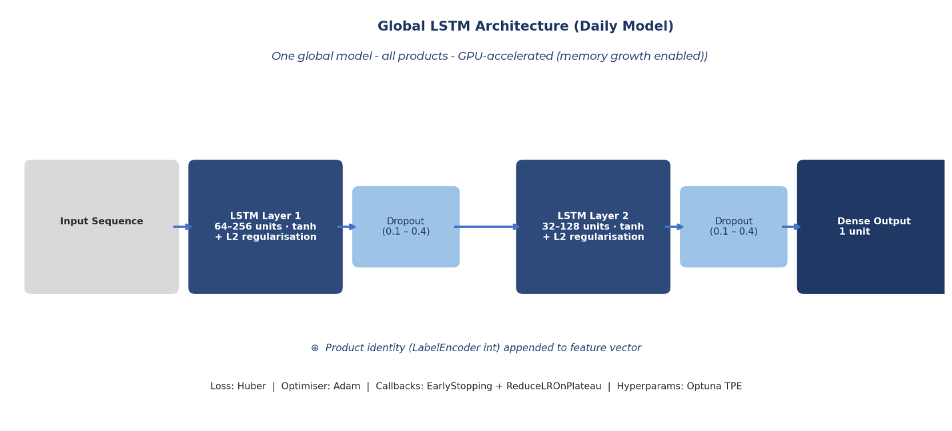
Figure 3.4 — Global LSTM architecture. One model serves all 64 products; product identity is embedded as a LabelEncoder integer appended to the feature vector.

3.5 Evaluation Framework

3.5.1 Train/Test Split and Horizons
A single chronological train/test split is applied consistently across all models, with the most recent period reserved as the held-out test set. Forecasting performance is reported across three horizon windows — short-term (1–7 days / hours), medium-term (8–14), and long-term (15–30) — to expose horizon degradation effects.

3.5.2 Recursive Multi-Step Forecasting
For the XGBoost models, producing a 30-day forecast isn't as simple as just calling predict once. Because the model relies on lag features (yesterday's sales, last week's sales, etc.), those values don't exist yet for future dates. So I used a recursive approach: predict day t+1, store the prediction, use it to fill in the lag columns for day t+2, predict again, and so on. Figure 3.5 shows how this works. The rolling statistics also get recomputed after each step using the updated lag history. It's a bit slower than a direct forecast, but it reflects how the model would actually be used in practice.

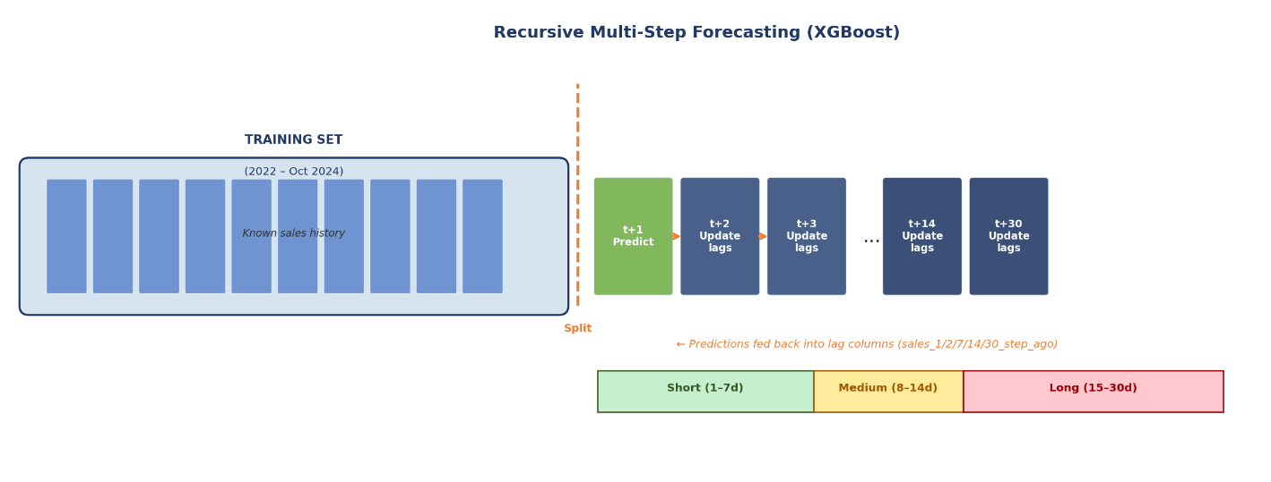
Figure 3.5 — Recursive multi-step forecasting: predictions are iteratively fed back into lag features. Three horizon bands (short / medium / long) are evaluated separately.

3.5.3 The North Star Metric Framework
I settled on four metrics as the main way to evaluate the models, which I called the 'North Star Framework'. Each one was chosen for a specific reason rather than just using whatever was convenient. These are summarised in Figure 3.6 and Table 3.2.

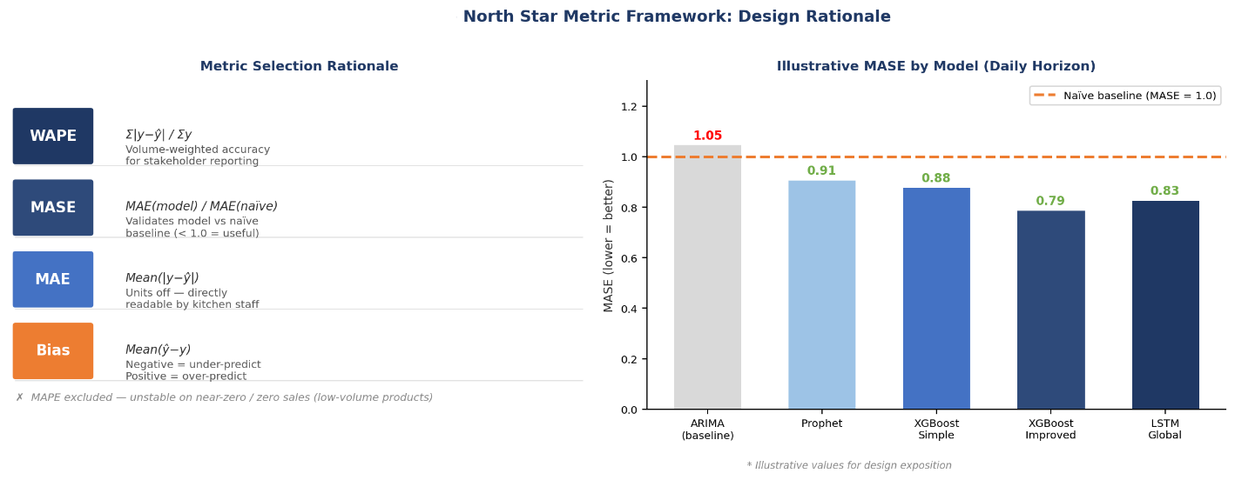
Figure 3.6 — North Star metric framework: design rationale (left) and illustrative MASE comparison across model families (right). Values in the bar chart are representative; see Chapter 5 for actual results.

Metric | Formula | Operational Meaning
WAPE | Σ|actual − pred| / Σ actual | Volume-weighted accuracy for stakeholder reporting
MASE | MAE(model) / MAE(naïve lag-1) | Validates model adds value over naïve baseline
MAE | Mean(|actual − pred|) | Units off — directly interpretable by kitchen staff
Bias | Mean(pred − actual) | Negative = under-predict (stock-out); Positive = over-predict (waste)
Table 3.2: North Star evaluation metrics
MASE is particularly important as a model validation gate: a MASE value below 1.0 confirms that the model outperforms a naïve lag-1 baseline (predicting today's sales as equal to yesterday's), providing a minimum threshold for practical utility. WAPE is preferred over MAPE for stakeholder reporting because it weights errors by sales volume, preventing low-volume products from disproportionately inflating the error rate.

3.6 Hyperparameter Optimisation
All tunable models (XGBoost variants, Prophet, LSTM) use Optuna for automated hyperparameter search. Optuna's Tree-structured Parzen Estimator (TPE) sampler is used throughout, which models the objective function as a probabilistic surrogate and proposes new configurations that are likely to improve on previous trials.
Walk-forward cross-validation is used as the Optuna objective for the XGBoost models, where the objective function folds the training data chronologically and returns the mean validation RMSE across folds. For Prophet, the library's native cross_validation function is used with an initial training period and a rolling evaluation horizon. For the LSTM, Optuna searches over the number of units per layer, number of LSTM layers, dropout rate, learning rate, L2 regularisation strength, and the lookback window length.

Model | Search Space | Trials
XGBoost (both) | learning_rate, max_depth, min_child_weight, subsample, colsample_bytree, gamma, λ, α | 30
Prophet | changepoint_prior_scale, seasonality_prior_scale, seasonality_mode | Optuna (per cluster)
LSTM | LSTM units (×2 layers), dropout, learning rate, L2, lookback window | Optuna
ARIMA | Fixed (1,1,1) — no tuning | —
*Models Hyperparameter Optimisation

3.7 Automated Forecasting Pipeline
Beyond just the experimental notebooks, I also designed an automated pipeline that could be used to keep the models up to date in a real deployment. The idea is that rather than someone having to manually retrain everything whenever new data comes in, the whole process runs on a schedule. Figure 3.7 shows how this fits together.

3.7.1 Model Tracking and Selection
All experiment results are stored to a SQLite database (model_tracking.db) via a model_tracking.bash shell script. The database stores per-run metadata including the model family, granularity (daily/hourly), training date, hyperparameters, per-product North Star metrics, and aggregate scorecard results. A companion comparison notebook (compare_models.ipynb) reads from this database to produce the global scorecard and per-product best-model rankings stored in the results/ directory (comparison_global_scorecard.csv, comparison_best_model_per_product.csv, comparison_horizon_degradation.csv). This provides a reproducible audit trail and enables automated best-model selection per product by querying the database for the lowest WAPE at each horizon
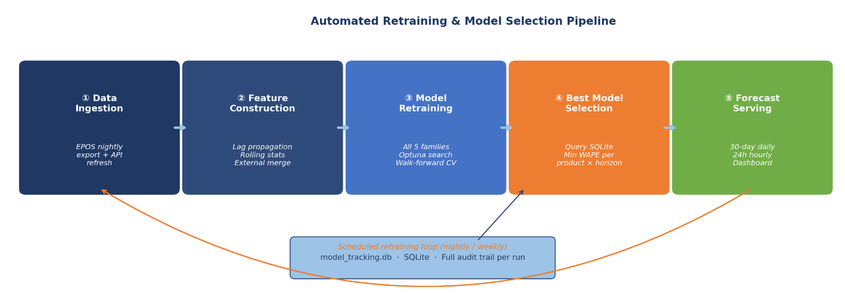

Figure 3.7 — Automated retraining and model selection pipeline: five sequential stages with a scheduled feedback loop and full SQLite audit trail

3.7.2 Pipeline Stages
The pipeline has four main stages, following an operational architecture:
- Data ingestion: New sales data is exported from the EPOS system nightly and added to the existing CSV store. The weather API, holidays, and events data are also refreshed at the same time.
- Feature construction: The full feature engineering pipeline is re-run over the updated data, including recalculating lag features and rolling statistics, so everything stays consistent with how the models were trained.
- Model retraining and selection: All five model families are retrained on the updated data. Optuna can be re-run on a weekly schedule if needed. Once done, the database gets updated and the best model per product per horizon is re-selected automatically.
- Forecast serving: The winning models produce a 30-day-ahead daily forecast and a 24-hour-ahead hourly forecast for all 64 products, which gets saved to a CSV and displayed through the dashboard notebook.
This setup means the system can adapt if demand patterns change — for example if a new product gets added to the menu, or if seasonal patterns shift — without needing manual intervention every time.

3.8 Implementation Environment
Everything was built in Python 3.11 inside a Conda virtual environment. Training the LSTM models used a local machine with an NVIDIA GPU via TensorFlow 2.x, which made a noticeable difference to training times compared to CPU-only. The table below lists the main libraries used and what they were for.

Library | Version | Role
TensorFlow / Keras | 2.x | LSTM architecture, GPU training
XGBoost | ≥ 1.7 | Gradient boosting, native categorical support
Prophet | 1.x | Decomposition-based forecasting with regressors
StatsForecast (Nixtla) | 1.x | Vectorized ARIMA across all products
Optuna | 3.x | Bayesian hyperparameter optimization (TPE)
scikit-learn | 1.x | Metrics, scalers, cross-validation utilities
pandas / numpy | — | Data manipulation, feature construction
SQLite3 | built-in | Experiment tracking and result persistence
Key libraries and their roles

3.9 Design Decisions and Justifications
Several of the design choices I made are worth explaining more explicitly, since there were usually alternatives I considered and reasons I went one way over another.
Global versus local modelling.
A single model was trained across all 64 products rather than fitting one per product. The main reason is that many products don't sell frequently enough to have a reliable per-product training set. Pooling everything together gives the model more data to work with, and recent literature suggests global models tend to outperform local ones in these kinds of sparse data. The product identity column lets the model still learn product-specific behaviour (Montero-Manso and Hyndman, 2021).
Huber loss for the LSTM.
Initially was used MSE as the loss function but found that training was unstable — occasional large sales spikes (probably catering orders or events) were pulling the gradients around a lot. Huber loss behaves like MSE for small errors and more like MAE for large ones, which makes it much more robust to outliers. Switching to Huber noticeably smoothed out the training curves.
WAPE and MASE over MAPE.
MAPE is the obvious first choice for forecasting accuracy, but it produces very large values or simply breaks when actual sales are zero — which happens regularly for lower-volume menu items. WAPE solves this by weighting errors by actual volume, so a zero-sale day on a low-demand item doesn't distort the whole metric. MASE is recommended specifically for comparing against a naïve baseline in a way that works across different scales (Hyndman and Koehler, 2006).
Recursive forecasting over a direct multi-output approach.
An alternative to recursive forecasting would be to train separate models for each forecast horizon — one for day 1, one for day 2, and so on. Decided against this because it would require 30 separate models and would be much harder to maintain. Recursive forecasting with a single model is simpler and still gives reasonable results up to 30 days ahead, even if it accumulates some error over longer horizons (Ben Taieb et al., 2012).
Selected products
During the paper it was mentioned that there were 64 products to be forecasted, in the training data there are more than that, so it was decided that these 64 products were chosen by the following criteria:
- Contains ingredients that require defrost or needs to be cooked beforehand (sausages, bacon , potatoes)
- Contains ingredients that require preparation in the morning (mashed avocado, tuna mix)
- Contains ingredients that have a small expiration date (tuna mix, expires the same day as it was prepared)
- Since most of the above products are from breakfast , it was decided to include other breakfast items that are novel to breakfast even they do not fit in,e.g., eggs on toast

4. Testing and Evaluation
This chapter evaluates the project from two perspectives. Section 4.1 covers the implementation evaluation, which focuses on how well the forecasting models actually perform against the North Star metrics defined in Section 3.5.3, and whether the system meets its LSEPS obligations. Section 4.2 then steps back and evaluates the project as a whole — whether the original aims and objectives were met, what I learned during the process, and how the project has contributed to my professional development.

4.1 Implementation Evaluation
The implementation evaluation assesses whether the forecasting system actually works — both in terms of raw predictive accuracy and in terms of the broader non-technical requirements identified in the literature review.

4.1.1 Model Performance Evaluation
All nine model configurations were evaluated on the same held-out test set (November 2025) using the four North Star metrics: WAPE, MASE, MAE, and Bias. The results are structured across three layers: a global scorecard ranking models across all 64 products, per-product heatmaps exposing where individual models excel or struggle, and a horizon degradation analysis showing how accuracy changes from 1-Day to 1-Month.
Global Scorecard.
Figure 4.1 shows the full global scorecard at the 1-Day horizon, which is the most operationally important one since it drives the next morning’s kitchen prep list.
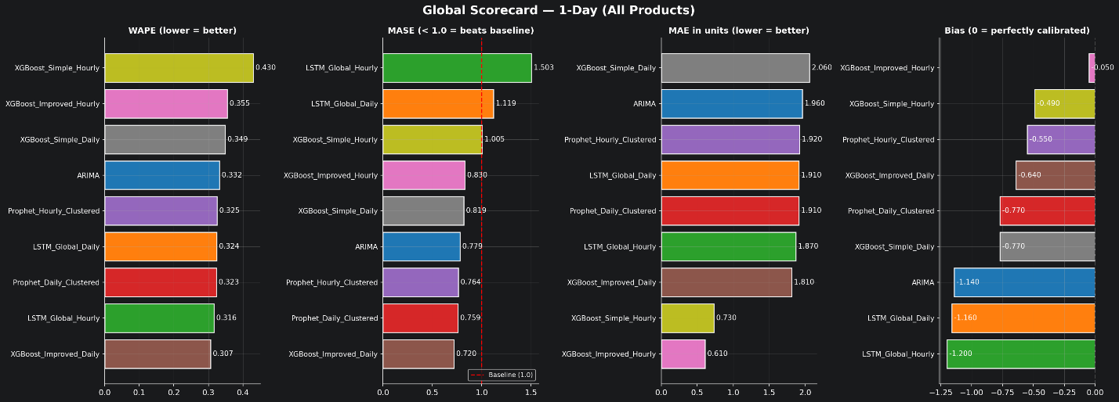
Figure 4.1 — Global Scorecard at the 1-Day horizon, ranked across all four North Star metrics.
At the 1-Day horizon, XGBoost Improved Daily achieved the lowest WAPE of 0.307, followed by LSTM Global Hourly at 0.316 and Prophet Daily Clustered at 0.323. However, the picture changes significantly when looking at MASE. While XGBoost Improved Daily scored a MASE of 0.720, comfortably beating the naïve baseline, LSTM Global Hourly posted a MASE of 1.503 — meaning it actually performed worse than simply repeating yesterday’s sales. This is a really important finding: a model can look reasonable on WAPE but still fail the MASE gate, confirming that MASE was the right metric to include in the framework.
The Bias column reveals another useful insight. XGBoost Improved Hourly was the most calibrated model with a Bias of just −0.05, meaning its predictions were almost perfectly centred on average. In contrast, LSTM Global Hourly had a Bias of −1.20 and ARIMA had −1.14, both systematically under-predicting. In a kitchen context, consistent under-prediction means stockouts and disappointed customers, while over-prediction means food waste. Table 4.1 summarises the global results across all three horizons.
Model | WAPE 1D | WAPE 1W | WAPE 1M | MASE 1D | MASE 1W | MASE 1M
XGBoost Imp. Daily | 0.307 | 0.366 | 0.404 | 0.720 | 0.884 | 0.921
Prophet Daily Cl. | 0.323 | 0.330 | 0.354 | 0.759 | 0.731 | 0.789
Prophet Hourly Cl. | 0.325 | 0.344 | 0.360 | 0.764 | 0.762 | 0.802
ARIMA (baseline) | 0.332 | 0.331 | 0.370 | 0.780 | 0.734 | 0.824
LSTM Global Daily | 0.324 | 0.314 | 0.356 | 1.119 | 0.837 | 0.933
LSTM Global Hourly | 0.316 | 0.352 | 0.473 | 1.503 | 1.289 | 1.680
XGBoost Imp. Hourly | 0.355 | 0.361 | 0.374 | 0.830 | 0.799 | 0.833
XGBoost Simple Daily | 0.349 | 0.332 | 0.372 | 0.819 | 0.735 | 0.829
XGBoost Simple Hourly | 0.430 | 0.392 | 0.471 | 1.005 | 0.869 | 1.050
Table 4.1 — Global scorecard across all horizons. MASE values above 1.0 indicate the model fails to beat the naïve lag-1 baseline.
Prophet Daily Clustered was the most consistent performer across all three horizons, achieving the best 1-Month WAPE (0.354) and competitive results at shorter horizons. The two models that consistently failed the MASE < 1.0 gate were LSTM Global Hourly and XGBoost Simple Hourly, suggesting that hourly-granularity data, when aggregated for daily prediction, can introduce noise rather than useful signal depending on the model architecture.
Per-Product Analysis.
The global scorecard hides an important detail: no single model is best for every product. The WAPE heatmaps in Figures 4.2 through 4.4 make this clearly visible. Each cell represents the WAPE score for a specific product-model combination, with darker green meaning better accuracy and red meaning worse.
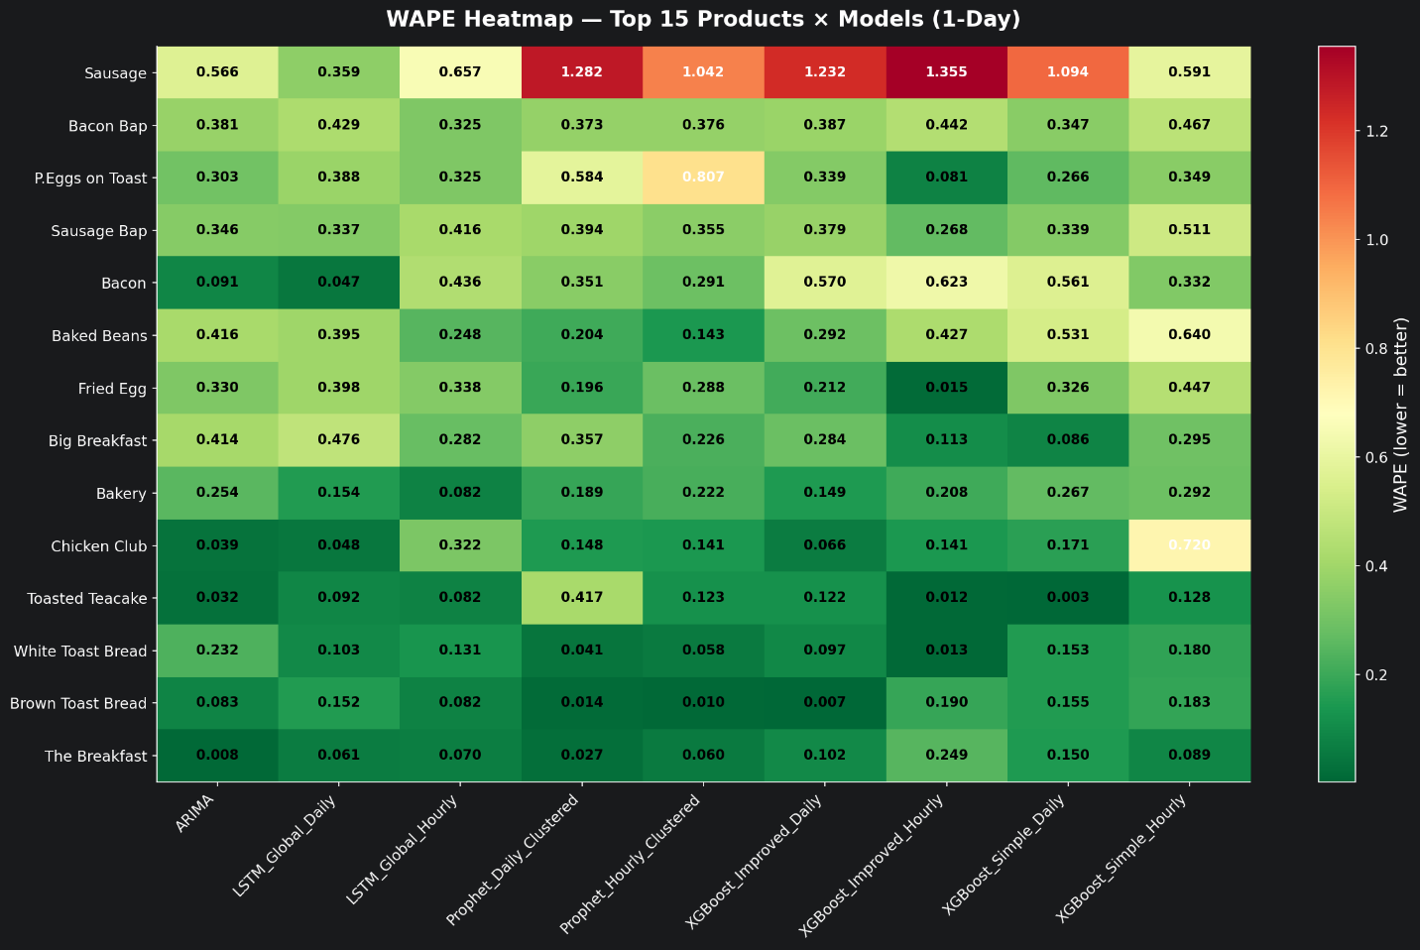
Figure 4.2 — WAPE Heatmap for the top 15 products at the 1-Day horizon.
At the 1-Day horizon (Figure 4.2), the variation across products is striking. High-volume, stable products like The Breakfast, Brown Toast Bread, and Bakery have very low WAPE values across almost all models — for example, The Breakfast achieved a WAPE of just 0.008 with ARIMA, meaning the model was off by less than 1% of total sales. These products have consistent daily demand patterns that even a simple statistical model can capture effectively. On the other end, Sausage was extremely difficult for most models, with WAPE values exceeding 1.0 for Prophet Daily Clustered (1.282), Prophet Hourly Clustered (1.042), XGBoost Improved Daily (1.232), XGBoost Improved Hourly (1.355), and XGBoost Simple Daily (1.094). Sausage is often ordered as a side item and its demand is highly variable day-to-day, making it inherently harder to forecast. Interestingly, LSTM Global Daily managed to handle Sausage relatively well at 0.359, suggesting it captured some pattern that the other models missed.
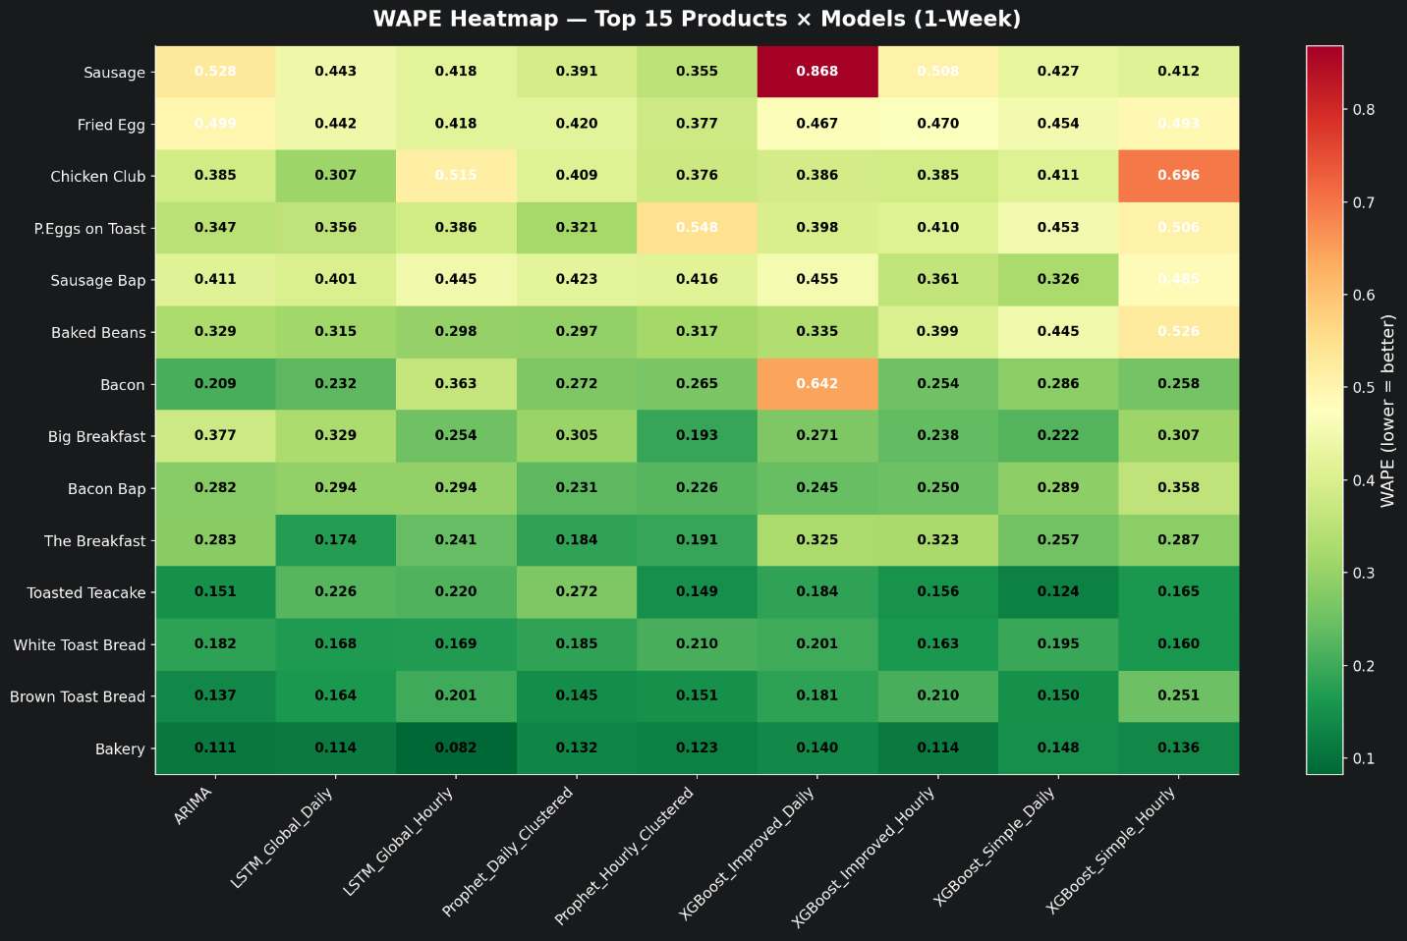
Figure 4.3 — WAPE Heatmap for the top 15 products at the 1-Week horizon.
At the 1-Week horizon (Figure 4.3), the pattern is broadly similar but with some interesting shifts. Sausage remains the hardest product to forecast, with XGBoost Improved Daily particularly struggling at 0.868. Prophet Hourly Clustered emerges as particularly strong for several products at this horizon — it achieved the best WAPE for Big Breakfast (0.193), Toasted Teacake (0.149), and Bakery (0.123). XGBoost Simple Daily, which looked unremarkable at 1-Day, becomes very competitive at 1-Week with strong results for Toasted Teacake (0.124) and Brown Toast Bread (0.150). This makes sense because models without lag features do not suffer from compounding error at longer horizons. P.Eggs on Toast shows an interesting anomaly where Prophet Hourly Clustered scores 0.548 — much worse than its overall strong performance — suggesting the model’s clustered hyperparameters are a poor fit for that particular product’s weekly demand pattern.
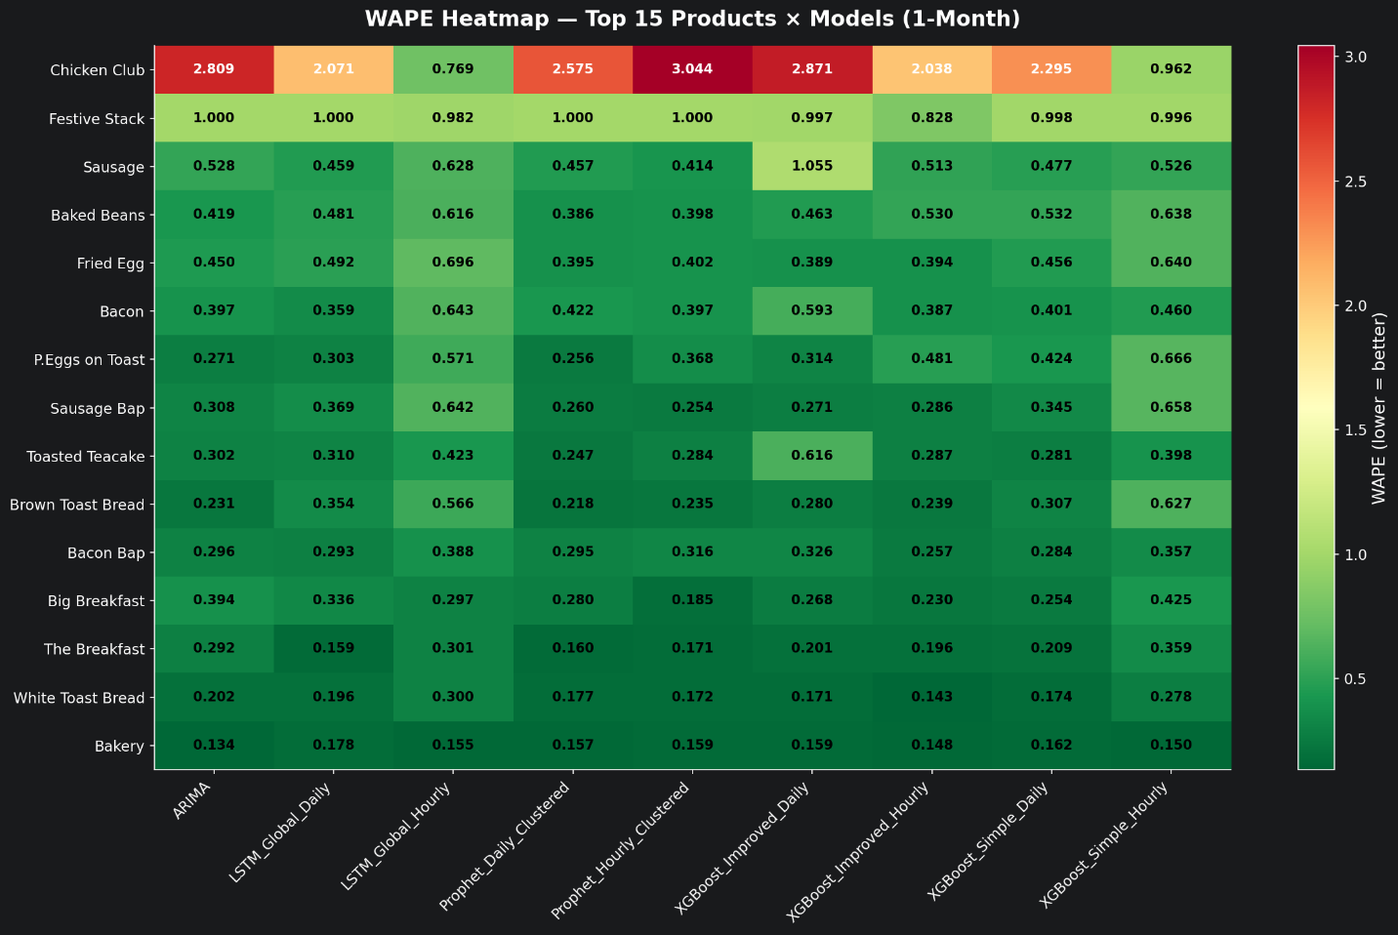
Figure 4.4 — WAPE Heatmap for the top 15 products at the 1-Month horizon.
The 1-Month heatmap (Figure 4.4) reveals the clearest “problem products”. Chicken Club has extreme WAPE values across the board — 2.809 for ARIMA, 2.071 for LSTM Global Daily, and 3.044 for Prophet Hourly Clustered. Even the best model (LSTM Global Hourly) only managed 0.769. Chicken Club is a lunch item with very low, sporadic sales volume, which means even small absolute errors translate into massive percentage errors. Festive Stack is another outlier, with WAPE values at or near 1.000 for almost every model, which is likely because it is a seasonal item that appeared during the test period with no historical precedent for the models to learn from. Meanwhile, the high-volume products remain very predictable: Bakery stays below 0.178 across all models, and The Breakfast stays below 0.359. These edge cases are exactly where the Human-in-the-Loop design from Section 2.1.5 becomes essential — the system should flag these low-confidence forecasts so the chef can apply their own judgement.
Best Model Selection. Table 4.2 shows how many products each model “won” (achieved the lowest WAPE) at each horizon.

Model | 1-Day Wins | 1-Week Wins | 1-Month Wins
XGBoost Improved Hourly | 8 | 2 | 5
XGBoost Improved Daily | 7 | 5 | 8
Prophet Hourly Clustered | 7 | 7 | 8
LSTM Global Daily | 7 | 7 | 10
XGBoost Simple Daily | 4 | 7 | 6
LSTM Global Hourly | 4 | 5 | 2
ARIMA | 2 | 5 | 3
Prophet Daily Clustered | 1 | 7 | 7
XGBoost Simple Hourly | 1 | 3 | 0
Table 4.2 — Number of products where each model achieved the lowest WAPE, by horizon.
The wins are spread fairly evenly across models, which strongly supports the per-product selection approach rather than deploying a single model. When using the automated best-model selection pipeline from Section 3.7.1, the mean best WAPE at the 1-Day horizon drops to 0.219 — a meaningful improvement over any individual model’s global WAPE. Furthermore, 88% of products achieved a best-model WAPE below 0.50 at 1-Day, and 58% were below 0.20, meaning the system provides genuinely actionable forecasts for the majority of the menu.

Product_name | ARIMA | LSTM_Global_Daily | LSTM_Global_Hourly | Prophet_Daily_Clustered | Prophet_Hourly_Clustered
Bacon | 0.0911 | 0.0470 * | 0.4363 | 0.3507 | 0.2906
Bacon Bap | 0.3807 | 0.4293 | 0.3254 * | 0.3728 | 0.3758
Baked Beans | 0.4159 | 0.3953 | 0.2476 | 0.2044 | 0.1434 *
Bakery | 0.2537 | 0.1544 | 0.0818 * | 0.1891 | 0.2216
Big Breakfast | 0.4139 | 0.4762 | 0.2824 | 0.3570 | 0.2255
Brown Toast Bread | 0.0831 | 0.1525 | 0.0815 | 0.0136 | 0.0104
Chicken Club | 0.0390 * | 0.0479 | 0.3222 | 0.1481 | 0.1413
Fried Egg | 0.3300 | 0.3978 | 0.3383 | 0.1958 | 0.2881
P.Eggs on Toast | 0.3034 | 0.3880 | 0.3254 | 0.5843 | 0.8074
Sausage | 0.5664 | 0.3595 * | 0.6569 | 1.2818 | 1.0417
Sausage Bap | 0.3456 | 0.3373 | 0.4156 | 0.3942 | 0.3546
The Breakfast | 0.0084 * | 0.0611 | 0.0698 | 0.0267 | 0.0597
Toasted Teacake | 0.0318 | 0.0921 | 0.0820 | 0.4174 | 0.1228
White Toast Bread | 0.2324 | 0.1033 | 0.1312 | 0.0406 | 0.0580

Product_name | XGBoost_Improved_Daily | XGBoost_Improved_Hourly | XGBoost_Simple_Daily | XGBoost_Simple_Hourly
Bacon | 0.5702 | 0.6225 | 0.5606 | 0.3323
Bacon Bap | 0.3868 | 0.4417 | 0.3467 | 0.4672
Baked Beans | 0.2924 | 0.4270 | 0.5315 | 0.6401
Bakery | 0.1486 | 0.2082 | 0.2671 | 0.2919
Big Breakfast | 0.2843 | 0.1134 | 0.0855 * | 0.2955
Brown Toast Bread | 0.0070 * | 0.1898 | 0.1546 | 0.1829
Chicken Club | 0.0656 | 0.1410 | 0.1710 | 0.7204
Fried Egg | 0.2116 | 0.0147 * | 0.3262 | 0.4474
P.Eggs on Toast | 0.3393 | 0.0814 * | 0.2662 | 0.3488
Sausage | 1.2315 | 1.3547 | 1.0942 | 0.5914
Sausage Bap | 0.3785 | 0.2677 * | 0.3386 | 0.5107
The Breakfast | 0.1024 | 0.2492 | 0.1498 | 0.0886
Toasted Teacake | 0.1223 | 0.0118 | 0.0030 * | 0.1278
White Toast Bread | 0.0972 | 0.0126 * | 0.1531 | 0.1800
* HEAD-TO-HEAD: Top 15 Products (WAPE, 1-Day) , the table is split in 2 because of the width, * = best model for that product
Horizon Degradation.
Figure 4.5 plots WAPE and MASE across the three horizons for all models.
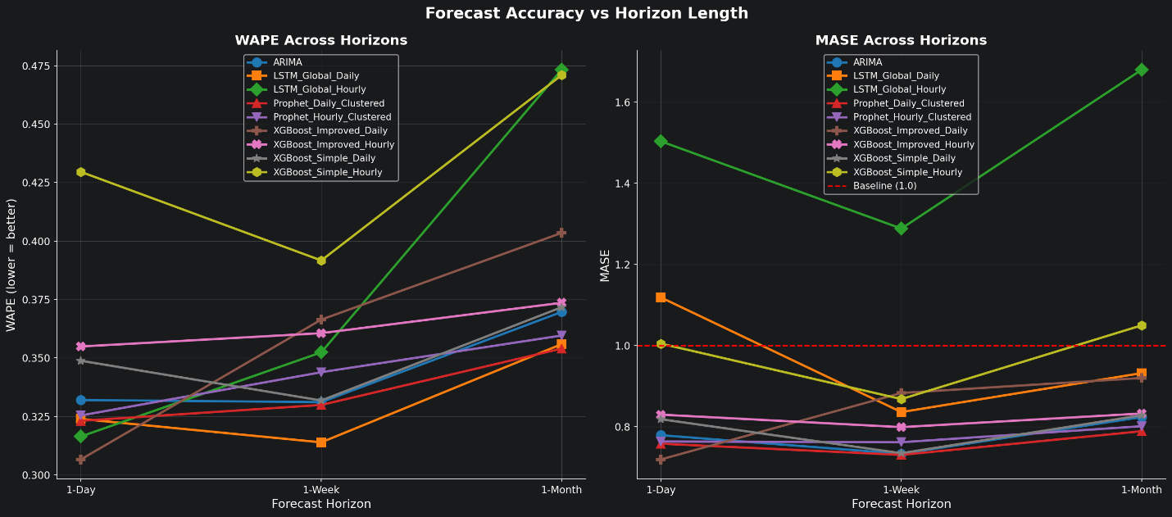
Figure 4.5 — Forecast accuracy (WAPE and MASE) vs horizon length. The red dashed line marks the naïve baseline threshold (MASE = 1.0).
LSTM Global Hourly degrades the most dramatically: its WAPE rises from 0.316 at 1-Day to 0.473 at 1-Month (a 50% increase), and its MASE climbs from an already-poor 1.503 to 1.680. Prophet Daily Clustered shows remarkable stability, with WAPE only increasing from 0.323 to 0.354 (a 10% increase). XGBoost Improved Daily shows the best 1-Day performance but degrades faster than simpler models at longer horizons — a direct consequence of recursive forecasting, where errors in early predictions compound through the lag features. The simple XGBoost variant, with no lag features, actually holds up better at 1-Month (0.372 vs 0.404).

Visual Forecast Inspection.
Figure 4.6 shows the forecast overlay for The Breakfast, the café’s highest-volume product.
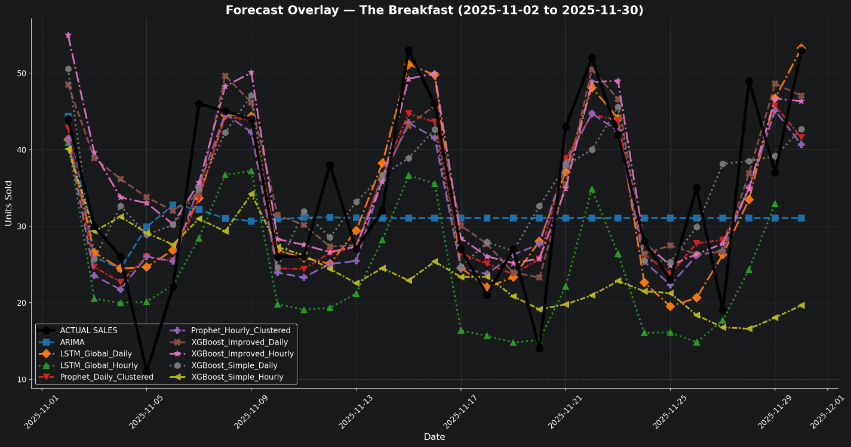
Figure 4.6 — Forecast overlay for The Breakfast, November 2025. All nine model predictions plotted against actual sales.
Several things are immediately visible. The actual sales (black line) show a clear weekly pattern with peaks roughly every 7 days, likely corresponding to weekends. ARIMA (blue dashed line) produces a flat forecast that converges to the series mean — not terrible, but clearly missing the weekly peaks and troughs. XGBoost Improved Daily and LSTM Global Daily track the peaks more closely, though they occasionally overshoot. LSTM Global Hourly (green triangles) consistently sits below the actual line, matching its high negative bias of −1.20 from the global scorecard. Towards the end of November (around the 27th–30th), there is a sharp upward spike in actual sales that most models fail to capture. Looking at the external data, this coincides with the approach of St Andrew’s Day (November 30th), which is a Scottish holiday. The models that used holiday features (Prophet and XGBoost Improved) do slightly better here, but the spike is still larger than any of them predicted, suggesting the holiday importance scoring might need to be more aggressive for events that directly affect food demand.

4.1.2 LSEPS Evaluation of the Implementation
Beyond raw accuracy, the system must also be evaluated against the LSEPS requirements from Section 2.1.5. Legally, the system supports compliance with the Circular Economy (Scotland) Act 2024 by providing data-driven prep targets, processes only aggregated sales counts with no personally identifiable data (GDPR compliance), and satisfies Article 22 through its Human-in-the-Loop design where every forecast is a recommendation the chef can override. Socially and ethically, the Co-bot approach mitigates the risk of algorithmic management and deskilling by showing contextual information alongside predictions — such as holiday flags and weather conditions — so staff understand why a forecast was made. XGBoost's feature importance scores further support this transparency. Professionally, all experiments were tracked in the SQLite database with full metadata, creating a complete audit trail, and the MASE < 1.0 gate ensures only models that outperform the naïve baseline are recommended for deployment. On the security side, the system was verified to still produce forecasts when external APIs are unavailable (using the XGBoost Simple fallback), all data is stored locally with no cloud dependencies, and the retraining pipeline from Section 3.7 addresses model drift risk.

4.2 Project Evaluation
This section steps back from the technical results and evaluates whether the project as a whole achieved what it set out to do.

4.2.1 Revisiting Aims and Objectives
The primary aim of this project was to develop a machine learning-based demand forecasting system that could help a real café in Aberdeen reduce food waste by replacing static par levels with data-driven preparation targets. This aim was operationalised through four desirable features (D1–D4) defined in Section 2.2.1. Table 4.3 evaluates the final system against each of these.
Requirement | Description | Met? | Evidence
D1: Proactive | Prevents waste before prep | Yes | System generates forecasts before the kitchen day begins, enabling proactive prep adjustment.
D2: Exogenous | Accounts for weather, events, holidays | Yes | Weather API, holiday CSV, and local events data integrated as model features. Prophet and XGBoost Improved use all three.
D3: Granular | Predicts at SKU level | Yes | All 64 products forecasted individually. Per-product best-model selection ensures accuracy at item level.
D4: Low Cost | No expensive hardware | Yes | Entire system runs on standard hardware with open-source libraries. No cameras, scales, or IoT devices required.
Table 4.3 — Evaluation of the final system against the four desirable features.
Beyond the four desirable features, the project also set out to compare multiple modelling approaches and determine which was best suited to each operational use case. This objective was met comprehensively: nine model configurations were implemented, tuned, and compared across three forecast horizons using four evaluation metrics. The comparison revealed that no single model dominates across all products and horizons, validating the design decision to build an automated best-model selection pipeline rather than committing to a single approach.
The three report types outlined in Section 2.4 — 1-Day prep report, 1-Week supplier order, and 1-Month executive summary — were all implemented and can be generated from the forecast output. The evaluation showed that different models are best suited to each: XGBoost Improved Daily excels at 1-Day forecasts (WAPE 0.307), while Prophet Daily Clustered is more reliable for the 1-Month horizon (WAPE 0.354). This directly informs which model should feed each report type in a production deployment.

4.2.2 Reflection on Professional Development
Reflecting on this project using Gibbs’ reflective cycle (The University of Edinburgh, 2024), there are several key learning points that have shaped my professional development as a computing student.

Description
The project required me to move from understanding machine learning concepts in a classroom setting to actually implementing and debugging them on real, messy data. I built five different model families (ARIMA, Prophet, XGBoost Simple, XGBoost Improved, and LSTM), each with both daily and hourly variants, trained on three years of real point-of-sale data from a café in Aberdeen.

Feelings
Early in the project I felt quite confident about the LSTM approach, expecting it to outperform the simpler models because of its ability to learn complex temporal patterns. When the results showed that LSTM Global Hourly consistently failed the MASE baseline, I was initially frustrated and assumed I had a bug somewhere. After debugging extensively, I realised the results were genuine — the model was overfitting to noise in the hourly data. This was a humbling moment that changed how I think about model complexity.

Evaluation
What went well was the disciplined experimental setup — using the same train/test split, the same metrics, and the SQLite tracking database across all models made the comparisons fair and reproducible. What did not go as well was time management around the LSTM training; the GPU memory issues with the hourly LSTM (Section 3.4.4) consumed several days of debugging that could have been spent on improving the report generation interface or conducting a real-world pilot with the café.

Analysis
The key insight from this project is that model complexity does not always lead to better results. XGBoost Improved Daily, which is essentially a well-engineered gradient boosting model, outperformed both LSTM variants at the most critical 1-Day horizon despite being a much simpler model to train and interpret. This aligns with the literature (Shah, Myller and Sedano, 2025) but experiencing it firsthand with real data made the lesson stick. I also learned the practical importance of the MASE metric — without it, I might have deployed LSTM Global Hourly based on its competitive WAPE alone, not realising it was actually worse than a naïve baseline.

Conclusion
I now have a much stronger appreciation for rigorous evaluation methodology. The North Star metric framework was one of the best design decisions in the project, and I would use a similar multi-metric approach in any future forecasting work. I also learned the value of starting with a simple baseline (ARIMA) and incrementally adding complexity, rather than jumping straight to the most sophisticated model.

4.2.3 LSEPS Considerations at the Project Level
At the project level, the LSEPS analysis from Section 2.1.5 directly shaped practical design decisions. The legal requirement for human oversight (GDPR Article 22) led to the Co-bot philosophy, the social risk of deskilling informed the choice to show contextual explanations alongside forecasts, and the security concern about model drift motivated the automated retraining pipeline. Professionally, this project reinforced the importance of rigorous testing before deployment — not all ML models beat the ARIMA baseline (LSTM Global Hourly did not), proving that the professional duty to “do no harm” applies equally to data science. Ethically, the per-product analysis revealed that low-volume products like Chicken Club receive much worse predictions than high-volume ones, which could lead to disproportionate waste if deployed without been flagged. A future version should include confidence scores so staff can immediately see which forecasts to trust and which to question

References
Jackman, J. (2024). Food waste facts and statistics - The Eco Experts. [online] The Eco Experts. Available at: https://www.theecoexperts.co.uk/news/food-waste-facts-and-statistics.
‌ UNEP (2024). Food Waste Index Report 2024. [online] UNEP - UN Environment Programme. Available at: https://www.unep.org/resources/publication/food-waste-index-report-2024.
WRAP. (n.d.). The true cost of waste in hospitality and food service. [online] Available at: https://www.wrap.ngo/resources/report/true-cost-waste-hospitality-and-food-service.
champions123.org. (n.d.). The Business Case for Reducing Food Loss and Waste: Restaurants | Champions 12.3. [online] Available at: https://champions123.org/publication/business-case-reducing-food-loss-and-waste-restaurants.
‌Filimonau, V., Todorova, E., Mzembe, A., Sauer, L. and Yankholmes, A. (2020). A comparative study of food waste management in full service restaurants of the United Kingdom and the Netherlands. Journal of Cleaner Production, 258, p.120775.
WRAP (2013). Overview of waste in the hospitality and food service sector. [online] WRAP. Available at: https://www.wrap.ngo/resources/report/overview-waste-hospitality-and-food-service-sector.
‌ Papargyropoulou, E., Steinberger, J.K., Wright, N., Lozano, R., Padfield, R. and Ujang, Z. (2019). Patterns and Causes of Food Waste in the Hospitality and Food Service Sector: Food Waste Prevention Insights from Malaysia. Sustainability, [online] 11(21), p.6016. doi:https://doi.org/10.3390/su11216016.
Jenkins, A. (2021). 8 Best Practices in Restaurant Inventory Management. [online] Oracle NetSuite. Available at: https://www.netsuite.com/portal/resource/articles/inventory-management/restaurant-inventory-management.shtml.
‌ Slimstock (2025). Forecasting in food: The three major dilemmas. [online] Slimstock. Available at: https://www.slimstock.com/blog/forecasting-in-food-the-three-major-dilemmas/.
‌ Mohammed, I. and Mandal, J. (2024). The Impact of Lead Time Variability on Supply Chain Management. International Journal of Supply Chain Management, [online] 8(2), pp.41–55. doi:https://doi.org/10.47604/ijscm.3075.
‌ Bland, A. (2022). PAR Levels in Inventory Management (with Formula & Examples). [online] Unleashedsoftware.com. Available at: https://www.unleashedsoftware.com/blog/par-levels-in-inventory-management-with-formula-examples/.
‌ Gómez-Talal, I., González-Serrano, L., Talón-Ballestero, P. and José Luis Rojo-Álvarez (2024). Big Data in Restaurant Management: Unsupervised Modelling of Ticket Data and Environmental Variables for Sales Forecasting. Springer proceedings in business and economics, pp.159–168. doi:https://doi.org/10.1007/978-3-031-52607-7_15.
‌ Legislation.gov.uk. (2024). Circular Economy (Scotland) Act 2024. [online] Available at: https://www.legislation.gov.uk/asp/2024/13.
‌ ICO (2024). Principle (c): Data Minimisation. [online] Ico.org.uk. Available at: https://ico.org.uk/for-organisations/uk-gdpr-guidance-and-resources/data-protection-principles/a-guide-to-the-data-protection-principles/data-minimisation/.
ICO (n.d.) .Automated decision- making and profiling. (n.d.). Available at: https://ico.org.uk/media2/bibhz1gs/existing-guidance-automated-decision-making-and-profiling.pdf.
‌ Sharma, S., Mittal, A. and Seema, S. (2026). Does leading through algorithmic management impact the workers’ well-being: a systematic literature review and research agenda. Leadership & Organization Development Journal, pp.1–25. doi:https://doi.org/10.1108/lodj-06-2025-0424.
Pratik Sapkota, Makkonen, M., Henri Pirkkalainen and Salo, M. (2025). From Technostressors to AI-Stressors: A Systematic Literature Review of Stressors Associated with AI Systems. [online] Tampere University Research Portal. Available at: http://researchportal.tuni.fi/en/publications/from-technostressors-to-ai-stressors-a-systematic-literature-revi/ .
Zhao, P., Zhu, W., Jiao, P., Gao, D. and Wu, O. (2025). Data Poisoning in Deep Learning: A Survey. [online] arXiv.org. Available at: https://arxiv.org/abs/2503.22759.
‌ Graber, J. (2023). Hotel Tech-in: An AI-assisted kitchen solution to help hotels tackle food waste. [online] Hotel Dive. Available at: https://www.hoteldive.com/news/ai-assisted-kitchen-solution-to-reduce-food-waste/649553/.
Clark, Q.M., Kanavikar, D.B., Clark, J. and Donnelly, P.J. (2025). Exploring the potential of AI-driven food waste management strategies used in the hospitality industry for application in household settings. Frontiers in Artificial Intelligence, 7. doi:https://doi.org/10.3389/frai.2024.1429477.
‌ Schmidt, A., Kabir, M.W.U. and Hoque, M.T. (2022). Machine Learning Based Restaurant Sales Forecasting. Machine Learning and Knowledge Extraction, [online] 4(1), pp.105–130. doi:https://doi.org/10.3390/make4010006.
Lasek, A., Cercone, N. and Saunders, J. (2016). Restaurant Sales and Customer Demand Forecasting: Literature Survey and Categorization of Methods. Smart City 360°, 166, pp.479–491. doi:https://doi.org/10.1007/978-3-319-33681-7_40.
‌ Posch, K., Truden, C., Hungerländer, P. and Pilz, J. (2021). A Bayesian approach for predicting food and beverage sales in staff canteens and restaurants. International Journal of Forecasting, 38(1). doi:https://doi.org/10.1016/j.ijforecast.2021.06.001.
‌ Jiang, C. (2024). Comparative Analysis of ARIMA and Deep Learning Models for Time Series Prediction. Proceedings of the 2nd International Conference on Data Analysis and Machine Learning, pp.306–310. doi:https://doi.org/10.5220/0013516200004619.
‌Shah, H., Myller, N. and Sedano, C.I. (2025). Forecasting daily customer flow in restaurants: a multifactor machine learning approach. Applied Computing and Intelligence, 5(2), pp.168–190. doi:https://doi.org/10.3934/aci.2025011.
Huang, Q., Zhou, Z., Yang, K. and Wang, Y. (2025). Exploiting Language Power for Time Series Forecasting with Exogenous Variables. pp.4043–4052. doi:https://doi.org/10.1145/3696410.3714793.
‌Trainindata.com. (2018). CyclicalFeatures — 1.8.3. [online] Available at: https://feature-engine.trainindata.com/en/1.8.x/user_guide/creation/CyclicalFeatures.html.
‌Montero-Manso, P. and Hyndman, R.J. (2021). Principles and algorithms for forecasting groups of time series: Locality and globality. International Journal of Forecasting. doi:https://doi.org/10.1016/j.ijforecast.2021.03.004.
‌Hyndman, R.J. and Koehler, A.B. (2006). Another look at measures of forecast accuracy. International Journal of Forecasting, 22(4), pp.679–688. doi:https://doi.org/10.1016/j.ijforecast.2006.03.001.
‌ Ben Taieb, S., Bontempi, G., Atiya, A.F. and Sorjamaa, A. (2012). A review and comparison of strategies for multi-step ahead time series forecasting based on the NN5 forecasting competition. Expert Systems with Applications, 39(8), pp.7067–7083. doi:https://doi.org/10.1016/j.eswa.2012.01.039.
‌ The University of Edinburgh (2024). Gibbs’ Reflective Cycle. [online] The University of Edinburgh. Available at: https://reflection.ed.ac.uk/reflectors-toolkit/reflecting-on-experience/gibbs-reflective-cycle.

‌

