

**NIKHITHA CHATLA**

3rd Year Engineering Graduate +91 7569996012

Computer Science and Engineering [nikhithachatla6@gmail.com](mailto:nikhithachatla6@gmail.com) Vaagdevi College of Engineering [www.vaagdevi.edu.in](http://www.vaagdevi.edu.in/)

<https://github.com/fallenscent22> <https://www.codechef.com/users/nikhitha08>

<https://fallenscent22.github.io/My-Portfolio/>

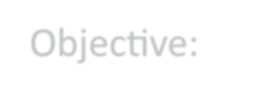

* Objective:

Enthusiastic computer science student with hands-on experience in software development projects, seeking an internship/entry-level position to apply and expand my programming skills. Passionate about learning and contributing to innovative software solutions.

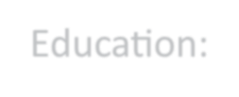

* Education:

BTech in CSE from Vaagdevi College of Engineering (2022-2026) 7.7/10

Senior Secondary Education (2020-2022) 9.1/10

Secondary Education (2020) 9.2/10

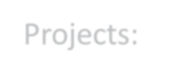

* Projects:

Developed a **Face Recognition System** using Python and OpenCV which detects humans faces with trained Data.

A **Medical chatbot** using Retrieval-Augmented Generation (RAG) with the LangChain framework and the BioMistral model. The chatbot is designed to provide medical information and assistance based on user Queries.

Developed a feature-rich **Digital Payment Wallet** using the MERN stack to facilitate seamless digital transactions automate recurring payments, and encourage smart savings for users.

# Skills:

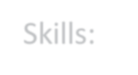

* + Technical: C and C++.
    - Data structures and Algorithms.
  + Functional: Team management, Leadership skills, Hardworking.

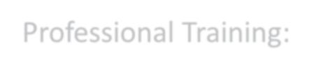

# Professional Training:

* + MERN stack by Next-Gen(EDU-net)