Студент:Аксенов А.Е.
Группа:М80-308Б-18
Номер по списку:1

«СИСТЕМЫ ПРОГРАММИРОВАНИЯ»
Курсовая работа 2020.
Часть 1.

Перечень документов в отчете.
Вариант грамматики:n01(заменить своим)

Распечатка файла code-gen.cpp.
>

/* $n01 */
#include "code-gen.h"
using namespace std;
int tCG::p01(){ // S -> PROG
string header ="/* " + lex.Authentication()+" */\n";
header += "#include \"mlisp.h\"\n";
header += declarations;
header += "//________________ \n";
S1->obj = header + S1->obj;
return 0;}
int tCG::p02(){ // PROG -> CALCS
S1->obj = "int main(){\n" + S1->obj
+ " std::cin.get();\n return 0;\n}\n";
return 0;}
int tCG::p03(){ // PROG -> DEFS
S1->obj += "int main(){\n"
" display(\"No calculations!\");newline();\n"
" std::cin.get();\n return 0;\n}\n";
return 0;}
int tCG::p04(){ // PROG -> DEFS CALCS
S1->obj += "int main(){\n" + S2->obj
+ " std::cin.get();\n return 0;\n}\n";
return 0;}
int tCG::p05(){ // E -> $id
S1->obj = decor(S1->name);
return 0;}
int tCG::p06(){ // E -> $int
S1->obj = S1->name + ".";
return 0;}
int tCG::p07(){ // E -> $dec
S1->obj = S1->name;
return 0;}
int tCG::p08(){ // E -> ADD
return 0;}
int tCG::p09(){ // E -> SUB
return 0;}
int tCG::p10(){ // E -> DIV
return 0;}
int tCG::p11(){ // E -> MUL
return 0;}
int tCG::p12(){ // E -> COND
return 0;}
int tCG::p13(){ // E -> CPROC
return 0;}
int tCG::p14(){ // ADD -> HADD E )
// S1->obj += (S1->count > 0 ? " + " : "+");
// S1->obj += S2->obj;
// S1->obj += ")";
if(S1->count == 0) {
S1->obj = S2->obj;
} else {
S1->obj += S2->obj;
}
S1->obj += ")";
S1->count = 0;
return 0;}
int tCG::p15(){ // HADD -> ( +
S1->obj = "(";
return 0;}
int tCG::p16(){ // HADD -> HADD E
// if(S1->count == 0) {
// S1->obj = S2->obj;
// } else {
// S1->obj += S2->obj;
// }
// // S1->obj += ")";
// S1->count = 0;
S1->obj += S2->obj + " + ";
S1->count++;
return 0;}
int tCG::p17(){ // SUB -> HSUB E )
S1->obj += S2->obj + ")";
return 0;}
int tCG::p18(){ // HSUB -> ( -
S1->obj = "(";
return 0;}
int tCG::p19(){ // HSUB -> HSUB E
S1->obj += S2->obj + " - ";
++S1->count;
return 0;}
int tCG::p20(){ // DIV -> ( / E )
S1->obj = "(1. / " + S3->obj + ")";
return 0;}
int tCG::p21(){ // MUL -> HMUL E )
if(S1->count == 0) {
S1->obj = S2->obj;
} else {
S1->obj += S2->obj;
}
S1->obj += ")";
S1->count = 0;
return 0;}
int tCG::p22(){ // HMUL -> ( *
S1->obj = "(";
return 0;}
int tCG::p23(){ // HMUL -> HMUL E
S1->obj += S2->obj + " * ";
S1->count++;
return 0;}

int tCG::p24(){ // COND -> HCOND ELSE )
S1->obj = S1->obj + S2->obj + ")";
return 0;}
int tCG::p25(){ // HCOND -> ( cond
S1->obj = "(";
return 0;}
int tCG::p26(){ // HCOND -> HCOND CLAUS
S1->obj += S2->obj;
return 0;}
int tCG::p27(){ // CLAUS -> HCLAUS E )
S1->obj += S2->obj + ") : ";
return 0;}
int tCG::p28(){ // HCLAUS -> ( BOOL
S1->obj = S2->obj + " ? (";
S1->count = 0;
return 0;}
int tCG::p29(){ // HCLAUS -> HCLAUS INTER
S1->obj += S2->obj + ", ";
++(S1->count);
return 0;}
int tCG::p30(){ // ELSE -> HELSE E )
S1->obj += S2->obj + ")";
return 0;}
int tCG::p31(){ // HELSE -> ( else
S1->count = 0;
S1->obj += "(";
return 0;}
int tCG::p32(){ // HELSE -> HELSE INTER
S1->obj += S2->obj + ", ";
++(S1->count);
return 0;}

int tCG::p33(){ // STR -> $str
S1->obj = decor(S1->name);
return 0;}
int tCG::p34(){ // CPROC -> HCPROC )
S1->obj += ")";
return 0;}
int tCG::p35(){ // HCPROC -> ( $id
S1->obj += decor(S2->name) + "(";
return 0;}
int tCG::p36(){ // HCPROC -> HCPROC E
if(S1->count)
S1->obj += ", ";
S1->obj += S2->obj;
++S1->count;
return 0;}
int tCG::p37(){ // BOOL -> $bool
if (S1->name == "#t") {
S1->obj = "true";
} else {
S1->obj = "false";
}
return 0;}
int tCG::p38(){ // BOOL -> $idq
S1->obj = decor(S1->name);
return 0;}
int tCG::p39(){ // BOOL -> REL
return 0;}
int tCG::p40(){ // BOOL -> CPRED
return 0;}
int tCG::p41(){ // CPRED -> HCPRED )
S1->obj += ")";
return 0;}
int tCG::p42(){ // HCPRED -> ( $idq
S1->obj = decor(S2->name) + "(";
return 0;}
int tCG::p43(){ // HCPRED -> HCPRED ARG
if(S1->count) S1->obj += ", ";
S1->obj += S2->obj;
++(S1->count);
return 0;}
int tCG::p44(){ // ARG -> E
return 0;}
int tCG::p45(){ // ARG -> BOOL
return 0;}
int tCG::p46(){ // REL -> ( = E E )
S1->obj = S3->obj + " == " + S4->obj;
return 0;}
int tCG::p47(){ // REL -> ( < E E )
S1->obj = "(" + S3->obj + " < " + S4->obj + ")";
return 0;}
int tCG::p48(){ // SET -> HSET E )
S1->obj += S2->obj;
return 0;}
int tCG::p49(){ // HSET -> ( set! $id
S1->obj = decor(S3->name) + " = ";
return 0;}
int tCG::p50(){ //DISPSET -> ( display E )
S1->obj = "display(" + S3->obj + ")";
return 0;}
int tCG::p51(){ //DISPSET -> ( display BOOL )
S1->obj = "display(" + S3->obj + ")";
return 0;}
int tCG::p52(){ //DISPSET -> ( display STR )
S1->obj = "display(" + S3->obj + ")";
return 0;}
int tCG::p53(){ //DISPSET -> ( newline )
S1->obj = "newline()";
return 0;}
int tCG::p54(){ //DISPSET -> SET
return 0;}
int tCG::p55(){ // INTER -> DISPSET
return 0;}
int tCG::p56(){ // INTER -> E
return 0;}
int tCG::p57(){ // CALCS -> CALC
return 0;}
int tCG::p58(){ // CALCS -> CALCS CALC
S1->obj += S2->obj;
return 0;}
int tCG::p59(){ // CALC -> E
S1->obj = " display("+S1->obj+"); newline();\n";
return 0;}
int tCG::p60(){ // CALC -> BOOL
S1->obj = " display("+S1->obj+"); newline();\n";
return 0;}
int tCG::p61(){ // CALC -> STR
S1->obj = " display("+S1->obj+"); newline();\n";
return 0;}
int tCG::p62(){ // CALC -> DISPSET
S1->obj += ";\n";
return 0;}
int tCG::p63(){ // DEFS -> DEF
return 0;}
int tCG::p64(){ // DEFS -> DEFS DEF
S1->obj += S2->obj;
return 0;}
int tCG::p65(){ // DEF -> PRED
return 0;}
int tCG::p66(){ // DEF -> VAR
return 0;}
int tCG::p67(){ // DEF -> PROC
return 0;}
int tCG::p68(){ // PRED -> HPRED BOOL )
S1->obj += "return " + S2->obj + ";\n}\n";
return 0;}
int tCG::p69(){ // HPRED -> PDPAR )
S1->obj += ")";
declarations += S1->obj + ";\n";
S1->obj += "{\n";
return 0;}
int tCG::p70(){ // PDPAR -> ( define ( $idq
S1->obj = "bool " + decor(S4->name) + "(";
S1->name = S4->name;
return 0;}
int tCG::p71(){ // PDPAR -> PDPAR $idq
if (S1->count) {
S1->obj += ", bool " + decor(S2->name);
} else {
S1->obj += "bool " + decor(S2->name);
}
++S1->count;
return 0;}
int tCG::p72(){ // PDPAR -> PDPAR $id
if (S1->count) {
S1->obj += ", double " + decor(S2->name);
} else {
S1->obj += "double " + decor(S2->name);
}
++S1->count;
return 0;}
int tCG::p73(){ // VAR -> VARDCL E )
S1->obj += S2->obj + ";\n";
declarations += S1->obj;
S1->obj = "";
return 0;}
int tCG::p74(){ // VARDCL -> ( define $id
S1->obj += "double " + decor(S3->name) + " = ";
return 0;}
int tCG::p75(){ // PROC -> HPROC BLOCK )
S1->obj += "{" + S2->obj + "}" + ";\n}\n";
return 0;}
int tCG::p76(){ // PROC -> HPROC E )
S1->obj += "return " + S2->obj+";\n}\n";
return 0;}
int tCG::p77(){ // HPROC -> PCPAR )
declarations += S1->obj + ");\n";
S1->obj = S1->obj + ") {\n";
S1->count = 0;
return 0;}
int tCG::p78(){ // HPROC -> HPROC INTER
S1->obj += S2->obj + ";\n";
return 0;}
int tCG::p79(){ // PCPAR -> ( define ( $id
S1->obj = "double " + decor(S4->name) + "(";
return 0;}
int tCG::p80(){ // PCPAR -> PCPAR $id
if(S1->count) S1->obj += ", ";
S1->obj += "double " + decor(S2->name);
S1->count++;
return 0;}
int tCG::p81(){ // BLOCK -> HBLOCK E )
S1->obj += "return " + S2->obj + ";\n";
return 0;}
int tCG::p82(){ // HBLOCK -> BLVAR )
S1->obj += ";\n";
return 0;}
int tCG::p83(){ // HBLOCK -> HBLOCK INTER
S1->obj += S2->obj + ";\n";
return 0;}
int tCG::p84(){ // BLVAR -> ( let ( LOCDEF
S1->obj += "double " + S4->obj;
return 0;}
int tCG::p85(){ // BLVAR -> BLVAR LOCDEF
S1->obj += ",\n" + S2->obj;
return 0;}
int tCG::p86(){ // LOCDEF -> ( $id E )
S1->obj = decor(S2->name) + "(" + S3->obj + ")";
return 0;}
//_____________________
int tCG::p87(){return 0;} int tCG::p88(){return 0;}
int tCG::p89(){return 0;} int tCG::p90(){return 0;}
int tCG::p91(){return 0;} int tCG::p92(){return 0;}
int tCG::p93(){return 0;} int tCG::p94(){return 0;}
int tCG::p95(){return 0;} int tCG::p96(){return 0;}
int tCG::p97(){return 0;} int tCG::p98(){return 0;}
int tCG::p99(){return 0;} int tCG::p100(){return 0;}
int tCG::p101(){return 0;} int tCG::p102(){return 0;}
int tCG::p103(){return 0;} int tCG::p104(){return 0;}
int tCG::p105(){return 0;} int tCG::p106(){return 0;}
int tCG::p107(){return 0;} int tCG::p108(){return 0;}
int tCG::p109(){return 0;} int tCG::p110(){return 0;}

Контрольная задача №1 – bit-count.

Полный скриншот трансляции без трассировки (крупный белый шрифт на ярком черном фоне).
>

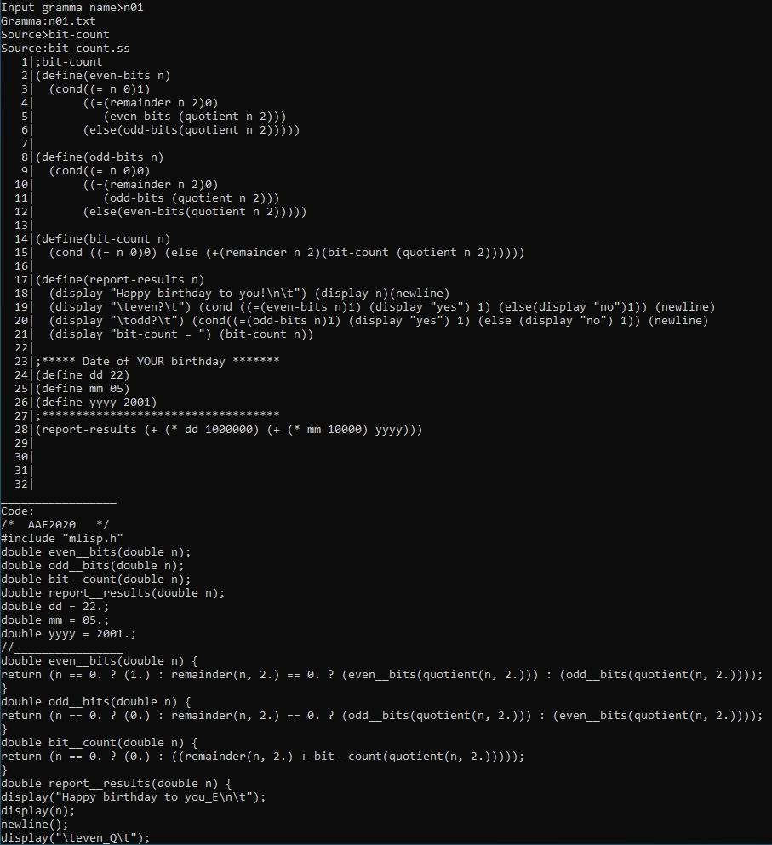

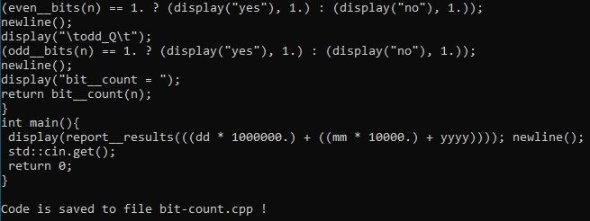

Распечатка файла bit-count.cpp .
>

/* AAE2020 */
#include "mlisp.h"
double even__bits(double n);
double odd__bits(double n);
double bit__count(double n);
double report__results(double n);
double dd = 22.;
double mm = 05.;
double yyyy = 2001.;
//________________
double even__bits(double n) {
return (n == 0. ? (1.) : remainder(n, 2.) == 0. ? (even__bits(quotient(n, 2.))) : (odd__bits(quotient(n, 2.))));
}
double odd__bits(double n) {
return (n == 0. ? (0.) : remainder(n, 2.) == 0. ? (odd__bits(quotient(n, 2.))) : (even__bits(quotient(n, 2.))));
}
double bit__count(double n) {
return (n == 0. ? (0.) : ((remainder(n, 2.) + bit__count(quotient(n, 2.)))));
}
double report__results(double n) {
display("Happy birthday to you_E\n\t");
display(n);
newline();
display("\teven_Q\t");
(even__bits(n) == 1. ? (display("yes"), 1.) : (display("no"), 1.));
newline();
display("\todd_Q\t");
(odd__bits(n) == 1. ? (display("yes"), 1.) : (display("no"), 1.));
newline();
display("bit__count = ");
return bit__count(n);
}
int main(){
display(report__results(((dd * 1000000.) + ((mm * 10000.) + yyyy)))); newline();
std::cin.get();
return 0;
}

Скриншот запуска задачи на С++.
>
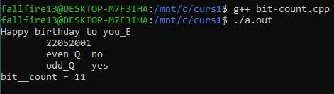
Скриншот запуска задачи на Лиспе.

>

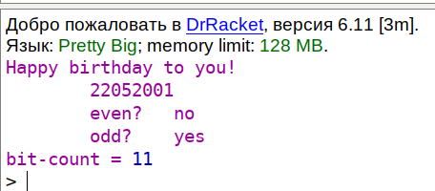

Контрольная задача №2 – golden-section20.

Полный скриншот трансляции без трассировки (крупный белый шрифт на ярком черном фоне).
>

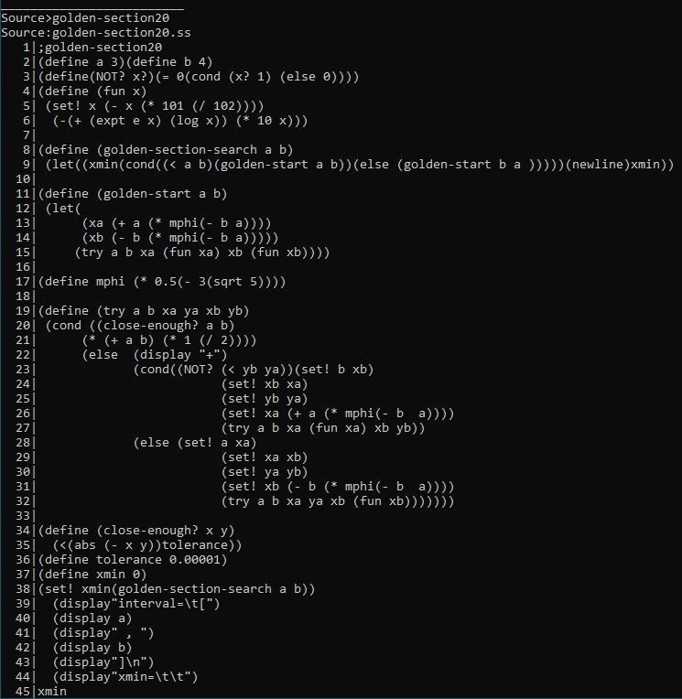

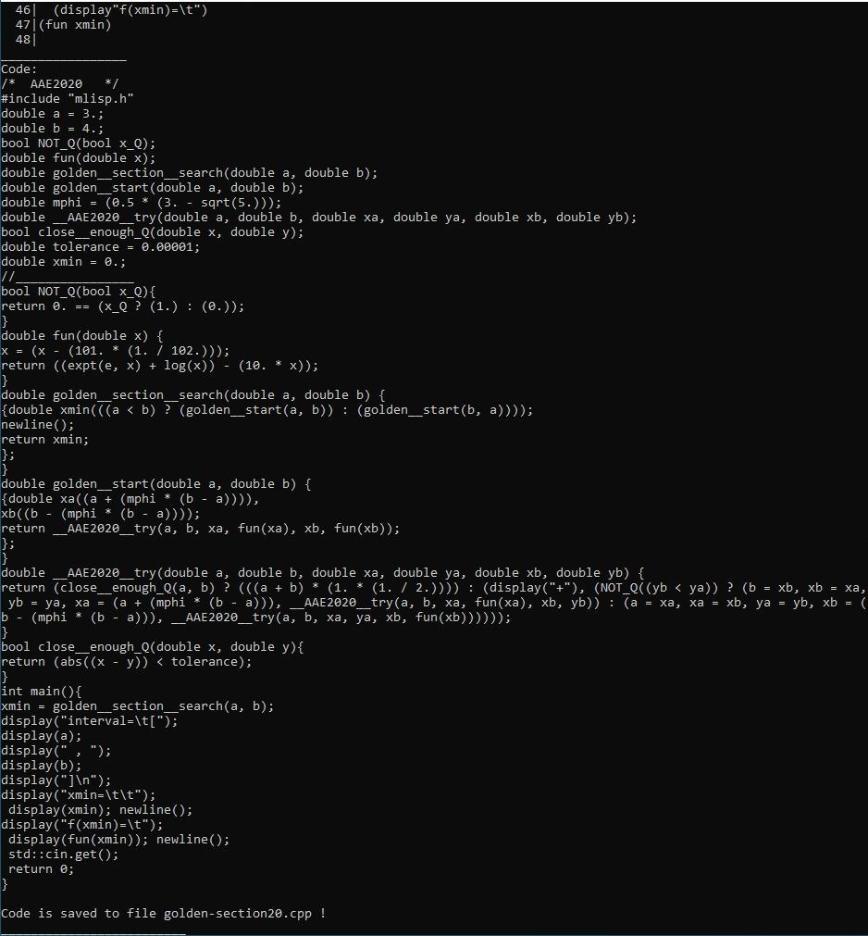

Распечатка файла golden-section20.cpp .
>

/* AAE2020 */
#include "mlisp.h"
double a = 3.;
double b = 4.;
bool NOT_Q(bool x_Q);
double fun(double x);
double golden__section__search(double a, double b);
double golden__start(double a, double b);
double mphi = (0.5 * (3. - sqrt(5.)));
double __AAE2020__try(double a, double b, double xa, double ya, double xb, double yb);
bool close__enough_Q(double x, double y);
double tolerance = 0.00001;
double xmin = 0.;
//________________
bool NOT_Q(bool x_Q){
return 0. == (x_Q ? (1.) : (0.));
}
double fun(double x) {
x = (x - (101. * (1. / 102.)));
return ((expt(e, x) + log(x)) - (10. * x));
}
double golden__section__search(double a, double b) {
{double xmin(((a < b) ? (golden__start(a, b)) : (golden__start(b, a))));
newline();
return xmin;
};
}
double golden__start(double a, double b) {
{double xa((a + (mphi * (b - a)))),
xb((b - (mphi * (b - a))));
return __AAE2020__try(a, b, xa, fun(xa), xb, fun(xb));
};
}
double __AAE2020__try(double a, double b, double xa, double ya, double xb, double yb) {
return (close__enough_Q(a, b) ? (((a + b) * (1. * (1. / 2.)))) : (display("+"), (NOT_Q((yb < ya)) ? (b = xb, xb = xa, yb = ya, xa = (a + (mphi * (b - a))), __AAE2020__try(a, b, xa, fun(xa), xb, yb)) : (a = xa, xa = xb, ya = yb, xb = (b - (mphi * (b - a))), __AAE2020__try(a, b, xa, ya, xb, fun(xb))))));
}
bool close__enough_Q(double x, double y){
return (abs((x - y)) < tolerance);
}
int main(){
xmin = golden__section__search(a, b);
display("interval=\t[");
display(a);
display(" , ");
display(b);
display("]\n");
display("xmin=\t\t");
display(xmin); newline();
display("f(xmin)=\t");
display(fun(xmin)); newline();
std::cin.get();
return 0;
}

Скриншот запуска задачи на С++.
>

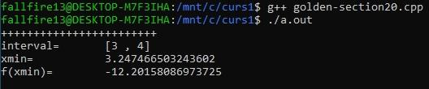

Скриншот запуска задачи на Лиспе.

>
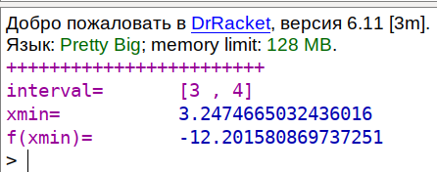

Контрольная задача №3 – coin20.

Полный скриншот трансляции без трассировки (крупный белый шрифт на ярком черном фоне).
>

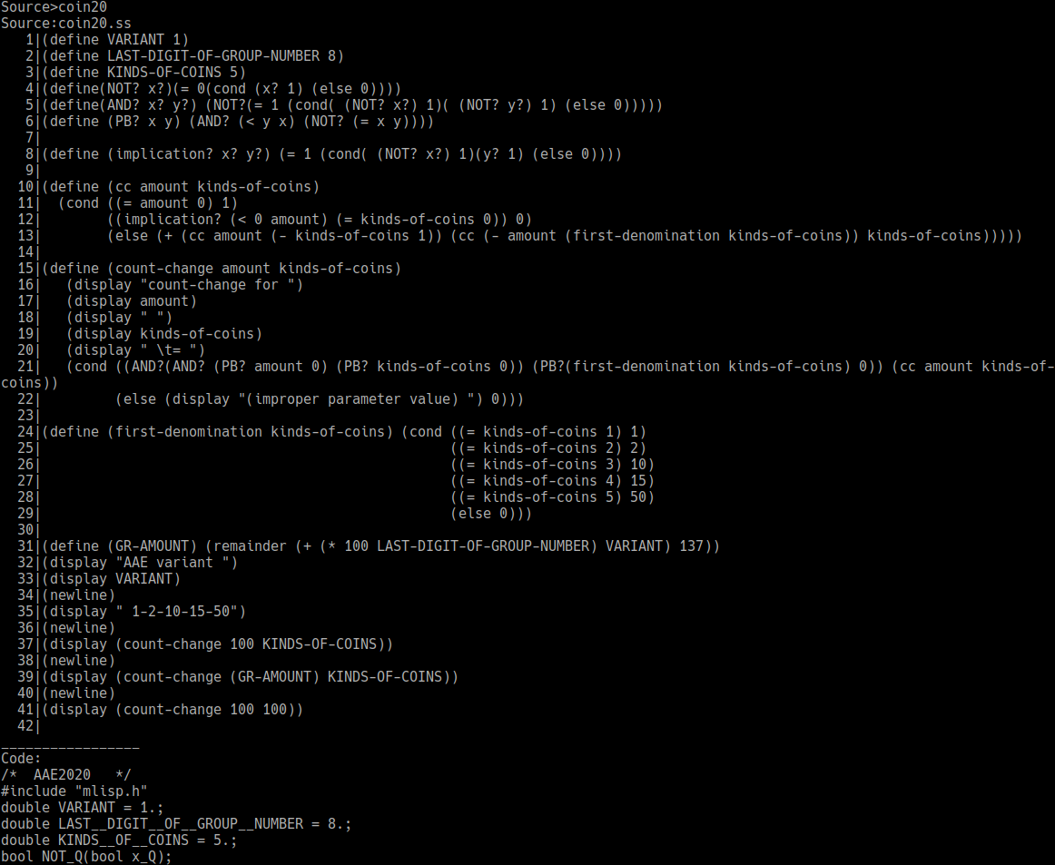

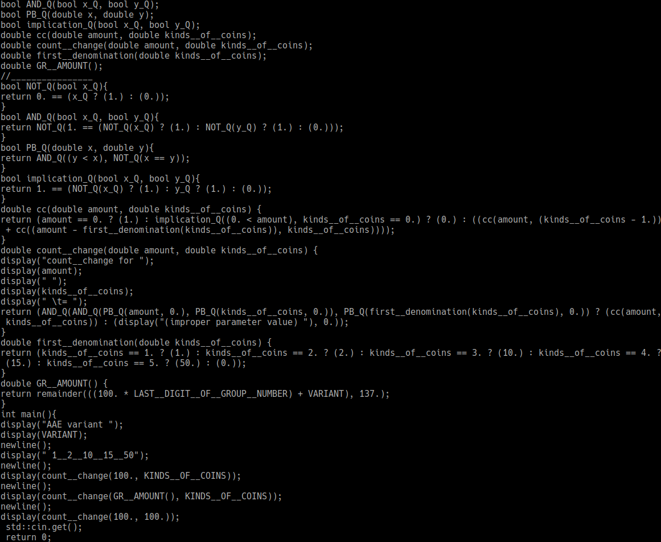
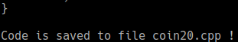

Распечатка файла coin20.cpp .
>

/* AAE2020 */
#include "mlisp.h"
double VARIANT = 1.;
double LAST__DIGIT__OF__GROUP__NUMBER = 8.;
double KINDS__OF__COINS = 5.;
bool NOT_Q(bool x_Q);
bool AND_Q(bool x_Q, bool y_Q);
bool PB_Q(double x, double y);
bool implication_Q(bool x_Q, bool y_Q);
double cc(double amount, double kinds__of__coins);
double count__change(double amount, double kinds__of__coins);
double first__denomination(double kinds__of__coins);
double GR__AMOUNT();
//________________
bool NOT_Q(bool x_Q){
return 0. == (x_Q ? (1.) : (0.));
}
bool AND_Q(bool x_Q, bool y_Q){
return 1. == (NOT_Q(x_Q) ? (1.) : NOT_Q(y_Q) ? (1.) : (0.));
}
bool PB_Q(double x, double y){
return AND_Q((y < x), NOT_Q(x == y));
}
bool implication_Q(bool x_Q, bool y_Q){
return 1. == (NOT_Q(x_Q) ? (1.) : y_Q ? (1.) : (0.));
}
double cc(double amount, double kinds__of__coins) {
return (amount == 0. ? (1.) : implication_Q((0. < amount), kinds__of__coins == 0.) ? (0.) : ((cc(amount, (kinds__of__coins - 1.)) + cc((amount - first__denomination(kinds__of__coins)), kinds__of__coins))));
}
double count__change(double amount, double kinds__of__coins) {
display("count__change for ");
display(amount);
display(" ");
display(kinds__of__coins);
display(" \t= ");
return (AND_Q(AND_Q(PB_Q(amount, 0.), PB_Q(kinds__of__coins, 0.)), PB_Q(first__denomination(kinds__of__coins), 0.)) ? (cc(amount, kinds__of__coins)) : (display("(improper parameter value) "), 0.));
}
double first__denomination(double kinds__of__coins) {
return (kinds__of__coins == 1. ? (1.) : kinds__of__coins == 2. ? (2.) : kinds__of__coins == 3. ? (10.) : kinds__of__coins == 4. ? (15.) : kinds__of__coins == 5. ? (50.) : (0.));
}
double GR__AMOUNT() {
return remainder(((100. * LAST__DIGIT__OF__GROUP__NUMBER) + VARIANT), 137.);
}
int main(){
display("AAE variant ");
display(VARIANT);
newline();
display(" 1__2__10__15__50");
newline();
display(count__change(100., KINDS__OF__COINS));
newline();
display(count__change(GR__AMOUNT(), KINDS__OF__COINS));
newline();
display(count__change(100., 100.));
std::cin.get();
return 0;
}

Скриншот запуска задачи на С++.
>

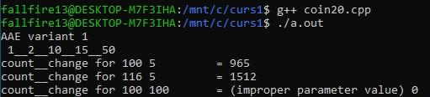

Скриншот запуска задачи на Лиспе.



