正确率相较于上一次高很多，泪目。这次我会以嵌入式和计算机二级来。大部分都是嵌入式了解不够。.这份多亿点,我给你加了一点

|  |  |  |  |  |  |  |  |  |  |
| --- | --- | --- | --- | --- | --- | --- | --- | --- | --- |
| 1 | 2 | 3 | 4 | 5 | 6 | 7 | 8 | 9 | 10 |
|  |  |  |  |  |  |  |  |  |  |
| 11 | 12 | 13 | 14 | 15 | 16 | 17 | 18 | 19 | 20 |
|  |  |  |  |  |  |  |  |  |  |
| 21 | 22 | 23 | 24 | 25 | 26 | 27 | 28 | 29 | 30 |
|  |  |  |  |  |  |  |  |  |  |

1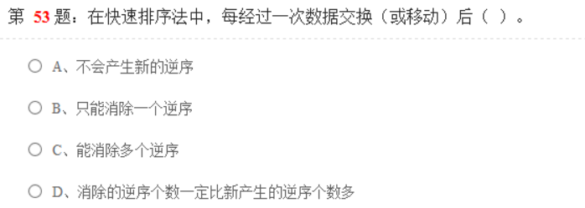

具体看书的排序法。

2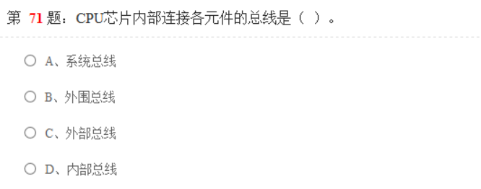

3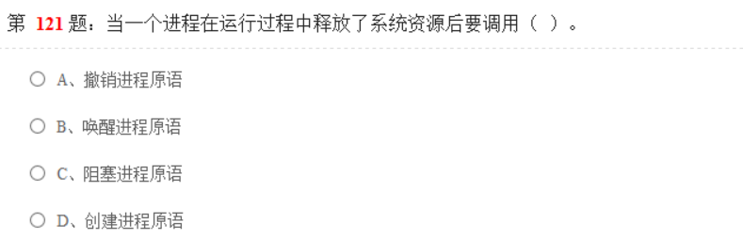

4. 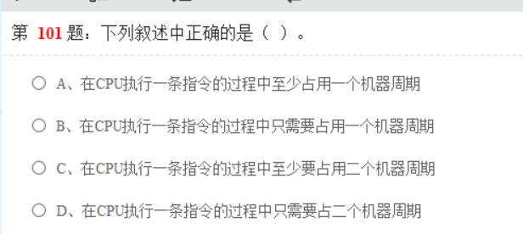

5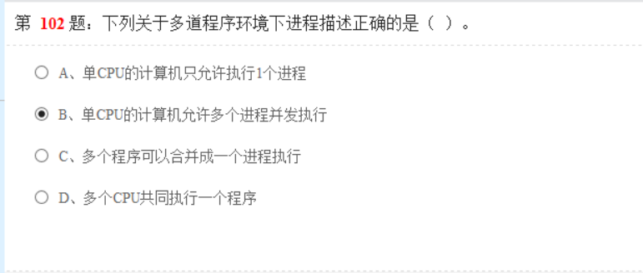

6送分题啊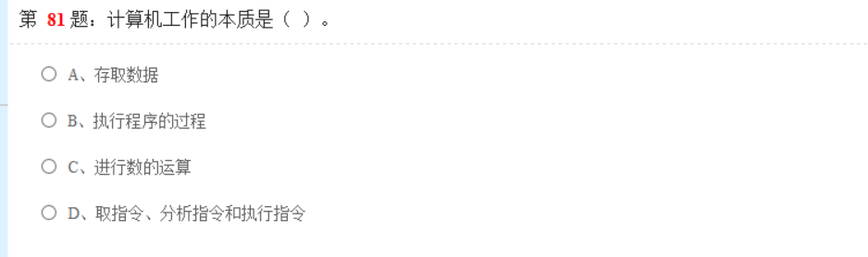

7. 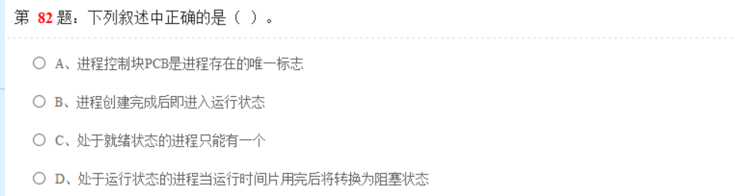

8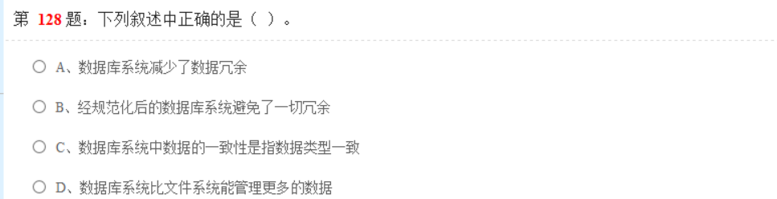

9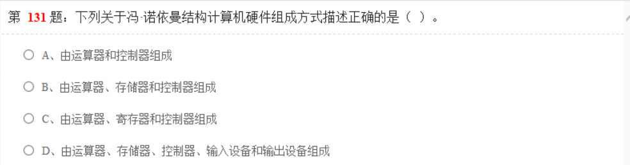

10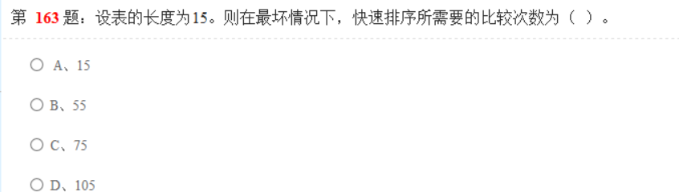

11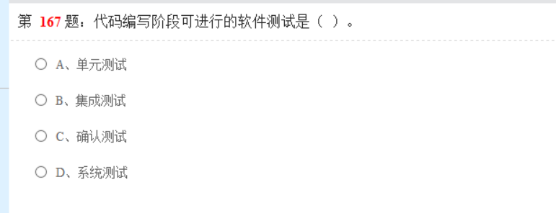

12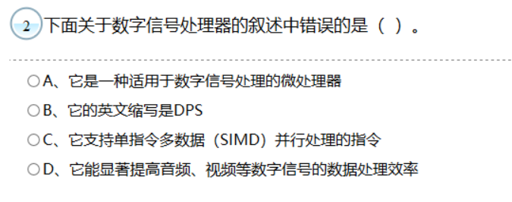

13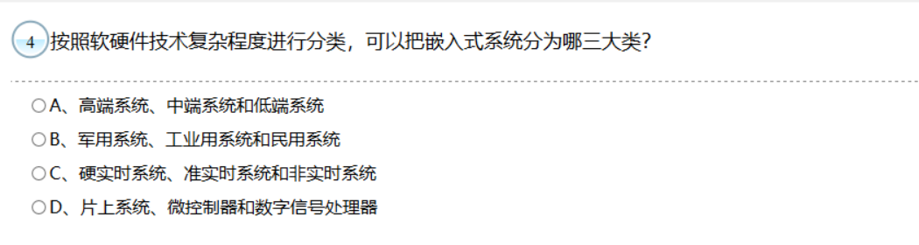

14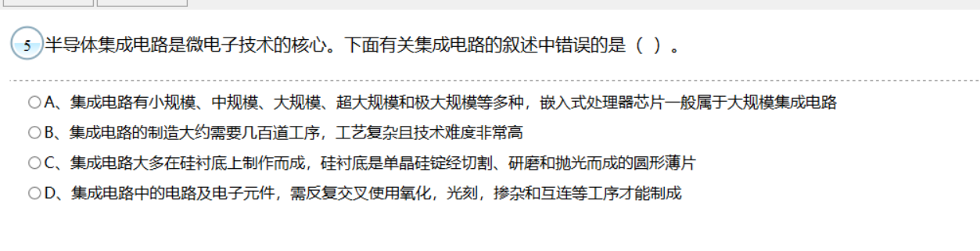

15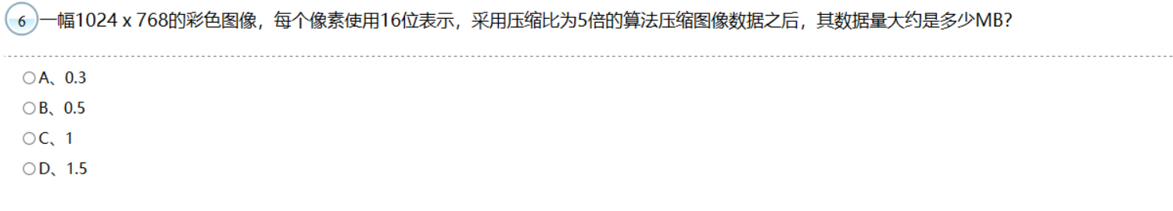

16

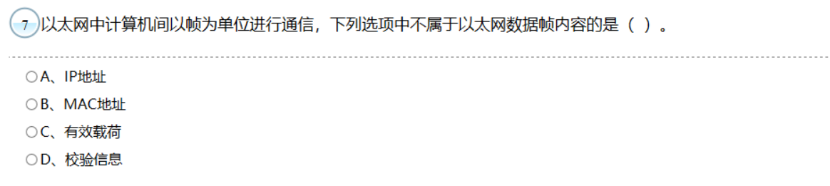

**17**

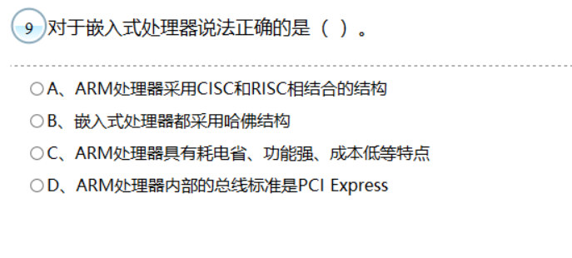

**18**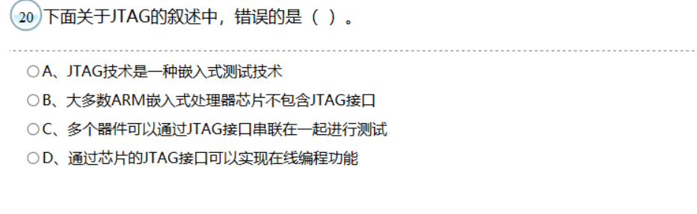

**19**

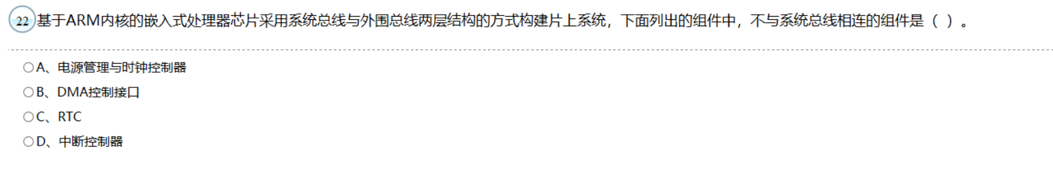

**20**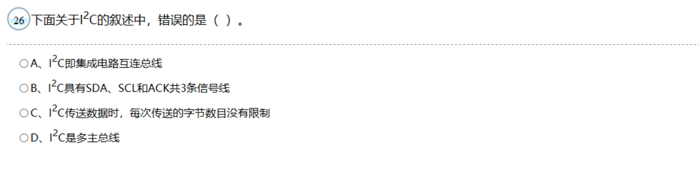

**21**

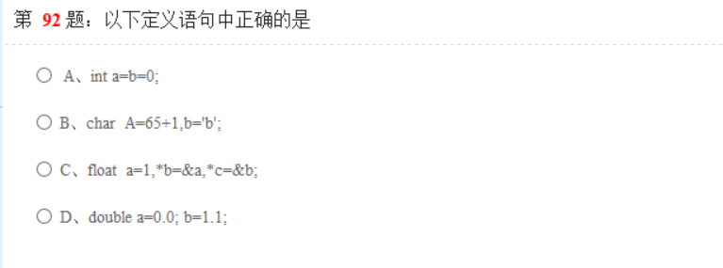

**22**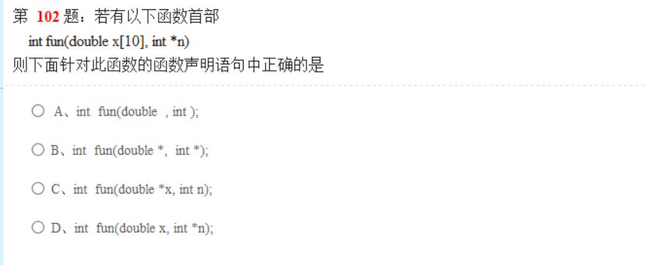

**23.说实话这选项属实不做人**

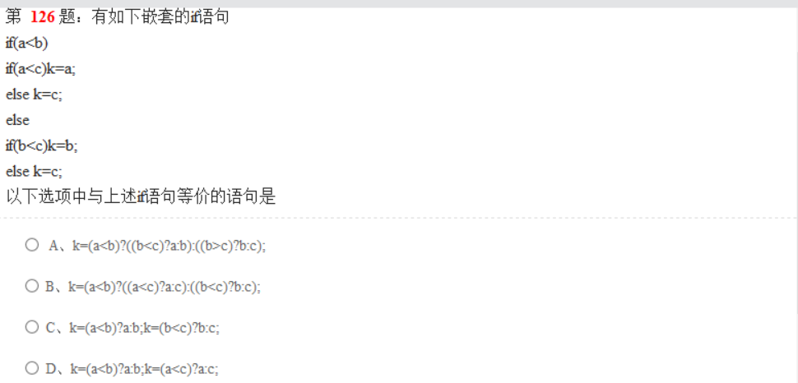

**24.**

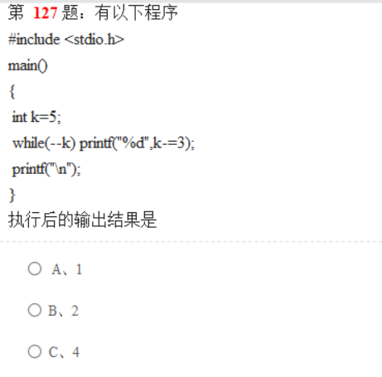

**25**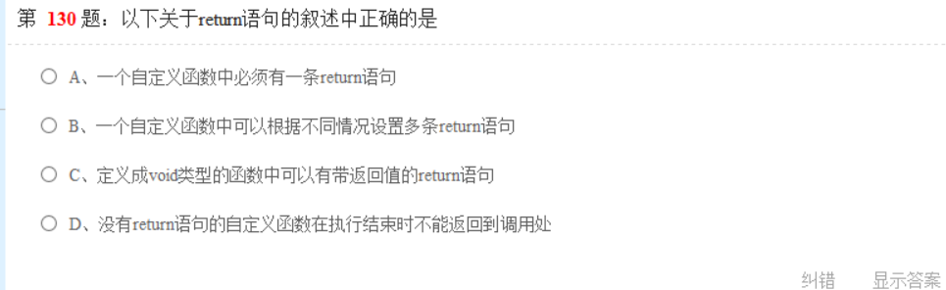

**26**

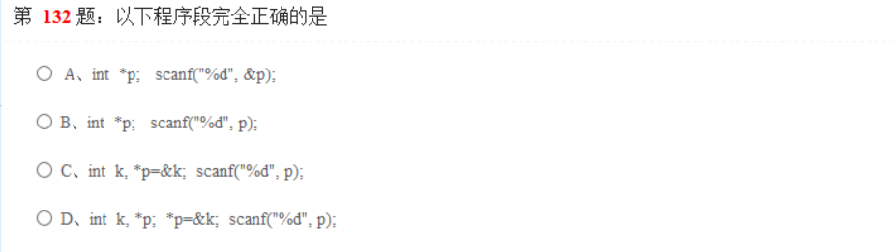

**27**

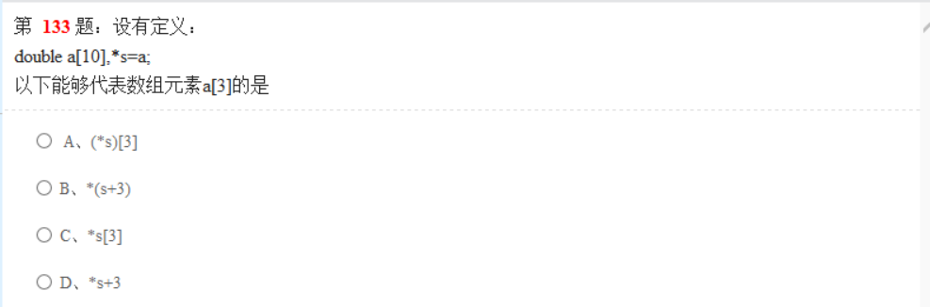

**28**

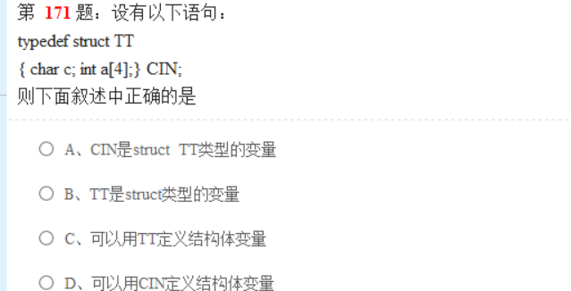

**29**

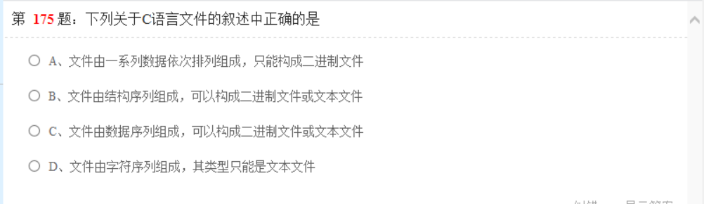

**30**

