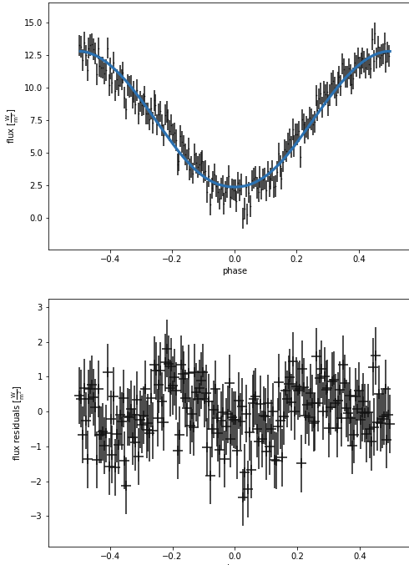
b['irrad_frac_refl_bol@secondary']=0.6
b.set_value('incl', component='binary', value=50*u.deg)
b.set_value('teff', component='primary', value=150000*u.K)
b.set_value('teff', component='secondary', value=3000*u.K)
b.set_value('mass', component='secondary', value=0.25*u.solMass)
b.set_value('q', component='binary', value=0.23)
b['q@binary'].set_limits([0.1736,0.25])

ParameterSet: 4 parameters
R message@nm_sol@solution: Optimization terminated successfully.
R nfev@nm_sol@solution: 500
R niter@nm_sol@solution: 214
R success@nm_sol@solution: True
ParameterSet: 4 parameters
incl@binary@orbit@component: 34.2971290794825 deg
q@binary@orbit@component: 0.24701909312409454
teff@primary@star@component: 249999.3050091848 K
teff@secondary@star@component: 3596.3608073457376 K

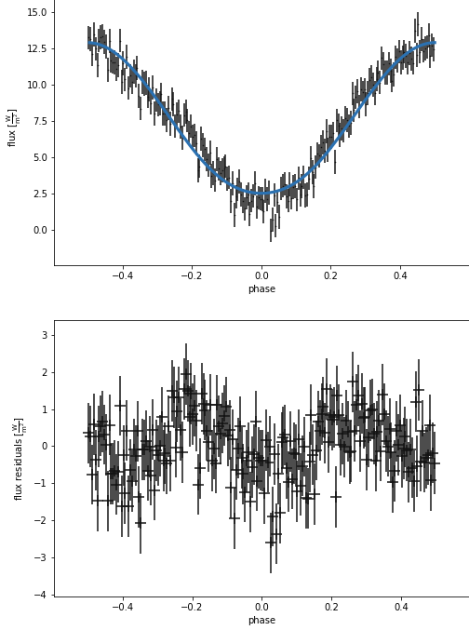
b.set_value('incl', component='binary', value=20*u.deg)
b.set_value('teff', component='primary', value=100000*u.K)
b.set_value('teff', component='secondary', value=3000*u.K)
b.set_value('mass', component='secondary', value=0.25*u.solMass)
b.set_value('q', component='binary', value=0.2)
b['q@binary'].set_limits([0.1736,0.25])

ParameterSet: 4 parameters
R message@nm_sol@solution: Optimization terminated successfully.
R nfev@nm_sol@solution: 301
R niter@nm_sol@solution: 127
R success@nm_sol@solution: True
ParameterSet: 4 parameters
incl@binary@orbit@component: 30.973003566158354 deg
q@binary@orbit@component: 0.17362679417505666
teff@primary@star@component: 139939.96851237514 K
teff@secondary@star@component: 2652.2125781878703 K

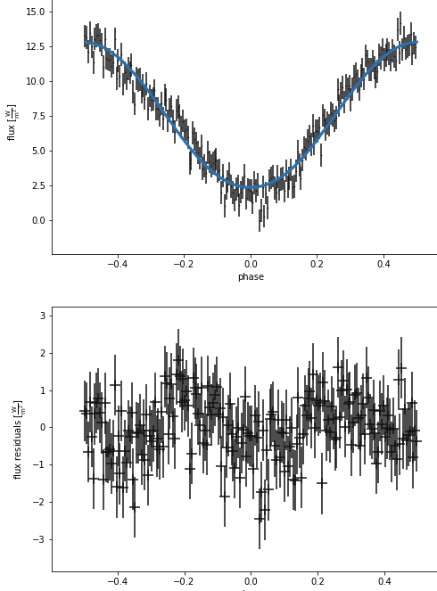
b.set_value('incl', component='binary', value=50*u.deg)
b.set_value('teff', component='primary', value=150000*u.K)
b.set_value('teff', component='secondary', value=3000*u.K)
b.set_value('mass', component='secondary', value=0.25*u.solMass)
b.set_value('q', component='binary', value=0.2)
b['q@binary'].set_limits([0.1736,0.25])

ParameterSet: 4 parameters
R message@nm_sol@solution: Maximum number of iterations has been exceeded.
R nfev@nm_sol@solution: 5353
R niter@nm_sol@solution: 1000
R success@nm_sol@solution: False
ParameterSet: 4 parameters
incl@binary@orbit@component: 30.10952829129269 deg
q@binary@orbit@component: 0.21776628261552058
teff@primary@star@component: 229788.95464824955 K
teff@secondary@star@component: 2638.8454077624147 K

b['irrad_frac_refl_bol@secondary']=0.5
b.set_value('incl', component='binary', value=30.10952829129269*u.deg)
b.set_value('teff', component='primary', value=229788.95464824955*u.K)
b.set_value('teff', component='secondary', value=2638.8454077624147*u.K)
b.set_value('mass', component='secondary', value=0.25*u.solMass)
b.set_value('q', component='binary', value=0.21776628261552058)
b['q@binary'].set_limits([0.1736,0.25])

ParameterSet: 4 parameters
R message@nm_sol@solution: Optimization terminated successfully.
R nfev@nm_sol@solution: 363
R niter@nm_sol@solution: 109
R success@nm_sol@solution: True
ParameterSet: 4 parameters
incl@binary@orbit@component: 30.773286026683564 deg
q@binary@orbit@component: 0.18188436922873136
teff@primary@star@component: 260566.99803590632 K
teff@secondary@star@component: 2798.455610879791 K

b.set_value('incl', component='binary', value=60*u.deg)
b.set_value('teff', component='primary', value=250000*u.K)
b.set_value('teff', component='secondary', value=3000*u.K)
b.set_value('mass', component='secondary', value=0.3*u.solMass)
b.set_value('q', component='binary', value=0.21776628261552058)
b['q@binary'].set_limits([0.14,0.5])

ParameterSet: 4 parameters
R message@nm_sol@solution: Optimization terminated successfully.
R nfev@nm_sol@solution: 433
R niter@nm_sol@solution: 164
R success@nm_sol@solution: True
ParameterSet: 4 parameters
incl@binary@orbit@component: 35.84199483113191 deg
q@binary@orbit@component: 0.23136093619138703
teff@primary@star@component: 282191.2006931246 K
teff@secondary@star@component: 3514.383865182288 K

b.set_value('incl', component='binary', value=35.84199483113191*u.deg)
b.set_value('teff', component='primary', value=182191.2006931246*u.K)
b.set_value('teff', component='secondary', value=3514.383865182288*u.K)
b.set_value('mass', component='secondary', value=0.3*u.solMass)
b.set_value('q', component='binary', value=0.23136093619138703)
b['q@binary'].set_limits([0.14,0.5])

