Jaclynn Fallon

Sunday, February 27, 2022

IT FDN 110 B Wi 22: Foundations Of Programming: Python

Assignment 05

Tuples, Lists, and Dictionaries

# Introduction

In this assignment we were tasked with re-working Assignment 04 to use a list of dictionaries instead of a 2-D list as the core data storage for the program. Also, instead of building up our own script from scratch we were provided with a partial solution, and had to word within the original structure/logic that someone else created.

# Converting the Inner Data Structure to Dictionaries

Luckily, working through the labs for Module 05 provided a lot of practice with code very similar, or identical to, to code we needed to complete the assignment. In fact, LAB05 B was nearly identical to Assignment 05. One of the main differences was that Assignment 05 asked us to load data into memory from a file at the beginning of the script instead of towards the end. This created an interesting situation where, if there wasn’t a file in the working directory (which there wouldn’t be the first time you ran the script), you would get an error. To troubleshoot this, I used my first instance of structured error handling, where the program would try to read data from file, but if the file didn’t exist instead of crashing it would print, “You’re CD inventory is empty! Try adding a CD to it”.

Another major difference was between LAB05 B and Assignment 05 was that Assignment 05 asked us to delete an item from inventory if the user wanted to. Although I hadn’t done this before in a previous script for this course, it turned out to be one of the easier tasks in the assignment.

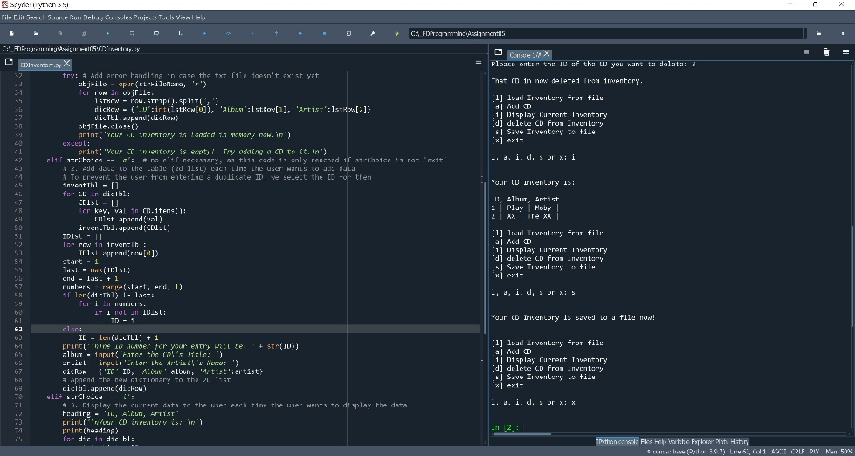

Figure 1 – CDInventory.py running in Spyder.

I did a little extra in this script by assigning the ID number to the CD instead of allowing the user to choose an ID. Frankly, this created a lot of headaches for me, but I had a hard time letting the problem go, and eventually I was able to add this functionality. I did this in Assignment 04, but it was much more difficult in Assignment 05 because the user could delete a CD from inventory, so a simple counter function to assign an ID would no longer suffice. I spent a lot of time trying to figure out how to find missing values in a range so that if the CD IDs were 1, 2, 3, 4, and the user deleted “3”, that they wouldn’t assign a duplicate ID of “4” next time they added a CD to inventory. Eventually I got this to work, but by the time I got it to work I was too lazy to figure out how to sort the dictionary, so if the user displays the data after adding a new CD it will show 1, 2, 4, 3 instead of 1, 2, 3, 4, lol… But still, overall, I’m happy with how the script turned out, and I think I learned a lot in this module.

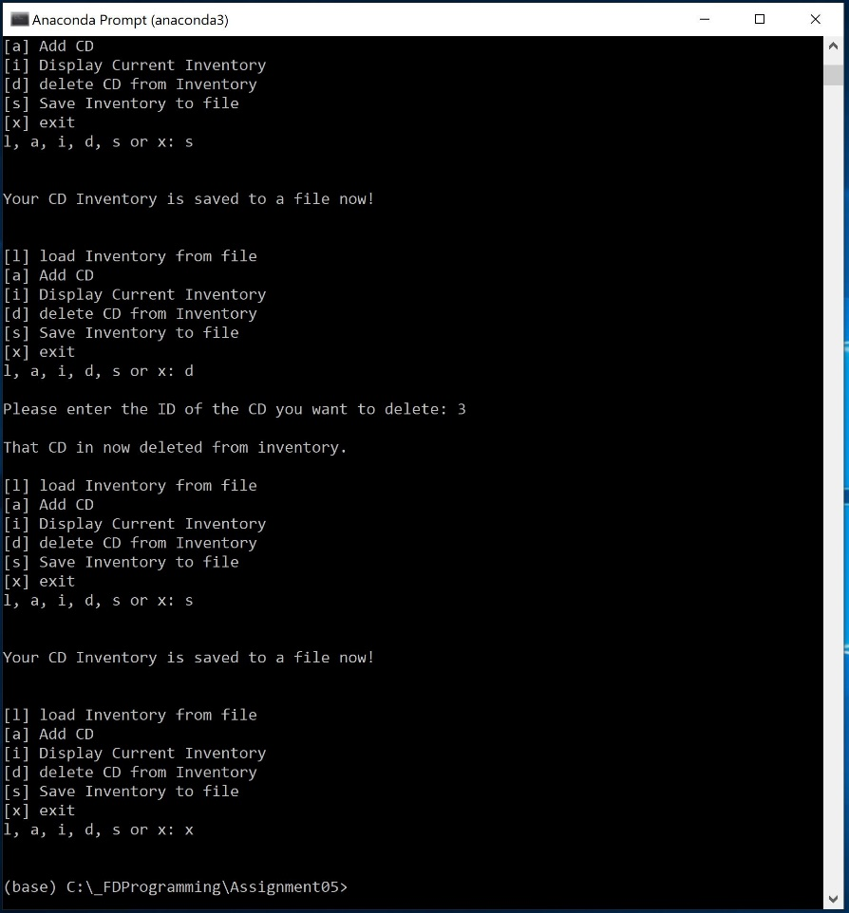

Figure 2 – CDInventory.py running in Anaconda Prompt terminal.

# Summary

In this assignment we modified an existing script to use dictionaries instead of lists as the inner structure for data storage. We had to extract data from and add data to a dictionary, delete items from lists, save data from dictionaries to a text file, and read data from a text file into a dictionary. This assignment was a big one, and I had to pull from multiple sources and everything we’ve learned so far to get it done.