Jaclynn Fallon

Sunday, March 6 2022

IT FDN 110 B Wi 22: Foundations Of Programming: Python

Assignment 06

Functions & Classes

# Introduction

The primary focus of this assignment was on learning how to use and create user-defined functions and classes. In addition to user defined functions and classes, we learned about the concepts behind them that make them work, such as arguments, parameters, encapsulation, and return values.

# Moving Code from the Script Body into Functions

When I first looked at this assignment it seemed incredibly difficult, and especially after last week’s assignment, I was afraid I wouldn’t be able to finish it in time. However, as usual, reading through the textbook chapter, reading through the module material and completing the labs prepared me well to finish the assignment.

I had a difficult time with the concepts in this module. I understood that a parameter was essentially a variable assigned to a function within the parentheses of a function header, and that an argument was more or less the value passed to the function parameter in the script body…. but I didn’t really understand their separation, or how they worked until I really started working on the assignment. Likewise, I had a theoretical understanding of how return values worked, but I didn’t *really* get it until I sat down and tried to get my own functions to return values so they could be used in other functions.

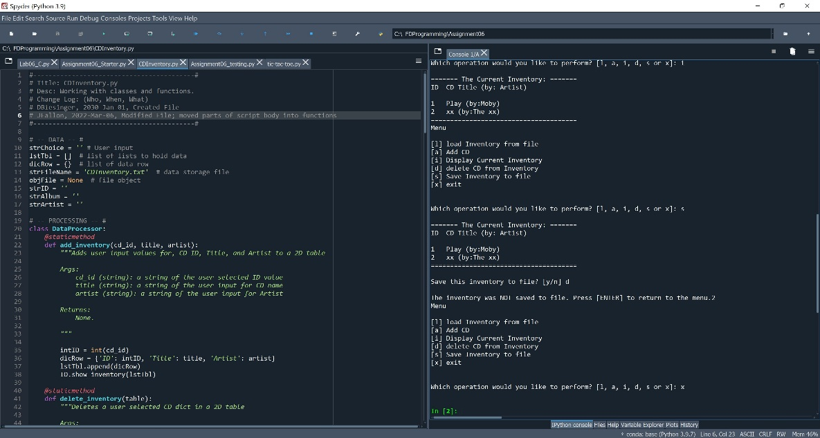

Figure 1 – CDInventory.py for Assignment 06 running in Spyder.

Honestly, I’m still not sure that I understand all the concepts completely, but hopefully anything that’s not clear will be resolved in this week’s class and with more practice. In order to get my get_inventory() function to work, I had to create three global variables, ‘strID, strAlbum, strArtist’. My script worked this way, but I’m not sure if there’s a better way that I could have done it without creating the global variables.

Also, I was not entirely sure which functions to put in which class. I ended up putting the add_inventory() and delete_inventory() functions in the DataProcessor class, and the get_inventory() function in the IO class because that *seemed* like the right classes for them to go in, but I wasn’t completely sure.

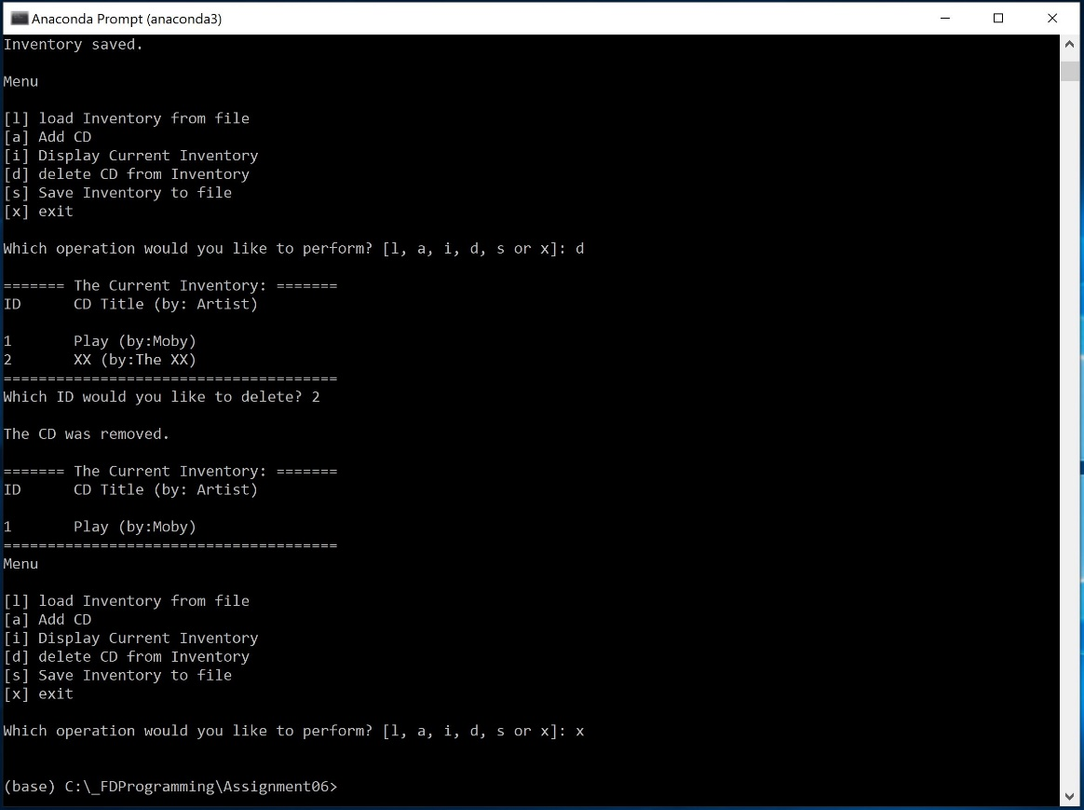

Figure 2 – CDInventory.py for Assignment 06 running in a console.

Lastly, I’ve been short on time the last two weeks, and was worried about getting behind, so I really stuck to a “no frills” script and just tried to complete the requirements and be sure I understood the main concepts. The only extras I included were some error handling in case the user tried to load a file that didn’t exist, and a few minor formatting changes. In past assignments I’ve tried to improve the handling of the ID assignment, but I did not have time for that this week.

Here is the link to my github repository for this week: <https://github.com/falloj/Assignment_06>

# Summary

In summary, this was a challenging assignment for me, where the concepts of arguments, parameters, and return values really didn’t sink in until I really got into the assignment and had to create my own functions. I hope that we will be able to focus some more on these concepts in future classes and assignments so they will really be driven home.