Jaclynn Fallon

Sunday, March 13, 2022

IT FDN 110 B Wi 22: Foundations Of Programming: Python

Assignment 07

Files & Exceptions

# Introduction

This Module introduced and some challenging new topics, including pickling and revisited some other challenging topics in greater depth, including script arguments and structured error handling.

# Changing the Script to Work in Binary

This was a challenging assignment, and the new concepts were hard for me to wrap my head around. As usual, I struggled quite a bit with the labs, and they took me longer to complete than I expected. Time spent on labs ate into the time I’d set aside to complete the assignment, but in the end it was worth it, because after applying the concepts once, the assignment went much faster applying them the second time.

There were a number of tasks to complete in this assignment, and since we were working with our code from Assignment 06, not a starter code, the first thing I did was go through the script and add TODO’s where I needed add or improve error handling, and change file handling from text to binary.

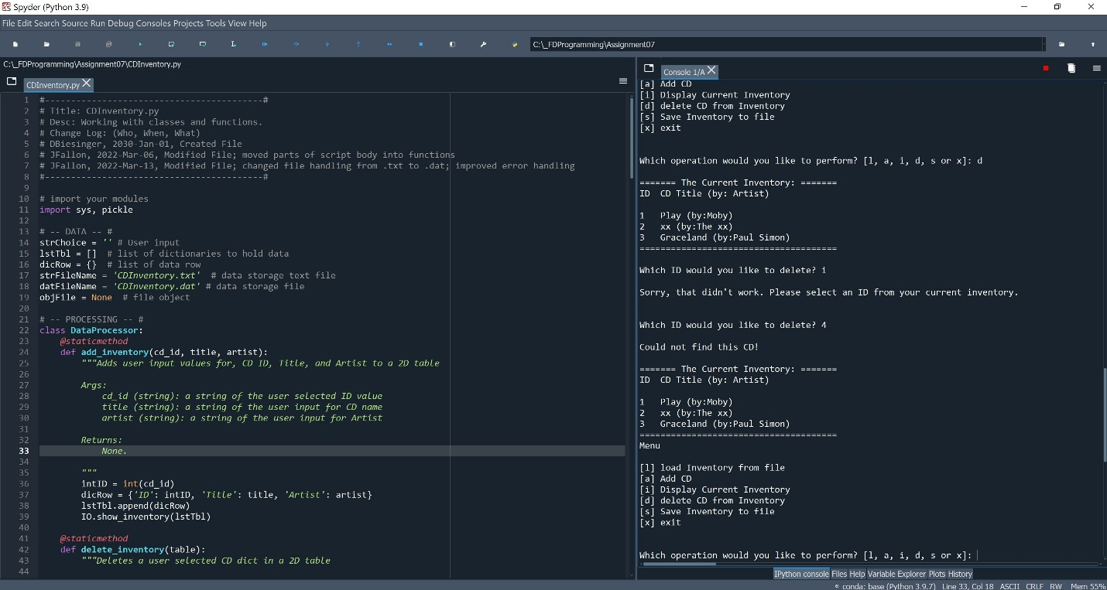

Figure 1 – CDInventory.py running in Spyder.

The first TODO I tackled was the write_file() function. I figured I could run through the program and save the CD Inventory to a .dat file to start. Then I would have a .dat file to work with, and I could move on to modifying the read_file() function from there.

To modify the write_file() function, I just copied my code straight out of Lab07 C, updated the variable names, and used the pickle.dump() function to save the CD inventory (a list of dictionaries) to a .dat file. Amazingly, this worked on the first try, and I could verify by the newly created CDInventory.dat file in my Assignment07 directory. Now I would need to modify the read_file() function to try loading the .dat file to make sure it wasn’t just a bunch of gibberish.

Modifying the read_file() function definitely did not work on the first try. I tried copying over my code from the labs, but because the data in the file was in a different format, this didn’t work right away, and I had to modify the code. I opened the file in ‘rb’ mode, and then used the pickle.load() function to unpickle the file object. Then I created a for loop to iterate through the items (which were dictionaries), and append them to the global list. I had to work with this process and throw in some print statements to make sure I was reading and appending the correct items, but once I got it working I removed the print statements, and the remainder of the script fell into place.

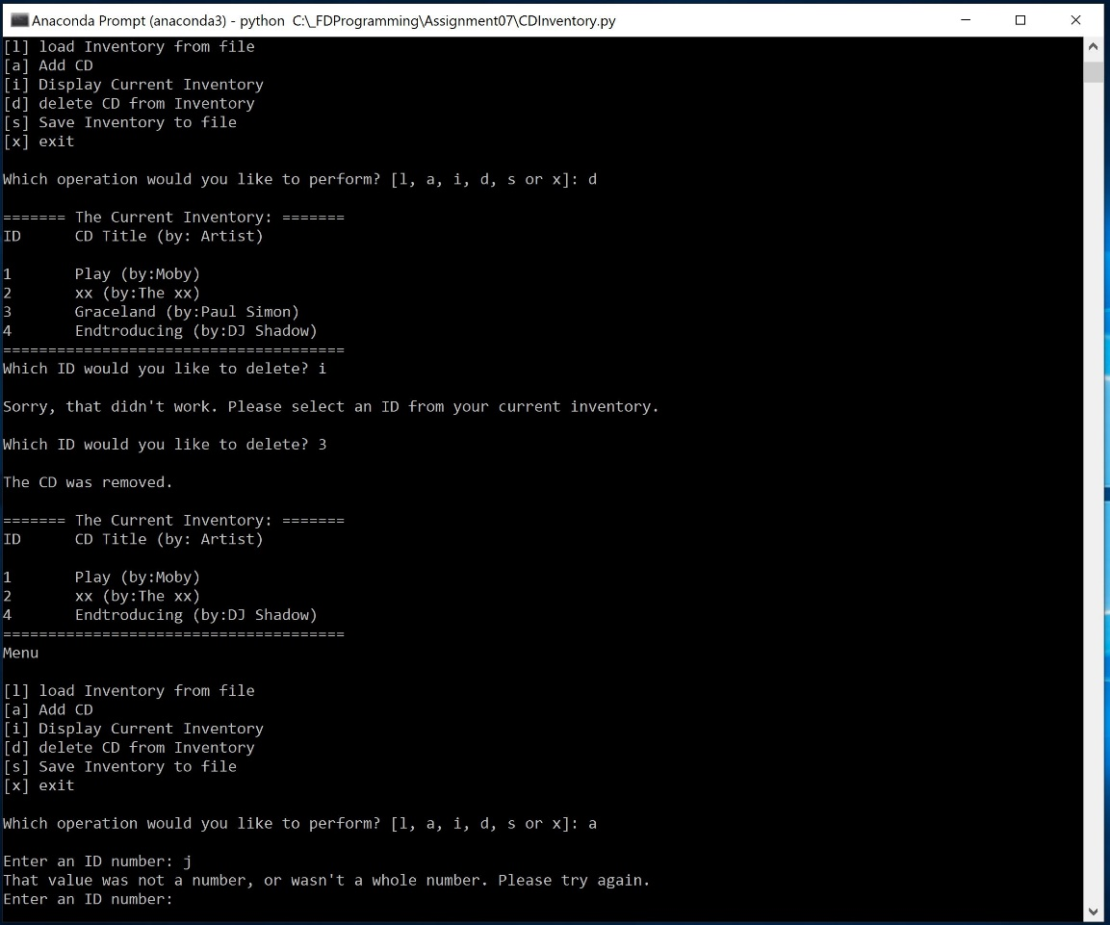

Figure 2 – CDInventory.py running in a terminal.

# Adding and Improving Error Handling

Once I had the binary file handling working, I went on the add or improve error handling. I had already worked in some error handling in previous iterations, but since Module 07 introduced specific exception types, I tried to go through and update my existing error handling with some more specific exception types. To do this, I temporarily disabled the existing error handling where I already had it, ran the script to get the error type, then added the exception type to the exception. I did this in the following locations:

* In the delete_inventory() function if the user tried to delete a non-numeric ID
  + I had this in Assignment 06, but it was in the main body of the code, and exited the user out of the function. I moved the error handling into the function and reworked it so the user was asked to try a different ID instead of being exited out of the function
* In the read_file() function if the user tried to load from file but the file didn’t exist yet
* In the get_inventory() function if the user tried to add a CD with a non-numeric ID value

# Independent Research & Posting to GitHub

Another part of this assignment was finding our own information sources regarding the topics covered in the module, instead of them being provided for us. Although as always, I relied most heavily on the book, the Module documentation and the lectures, I they weren’t enough to get through this assignment. Of course, the explanations from python.org are always good, and I found https://docs.python.org/3/library/pickle.html to be helpful. Another site that I found to be helpful for understanding pickling was https://realpython.com/python-pickle-module. For very specific issues, I found a few threads on stackoverflow.com to be helpful, and although it wasn’t for the assignment specifically, I found https://cs.stanford.edu/people/nick/py/python-main.html to be extremely helpful for Lab 07 B.

We were also asked to post our script and knowledge document to GitHub, and here is the link to my GitHub repository for this assignment: https://github.com/falloj/Assignment_07

# Summary

This was a very challenging module. Although the assignment was challenging, I was able to build on the error handling I had already created in Assignment 06 to improve my script, and I was able to use the concepts I’d learned in the labs to change the script to read and write binary information instead of plain text. Additionally, in this assignment I felt like I developed a better grasp of working with functions, arguments, and parameters, which I was less sure of at the end of Assignment 06.