Development of an Artificial Intelligence Model to Classify Severity of Hemorrhage Using Arterial Pressure Waveform Data

Fahim Usshihab Mobin, Fellow, IEEE, Antonio C. Renaldo, Micaela K. Gomez, Sandra Januszko, Jacob Dooley, James E. Jordan, Oguz Akbilgic, Timothy K. Williams and Elaheh Rahbar
Abstract— Hemorrhagic shock is a life-threatening condition characterized by significant blood loss resulting in inadequate tissue perfusion and end-organ ischemia. If not promptly treated, it can rapidly progress to multi-system organ failure and death. Early recognition and intervention are therefore essential to minimize morbidity and mortality. The severity of hemorrhage is typically classified by the percentage of blood volume lost. In trauma settings, the accurate and rapid assessment of hemorrhage severity is critical for guiding clinical decisions. Traditionally, mean arterial pressure (MAP) is used to grossly assess perfusion and guide patient care. We postulate that there may be valuable time-dependent and spatial information from the pressure waveforms that could provide greater insights into the state of hemorrhage in real-time. In this study, we developed artificial intelligence (AI) models to determine the severity of hemorrhagic shock using real-time pressure waveform data from an established swine model. Our goal was to evaluate and compare the performance of one-dimensional multi-head convolution neural networks (MH-CNNs), Random Forest (RF) models and Decision Tree (DT) models on the accurate classification of hemorrhage severity in comparison to the current clinical Acute Trauma Life Support (ATLS) algorithm. We observed an accuracy of 79% with the MH-CNN compared to 74% for RF and 54% for DT models with 15 features, respectively. In contrast, the DT model we developed that utilized the 3 key features from the ATLS parameters only performed with 54% accuracy, but displayed a different F1 score distribution and negative predictive value when compared with the 15 feature DT model. The incorporation of a genetic algorithm to the RF model consistently improved hemorrhage classification accuracy. The best accuracy of hemorrhage classification in the RF and DT models was observed using the top 15 waveform features at 74% and 54%, respectively. This study demonstrates improved hemorrhage classification using AI models with pressure waveform data, compared to time-averaged pressure data and ATLS hemodynamic parameters. In particular, RF models tuned with genetic algorithms achieved a Cohen’s κ of 0.637 and mean AUC of 0.897 across all four hemorrhage classes. Notably, all misclassifications primarily appeared in cases between adjacent hemorrhage classes (e.g., 20% vs. 30%), as opposed to non-adjacent classes (e.g., 0% vs. 30%), implying the model has learned a meaningful underlying severity continuum which exists beyond the simplistic approach of the ATLS parameters. Future studies are needed to evaluate the practicality of this approach to evaluating real-time pressure waveform data for classification of uncontrolled hemorrhage.

Index Terms— machine learning, hemorrhagic shock, pressure waveform, waveform analysis, random forest, multi-head CNN

I. INTRODUCTION
H
emorrhagic shock, a form of hypovolemic shock, is a life-threatening condition caused by significant blood loss leading to inadequate tissue perfusion. If untreated, this hypoperfusion results in end-organ ischemia, multi-system organ failure and eventually death. The majority of hemorrhage-related deaths occur within the first 6 hours of injury, demonstrating a need for rapid and accurate identification of hemorrhage severity [1,2,3,4].

Clinically, the Advanced Trauma Life Support (ATLS) classification remains the gold standard for assessing the severity of hemorrhagic shock in trauma patients [4]. ATLS defines the four shock classes based on patient vital signs including heart rate (HR), systolic blood pressure (SBP), and pulse pressure (PP), in tandem with a rough estimation of blood loss as a percentage of total volume. Under this standard, class I hemorrhage (<750 mL of blood loss, or <15% of blood volume) refers to minimal impact hemorrhage, with normal SBP and PP, and HR remaining below 100 bpm. Class II hemorrhage (750-1500 mL of blood loss, or 15-30% of blood volume) refers to moderate hemorrhage, with HR above 100 bpm, normal SBP and PP, and decreasing PP. Class III hemorrhage (1500-2000 mL of blood loss, or 30-40% of blood volume) refers to severe hemorrhage, with HR above 120 bpm, decreased SBP and PP, and lower PP. Class IV hemorrhage (>2000 mL of blood loss, or >40% of blood volume) refers to life-threatening hemorrhage, with HR above 140 bpm, significant hypotension and PP, and further PP reduction.

Despite the critical importance of accurate blood loss estimation in hemorrhage level classification, a practical, real-time method for precise blood loss measurement is still lacking. First responders often rely on subjective visual estimates of blood loss at the scene, but these are imprecise and cannot account for internal bleeding. Similarly, clinicians’ assessments based on soaked clothing or dressings are frequently inaccurate. In a prospective, single-blinded, observational study, emergency room physicians were asked to estimate fixed volumes of blood on various surfaces (i.e., bedsheets, gauze, clothing). Despite the controlled setup, only 8% of estimates were within 20% of actual blood loss highlighting the inaccuracy of visual blood loss estimation. Notably, increased clinical experience did not result in more accurate assessment of blood loss [5]. Alternative methods such as facial recognition for calorimetric assessment of anemia have been slowly introduced by researchers [6]. This clinical problem motivates the need for better tools to accurately predict hemorrhage severity.

Arterial pressure waveform data provides a continuous insight into pulsatile cardiovascular dynamics, making it an invaluable tool in the broader clinical setting. This data gives a numerical representation of flow of blood through arteries which is reflected by key parameters such as PP, HR, mean arterial pressure (MAP), and estimated cardiac output (CO) and promotes the ability to capturing time variant characteristics of the waveform like rise time and decay time, as illustrated in Figure ‎1.

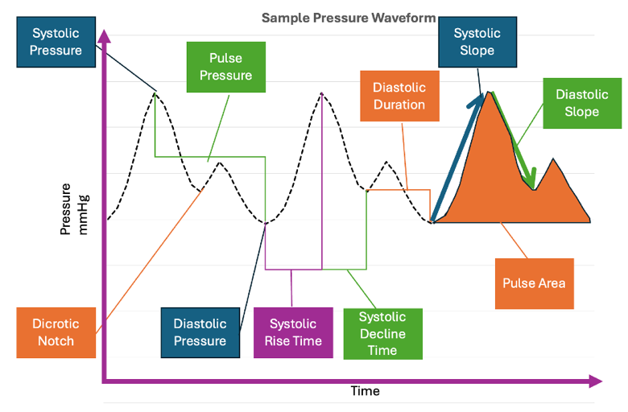
Figure 1. Representative arterial blood pressure waveform illustrating some key hemodynamic features. This sample waveform highlights systolic blood pressure (SBP), defined as the maximum peak pressure, and diastolic blood pressure (DBP), defined as the minimum trough pressure. The inflection point blood pressure (IFBP), corresponding to the dicrotic notch, marks the transition between systole and diastole. Pulse pressure (PP) is defined as the difference between SBP and DBP. Temporal characteristics include systolic rise time (t_sys_rise), representing the interval from waveform onset to peak systole; systolic decline time (t_sys_dec), representing the interval from peak systole to the inflection point; and diastolic duration (t_dia), representing the interval from the inflection point to the end of the pulse. Morphological features include the systolic slope (slope_sys), indicating the rate of pressure increase during systole, and the diastolic slope (slope_dia), indicating the rate of pressure decay during diastole. The pulse area (PA) represents the total area under the waveform over one cardiac cycle..
Covertino et al., who have arguably enabled the most detailed study into the nature of pressure waveforms, posit that pressure and flow waveforms uniquely contain insights into the pulsatility of the flow feature information to describe both cardiac loading conditions and compensatory mechanisms simultaneously, both directly and indirectly [7]. They present this notion on the logical premise that arterial pressure waveforms are comprised of two halves; the ejected wave and the reflected wave, with the former preserving features of heart contractility and the later reflecting characteristics of arterial vasculature [7]. Continuing this work, some researchers have increasingly leveraged this approach to pressure waveform data to develop artificial intelligence models to monitor and predict physiological states in a variety of capacities. For instance, work performed by Bedolla et al. aimed to develop algorithms to extract features from arterial pressure waveforms to track physiological decompensation during simulated HS [3]. This unique study employed ML decision tree-based models and DL models like CNNs to predict CRM to obtain continuous measure of shock onset and compare the efficacy of the models. The researchers were then able to develop an explainable and interpretable ML algorithm that identifies key waveform features responsible for tracking CRM along with a DL algorithm. This innovative approach opens a variety of possible innovative approaches to analysing arterial pressure waveform data to better understand HS..

The ATLS standard used clinically relies mainly on secondary indicators like MAP which is a time-averaged metric. Considering the findings from the Bedolla et al. study, we postulate that there may be valuable time-dependent and spatial information from the pressure waveforms that could enhance real-time assessment of hemorrhagic shock beyond what is captured in traditional metrics [3]. In this study, we aimed to leverage artificial intelligence (AI) models to improve diagnosis and management of hemorrhagic shock cases by determining its severity using these time-dependent and spatial pressure waveform parameters in an established controlled hemorrhage model. Our goal in this study to evaluate and compare the performance of one-dimensional multi-head convolution neural networks (MH-CNNs), Random Forest (RF) models and Decision Tree (DT) models on the correct classification of hemorrhage severity relative to the hemodynamic parameters included in the ATLS standard.

II. Method

A. The Hemodynamic Data from Swine Hemorrhage Model
The data leveraged in this study comes from a porcine model designed to investigate the physiological impact of hemorrhage and differing occlusive treatment strategies. This study was conducted under an approved animal use protocol at Wake Forest University School of Medicine. The employed animal model provided detailed vector data that characterize change in blood flow and pressure during controlled hemorrhage and resuscitation. Yorkshire swine (N=54, 27 female, 27 male) were subjected to 10%, 20%, and 30% hemorrhage (based on total blood volume) over 30 minutes (n=18/hemorrhage group) and hemodynamic data was captured in real time.

B. Arterial Pressure Waveform Pre-Processing
Arterial Pressure waveforms from the left subclavian artery and the distal aorta were predominatntly leveraged in this study, referred to as proximal and distal pressure readings. A custom algorithm was developed to individually isolate all cardiac cycles in this dataset. This allowed us to boost the waveform data for model training. One minute of data was sampled prior to end of hemorrhage and each individual waveform extracted during this time point was treated as an individual sample of the same target hemorrhage. Additionally, to obtain a non-hemorrhage control data, sampling was performed at baseline (i.e., time=0). A Savitzky-Golay filter was applied to reduce high-frequency noise, preserving the key physiological features of the waveforms before they were incorporated into any of the developed AI models. A custom ML algorithm was developed in Python to evaluate various combinations of polynomial orders (2-5) and window sizes to minimize the root mean square error, ensuring optimal noise reduction for the model. Based on this algorithm, a polynomial order of 3 with a window size of 25 was chosen and applied unanimously across all data.

C. Data Boosting to Include Variations in Hemorrhage Rate
To further boost the dataset for more representation of lower hemorrhage levels and at varying rates, (i.e.,10% and 20% blood volume loss), an additional boosting strategy was implemented to sample data from intermediate time points from the experimental dataset from samples that were subjected to 20% and 30% (by volume) hemorrhage levels. For instance, over the 30-minute hemorrhage, data from a subject undergoing 30% blood volume loss was used to obtain extra data points 10 minutes and 20 minutes into the hemorrhage, representing 10% and 20% hemorrhage levels, respectively. This approach resulted in the creation of 54 complete datasets, each representing one of these hemorrhage levels, thereby effectively boosting the dataset.

This sampling strategy does introduce a level of variability into the dataset. While all subjects in a single hemorrhage group would have been hemorrhaged to the same volume of blood loss, the added groups experience different rates of hemorrhage, which adds variation that may be more reflective of human respsonses. Table 1 depicts the variation in average HR and MAP as well as the number of waveforms in each hemorrhage group after boosting.

Table 1. Summary of arterial pressure waveform extraction. We used a t-test to compare pre- vs. post-boosting mean arterial pressures (MAP) and heart rate (HR) in the 10% and 20% hemorrhage groups. By boosting the number of waveforms, only HR was slightly higher in the boosted data set within the 20% hemorrhage group (p=0.027).
 | Hemorrhage Levels
 | 0% | 10% |  | 20% |  | 30%
# of Waveforms | N=5361 | N=1595 | N=5491 | N=1672 | N=3915 | N=2223
MAP (mmHg) | 59 ± 6 | 47 ± 4 | 45 ± 6 | 40 ± 6 | 36 ± 8 | 27 ± 7
HR (bpm) | 101 ± 23 | 96 ± 16 | 106 ± 25 | 115 ± 28 | 120 ± 29 | 132 ± 32

It should be noted that this variability enhances the model by making it more reflective of real clinical scenarios, where patients are more than likely to experience varying rates of blood loss and hence have lost different blood volumes. By not relying on perfectly controlled data from subject uniformly being bled at a similar rate, this approach acknowledges the unpredictability of trauma cases, making it better poised to handle real-world complexity.

D. AI Model Development
To ensure model generalizability, data was distributed at the subject level by generating a sub-algorithm that ensured that a single animal’s data would only be applied to the train, test or validation data set. A train-test-validation split of 70%-15%-15% was utilized for all models. To further ensure a balanced representation of all hemorrhage levels, we balanced classes further in training, testing and validation by limiting the number of waveforms analyzed to match the least represented class.

The multi-head (MH)-CNN model was trained on the Savtizky-Golay (SG) filtered blood pressure waveform data, as DL models are inherently able to classify waveform data without further processing. ML models, on the other hand, are by design made to classify based on scalar data rather than vector data like arterial pressure. Feature engineering, the process of extracting key scalar characteristics from vector waveform data was performed on the waveform data used to train the MH-CNN model to train the DT and RF models. Thirty parameters were extracted from each waveform and were individually categorized in the following five groupings: i) pressure-related parameters, ii) time-related parameters, iii) derived parameters, iv) area parameters, and v) slope parameters. RF and DT models were trained using these parameters. These parameters are listed in Table 2. All models were trained to classify the pressure waveforms as a hemorrhage level (0%, 10%, 20%, 30%). We also implemented a separate DT model using the main parameters for the ATLS standard, namely HR, MAP and pulse pressure (PP) to generate a comparison for the other models. An illustration of the data processing steps is provided in Figure 2.

Table 2. Comprehensive list of feature engineered parameters from the arterial pressure waveforms. We focused on the five main categories including: standard pressure parameters, pressure derived metrics, time intervals, area calculations, and time point-dependent slopes.
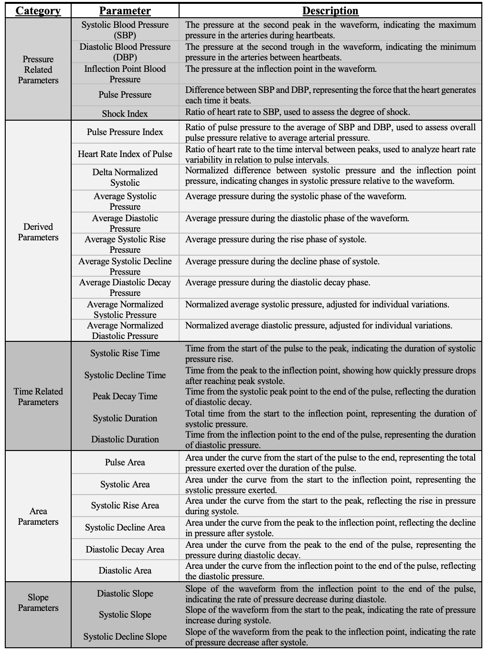

F. Model Optimization
Feature importance in the machine learning models was quantified using the mean normalized Gini impurity decrease. In the DT model, hyperparameter tuning was accomplished by adjusting the maximum depth of the tree, 15, and the minimum samples required for a split, 2, and minimum samples per each leaf node, 1. This process controlled the complexity of the tree and prevented overfitting, ensuring that the model generalized well to new data.

In the RF model, hyperparameter tuning focused on the number of features used for splits, tree depth, and the number of trees in the forest. Genetic algorithms were employed for the RF model to select the best subset of decision trees from the ensemble with their fitness being evaluated based on classification accuracy. Evolutionary operations such as crossover, mutation, and selection were used to iteratively improve performance over multiple generations. Furthermore, performance was optimized by selecting the most relevant features to reduce model complexity in both DT and RF models. Node splits in the RF model were evaluated using the Gini impurity criterion. In the final models, the maximum tree depth was uniformly 12 across all trees with the leaf count per tree ranging from 127 to 258. The mean root node Gini impurity was 0.648 ± 0.035, supporting the class-balancing strategy employed in data preparation.

Conversely, MH-CNN efficacy was influenced by tuning hyperparameters like learning rate, batch size, optimizer selection, and filter sizes. Architecture optimization involves adjusting the number of hidden layers and epochs to effectively capture complex features. Regularization techniques, including batch normalization and weight regularization, were employed to prevent overfitting.

To further diversity the models tested, we created a variety of groups of each model type in our preliminary analysis. In the MH-CNN models, we compared models with exclusively L1 normalization to models with exclusively L2 normalization. L1 normalization yielded more effective F1 score distribution, and hence were standardized for all MH-CNN models. For RF models, we compared models that relied on genetic algorithm (GA) to those that did not use them. The GA used a population size of 100 and evolved to a limit of 50 generations. Tournament selection (size = 3) was applied to select individuals for reproduction. Uniform crossover was used with a probability of 0.5, and Gaussian mutation was applied with mean μ = 0, standard deviation σ = 1, and gene mutation probability of 0.05. The overall mutation probability was set to 0.2. Elitism was implemented by preserving the best individual from each generation. To assess each model and compare them, we used model accuracy, F1-score, confusion matrix and area under the ROC curve as metrics of model effectiveness.
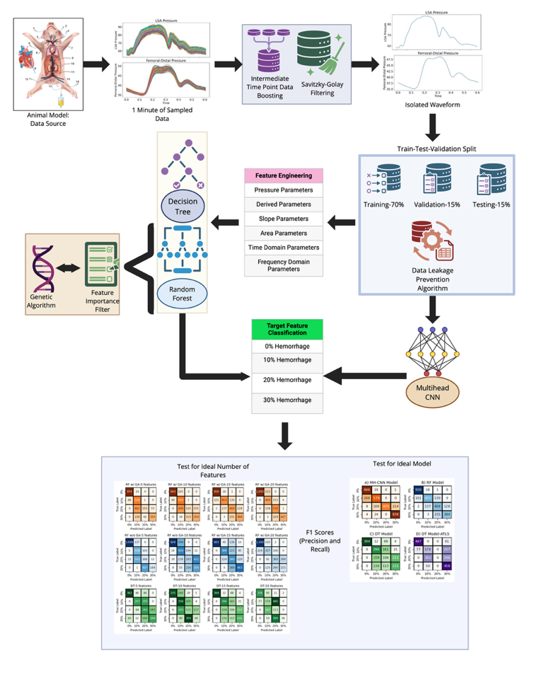
Figure 2. Visual representation of the arterial pressure waveform data processing and side-by-side model development comparison.

III. Results
A two-stage process approach was taken to perform feature selection in an effort to consider both computational efficiency and optimal feature interactions. First an initial RF and DT model was trained on the entire feature pool, and feature importance was determined based on this initial model. Then the top 5,10,15 and 20 features were retained to create a reduced dimension space, capturing the most dominant variables in each run. RF models, while able to create an extensively tested ranking system, are unable to optimize model accuracy based on feature interactions. To address this, a genetic algorithm (GA) was implemented to evolve the feature combinations developed in this constrained space, iteratively evolving and evaluating multiple generations of RF models to maximize classification performance.

Across the various iterations of this feature selection process, there was some variability in the feature ranking across models. Holistically, the primary top performing features belonged to three major categories: derived parameters, time-domain features and frequency domain features. Specifically, the top 20 features across all of the models were as follows: (i) Derived Parameters: Pulse Pressure, Average Pressure, Minimum Pressure, Max Pressure, MAP, Augmentation Pressure, (ii) Time-Domain Features: Heart Rate, Heart Rate Interval, Peak-to-Peak Interval, Inflection Time, and (iii) Frequency-Domain Features: Fast Fourier Transform (FFT) Frequency and Power Spectal Density (PSD). The results of these individual models are depicted in Figure 3, where the confusion matrices for the models with 5, 10, 15 and 20 features are shown. Based on these findings, we recognized that models with the top 15 features performed the best and provided strong classification of hemorrhage groups.

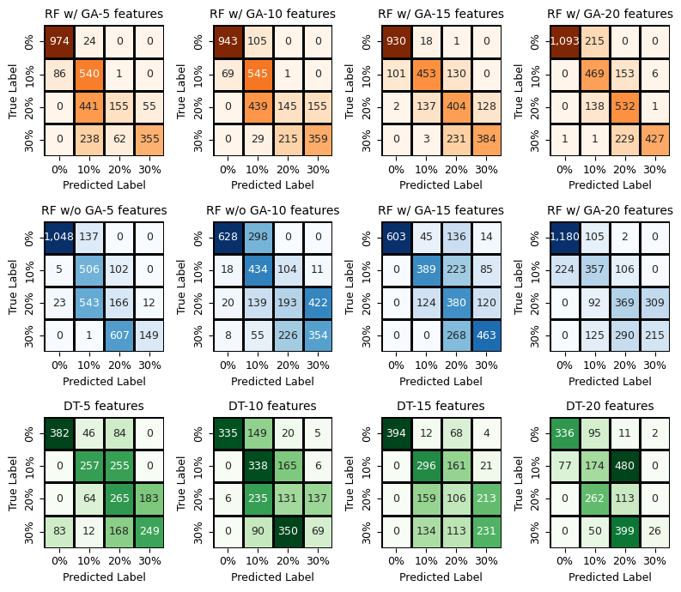
Figure 3. Testing feature importance across ML models. Models which had 15 features exhibited the F1 scores and high accuracies. RF models with GA also outperformed RF models without GA, and both models outperformed DT. Confusion matrices for the Random Forest model (top row – w/GA, middle row- w/o GA) with 5, 10, 15 and 20 features are shown. The bottom row illustrates the matrices for the Decision tree model with 5, 10, 15 and 20 features. Introduction of GA positively improves model variance, improving model performance in GA w/GA. Additionally, we see a consistent improvement with 15 features in both the RF and DT models. The top 20 features across models were as follows: (A) Derived Features: Pulse Pressure, Average Pressure, Minimum Pressure, Max Pressure, MAP, Augmentation Pressure (B) Time-Domain Features: Heart Rate, Heart Rate Interval, Peak-to-Peak Interval, Inflection Time (C) Frequency-Domain Features: Fast Fourier Transform Frequency and Power Spectal Density
Leveraging this idealized selection of 15 features, a second series of tests were performed evaluate the GA impact on RF in contrast to a MH-CNN model and a DT model, with one using the 15 features and the other using only 3 ATLS parameters, The MH-CNN achieved the highest accuracy at 79%, likely reflecting its deep learning capabilities, which allow it to extract complex, high-dimensional features from multichannel hemodynamic data. The RF model followed with 74% accuracy, likely as a result of its ensemble approach that combines multiple DTs, which structurally mitigates standard DT limitations like overfitting, which allows it effectively captures non-linear feature interactions. Notably, the RF model augmented with GA consistently outperformed RF without GA in accuracy and hence was preserved. In contrast, the DT model was the least effective, achieving 54% accuracy. This is likely due to the fact that while DT models offer interpretability, they are prone to overfit, even with careful hyperparameter tuning. A second DT model, trained exclusively on ATLS hemodynamic parameters, also presented with 54% accuracy, but also showed a distinct notably poor F1 score distribution compared to the other models (F1 scores: 0%: 0.87, 10%: 0.35, 20%: <0.001, 30%: 0.6). In the RF model with GA, which performed the best among the ML models, the model achieved a weighted F1 score of 0.738 and a Cohen’s κ of 0.637. The mean one-vs-rest AUC across the four hemorrhage classes was 0.897. The confusion matrices for all four models are displayed in Figure ‎4.

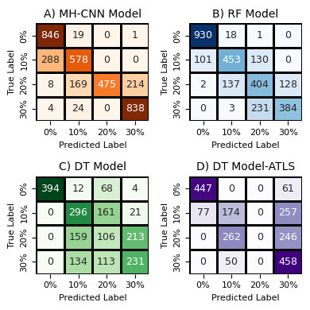
Figure 4. Confusion matrices from each AI model for hemorrhage classification. A) 1D MH-CNN model (79% accuracy) B) Random Forest model (w/GA) (74% accuracy-15 features) C) Decision Tree (54% accuracy-15 features) D) Decision Tree with only ATLS features (54% accuracy-3 features).
Based on F1 scores, which are depicted in Table 3, our data implies that 0% hemorrhage is the easiest to classify across all models, with each demonstrating high accuracy in classifying this level of hemorrhage. This suggests that the features associated with a euvolemic state are distinct and easily recognizable when compared to any hypovolemic state. This confirms that the challenge in classification lies in a model being able to distinguish between different grades of hemorrhage, and that the best performing model would be the one that is best able to differentiate these hemorrhages well. Consequently, 10% and 20% hemorrhage presented the greatest challenge to the models, as indicated by comparatively lower F1 scores in all models. This difficulty in classification may stem from overlapping features, class imbalance, or noise affecting the model's ability to distinguish these different grades of hemorrhage effectively. However, more advanced models, particularly the RF with Genetic Algorithm and the MH-CNN model seem to, exhibit superior performance in classifying these more challenging 10% and 20% hemorrhage levels. The consistent strength of these models underscores the significance of advanced feature selection and deep learning techniques in enhancing model generalization. This is evidenced by the fact that simpler models like the RF without a Genetic Algorithm and Decision Tree struggled to distinguish these classes well, particularly with the 20% hemorrhage class, indicating a need for further feature engineering or advanced model tuning to enhance their predictive capabilities.

Table 3. F1 scores with respect to each machine learning model and number of features.
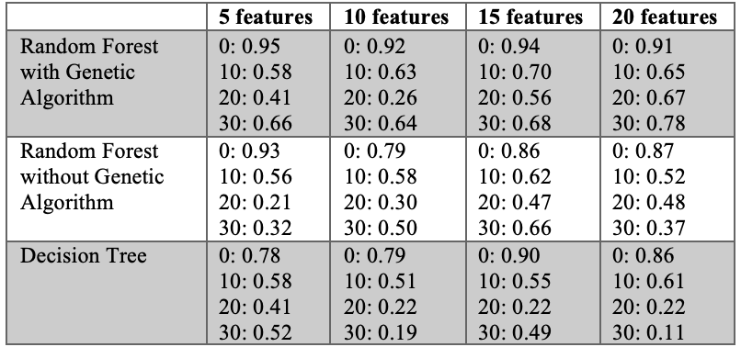

Inspection of the RF model with GA performance reveals that precision–recall asymmetries were stratified relative to hemorrhage severity and are depicted in Table 4. For example, the 0% hemorrhage was classified with high precision (0.90) and near-perfect recall (0.98), with minor misclassifications occurring with the adjacent 10% class. Concurrently, 10% hemorrhage showed moderate precision (0.74) and relatively lower recall (0.66), with errors distributed between the 0% and 20% classes in both directions.. Similar trends existed with the 20% hemorrhage subjects, which was the most challenging to classify, and yielded the lowest precision (0.53) and lowest specificity (0.84). Classification errors were nearly equally distributed toward the adjacent 10% and 30% classes, a trend which was consistent with the transitional nature of this hemorrhage level, at which compensatory mechanisms are most active and the pressure waveform signature is most ambiguous. The 30% class achieved moderate precision (0.750) and high specificity (0.944), but 37.4% of true 30% samples were misclassified as 20% suggesting that at the severe end of the spectrum, residual physiological overlap with the 20% class remains the primary classification challenge.

Notably, all meaningful misclassifications between classes occurred almost exclusively between adjacent hemorrhage classes, with very few errors observed between non-adjacent classes. This consistent pattern of bidirectionalal misclassification likely reflects the physiological impact of early compensatory responses producing waveform features resembling both the euvolemic state and mild hemorrhage. This may actually imply the model is identifying an underlying severity continuum rather than treating the four classes as categorically independent, distinguishing this model’s approach from the ATLS framework.

Table 4. Full classification metrics table across four models.
Model | Metric | 0% | 10% | 20% | 30% | Avg
Multi-Head CNN | Precision | 0.74 | 0.73 | 1.00 | 0.80 | 0.82
 | Recall | 0.98 | 0.67 | 0.55 | 0.97 | 0.79
 | F1 Score | 0.84 | 0.70 | 0.71 | 0.87 | 0.78
Random Forest (GA) | Precision | 0.90 | 0.74 | 0.53 | 0.75 | 0.73
 | Recall | 0.98 | 0.66 | 0.60 | 0.62 | 0.72
 | F1 Score | 0.94 | 0.70 | 0.56 | 0.68 | 0.72
Decision Tree (15 features) | Precision | 1.00 | 0.49 | 0.24 | 0.49 | 0.56
 | Recall | 0.82 | 0.62 | 0.22 | 0.48 | 0.54
 | F1 Score | 0.90 | 0.55 | 0.23 | 0.49 | 0.54
Decision Tree (ATLS) | Precision | 0.85 | 0.36 | 0.00 | 0.45 | 0.42
 | Recall | 0.88 | 0.34 | 0.00 | 0.90 | 0.53
 | F1 Score | 0.87 | 0.35 | 0.00 | 0.60 | 0.45

IV. Discussion
Hemorrhage severity classification is inherently complex due to the great variations in the relationship between blood pressure and individual responses to blood loss. The results of this study confirm the inefficacy in ATLS parameters in fully capturing this relationship, and how classification accuracy is improved through introducing into the classification scheme temporal, morphological and spectral information obtained from the hemodynamic signals. Furthermore, the high performance of the MH-CNN model in tandem with the RF model with GA demonstrates the importance of additionally accounting for high-dimensional feature interactions that simpler modeling strategis, like DTs, are structurally unable to capture. These findings overall demonstrate the paradigm promoted by multimodal AI approaches to enhance classification performance, which ultimately has the potential to improve patient outcomes.

It is difficult to effectively contextualize the study results within existing literature due to the unique nature of the experimental protocol, dataset and algorithms employed. To best compare our findings, we analyzed commonly selected features from our DT and RF models with those employed by two other published models: a compensatory reserve management (CRM) model developed by Bedolla et al. and a fluid responsiveness model developed by Gupta et al [3][8][9].

The goals of the Bedolla model align closely with the goals of our model in the sense that the implemented experimental protocol aimed to simulate hypovolemic conditions while aiming to classify a subjects’ level of decompensation. The Gupta model, on the other hand, essentially represents the opposite scenario of developing a model optimized to predict whether fluid resuscitation will have a positive impact on cardiac performance in swine following circulatory shock. Table 5 depicts the most important features applied in our best performing DT and RF models compared with the top 10 features from the Bedolla and Gupta models. There are some consistent features of importance shared across our model and those reported by Bedolla and Gupta. For example, pulse pressure, heart rate, and the normalized incline/decline of the systolic pressure (i.e. slope) seem to be strong predictors of hemorrhage, CRM and fluid resuscitation. These data collectively show the value of pressure waveform analysis and how utilizing a combination of temporal dynamics, signal morphology and spectral characteristics can improve real-time hemorrhage or CRM status. This notion is further supported by Covertino et al. where a multimodal feature spaces is imperative to create a robust classification scheme to effectively describe and classify physiological pressure signals [7].

Table 5. Feature importance across models.
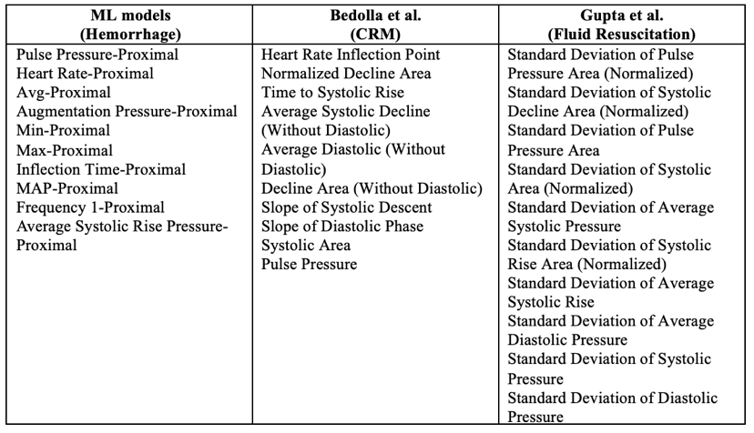

Despite each study having key structural and experimental differences, further examination of each model’s feature importance revealed several key trends of interest. First, HR plays a crucial role in hemorrhage classification in both our ML hemorrhage models and Bedolla’s CRM model. This importance may be the result of the body’s compensatory responses, which increase heart rate after significant blood loss. In our hemorrhage model, the raw value of the heart rate had the most predictive value whereas in the Bedolla et al. model, the inflection point had more value. This difference may be attributable to inherent physiological differences between CRM and hemorrhage. The CRM model works to estimate the body’s level of physiological decompensation during hypovolemia as opposed to the actual level of hemorrhage itself as is the goal of our ML models. Hence, a CRM model would need to highlight critical inflection points when these compensatory responses begin to either intensify or fail. This provides a metric to quantifiably determine the body's remaining reserve. In case of hemorrhage models, the key point of interest lies in the fact that the body, post-hemorrhage, elevates the heart rate to maintain peripheral oxygen delivery. As a result, it becomes reasonable to argue that in a hemorrhage model, the raw value of the heart rate may be a stronger indicator of hemorrhage severity than the actual variations in these values as is the case of the CRM model.
Next, in our ML models, the pulse PP was almost unanimously the most predictive feature. Conversely, in the Bedolla model PP was found to have a had a notably lower feature importance. This is likely because, as was the case of HR, the CRM model’s focus in the physiological sense is more on directed towards the body’s overall capacity to compensate for blood volume loss rather than direct metrics of blood loss, like with PP. In the context of fluid resuscitation models, on the other hand, the variability in PP area was more informative, likely due to its ability to reflect homeostatic attempts to stabilize blood flow post hemorrhage. A possible explanation for this is that PP area may serve as a snapshot into the fluctuations in both vascular tone and pressure post fluid reintroduction, which consequently can capture how the system adapts to the fluid.

In a similar vein, systolic blood pressures (SBP) were found to be important across all datasets, but each model focused on a different aspect of it. For instance, our hemorrhage models and the CRM model emphasizes their absolute drop, indicating vascular collapse. This can prospectively work as an early indicator of physiological instability. The resuscitation models, on the other hand highlight their variability, showing the cardiovascular system’s struggle to regain homeostasis [9]. This may also imply that in the process of resuscitation, trend behavior and fluctuations are more informative of patient status as opposed to absolute values. Collectively, these observations help frame our research within the broader literature, demonstrating the value of RF based models for hemorrhage classification.

When considering the results from the models that adopted the ATLS approach, we explored the inherent feature importance of HR, PP and SBP. We repurposed the DT algorithm used in our study with strictly these three features as the inputs. These models generally achieved accuracies >40% which, considering the complexity of hemorrhage prediction in general, may seem at face value to be effective. However, it is worth noting that with higher levels of hemorrhage (i.e. 20% and 30%) these factors performed quite ineffectively and consistently had F1 scores <0.5, evidencing the necessity for advanced feature engineering besides these simpler features.
Based on these results, it appears the reliance on these relatively simple metrics to assess shock severity assumes that the parameters will change proportionally to the severity of hemorrhage. From this perspective, it would be reasonable to use these markers as a primary marker of degree of hemorrhagic shock, an the assumption that is grounded in the physiology of blood loss, but doing so inherently limits the ability to account for the wide range of compensatory mechanisms that vary within patient populations. Our developed ML models that employ further feature engineering already consider the same parameters as ATLS, while also allowing for a broad range of other features help develop a non-linear classification scheme for the patient population. With this larger range of features, these models can capture complex patterns not accounted for in ATLS, while, in the case of the RF model, not being strictly reliant on those parameters.

A. Clinical Relevance
Clinicians have traditionally relied on non-central (and non-invasive), peripheral pressure measurements to obtain this data rather than central pressure readings (e.g., from left subclavian artery within this porcine model), which are comparatively more difficult to obtain in clinical settings with the exception of surgical settings wherein arterial flow and pressure lines can be introduced to guide anesthesia and vasoconstrictive drug introduction. This study relied exclusively on central pressure waveform data as opposed to peripheral pressure measurements, which likely led to the improved prediction accuracy of these models. While these central waveform features are not currently available without invasive methods, these study results demonstrate that the development of more practical invasive methods to capture these waveforms has clear prospect to improve hemorrhage classification in a clinical setting, making it viable focus for future research and development of clinical tools.

Another future pathway to consider is to expand the applicability of this model towards the task of redeveloping the model to test a wider range of hemorrhage volumes and rates would allow for a more comprehensive study of different combinations of blood loss and rate of bleeding to the goal of categorizing blood loss in more general clinically relevant classifications, like from Class I to IV. As mentioned prior, ATLS has been the clinical standard of hemorrhage grade classification for decades. Several studies have highlighted significant limitations in the effectiveness of this protocol. For instance, a recent retrospective analysis from the indicated that only 9.3% of trauma patients could be appropriately classified using the ATLS shock classes based on the prescribed vital signs [2]. This implies that 90% of trauma patients cannot be effectively classified into the ATLS classification, suggesting to an extent the variability in patient responses to hemorrhage is not best addressed by ATLS.

The models developed in this study provide a promising path forward due to their leveraging of continuous data and analyzing dynamic physiological patterns in this data to capture this variability more holistically. The nature of the developed models can adapt to subtle changes in vital signs and tailor predictions to the better explicate the underlying physiological trajectory of each patient. To better realize this potential, future studies must aim to validate these models on larger more heterogeneous patient populations in addition to incorporating different sources of data to further increase the predictive power of these models.

B. Limitations
As with all studies, we would like to acknowledge a few limitations. Each of these AI models come with their own unique constraints that may impact classification accuracy. A major limitation for the MH-CNN model lies in the relatively small sample size from the original animal study. Deep learning models, like CNNs, require extensive data to train effectively and capture complex patterns, at times needing hundreds of thousands of training samples depending of the level of complexity in the problem [11]. With a limited dataset, like the one used in this study, the CNN risks overfitting, which can lead to poor generalization to new cases [12]. The RF model, while more robust than a single decision tree, can at times struggle in cases where there is high-dimensional data or when the relationships between features are highly complex. DT models are also highly prone to overfitting, especially in cases there is a limited dataset, and at times may create detailed splits to classify the data, which may not generalize well when applied to other datasets. However, there is an opportunity to externally validate and test our algorithm with other porcine hemrrhage datasets and this is a future goal.

Furthermore, the employed experimental procedure classifies hemorrhage from a situation simulated to reach to a specific volume of blood loss. In trauma scenarios, the rate of blood loss can vary drastically even within the same level of blood volume loss, which does limit the clinical translatability of this model to certain cases of hemorrhage. While this issue was to an extent addressed with a data boosting methodology, further studies leveraging uncontrolled hemorrhage data would be needed to further refine the model.

VI. Conclusion

This study demonstrates the potential of AI models in accurately classifying the severity of hemorrhagic shock using arterial pressure waveforms. Traditionally, hemorrhage patient evaluation has relied on parameters like MAP and HR, but as we have demonstrated, these metrics alone are prone to fail in capturing the complex and nonlinear physiological responses during shock due to this inherent patient variability. This limitation demonstrates the pressing need for next-generation diagnostic tools that enhance the ability to accurately assess the severity of hemorrhagic shock in a clinical setting.

By leveraging AI-based approaches, we demonstrate a methodology that can accurately classify hemorrhage severity, particularly for intermediate hemorrhage levels. These advanced tools can serve to facilitate the prompt initiation of appropriate resuscitative measures, potentially improving patient outcomes and reducing mortality rates making them a promising tool for real-time, precise assessments of HS severity. Thus, their integration into trauma settings has the potential to transform clinical decision-making, ultimately improving outcomes for shock patients.

Appendix
Appendixes, if needed, appear before the acknowledgment.

References and Footnotes

Submitting Your IEEE Copyright Form
Authors must submit an electronic IEEE Copyright Form (eCF) upon submitting their final manuscript files. You can access the eCF system through your manuscript submission system or through the Author Gateway. You are responsible for obtaining any necessary approvals and/or security clearances. For additional information on intellectual property rights, visit the IEEE Intellectual Property Rights department web page at https://www.ieee.org/publications/rights/index.html

Acknowledgment
The preferred spelling of the word “acknowledgment” in American English is without an “e” after the “g.” Use the singular heading even if you have many acknowledgments. Avoid expressions such as “One of us (S.B.A.) would like to thank ... .” Instead, write “F. A. Author thanks ... .” In most cases, sponsor and financial support acknowledgments are placed in the unnumbered footnote on the first page, not here.

References

Johnson AB, Burns B. Hemorrhage. In: StatPearls. StatPearls Publishing; 2024. Accessed September 16, 2024. http://www.ncbi.nlm.nih.gov/books/NBK542273/

Latif RK, Clifford SP, Baker JA, et al. Traumatic hemorrhage and chain of survival. Scand J Trauma Resusc Emerg Med. 2023;31:25. doi:10.1186/s13049-023-01088-8

Bedolla CN, Gonzalez JM, Vega SJ, Convertino VA, Snider EJ. An Explainable Machine-Learning Model for Compensatory Reserve Measurement: Methods for Feature Selection and the Effects of Subject Variability. Bioengineering. 2023;10(5):612. doi:10.3390/bioengineering10050612

Mutschler M, Paffrath T, Wölfl C, et al. The ATLS® classification of hypovolaemic shock: A well established teaching tool on the edge? Injury. 2014;45:S35-S38. doi:10.1016/j.injury.2014.08.015

Ashburn JC, Harrison T, Ham JJ, Strote J. Emergency Physician Estimation of Blood Loss. West J Emerg Med. 2012;13(4):376. doi:10.5811/westjem.2011.9.6669

Sokoliuk V, Levchenko O. Blood Loss Estimation Techniques. In: Prabhakar H, S Tandon M, Kapoor I, Mahajan C, eds. Transfusion Practice in Clinical Neurosciences. Springer Nature; 2022:409-416. doi:10.1007/978-981-19-0954-2_37

Va, C., Md, W., Jf, G. & Bc, L. The Compensatory Reserve For Early and Accurate Prediction Of Hemodynamic Compromise: A Review of the Underlying Physiology. PubMed https://pubmed.ncbi.nlm.nih.gov/26950588/.

Akbilgic O, Butler L, Karabayir I, et al. ECG-AI: electrocardiographic artificial intelligence model for prediction of heart failure. Eur Heart J - Digit Health. 2021;2(4):626-634. doi:10.1093/ehjdh/ztab080

Ali J, Khan R, Ahmad N, Maqsood I. Random Forests and Decision Trees. Int J Comput Sci IssuesIJCSI. 2012;9.

Gupta CB, Basu D, Williams TK, et al. Improving the precision of shock resuscitation by predicting fluid responsiveness with machine learning and arterial blood pressure waveform data. Sci Rep. 2024;14:2227. doi:10.1038/s41598-023-50120-5

Gu J, Wang Z, Kuen J, et al. Recent advances in convolutional neural networks. Pattern Recognit. 2018;77:354-377. doi:10.1016/j.patcog.2017.10.013

Zhang C, Bengio S, Hardt M, Recht B, Vinyals O. Understanding deep learning requires rethinking generalization. Published online February 26, 2017. doi:10.48550/arXiv.1611.03530


Fahim U. Mobin. (Fahim Mobin (Student Member, IEEE) was born in Hackensack, New Jersey in the Unitd States. He received the B.S. degree in mechanical engineering from The Pennyslvania State University in 2018, and is currently pursuing the Ph.D. degree in biomedical engineering at the Wake Forest School of Medicine-Virginia Tech College of Engineering joint biomedical engineering program. His major field of study is computational modeling, machine learning, and physiological signal analysis.

He is currently a Graduate Researcher with [Lab/Institution Name], where he develops machine learning models and computational pipelines for analyzing cardiovascular and hemorrhagic shock data. His work includes the development of pressure–volume loop analysis algorithms, predictive models for hemorrhage severity, and data-driven approaches for kidney injury detection using blood gas metrics. He has implemented a variety of machine learning architectures, including multilayer perceptrons, convolutional neural networks, and ensemble models enhanced with advanced feature selection techniques such as genetic algorithms. His research interests include physiological signal processing, interpretable machine learning, scientific computing, and the integration of data-driven models with underlying physical and biological principles.

Mr. Mobin is a member of IEEE and other professional organizations in biomedical engineering and data science. His work has contributed to interdisciplinary research at the intersection of engineering and medicine, with a focus on improving clinical decision-making through computational methods. The third paragraph begins with the author’s preferred title and last name (e.g., Dr. Smith, Prof. Jones, Mr. Kajor, Ms. Hunter, Mx. Riley). List any memberships in professional societies other than the IEEE. Finally, list any awards and work for IEEE committees and publications.

Second B. Author photograph and biography not available at the time of publication.

Third C. Author Jr. (Member, IEEE), photograph and biography not available at the time of publication.

Fahim U. Mobin, Antonio C. Renaldo, Sandra Januszko, and Jacob Dooley are with the Department of Biomedical Engineering, Wake Forest University School of Medicine, Winston-Salem, NC, USA (e-mail: fmobin@wakehealth.edu). Micaela K. Gomez is with both the Department of Biomedical Engineering and the Department of Vascular and Endovascular Surgery, Wake Forest University School of Medicine, Winston-Salem, NC, USA. James E. Jordan is with the Department of Cardiothoracic Surgery, Wake Forest University School of Medicine, Winston-Salem, NC, USA. Oguz Akbilgic is with the Center for Artificial Intelligence Research, Wake Forest University School of Medicine, Winston-Salem, NC, USA. Timothy K. Williams is with the Department of Vascular and Endovascular Surgery, Wake Forest University School of Medicine, Winston-Salem, NC, USA. Elaheh Rahbar is with the Department of Biomedical Engineering, Wake Forest University School of Medicine, Winston-Salem, NC, USA, and also with the Department of Biomedical Engineering, Texas A&M University, College Station, TX, USA (e-mail: erahbar@tamu.edu).

