

Functional Safety Concept Lane Assistance

**Document Version: 1.0**

**Template Version 1.0, Released on 2017-06-21**

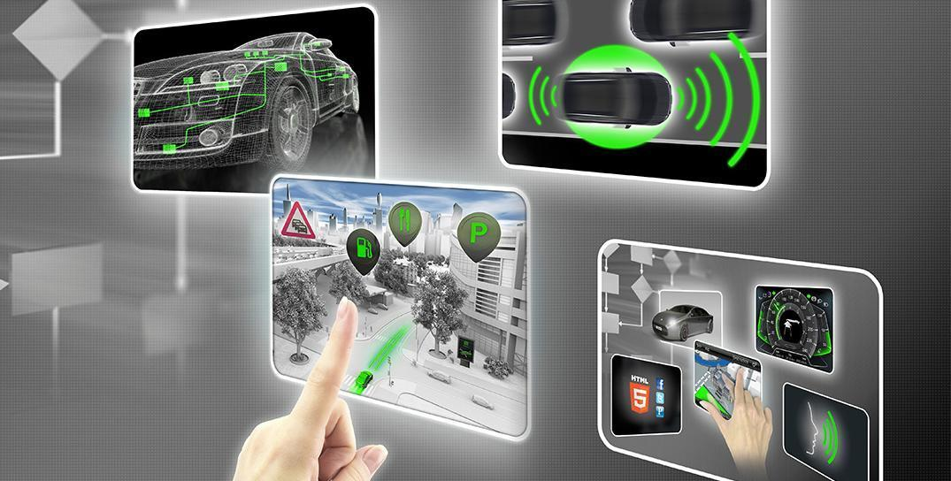

# Document history

|  |  |  |  |
| --- | --- | --- | --- |
| Date | Version | Editor | Description |
| 2018-03-26 | 1.0 | Felipe A. L. Reis | First submission. |
| 2018-03-29 | 1.0 | Felipe A. L. Reis | Second submission. |
|  |  |  |  |
|  |  |  |  |
|  |  |  |  |

# Table of Contents

Document history

Table of Contents

Purpose of the Functional Safety Concept

Inputs to the Functional Safety Concept

Safety goals from the Hazard Analysis and Risk Assessment

Preliminary Architecture

Description of architecture elements

Functional Safety Concept

Functional Safety Analysis

Functional Safety Requirements

Refinement of the System Architecture

Allocation of Functional Safety Requirements to Architecture Elements

Warning and Degradation Concept

References

# 

# Purpose of the Functional Safety Concept

Functional safety has the major purpose to reduce risks to acceptable levels, avoiding accidents. Functional safety contains some safety requirements that must be done to achieve it’s major purpose.

Functional safety is also part of ISO 26262 requirements and also one of the documents to guarantee the safe management.

# Inputs to the Functional Safety Concept

## Safety goals from the Hazard Analysis and Risk Assessment

The goal of this document is provide a hazard analysis and risk assessment to predict and identify possible problems that can cause accidents and lead to an injury. The major objective is to reduce the risk to acceptable levels, tolerated by society.

|  |  |
| --- | --- |
| **ID** | **Safety Goal** |
| Safety_Goal_01 | “The lane keep item shall ensure that the lane departure oscillating torque amplitude is below Max_Torque_Amplitude” [1]. |
| Safety_Goal_02 | “The lane keep item shall ensure that the lane departure oscillating torque frequency is below Max_Torque_Frequency” [1]. |

Table 1. Safety goals

## Preliminary Architecture

The preliminary Lane Assistance System Architecture is defined in Image 1. As shown in Image 1, the Item boundary contains three subsystems:

* Camera system *(Camera Sensor ECU);*
* Car Display System *(Car Display ECU);*
* Electronic Power Steering System *(Electronic Power Steering ECU).*

Outside Item boundary is some system like wheel, throttle and other components of the vehicle.

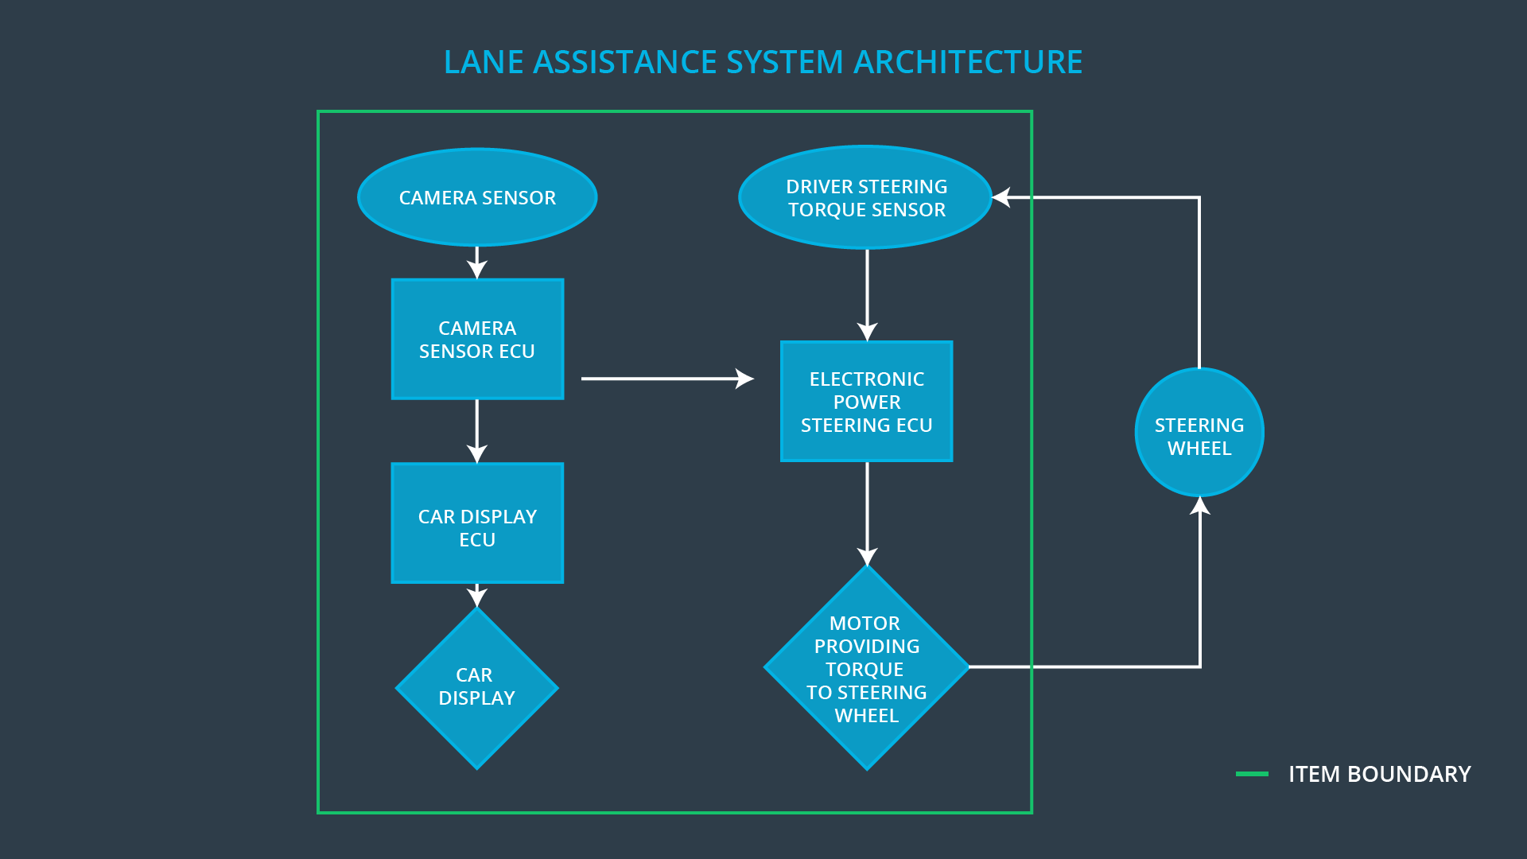

Image 1. Preliminary Lane Assistance System Architecture

### Description of architecture elements

|  |  |
| --- | --- |
| **Element** | **Description** |
| Camera Sensor | Responsible for detect lane lines (using optical detection). |
| Camera Sensor ECU | ECU (Electronic Control Unit) is responsible to retrieve data from camera sensor and process its information. If the ECU identifies the vehicle leaving the lane, it is its responsibility to send a signal to start LKA and LDW functions. |
| Car Display | Responsible for indicate the driver the current usage of the system. |
| Car Display ECU | Responsible for receive and process signal from Camera Sensor ECU and determine if the display must show a visible information to the driver. |
| Driver Steering Torque Sensor | Responsible for identify the torque applied by the driver to correct the trajectory. |
| Electronic Power Steering ECU | Responsible for receive data from Camera Sensor ECU and Driver Steering Torque Sensor and determine the correct extra torque that should be applied by motor to correct the trajectory with the best way possible. Also responsible to vibrate the steering wheel, indicating the driver that the system is working right now. |
| Motor | Responsible for add an extra torque to correct the trajectory. |

Table 2. Architecture elements

# Functional Safety Concept

The functional safety concept consists of:

* Functional safety analysis
* Functional safety requirements
* Functional safety architecture
* Warning and degradation concept

## Functional Safety Analysis

|  |  |  |  |
| --- | --- | --- | --- |
| **Malfunction ID** | **Main Function of the Item Related to Safety Goal Violations** | **Guidewords (NO, WRONG, EARLY, LATE, MORE, LESS)** | **Resulting Malfunction** |
| Malfunction_01 | Lane Departure Warning (LDW) function shall apply an oscillating steering torque to provide the driver a haptic feedback | MORE | LDW applies a torque with higher amplitude than recommended causing difficult to the driver control the car. |
| Malfunction_02 | Lane Departure Warning (LDW) function shall apply an oscillating steering torque to provide the driver a haptic feedback | MORE | LDW applies a torque with higher frequency than recommended causing difficult to the driver control the car. |
| Malfunction_03 | Lane Keeping Assistance (LKA) function shall apply the steering torque when active in order to stay in ego lane | NO | LKA is not limited in time, then it just not avoid the driver takes the hands off the wheel. |

Table 3. Malfunctions

## Functional Safety Requirements

Lane Departure Warning (LDW) Requirements:

|  |  |  |  |  |
| --- | --- | --- | --- | --- |
| **ID** | **Functional Safety Requirement** | **ASIL** | **Fault Tolerant Time Interval** | **Safe State** |
| Functional  Safety Req. 01-01 | “The lane keep item shall ensure that the lane departure oscillating torque amplitude is below Max_Torque_Amplitude” [1]. | C | 50 ms | Set the vibration torque to zero. |
| Functional Safety Req. 01-02 | “The lane keep item shall ensure that the lane departure oscillating torque frequency is below Max_Torque_Frequency” [1]. | C | 50 ms | Set the vibration torque to zero. |

Table 4. LDW Requirements

Lane Departure Warning (LDW) Verification and Validation Acceptance Criteria:

|  |  |  |
| --- | --- | --- |
| **ID** | **Validation Acceptance**  **Criteria and Method** | **Verification Acceptance**  **Criteria and Method** |
| Functional Safety Req. 01-01 | Some tests may be set to view the driver's reaction for different torque amplitudes. The results must be between a tested min and a max limit. | Verify if the system amplitude is really between min and max allowed amplitudes, ensuring a comfort and an alert vibration. |
| Functional Safety Req. 01-02 | Some tests may be set to view the driver's reaction for different torque frequencies. The results must be between a tested min and a max limit. | Verify if the system amplitude is really between min and max allowed frequencies, ensuring a comfort and an alert vibration. |

Table 5. LDW Verification and Validation Acceptance Criteria

Lane Keeping Assistance (LKA) Requirements:

|  |  |  |  |  |
| --- | --- | --- | --- | --- |
| **ID** | **Functional Safety Requirement** | **ASIL** | **Fault Tolerant Time Interval** | **Safe State** |
| Functional Safety Req. 02-01 | System should not performance any assistance above the Max_Duration, defined only to keep the vehicle in the lane. | B | 500ms | The extra torque should be set to zero. |

Table 6. LKA Requirements

Lane Keeping Assistance (LKA) Verification and Validation Acceptance Criteria:

|  |  |  |
| --- | --- | --- |
| **ID** | **Validation Acceptance**  **Criteria and Method** | **Verification Acceptance**  **Criteria and Method** |
| Functional Safety Req. 02-01 | Verify the average time to set the car back to lane and add an extra tolerance, defining the Max_Duration time. | LKA should not work more than Max_Duration time, prevent the driver to take his hands out of the steering wheel. |

Table 7. LKA Verification and Validation Acceptance Criteria

## Refinement of the System Architecture

The refined Lane Assistance System Architecture is defined in Image 2. As shown in Image 2, the Electronic Power Steering ECU take much more responsibilities when compared to the preliminar Lane Assistance System Architecture, in Image 1.

The refined system architecture contains some tests to identify integrity of the data, safety tests and other resources to prevent failures. Also, this architecture contains some information about the risks ASIL, derived from each part of the system.

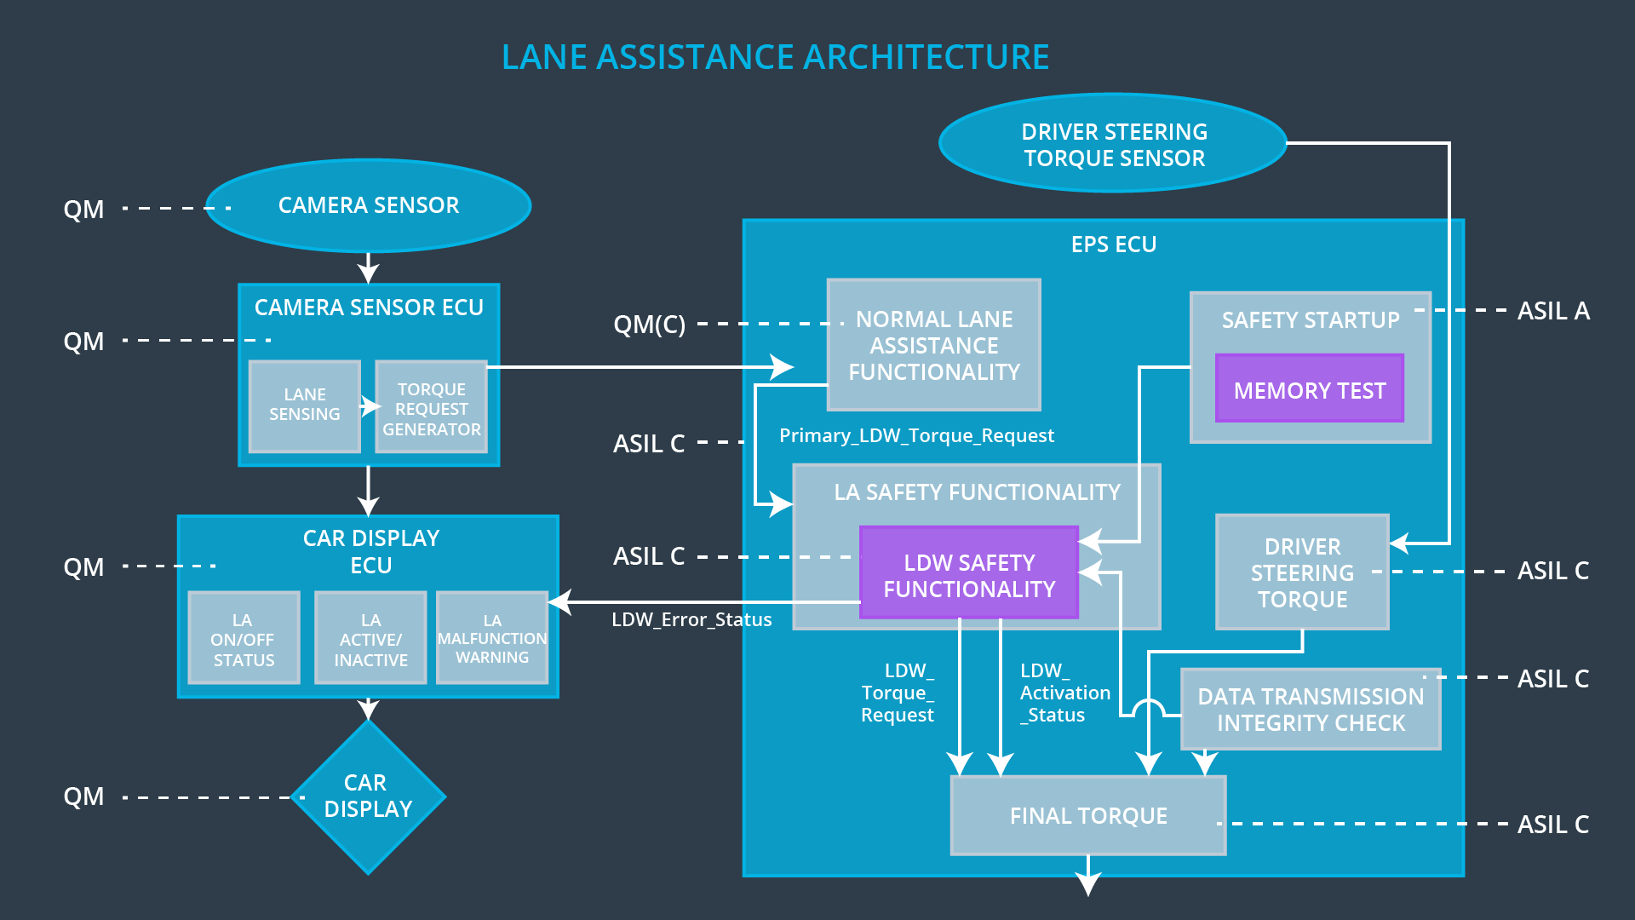

Image 2. Refined Lane Assistance System Architecture

## Allocation of Functional Safety Requirements to Architecture Elements

|  |  |  |  |  |
| --- | --- | --- | --- | --- |
| **ID** | **Functional Safety Requirement** | **Electronic Power Steering ECU** | **Camera ECU** | **Car Display ECU** |
| Functional Safety Req. 01-01 | “The lane keep item shall ensure that the lane departure oscillating torque amplitude is below Max_Torque_Amplitude” [1]. | **YES** | **NO** | **NO** |
| Functional Safety Req. 01-02 | “The lane keep item shall ensure that the lane departure oscillating torque frequency is below Max_Torque_Frequency” [1]. | **YES** | **NO** | **NO** |
| Functional Safety Req. 02-01 | The lane keep item shall ensure that the lane keep assistance do not work more than Max_Duration | **YES** | **NO** | **NO** |

Table 8. Functional Safety Requirements and Allocation of Elements

## Warning and Degradation Concept

|  |  |  |  |  |
| --- | --- | --- | --- | --- |
| **ID** | **Degradation Mode** | **Trigger for Degradation Mode** | **Safe State invoked?** | **Driver Warning** |
| WDC-01 | Turn off the functionality. | System working more time than allowed by Max_Duration time. | NO | Warning light. |
| WDC-02 | Turn off the functionality. | Steering wheel torque is above Max_Frequency or Max_Amplitude limits. | YES | Warning light. |

Table 9. Warning and Degradation

# References

[1] Functional Safety: Functional Safety Requirements. **Udacity**. Available in: <https://classroom.udacity.com/nanodegrees/nd013/parts/6047fe34-d93c-4f50-8336-b70ef10cb4b2/modules/6dc3d743-2b0f-4ae6-97b7-e2ff866f17ef/lessons/77ba6d2d-fd67-4ed3-96ba-128120ca25c7/concepts/c5ad8ba4-2d9d-44b6-bede-d7dd3aef381a>. Accessed in 2018-03-26.