High-Level AI Architecture — Dual Environment Design
1) The Two Environments at a Glance
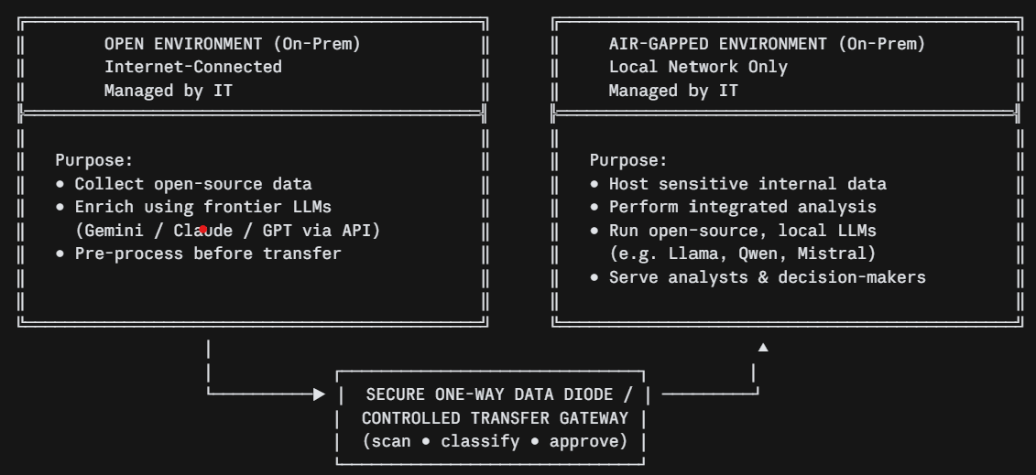

2) Open Environment — Internal Layers
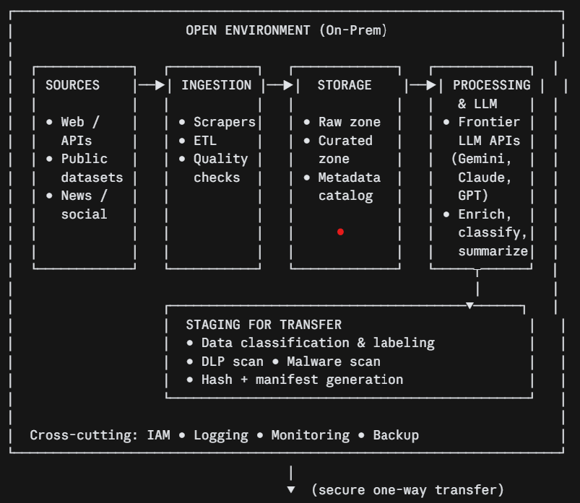
3) Air-Gapped Environment — Internal Layers
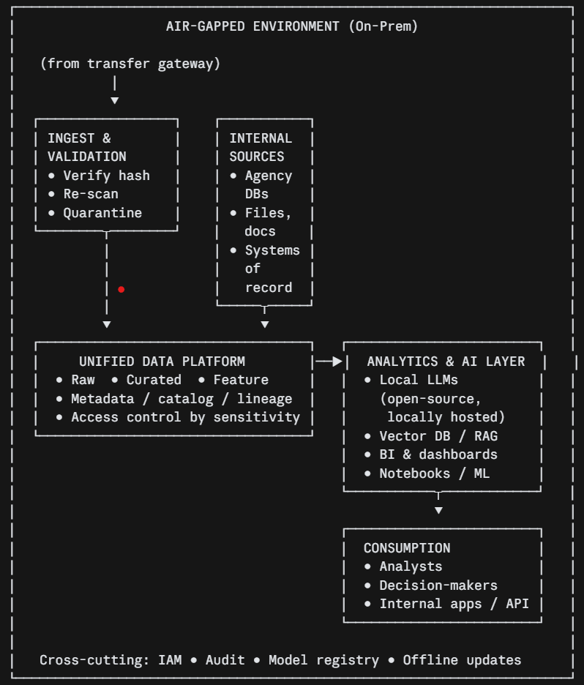

4) How the Two Sides Interact (at a glance)
