Waldo & Rigby
General Setup (using pi and waldo per SSH) 1
Set fixed IP for raspberry pi 1
Set fixed IP for Laptop 1
Mount remote file system 1
Raspberry Pi credentials 2
Waldo commands 2
set_servo (recalibrate a servo) 2
Requirements: 2
Steps 2
play (play an entire project) 2
Editor 3
remover / adder 3
Convenience functions 3
Rigby (remote keyboard) 3
Setup 3
(Re-)calibrate 3
Configure buttons 4
Photos 5

General Setup (using pi and waldo per SSH)

Set fixed IP for raspberry pi
1. Edit /etc/dhcpcd.conf, enable static ip config:

interface eth0
static ip_address=192.168.0.4/24
static routers=192.168.0.1
static domain_name_servers=192.168.0.1

2. reboot

Set fixed IP for Laptop
# ifconfig enp0s25 192.168.0.5 netmask 255.255.255.0 up

Mount remote file system
$ mkdir remote_waldo

$ sshfs pi@192.168.0.4:/home/pi/tmp_waldo_projects remote_waldo/

Raspberry Pi credentials
pi / 1234

Waldo commands

set_servo (recalibrate a servo)
This functionality is used to store the settings of a certain servo (e.g., of a box) for a certain channel within a certain project.

Requirements:
- Potentiometer is connected to the topr-ow of connectors (labelled 0-23), on Pin 8.
- Servo to calibrate is connected to bottom-row, to one of the pins.

Steps
( Servo on Pin 2, Potentiometer on Pin 8)
$ python main.py -ss /path/to/project channelName

Set MCP3008 Pin [default 8] # this is the potentiometer, you can just hit enter

Set Servo Pin [default 0] # this is the servo pin, here use 2

Set minimum position: # hit ‘m’ to set the value with the potentiometer

Set maximum position: # hit ‘m’ to set the value with the potentiometer

Set start position: # usually use the minimum position to start closed

play (play an entire project)
$ python main.py -p /path/to/project [start_offset_in_seconds]
Create a new project
- Copy the folder from an existing project
- Remove all channel files
- Replace audio file in path/to/project/audio
- Delete channels that are not needed anymore from the config file
- Call set_servo for all channels if the servos are not calibrated
- Record channels
$ python main.py -r /path/to/project channelName

Editor
$ python editor.py /path/to/project

remover / adder
Switch between “remover” and “adder” mode.
- Adder (default after start of editor): clicking adds a point
- Remover: clicking removes the closest point

Convenience functions
- Erase all: remove all added points from the editor.
- First/last to y = zero: changes the first and last point added by clicking to y = 0.
- add start/end: add a value at t = 0, and t = end_of_recording with y = 0 for both values.
- Save (needs to have channelName set in input field): write the new line to this channelName
- set same height (needs to have channelName set in input field): set last / first added point y value such, that they match the previously existing y value at that time.
- Merge (needs to have channelName set in input field): Merge the currently drawn line with the existing line (useful, if only a certain part of the curve needs to be changed).

Rigby (remote keyboard)

Setup
- Connect rigby with RJ-45 cable to special port on pi (“pin 0-5”)
- Boot pi

(Re-)calibrate
Needs to be done when the cable connecting rigby and the pi has changed.
- Kill running waldo.py process
- Calibrate:
$ python waldo.py -cal

Configure buttons
Button commands are stored in config file, the following config for example defines the first 10 buttons (note the PROJECT_PATH on top):
Hint: cancel must be button 30, due to special logic in the code,
PROJECT_PATH: ~/waldo_projects
REC_REPL: false
button_value:
0: 89
1: 932
2: 778
3: 670
4: 594
5: 306
buttons:
1: -p s1_tonleiter_einzaehlen
2: -p s23_teaser_variante_tonleiter
3: -p s12_refrain_piano
4: -p s4_variante_solostimmen
5: -p s9_variante_lalala
6: -p reset
7: -p reset
8: -p reset
9: -p reset
10: -p reset
mcp:
0:
CLK: 4
CS: 27
MISO: 17
MOSI: 18
1:
CLK: 22
CS: 25
MISO: 23
MOSI: 24
2:
CLK: 5
CS: 13
MISO: 6
MOSI: 12

Photos

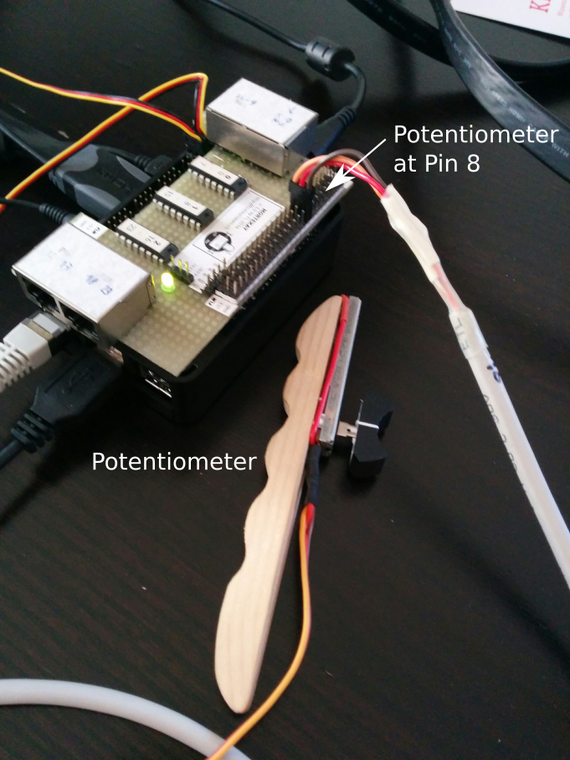 | 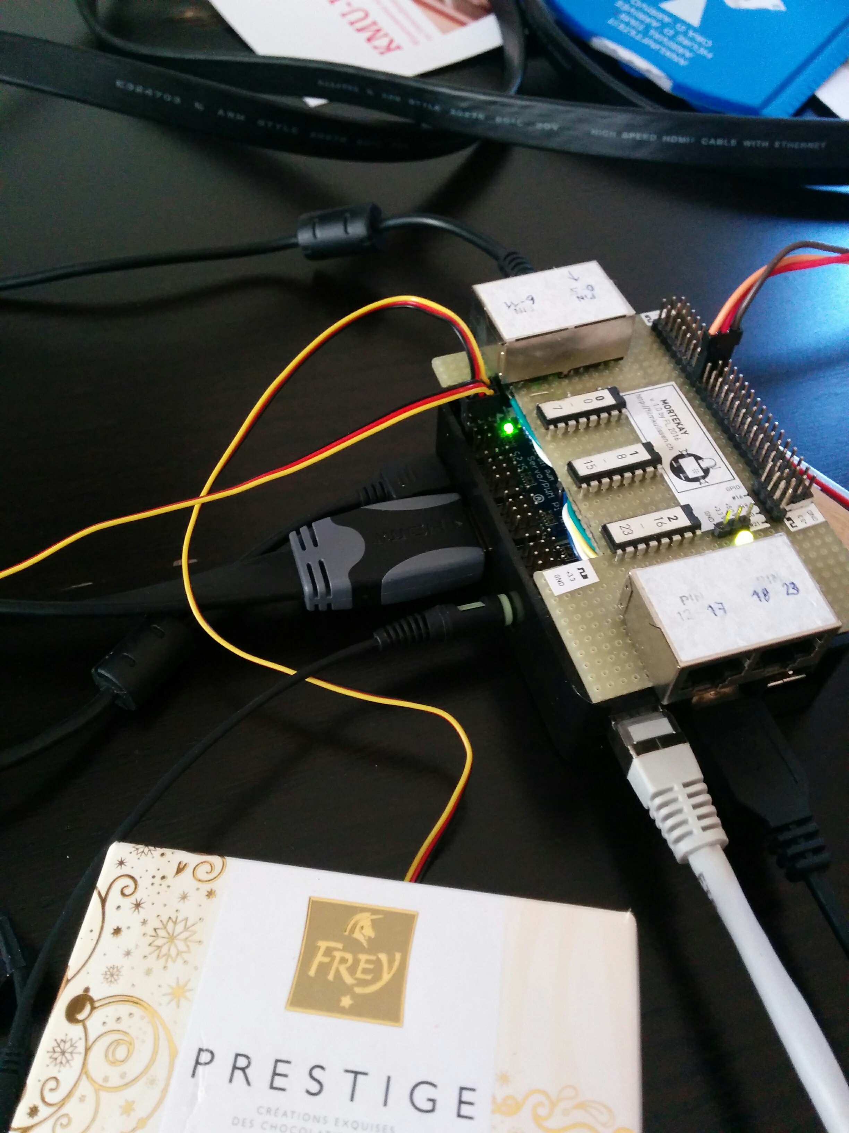
Connecting the Potentiometer on Pin 8 | Connecting servos on (pin 0 and 1)

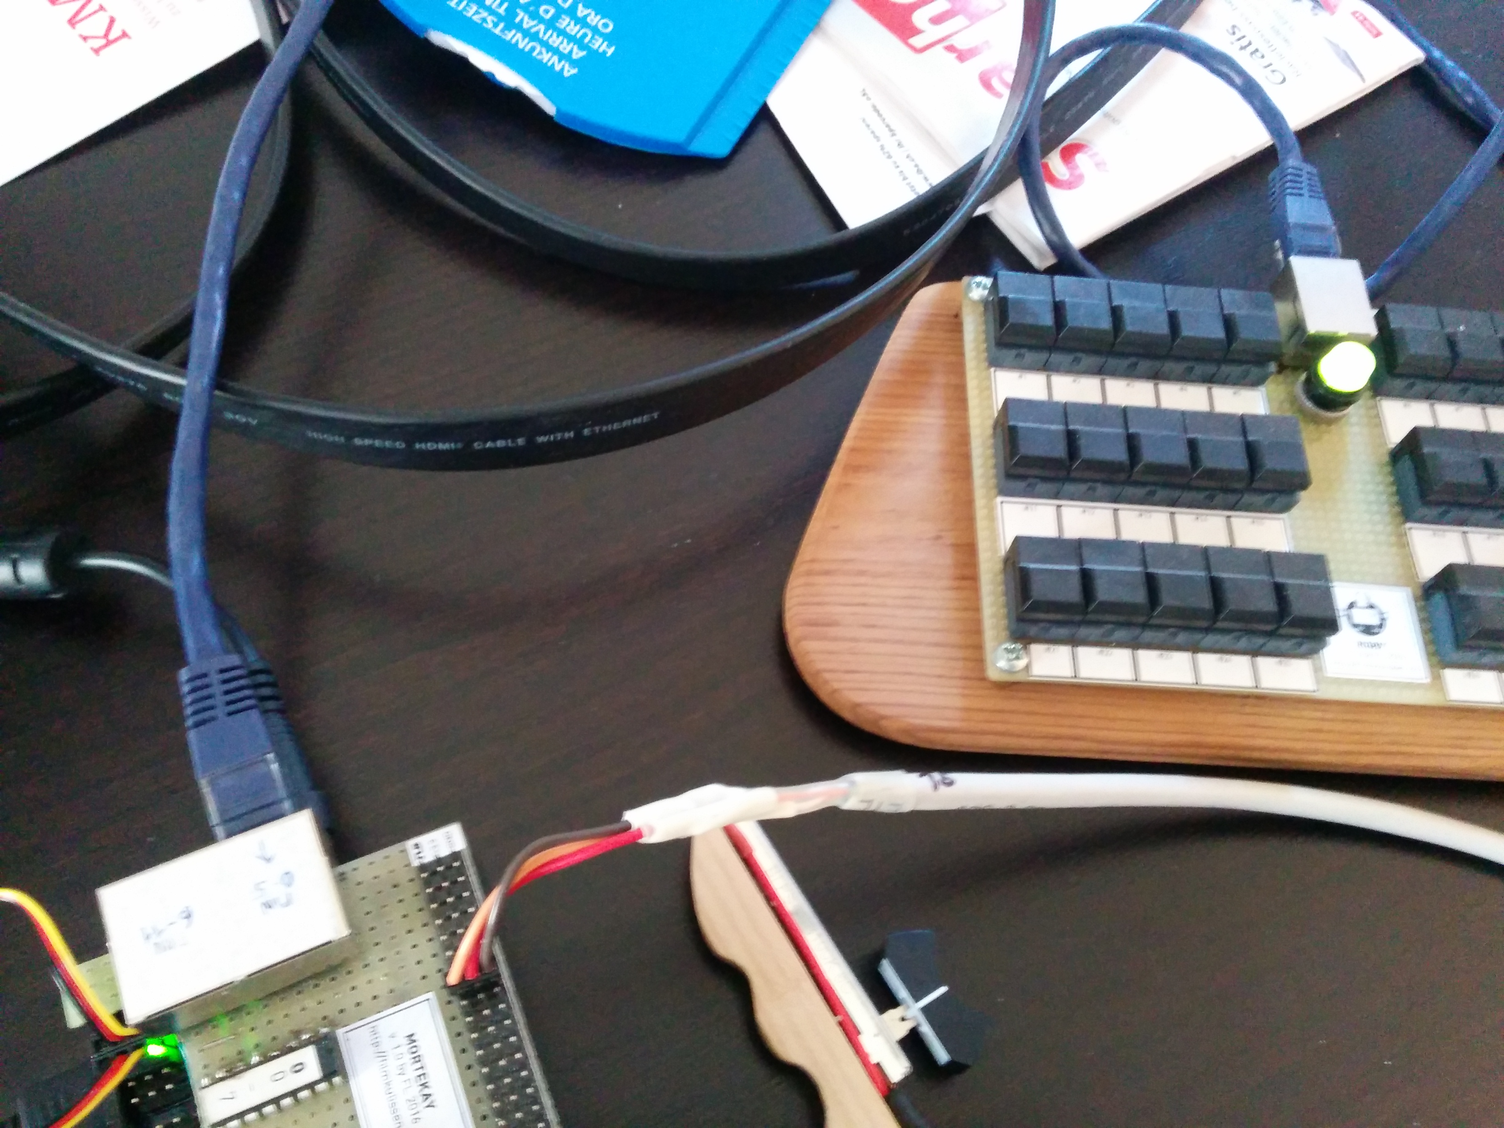
Rigby (Ethernet on Pin 0-5)

