**Introduction:**

This report details the steps to complete an exercise using the Serpent Monte Carlo code. This exercise aimed to gain hands-on experience using the Serpent code and to understand its capabilities and potential applications. The exercise involved reading through the Serpent manual, installing an SSH client, requesting an account on a Serpent server, and connecting to the server to run example simulations. The report includes correcting the path to the directory file, running the example simulations, and analyzing the output files. The report also covers varying input parameters and plots the neutron flux distribution obtained for different cases. Screenshots were taken throughout the process and are included in the report to document the steps taken.

**Serpent path:**

Fig 1: Error message Fig 2: Path directory changed in the input file.

**Running input files:**

The following command is used for running the examples of SERPENT input files for PWR, PWRMOX, CANDU, and BWR:

*nohup sss <input file> > /dev/null &*

**PWR:**

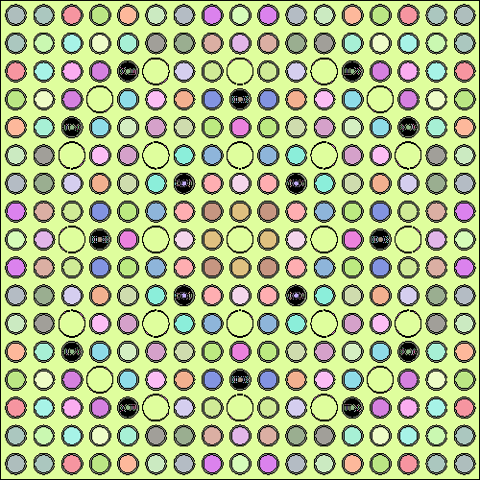

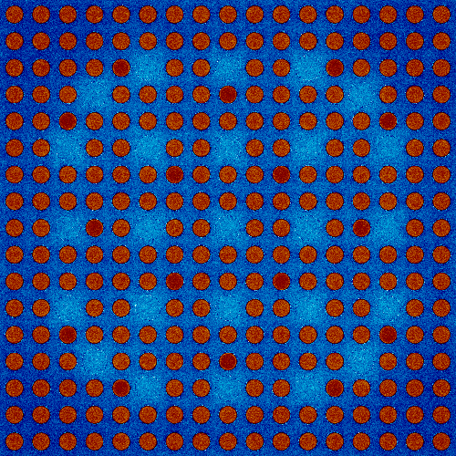

3a: Geometry 3b: Mesh (ep 1) 3c: Mesh (ep 42)

Fig 3: PWR geometry and mesh state initially and after running all the cycles.

**BWR:**

4a: Geometry 4b: Mesh

Fig 4: BWR geometry and mesh state after running all the cycles.

**CANDU:**

5a: Geometry 5b: Mesh

Fig 5: CANDU geometry and mesh state after running all the cycles.

**PWR MOX:**

6a: Geometry 6b: Mesh

Fig 6: PWR MOX geometry and mesh state after running all the cycles.

**Methods:**

ENDF BVII cross-section libraries are used for PWR simulation, and the rest of the CANDU, PWR MOX and BWR simulations had data from the JEFF311 database. The neutron population was 2000 with 500 cycles set as default values, with the number of inactive cycles set at 20 (set pop 2000 500 20).

Changing the neutron population from 2000 to 5000 with the other two parameters of the cycles resulted in this for BWR:

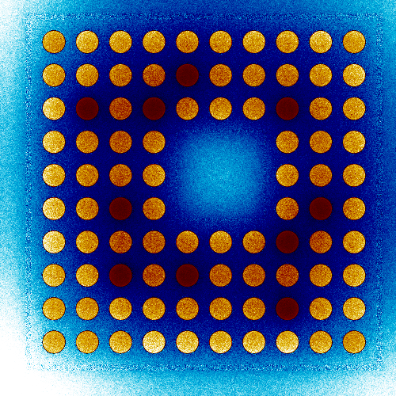

7a: Geometry 7b: Mesh

Fig 7: BWR geometry and mesh state after running all the processes.

Whereas changing the active cycles from 500 to 600 resulted in this for BWR:

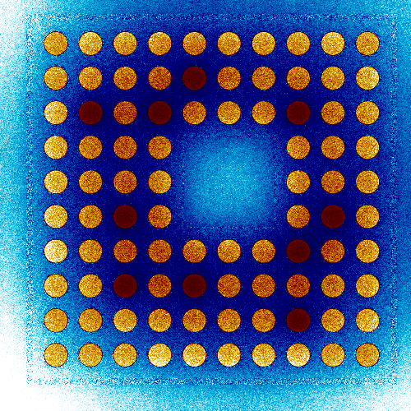

8a: Geometry 8b: Mesh

Fig 8: BWR geometry and mesh state after running all the processes.

In addition to that, changing the inactive cycles from 20 to 30 resulted in this for BWR:

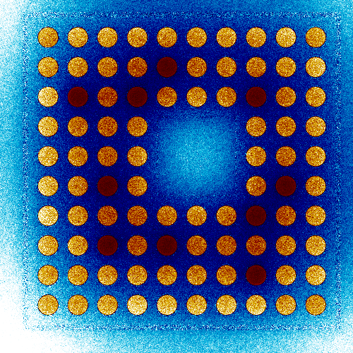

9a: Geometry 9b: Mesh

Fig 9: BWR geometry and mesh state after running all the processes.

**Discussions:**

In a BWR (Boiling Water Reactor) simulation using the SERPENT code, changing the neutron population and the number of active and inactive cycles can significantly impact the simulation results.

The neutron population, also known as the neutron source, represents the number of neutrons present in the system at the beginning of the simulation. Increasing the neutron population will result in more interactions and fission events, which will increase the power of the reactor and the number of new neutrons produced by fission. Decreasing the neutron population will have the opposite effect, diminishing the power and the number of new neutrons produced.

The number of active and inactive cycles represents the number of times the simulation will iterate through the reactor core's active and inactive portions. The active portion of the core represents the portion of the core where fission reactions are taking place, and the inactive part represents the portion of the core where fission reactions are not taking place. Increasing the number of active and inactive cycles will increase the number of fission events and the number of new neutrons produced, increasing the reactor’s power. Decreasing the number of active and inactive cycles will have the opposite effect, diminishing the power and the number of new neutrons produced.

It is important to note that changing the neutron population and the number of active and inactive cycles will also affect other parameters, like the burnup, reactivity, and power distribution, which are essential to the reactor design and safe operation.

In summary, when the neutron population and the number of active and inactive cycles are changed in SERPENT input files for simulating a BWR reactor, it affects the power and the number of new neutrons produced, which in turn affects other parameters that are important to the reactor design and safe operation.